
TRIC-1440

2 IN 1 “RAP’ TOUT” &
ICE DESSERT MACHINE

INSTRUCTION MANUAL
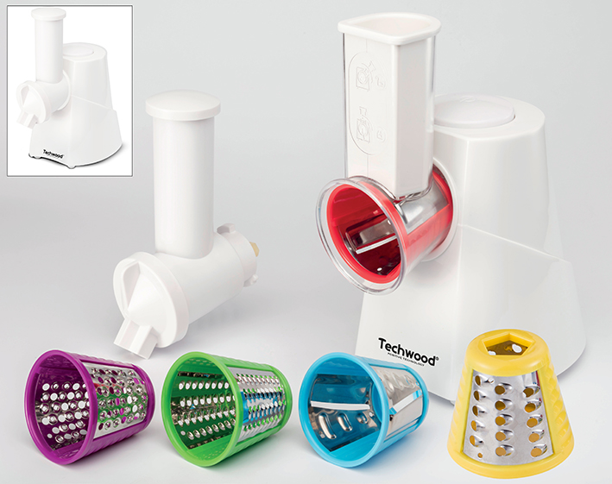
IMPORTANT SAFEGUARDS
Dear consumer, Please read these instructions carefully before use in order to avoid damage due to incorrect use and to better understand the functions of this product. Please pay particular attention to the safety guide. If you pass the device on to a third party, these Operating Instructions must also be handed over. Please keep them for future references.

- Please read these instructions carefully before use.
- Keep present instructions for future references.
- Check that your mains voltage corresponds to that stated on the appliance.
- Only use the appliance for domestic purposes and household or similar applications such as :
-staff kitchen areas, in shops, offices and other working environments ;
-by clients in hotels, motels and other residential type environments ;
- Environment type like :
• Farm Houses • Bed and Breakfast.
- Only use the appliance in the way indicated in these instructions.
- Never use this unit near bathtub, shower, wash-hand basins or other containers with water.
- Never use this apparatus near water projections.
- Never use this apparatus with the wet hands.
- If, unfortunately the apparatus is wet, immediately withdraw the cord of the socket-outlet.
- Inform potential users of these instructions.
- Never leave the appliance unsupervised when in use.
- The appliance must be used only for its intended purpose. No responsibility can be taken for any possible damage caused by incorrect use or improper handling.
- Children and persons with disabilities are not always aware of the danger posed by the use of appliances.
- This appliance shall not be used by children.
- Keep the appliance and its cord out of reach of children.
- Appliances can be used by persons with reduced physical, sensory or mental capabilities or lack of experience and knowledge if they have been given supervision or instruction concerning use of the appliance in a safe way and if they understand the hazards involved.
- Children shall not play with the appliance.
- In order to ensure your children‘s safety, please keep all packaging (plastic bags, boxes, polystyrene etc.) out of their reach.
- Caution ! Do not allow small children to play with the foil :
there is a danger of suffocation !
- From time to time check the cord for damages. Never use the appliance if cord or appliance shows any signs of damage.
- Never immerse the appliance in water or any other liquid for any reason whatsoever.
- Never place it into the dishwasher.
- Never use the appliance near hot surfaces.
- If the supply cord is damaged, it must be replaced by the manufacturer, its service agent or similarly Competent qualified person^{(*)} in order to avoid a hazard.
- Disconnect the power source cable before any operation of cleaning of maintenance and accessories assembly.
- Never use the appliance outside and always place it in a dry environment.
- Never use accessories, which are not recommended by the producer. They could constitute a danger to the user and risk to damage the appliance.
- Never use any other connector than the one provided.
- Never move the appliance by pulling the cord. Make sure the cord cannot get caught in any way.
- Never wind the cord around the appliance and do not bend it
- Ensure that the power cord does not come into contact with hot parts of this unit.
- Make sure the appliance has cooled down before cleaning and storing it.
- The temperature of accessible surfaces may be very high when the appliance is operating. Never touch these parts, of apparatus, to avoid burning itself.
- Make sure the appliance never comes into contact with flammable materials, such as curtains, cloth, etc...& the power cord and plug do not come in contact with water.
- Before cleaning, always unplug the appliance from the power supply and let it cool down.
- This appliance is not intended to be operated by means of an external timer or separate remote-control system.
- Always place the unit on a flat surface. Ensure, also, not to cover the device and not to put anything on it.
- Always remove the plug from the wall socket when the appliance is not in use.
- When using an extension lead always make sure that the entire cable is unwound from the reel. Use solely CE approved extension leads. Input power must be at least 16A, 250V, 3000W.
- Incorrect operation and improper use can damage the appliance and cause injury to the user.
- This device, designed for home use, complies with standards relating to this type of product.
- The item is not to be used, if it has been dropped or if there are visible signs of damage or if it is leaking.
- Regarding the instructions for cleaning, thanks to refer to the below paragraph of the manual.
- This appliance is only intended for household use.
- Avoid spillage on the connector.
- Potential injury from misuse
- The heating element surface is subject to residual heat after use.

^{(*)} Competent qualified person : after sales department of the producer or importer or any person who is qualified, approved and competent to perform this kind of repairs.

GENERAL INFORMATION

The symbol "OPEN BOOK" means a recommendation to read important things contained in the record.

The symbol "BIN" crossed out, abbreviation WEEE (Waste of Electrical and Electronic Equipment) means that at the end of life, it should not be discarded with household waste, but filed to the sorting of the locality. Waste recovery can help preserve our environment.
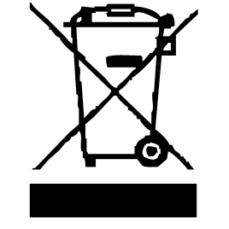

The symbol "CE" is the guarantee of compliance with harmonized European standards, voluntary, reflecting the essential requirements into technical specifications. These standards are not mandatory but are guarantees of compliance with essential requirements.


The symbol ROHS (Restriction of use of some Hazardous Substances) on the Environmental Protection, certifies that for each of the five hazardous substances • Lead • Mercury • (hexavalent) chromium • products for protection against flames PBB and PBDE, the peak concentration is equal to or less than 0.1% of the weight of homogeneous material, and 0.01% for the 6th • cadmium.


The symbol "DOUBLE SQUARE" means a double insulated. A basic insulation and supplementary insulation. This device requires no connection to the mass of a protective conductor grounded. The materials are said : double insulation class II.


The symbol "TUB / SHOWER" crossed out means to never use the unit in a bathroom, a shower in or near water spray. (IP20 Minimum distance 3M.)



The symbol "GLASS / FORK" means that the device is compatible and can come into contact with foodstuffs.


The symbol "TRIMAN" indicates that the consumer is invited to dispose the product as part of a separate collection (eg recycling bin, waste, voluntary intake point).

For more information : http://www.quefairedemesdechets.fr

SPECIAL WARNING FOR CHOPPER

Caution !
- Always disconnect from power supply if it is left unattended and before assembling, disassembling or during cleaning.
- Switch off the appliance and disconnect from supply before changing accessories approaching parts that move in use.
- Potential injuries can occur with misuse. Care shall be taken when handling the sharp cutting blades, emptying the bowl and during cleaning, as they are extremely sharp.
- Regarding the instructions for cleaning surfaces in contact with food or oil, thanks to refer to the below paragraph
" CLEANING AND MAINTENANCE " in manual.
- Regarding the instructions for the use of accessories, operation times and speed settings, refer to the below paragraphs.
- Potential injuries can occur with misuse. Care shall be taken when handling the sharp cutting blades, emptying the bowl and during cleaning, as they are extremely sharp.
- the device shall not be not used continuously more than 10 minutes and shall rest at least for 20 minutes.

BEFORE THE FIRST USE

- Remove the appliance and all accessories gently, paying attention to sharp accessories.
- Clean all accessories and bowls with soapy water and wipe them thoroughly.
- Clean the exterior of the appliance with a damp sponge or cloth and wipe it. Unwind the power cord completely.
- Check that the voltage in the country where you are, corresponds to the voltage indicated on the device.
- Plug the unit into a good electrical outlet, (earthed if the device is class I), to avoid danger.
- Disconnect the power cable from the power supply before performing any maintenance cleaning and accessory fitting.
- Always place the appliance on a table or horizontal flat surface.
- Never modify the device.
- The device should not be left unattended when connected to the main power supply.
- The appliance must not be used if it has dropped and shows visible signs of damage or leakage.

KNOWING ITS UNIT
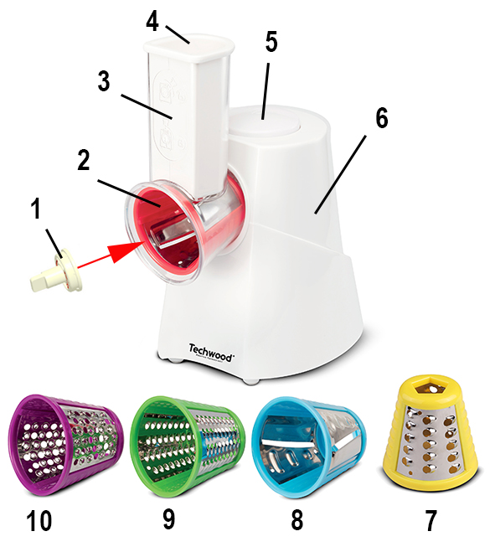
RAPTOUT

1. Cone clamping screw when in place
2. Cutting cone (slicer)
3. Chimney for entrance of vegetables
4. Pusher
5. On / off push button
6. Base + Engine
7. 8. 9. 10. Different types of cones

8

ACCESSORIES

Blue cone : to cut thin slices.
Red cone : to cut thick slices.
Green cone : fine grater.
Yellow cone : grater with big holes.
These 2 accessories are suitable for grating, carrots, zucchini, potatoes, peppers, hard cheese (parmesan) or chocolate to cook.
Purple cone : to grind the ingredients
This accessory is suitable, for example, for grinding dried fruits such as hazelnuts, walnuts, almonds or coconut. (without the shells !!!)
It can also grind hard cheese (parmesan), chocolate or other hard and dry ingredients.
INSTALLING THE CONE HOLDER
Or
THE ICE DESSERT MACHINE

1. Hold the cone holder inclined at 1/4 turned to the right and insert it into the motor base (on the front).
2. Turn the cone holder 1/4 turn to the left until it clicks.
3. Insert the chosen cone into the cone-holder
4. Screw in the clamping screw inside and in the centre of the cone.

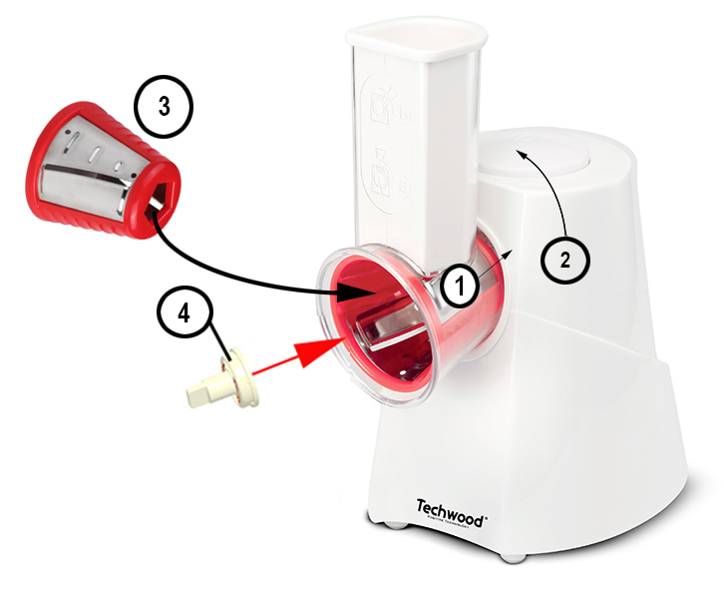

Note: To remove the cone and the cone holder perform the reverse operation.

CONE INSTALLATION

1. Ensure that the cone holder is in place and secured.
2. Select the cone suitable for intended use.
3. Unscrew and remove the screw cone of the axis. (if necessary)
4. Insert the cone in the cone holder by checking the position of the axis.

5. Screw the Cone clamping screw (to the left), to secure the cone.
Note : the cone should not be free on its axis if properly installed.
6. After use, to remove the cone and the cone holder perform the reverse operation.
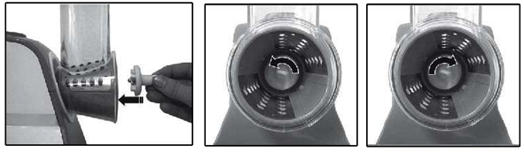

USE OF “RAPTOUT” MACHINE

- Place the unit on a flat level, slip if possible.
- Connect the equipment into an outlet properly installed.
- Place a bowl under the opening of the cone holder to recover the shredded food.
Note : Press the “On” switch briefly once or twice before placing food in the feed tube. This will ensure that the cone is properly attached to the drive shaft of the motor.
- Hold down the "On" pusher and introduce the food to be grated or sliced into the tube.
Note: When releasing the button, the unit will stop automatically.
- Use the pusher (if necessary) to push food inside the tube.
At the end of the use,
- Release the Start / Stop button to stop the unit.
- Remove the electric plug from the outlet.
- Remove the cone as described above.
- Clean the device and accessories after each use, as described below.
Tip: Wash removable parts immediately under the tap, because once dry, fruit pulp or leftover vegetable can be removed with more difficulty.

ACCESSORY TO MAKE ICE DESSERTS

1. Spout and system lid
2. Grinding auger
3. Body of the accessory with chimney for ingredient input
- Pusher

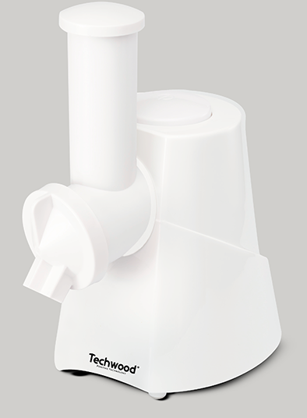
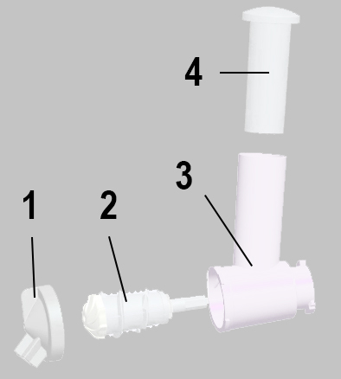

USE IN ICE DESSERT MACHINE

The day before
1- Choose fresh fruits and freeze them for 24 hours.
2- Freeze also ice (perfume according to your taste).

ASSEMBLY OF THE ACCESSORY

1. Insert the auger into the body of the frozen dessert accessory.
2. Take the spout, make sure the gasket is properly placed inside.
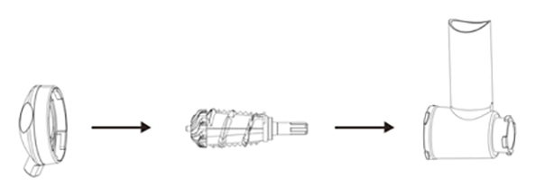
3. Center and secure the spout on the front of the accessory by turning it counter clockwise to lock it.

MOUNTING THE ACCESSORY ON THE BASE

1. Insert the tip (A) of the mounted accessory into the hole in the base of the unit (B) (hole in front).
2. Turn to the left to lock the assembly on the base

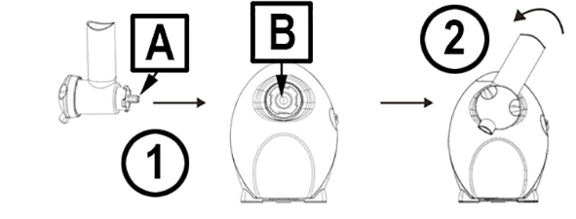

IMPLEMENTATION

1. Plug in the appliance and place a small bowl under the spout.
2. Hold down the "On" button
Note: When releasing the button, the unit will stop automatically.
3. Introduce 4 tablespoons of ice, then a portion of the frozen fruit,
4. Introduce ice and fruit again ; All, slowly in the tube of the accessory.
Notes : Do not overload the device.
Use the pusher and apply constant pressure to the pusher (without
forcing) to get the ingredients into the tube.
NEVER USE FINGERS TO PUSH FOOD
IMPORTANT: wait a few moments for the frozen mixture (fruit + ice) goes down
into the bowl placed under the spout.
NOTE: It is possible to mix fruit and ice before introducing them into the appliance.
At the end of the use,
1. Release the push button to stop the device.
2. Remove the power plug from the power outlet.
3. Remove the accessory as described above.
4. Clean the device and accessories after each use as described below.
Tip: Wash the removable parts immediately under the tap because, once dry, the fruit pulp can be removed with more difficulty.

CLEANING AND MAINTENANCE

Be careful when handling the cones for cleaning. The stainless-steel blade is extremely sharp and can cause severe cuts.
Always disconnect the apparatus and let it cool before cleaning.
Clean the outside of the apparatus with a sponge or slightly wet linen.
The parts (removable) in contact with food like cones, holder, bowl, forks, Spatula etc. can be washed in hot water with sponge and soft detergent or put in the dishwasher.
Never plunge the apparatus in water or all other liquid!
Do not use abrasive cleaners, gritting, or metal brush or another cutting object.

Problem | Cause | Solution
The device stops working | The device may be obstructed. | Stop the unit and unplug the electrical outlet. Remove the spout by turning to the right and remove the accessory.  Clean, wipe and reassemble the unit.
The fruits escape from the sides of the spout | poorly positioned seal | Stop the unit and unplug the electrical outlet. Remove the spout. Clean, wipe and reassemble the gasket.
The ice cream coming out is too liquid | 1. Fruits and or ice are not frozen enough.  2. Too much juicy fruit. | 1. Return the ingredients to the freezer for several hours.  2. Reduce the amount of fruit

STORAGE

-Ensure the unit is completely cool and dry.
-Do not wrap the cord around the appliance, as this will cause damage.
-Keep the appliance in a cool, dry place.

GUARANTEE

Before being delivered, all our products are subjected to a rigorous control.
This apparatus is guaranteed 24 months starting from the date of purchase by the consumer.
The documents in proof of guarantee are :
• The invoice and
• The filled and stamped warrantee plate (located on side or bottom of the gift box). Without these documents in proof, no free replacement, nor no free repair, can be carried out.
During the warranty period, we deal for free, the defects of the apparatus or the accessories, rising from a defect of materials or manufacture by repair or, replacement. The services within the framework of the guarantee do not involve any extension of the warranty period and does not give right to a new guarantee !
In the event of recourse to the guarantee, bring back the complete apparatus to your retailer, in its original packing, accompanied by the proofs of purchase.
The breakage of parts out of glass or plastic is, in all the cases, not warranted. Defects on the accessories or the wearing parts (for example: coals of engines, hooks, drive belts, remote control of replacement, teeth brushes of replacement, webs etc) as well as cleaning, maintenance or it replacement of wearing parts are not guaranteed and are thus to pay !
In the event of foreign intervention, the guarantee becomes null and void.
After flow of the warranty period, repairs can be carried out, against payment, by a specialized trade or a repair service.

RECIPES
MINT CHOCOLATE CHIP  Ingredients: 2 frozen ripe banana,  1 oz. mint dark chocolate  - Insert one frozen banana  - Add 1 oz dark mint chocolate  - Insert second frozen banana  - Stir in bowl to combine | LEMON / RASPBERRY  Ingredient: 2 frozen ripe bananas,  1 tbsp. lemon juice + chopped zest of one lemon, 1/2 cup frozen raspberries  - Insert one frozen banana  - Add 1 tbsp. lemon zest  - Add 1/2 cup frozen raspberries  - Insert second frozen banana  - Stir in bowl to combine
PERFECTLY PEACH  Ingredients: 1/2 cup peaches, 1/4 cup frozen cantaloupe, 1/4 cup frozen cream  - Insert 1/4 cup of frozen cantaloupe  - Add 1/8 frozen cream  - Add 1/2 cup peaches  - Add 1/8 cup frozen cream | STRAWBERRY  Ingredient: 2 cups frozen strawberry, 1/2 cup frozen cream, 1/2 cup ice cube milk  - Insert one cup of frozen strawberry  - Add frozen cream  - Insert second cup of strawberry  - Add crushed ice cube of milk
BLACKBERRY VANILLA BEAN  Ingredients: 2 vanilla beans, 3/4 cup frozen blackberries, 1/4 cup of pistachios (crushed), 1/4 cup frozen cream  - Split 2 vanilla bean lengthwise and scrape seeds from vanilla bean  - With a knife spread the vanilla seeds over blackberry  - Insert half frozen blackberry  - Add 1/4 cream  - Add remained frozen blackberry  - Add 1/4 cup pistachios | TROPICAL TEASE  Ingredients: 1/2 cup frozen pineapple chunks, 1/2 cup frozen mango chunks, 1/4 cup shredded coconut, 1/2 cup frozen cream  - Add 1/2 cup frozen pineapple  - Add 1/4 cup frozen cream  - Add 1/2 cup frozen mango chunks  - Add 1/4 cup frozen cream  - Sprinkle shredded coconut on top of fruit dessert

SPECIFICATIONS

Power supply 220-240V~ 50/60Hz
Power 150W
Norm Class II
Made in PRC

The characteristics can change without prior notice.

CAUTION: In order to minimize the risks of electric shock, In the event of breakdown, not to open the case but to call upon a qualified technician for repairs.

This device complies with EC directives, it was controlled according to all current European directives, applicable such as: electromagnetic compatibility (EMC) and low voltage (LVD).

This device has been designed and manufactured in compliance with the latest regulations and technical requirements for safety.

Imported by Sotech International
" LE PERIPOLE " N°A-107
33, Avenue du Marechal de Lattre de Tassigny
94120 Fontenay sous-bois - France

