TMB-366



STAND MIXER

Instruction manual
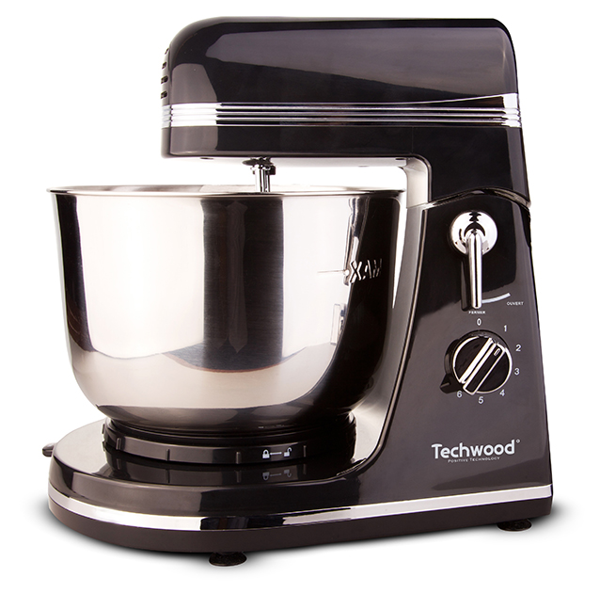
IMPORTANT SAFEGUARDS
Dear consumer, Please read these instructions carefully before use in order to avoid damage due to incorrect use and to better understand the functions of this product. Please pay particular attention to the safety guide.
If you pass the device on to a third party, these Operating Instructions must also be handed over.
Please keep them for future references.

- Please read these instructions carefully before use.
- Keep present instructions for future references.
- Check that your mains voltage corresponds to that stated on the appliance.
- Only use the appliance for domestic purposes and household or similar applications such as:
-staff kitchen areas, in shops, offices and other working environments;
-by clients in hotels, motels and other residential type environments;
- Environment type like :
• Farm Houses • Bed and Breakfast.
- Only use the appliance in the way indicated in these instructions.
- Never use this unit near bathtub, shower, wash-hand basins or other containers with water.
- Never use this apparatus near water projections.
- Never use this apparatus with the wet hands.
- If, unfortunately the apparatus is wet, immediately withdraw the cord of the socket-outlet.
- Inform potential users of these instructions.
- Never leave the appliance unsupervised when in use.
- The appliance must be used only for its intended purpose. No responsibility can be taken for any possible damage caused by incorrect use or improper handling.
- Children and persons with disabilities are not always aware of the danger posed by the use of appliances.
- This appliance shall not be used by children.
- Keep the appliance and its cord out of reach of children.
- Appliances can be used by persons with reduced physical, sensory or mental capabilities or lack of experience and knowledge if they have been given supervision or instruction concerning use of the appliance in a safe way and if they understand the hazards involved.
- Children shall not play with the appliance.
- In order to ensure your children‘s safety, please keep all packaging (plastic bags, boxes, polystyrene etc.) out of their reach.
- Caution ! Do not allow small children to play with the foil :
there is a danger of suffocation !
- From time to time check the cord for damages. Never use the appliance if cord or appliance shows any signs of damage.
- Never immerse the appliance in water or any other liquid for any reason whatsoever.
- Never place it into the dishwasher.
- Never use the appliance near hot surfaces.
- If the supply cord is damaged, it must be replaced by the manufacturer, its service agent or similarly Competent qualified person^{(*)} in order to avoid a hazard.
- Disconnect the power source cable before any operation of cleaning of maintenance and accessories assembly.
- Never use the appliance outside and always place it in a dry environment.
- Never use accessories, which are not recommended by the producer. They could constitute a danger to the user and risk to damage the appliance.
- Never use any other connector than the one provided.
- Never move the appliance by pulling the cord. Make sure the cord cannot get caught in any way.
- Never wind the cord around the appliance and do not bend it
- Ensure that the power cord does not come into contact with hot parts of this unit.
- Make sure the appliance has cooled down before cleaning and storing it.
- The temperature of accessible surfaces may be very high when the appliance is operating. Never touch these parts, of apparatus, to avoid burning itself.
- Make sure the appliance never comes into contact with flammable materials, such as curtains, cloth, etc...& the power cord and plug do not come in contact with water.
- Before cleaning, always unplug the appliance from the power supply and let it cool down.
- This appliance is not intended to be operated by means of an external timer or separate remote-control system.
- Always place the unit on a flat surface. Ensure, also, not to cover the device and not to put anything on it.
- Always remove the plug from the wall socket when the appliance is not in use.
- When using an extension lead always make sure that the entire cable is unwound from the reel. Use solely CE approved extension leads. Input power must be at least 16A, 250V, 3000W.
- Incorrect operation and improper use can damage the appliance and cause injury to the user.
- This device, designed for home use, complies with standards relating to this type of product.
- The item is not to be used, if it has been dropped or if there are visible signs of damage or if it is leaking.
- Regarding the instructions for cleaning, thanks to refer to the below paragraph of the manual.
- This appliance is only intended for household use.

^{(*)} Competent qualified person : after sales department of the producer or importer or any person who is qualified, approved and competent to perform this kind of repairs.

SPECIAL WARNING FOR FOOD PROCESSOR

Caution !
- Always disconnect from power supply if it is left unattended and before assembling, disassembling or during cleaning.
- Switch off the appliance and disconnect from supply before changing accessories approaching parts that move in use.
- Potential injuries can occur with misuse.
- Care shall be taken when emptying the bowl and during cleaning.
- Regarding the instructions for cleaning surfaces in contact with food or oil, thanks to refer to the below paragraph "cleaning" in manual.
- Regarding the instructions for the use of accessories, operation times and speed settings, refer to the below paragraphs.

GENERAL INFORMATION

The symbol "OPEN BOOK" means a recommendation to read important things contained in the record.

The symbol "BIN" crossed out, abbreviation WEEE (Waste of Electrical and Electronic Equipment) means that at the end of life, it should not be discarded with household waste, but filed to the sorting of the locality. Waste recovery can help preserve our environment.
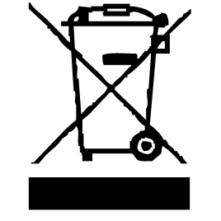

The symbol "CE" is the guarantee of compliance with harmonized European standards, voluntary, reflecting the essential requirements into technical specifications. These standards are not mandatory but are guarantees of compliance with essential requirements.



The symbol "GLASS / FORK" means that the device is compatible and can come into contact with foodstuffs.

The symbol ROHS (Restriction of use of some Hazardous Substances) on the Environmental Protection, certifies that for each of the five hazardous substances • Lead • Mercury • (hexavalent) chromium • products for protection against flames PBB and PBDE, the peak concentration is equal to or less than 0.1% of the weight of homogeneous material, and 0.01% for the 6th • cadmium.


The symbol "DOUBLE SQUARE" means a double insulated. A basic insulation and supplementary insulation. This device requires no connection to the mass of a protective conductor grounded. The materials are said: double insulation class II.


The symbol "TRIMAN" indicates that the consumer is invited to dispose the product as part of a separate collection (eg recycling bin, waste, voluntary intake point).


For more information : http://www.quefairedemesdechets.fr

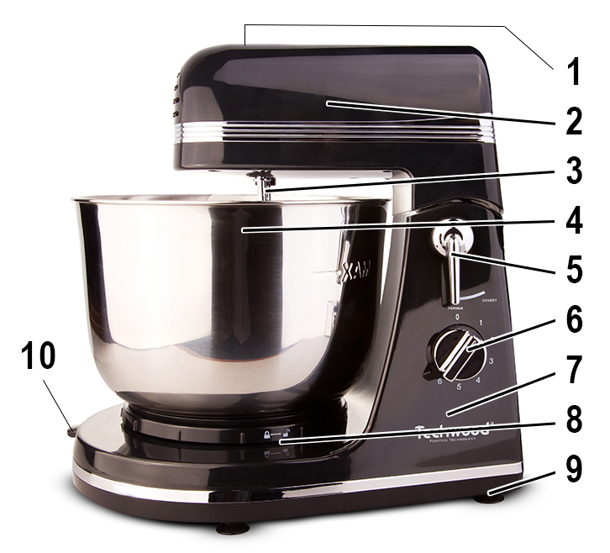
TO KNOW IT’S UNIT

- Ejection button for accessories
- Liftable part of the device
- Accessories fixing axis
- 3.5L SS rotating bowl
- Lock/Unlock button.
To raise the above part
of the robot
- Speed selector
- Base of the device.
- Locking of the bowl
- Anti-slip feet
- Adjustment Left / Right of the bowl

BEFORE FIRST USE

1. Place the mixer on a flat, dry surface such as a bench.
2. Make sure the power cord is unplugged and the speed selector is in the '0'
position.
3. Remove any packaging material and labels.
4. Remove the bowl and accessories.
5. Wash the accessories in hot, soapy water with a sponge.
6. Rinse and dry thoroughly.
(these parts can also be put in the dishwasher)

SETTING UP

• Unwind the power cord completely.
• Check that the voltage in the country where you are, corresponds to the voltage indicated on the device.
• Plug the unit into a good electrical outlet, (earthed if the device is class I), to avoid danger.
• Disconnect the power cable from the power supply before performing
maintenance cleaning and accessory mounting.
• Never modify the device.

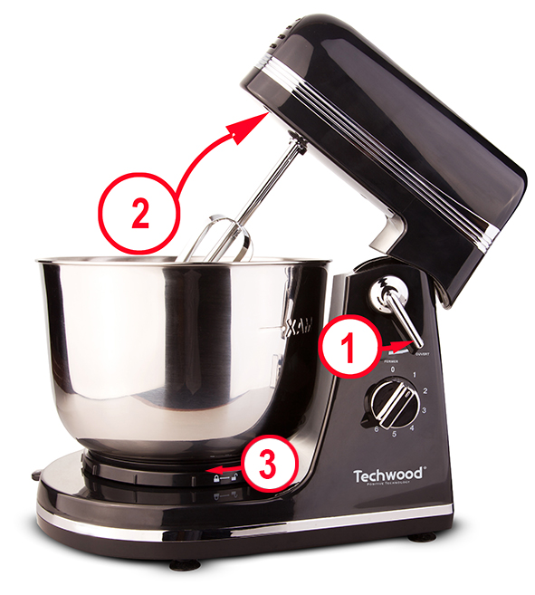
Press the unlock button on the engine block (1)
and move it towards to the right to open the lock.
Raise (2) the upper part of the robot

Place the bowl on its base and turn
clockwise (3) to fix it on its support.
Insert the dough hooks or whisks,
according to your choice.

On the hooks and whips where are letters "L" and "R". The device facing you, the hooks or whips with the letter "L" are fixed on the left and those with an "R" on the right.

The whip and hook eject button is located on the top of the top.
Push the whip or hook until they click, so they are properly attached.
Connect the unit to the mains, making sure the speed selector is
set to 0.
Place the ingredients in the bowl and select a speed of 0 to 6.
0 indicating that the device is stopped and 6 being the maximum speed.
To add ingredients while the food processor is running, reduce the speed to 1 and push the adjustment lever down and To the right or left, (depending on the starting position of the setting). The bowl will change position and add ingredients.

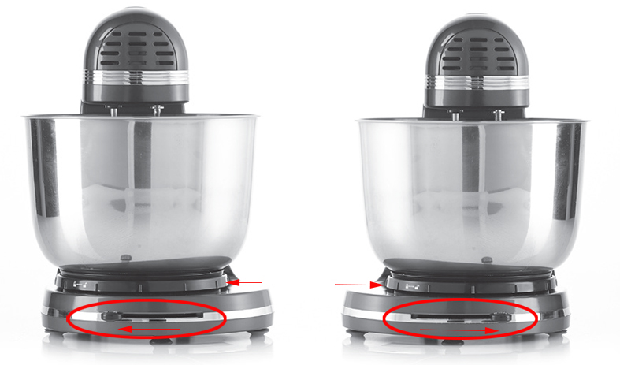

If necessary, stop the appliance and use a spatula to push ingredients to the centre of the bowl.
After refocusing the ingredients, restart the device.
When you are satisfied with the food preparation, return the speed selector to 0 to stop the appliance and disconnect it.
Press the eject button (on the top of the unit) to remove the accessories. (whips or dough hooks).
Note : Never press this button while the unit is operating.

Accessory User Guide

The guide below provides speed settings.
Start at the MIN speed and then increase the speed according to the recipe.
This table is provided for information only. Do your own experiment to refine the settings.

Accessories | Picture | Speed setting | Time | Capacity
Kneading Hook | 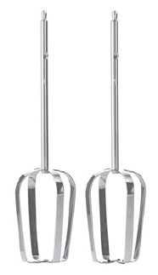 | 1-2 | 30sec at speed1 and 3-5min at speed 3 | 600 g flour and  300 ml water
Whisk | 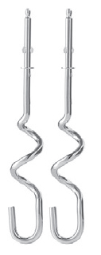 | 5-6 | 5-7min | From 3 to 10 white eggs

USE

Put all liquid ingredients in the bowl and then add the dry ingredients.
Always stay near the machine during use.

Add ingredients as close to the sides of the bowl as possible and not directly into the rotating accessories.

Start at low speed until the ingredients are well mixed. This will reduce the risk of the contents splashing from the bowl. Always add ingredients as close to the sides of the bowl as possible and not directly into the rotating tool.
When preparing cake mixtures, use speed level 1/2 for low speed, level 3/4 for medium speed, and level 5/6 for high speed. To obtain the best results, mixtures should be processed for the amount of time stated on the package.
Mixtures containing large amounts of liquid must be processed at low speed to avoid splashing. Increase speed when the mixture has thickened.
For mixing thin types of dough choose the medium speed. Switch off the machine regularly to clean the sides by using a rubber spatula.
Short crust pastry is one of the thickest types of dough, but you can make the mixing easier by :
- Adding butter or margarine of room temperature
- Adding the ingredients one at a time and mixing the ingredients well before adding a new ingredient
- Adding one cup of flour at a time
Note : If there are some difficulties in mixing the dough, increase the speed.
If, by mistake, something gets stuck in the tool, or the motor stops, switch off the machine and remove the plug from the power socket. Solve the problem or reduce the amount in the bowl. Let the motor cool off for 5 minutes before the machine is switched on again.
Notes : Use the whisk for whipping egg whites, cream, and similar. The whisk is
not suited for thick mixtures such as dough and mashed potatoes.
A hand mixer is recommended for smaller amounts.

The machine can whip a minimum of 3 egg-white / 1 cup of cream. Whipping is more efficient when the whisk is completely submerged in the liquid.
Egg whites
Put the egg whites into the dry clean bowl. Attach the bowl to the support and whip the egg whites.
Note : Avoid splashing by gradually increasing the speed to the wanted speed level. See guide below.
Amount Speed Time
3-6 egg whites 6 - MAX 2min
8-10 egg whites 5 - 6 2min
Egg whites are whipped quickly. Keep an eye on the egg whites to avoid whipping them for too long.
Whipped cream
Pour cold cream into the cooled bowl. Attach the bowl to the support and fix the whips on the device. Avoid splashing by gradually increasing the speed to the wanted rate.
Amount Speed Time
1 cup 5-6 1min
½ litre 6-MAX 1min
Cream is whipped fast. Keep an eye during whipping.

APPLICATION EXAMPLES

Beating of Egg-white
Put 8 egg-white in the BOWL with the WHISK at speed 6.

Beating of cream
Put 600g cream with the FLAT BEATER in the BOWL at speed 4.

Kneader
Bread dough
Put 500g of wheat flour, 30cl of warm water, 30g of yeast and 15g of salt in the bowl and beat with the kneader at speed 4. Knead until you obtain a smooth ball.

CLEANING AND MAINTENANCE

Before cleaning, always: switch off the appliance, disconnect the apparatus and let it cool.
Clean the outside of the apparatus with a sponge or slightly wet linen.
The parts (removable) in contact with food like plate, bowl, forks, Spatula etc. can be washed in hot water with sponge and soft detergent or put in the dishwasher.
Never plunge the apparatus in water or all other liquid!
Do not use abrasive cleaners, gritting, or metal brush or another cutting object.
Tilt up the top of the unit and, if you need to remove the accessories: press the eject button.
Turn the bowl counter clockwise until it detaches from the base.
Wash the mixing bowl and the beaters or whisks in hot water with soap. (or in the dishwasher).

STORAGE

-Ensure the unit is completely cool and dry.
-Do not wrap the cord around the appliance, as this will cause damage.
-Keep the appliance in a cool, dry place and out of reach from children.

GUARANTEE

Before being delivered, all our products are subjected to a rigorous control.
This apparatus is guaranteed 24 months starting from the date of purchase by theconsumer.
The documents in proof of guarantee are:
• The invoice and
• The filled and stamped warrantee plate (located on side or bottom of the gift box). Without these documents in proof, no free replacement, nor no free repair, can be carried out.
During the warranty period, we deal for free, the defects of the apparatus or the accessories, rising from a defect of materials or manufacture by repair or, replacement. The services within the framework of the guarantee do not involve any extension of the warranty period and does not give right to a new guarantee!
In the event of recourse to the guarantee, bring back the complete apparatus to your retailer, in its original packing, accompanied by the proofs of purchase.
The breakage of parts out of glass or plastic is, in all the cases, not warranted. Defects on the accessories or the wearing parts (for example: coals of engines, hooks, drive belts, remote control of replacement, teeth brushes of replacement, webs etc) as well as cleaning, maintenance or it replacement of wearing parts are not guaranteed and are thus to pay!
In the event of foreign intervention, the guarantee becomes null and void.
After flow of the warranty period, repairs can be carried out, against payment, by a specialized trade or a repair service.

SPECIFICATIONS

Power supply 220-240V~ 50/60Hz
Power 300W
Norm Class II
Bowl Capacity 3,5 L
Made in PRC

The characteristics can change without prior notice.

This device complies with EC directives, it was controlled according to all current European directives, applicable such as: electromagnetic compatibility (EMC) and low voltage (LVD).

This device has been designed and manufactured in compliance with the latest regulations and technical requirements for safety.

CAUTION: In order to minimize the risks of electric shock, In the event of breakdown, not to open the case but to call upon a qualified technician for repairs.

Imported by Sotech International
" LE PERIPOLE " N°A-107
33, Avenue du Marechal de Lattre de Tassigny
94120 Fontenay-sous-Bois - France

