TFF-99i

Fryer


ELECTRIC FONDUE - FRYER

Instruction manual

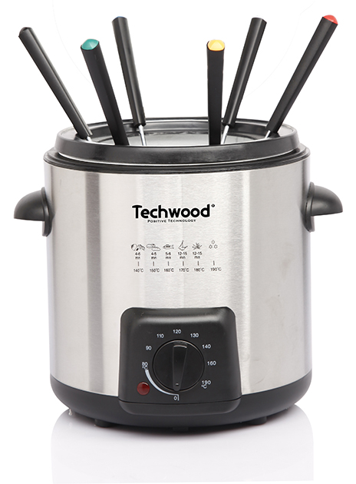
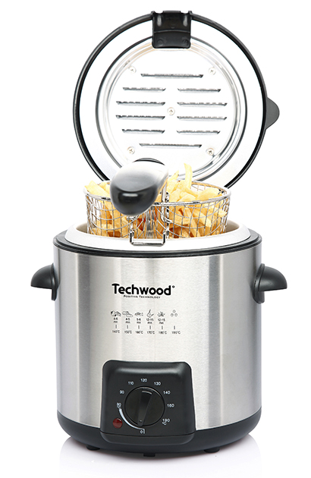
IMPORTANT SAFEGUARDS

OR

Fondue
Dear consumer, Please read these instructions carefully before use in order to avoid damage due to incorrect use and to better understand the functions of this product. Please pay particular attention to the safety guide.
If you pass the device on to a third party, these Operating Instructions must also be handed over.
Please keep them for future references.

- Please read these instructions carefully before use.
- Keep present instructions for future references.
- Check that your mains voltage corresponds to that stated on the appliance.
- Only use the appliance for domestic purposes and household or similar applications such as:
- staff kitchen areas, in shops, offices and other working environments;
- By clients in hotels, motels and other residential type environments;
- Environment type like :
• Farm Houses • Bed and Breakfast.
- Only use the appliance in the way indicated in these instructions.
- Never use this unit near bathtub, shower, wash-hand basins or other containers with water.
- Never use this apparatus near water projections.
- Never use this apparatus with the wet hands.
- If, unfortunately the apparatus is wet, immediately withdraw the cord of the socket-outlet.
- Inform potential users of these instructions.
- Never leave the appliance unsupervised when in use.
- The appliance must be used only for its intended purpose. No responsibility can be taken for any possible damage caused by incorrect use or improper handling.
- Children and persons with disabilities are not always aware of the danger posed by the use of appliances.
- This appliance shall not be used by children from 0 year to 8 years.
- This appliance can be used by children aged from 8 years and above if they are continuously supervised.
- This appliance can be used by people with reduced physical, sensory or mental capabilities or lack of experience and knowledge if they have been given supervision or instruction concerning use of the appliance in a safe way and understand the hazards involved.
- Keep the appliance and its cord out of reach of children aged less than 8 years.
- Cleaning and user maintenance shall not be made by children. Children should not play with the appliance.
- In order to ensure your children‘s safety, please keep all packaging (plastic bags, boxes, polystyrene etc.) out of their reach.
- Caution ! Do not allow small children to play with the foil :
there is a danger of suffocation !
- From time to time check the cord for damages. Never use the appliance if cord or appliance shows any signs of damage.
- Never immerse the appliance in water or any other liquid for any reason whatsoever.
- Never place it into the dishwasher.
- Never use the appliance near hot surfaces.
- Do not operate the appliance with a damaged cord or plug, or after the appliance has been damaged in any manner.
- If the supply cord or appliance is damaged, it must be replaced by the manufacturer or its service agent or a similarly qualified person in order to avoid a hazard.
- Disconnect the power source cable before any operation of cleaning of maintenance and accessories assembly.
- Never use the appliance outside and always place it in a dry environment.
- Never use accessories, which are not recommended by the producer. They could constitute a danger to the user and risk to damage the appliance.
- Never use any other connector than the one provided.
- Never move the appliance by pulling the cord. Make sure the cord cannot get caught in any way.
- Never wind the cord around the appliance and do not bend it
- Ensure that the power cord does not come into contact with hot parts of this unit.
- Make sure the appliance has cooled down before cleaning and storing it.
- The temperature of accessible surfaces may be very high when the appliance is operating. Never touch these parts, of apparatus, to avoid burning itself.
- Make sure the appliance never comes into contact with flammable materials, such as curtains, cloth, etc...& the power cord and plug do not come in contact with water.
- Before cleaning, always unplug the appliance from the power supply and let it cool down.
- This appliance is not intended to be operated by means of an external timer or separate remote-control system.
- Always place the unit on a flat surface. Ensure, also, not to cover the device and not to put anything on it.
- Always remove the plug from the wall socket when the appliance is not in use.
- When using an extension lead always make sure that the entire cable is unwound from the reel. Use solely CE approved extension leads. Input power must be at least 16A, 250V, 3000W.
- Incorrect operation and improper use can damage the appliance and cause injury to the user.
- This device, designed for home use, complies with standards relating to this type of product.
- The appliance must be used and rested on a table or flat & stable surface.
- The item must not be left unattended when it is connected to main supply.
- The item is not to be used, if it has been dropped or if there are visible signs of damage or if it is leaking.
- Regarding the instructions for cleaning, thanks to refer to the below paragraph of the manual.
- This appliance is only intended for household use.

^{(*)} Competent qualified person : after sales department of the producer or importer or any person who is qualified, approved and competent to perform this kind of repairs.

GENERAL INFORMATION

The symbol "OPEN BOOK" means a recommendation to read important things contained in the record.

The symbol "BIN" crossed out, abbreviation WEEE (Waste of Electrical and Electronic Equipment) means that at the end of life, it should not be discarded with household waste, but filed to the sorting of the locality. Waste recovery can help preserve our environment.
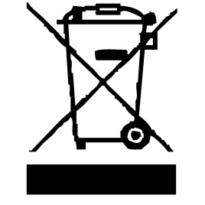

The symbol "CE" is the guarantee of compliance with harmonized European standards, voluntary, reflecting the essential requirements into technical specifications. These standards are not mandatory but are guarantees of compliance with essential requirements.


The symbol "GLASS / FORK" means that the device is compatible and can come into contact with foodstuffs.

The symbol ROHS (Restriction of use of some Hazardous Substances) on the Environmental Protection, certifies that for each of the five hazardous substances • Lead • Mercury • (hexavalent) chromium • products for protection against flames PBB and PBDE, the peak concentration is equal to or less than 0.1% of the weight of homogeneous material, and 0.01% for the 6th • cadmium.
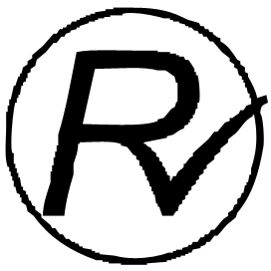

The symbol "HOT WALL" warns the user that the walls of the unit can become very hot, and to take precautions as required.


The symbol "TRIMAN" indicates that the consumer is invited to dispose the product as part of a separate collection (eg recycling bin, waste, voluntary intake point).


For more information : http://www.quefairedemesdechets.fr

IMPORTANT WARNINGS SPECIFIC FOR DEEP FRYER

- Regarding the instructions for cleaning surfaces in contact with food or oil, thanks to refer to the below paragraph of the manual.
- Do not move the device when the fat is liquid, that is to say hot.
- Keep the lid closed completely during operation.
- Fill the basket out of the fryer to avoid any splashing.
- Always use the frying basket.
- Caution : Never mix grease and oil. The fryer may foam and overflow.
    - It is also dangerous to mix different kind of oils or fats!
- If the machine catches fire, never try to extinguish the flames with water. => Close the lid of the device. => Extinguish the flames with a damp cloth.
- IMPORTANT NOTE : This fryer is equipped with 2 thermostats. An adjustable thermostat, so as to adjust the temperature, depending on the food, and a safety thermostat.
- Cooking appliances should be positioned in a stable situation with the handles (if any) positioned to avoid spillage of the hot liquids.

WARNING: BURN HAZARD.
• During operation, the temperature of the appliance surface may be hot.
• The heating parts remain hot, long time after stopping the machine.
• The symbol "Hot Surface" warns the user that the apparatus walls may become hot, and to take precautions.

FIRST USE

Before first use, remove the device and all accessories and being careful with sharp accessories.

• Clean the apparatus according to the instructions in "Cleaning" paragraph.

• Place the machine on a suitable flat, stable surface.

USE

- Unroll the power cord completely.
- Check that the tension in force in the country where you are corresponds to that indicated on the apparatus.
- Connect the apparatus in a correct socket-outlet, (and connected to the ground if the unit is Class I), to avoid any danger.
- Disconnect the power source cable before any operation of cleaning of maintenance and accessories assembly.
- Never modify the appliance in anyway.

Recommendations for use

1. Regularly remove leftover frying in oil (eg pieces of French fries).

Note: It is advisable to change the oil after 8 to 10 uses.

2. Use a high-quality oil or fat for your fries, because the fat or cooking oil must be able to heat at high temperatures.

3. Avoid using margarine, olive oil or butter. These types of fats are unsuitable for frying and can give off smoke, even at low temperatures.

4. In order to reduce the acrylamide content of starchy foods (potatoes, cereals), it is advisable not to exceed a frying temperature of 170 ° C (possibly 175 ° C). In addition, the frying time should be as short as possible and the food should remain in the frying only until a golden colour is obtained, no more.

5. Choose the appropriate frying temperature, taking into account the nature of the food you want to fry. In general, pre-cooked foods require a higher temperature than raw food products.

6. Never lift or move the fryer when the oil or fat is still hot.

7. Always make small cuts on dough-based food products before frying. Let them slip slowly into the oil.

8. Do not overfill the frying basket.

9. Beforehand, dry the moist food with a cloth.

Using your fryer

Fondue

Important note ! The device is not suitable for cheese or chocolate fondues. These foods may stick to the bottom of the pan or overheat.
1. Make sure the unit is turned off, unplugged and cold.
2. Detach the cover of the device. To do this, open the lid and pull it upwards.
3. Take out the frying basket and fill the tray with special fondue oil. The filling level must be between the Min and Max marks (between 450 & 600ml).
We recommend that you follow this advice !
4. Place the splash guard ring on the unit.
5. Plug the unit into a 220-240V ~ 50Hz power outlet.
6. Turn the thermostat knob clockwise. The "On" light comes on.
7. Set the thermostat to approximately 130 ° C
Notes: You can check if the temperature is reached with a spoon
in wood or a skewer. By plunging the utensil into the oil,
small air bubbles must form.
It is also possible to immerse one of the foods in the oil.
8. Pierce pieces of meat with the fondue forks and immerse them in the oil.
Note : The cooking will be from 1 to 2 minutes according to the size of the
pieces of meat. More the pieces of meat or other food are smaller,
more it will cook quickly.
9. Pre-dry food with a tea towel or paper towel.
10. Adapt the temperature of the device so that the oil always quivers slightly.

CAUTION : Introduce the food gently into the oil.
The container in which you are frying is open, so it is impossible to avoid, completely, splashing oil.

Frying

1. Make sure the unit is turned off, unplugged and cold.
2. Open the lid.
3. Take out the frying basket and fill the container (1L maximum) with oil or fat. This amount must be between the fill level marks: Min and Max.
Notes: We recommend that you follow this advice !
If you use grease, cut it into small pieces and place it in the bottom of
the machine.
Never put fat in the frying basket !
4. Close the lid.
5. Plug the unit into a power outlet.
6. Turn the thermostat knob clockwise. The "On" light comes on.
7. Set the thermostat to the desired temperature.
8. First place the food to be cooked in the frying basket.
(out of the fryer)
Note : The basket must not be filled beyond the edge of the basket.
9. Open the lid and gently dip the frying basket into the oil.
10. Remove the handle from the frying pan.
11. Close the lid.
12. When the cooking is finished, open the lid carefully (be careful, possible emanation of hot smoke !).
13. Lift the frying basket with the handle.
14. Let the fried foods drip for a short time.

After use

To turn the unit off, turn the thermostat counter-clockwise (to the left to the stop point,) then disconnect the power cable.
Allow the frying oil to cool for a long time.
Check that the temperature is safe before moving the oil filled unit.

CLEANING AND MAINTENANCE

Always Check that the power cable is unplugged.
Wait for the fryer to cool completely before cleaning.
Note : It is important to wait one to two hours after use avoid any risk of burns.

EXTERNAL CLEANING

Never immerse the appliance or the electrical control panel in water.
Clean the lid and the sides of the appliance with a damp sponge or cloth and possibly a degreasing product.
Rinse and dry.
Note: Remove the lid by lifting up to facilitate cleaning.

INTERIOR CLEANING

Take advantage of the oil change to clean the inside of the grease tray.
After removing the oil (or grease) Wipe the tray with paper towel and remove greasy deposits, with a damp sponge coated with mild detergent.

Parts in contact with food such as: Frying basket (removable), Bowl, Fork, Spatula, Oil Tray etc. must be cleaned in hot water with a sponge and washing-up liquid or in the dishwasher.
Rinse well and dry before filling with oil.
Do not use scouring agents or scouring objects, to avoid damage to the appliance.

Filter and filtering

To filter the oil, through a sieve placed on a suitable container, pouring it by the side.
After 8 to 10 uses, oil or grease is no longer filterable. It is advisable to throw it away.

The filter must be changed regularly.
To change the filter, remove the filter cover, located inside the cover of the device.
Remove the used filter and replace it with a new filter.
Replace the cover.
Note : Never use the fryer without filter.

STORAGE

-Ensure the unit is completely cool and dry.
-Do not wrap the cord around the appliance, as this will cause damage.
-Keep the appliance in a cool, dry place and out of reach from children.

GUARANTEE

Before being delivered, all our products are subjected to a rigorous control.
This apparatus is guaranteed 24 months starting from the date of purchase by the consumer.
The documents in proof of guarantee are :
• The invoice and
• The filled and stamped warrantee plate (located on side or bottom of the gift box). Without these documents in proof, no free replacement, nor no free repair, can be carried out.
During the warranty period, we deal for free, the defects of the apparatus or the accessories, rising from a defect of materials or manufacture by repair or, replacement. The services within the framework of the guarantee do not involve any extension of the warranty period and does not give right to a new guarantee !
In the event of recourse to the guarantee, bring back the complete apparatus to your retailer, in its original packing, accompanied by the proofs of purchase.
The breakage of parts out of glass or plastic is, in all the cases, not warranted. Defects on the accessories or the wearing parts (for example: coals of engines, hooks, drive belts, remote control of replacement, teeth brushes of replacement, webs etc) as well as cleaning, maintenance or it replacement of wearing parts are not guaranteed and are thus to pay !
In the event of foreign intervention, the guarantee becomes null and void.
After flow of the warranty period, repairs can be carried out, against payment, by a specialized trade or a repair service.

SPECIFICATIONS

Power supply 220-240V~ 50/60Hz
Power 840W
Norm Class I
Made in P.R.C

The characteristics can change without prior notice.

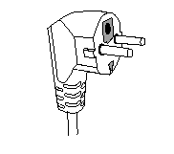
This unit is equipped with an electrical outlet with earth and must be earthed in an according plug.
Note : In the event of question concerning the earth or electric connection, please consult a qualified personnel.
In the event of short-circuit, earthing reduces the risk of electric shock while making possible the current to be evacuated by the wire of ground.
CAUTION: In order to minimize the risks of electric shock, In the event of breakdown, not to open the case but to call upon a qualified technician for repairs.

This device complies with EC directives, it was controlled according to all current European directives, applicable such as: electromagnetic compatibility (EMC) and low voltage (LVD).

This device has been designed and manufactured in compliance with the latest regulations and technical requirements for safety.

Imported by Sotech International
" LE PERIPOLE " N°A-107
33, Avenue du Marechal de Lattre de Tassigny
94120 Fontenay sous-bois - France

