TCV-372


ELECTRIC STEAM COOKER

Instruction manual

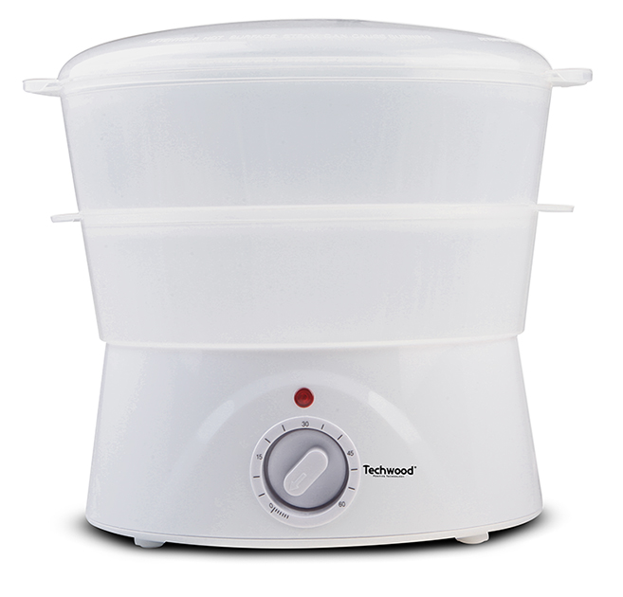
Dear consumer, Please read these instructions carefully before use in order to avoid damage due to incorrect use and to better understand the functions of this product. Please pay particular attention to the safety guide.
If you pass the device on to a third party, these Operating Instructions must also be handed over.
Please keep them for future references.

IMPORTANT SAFEGUARDS

- Please read these instructions carefully before use.
- Keep present instructions for future references.
- Check that your mains voltage corresponds to that stated on the appliance.
- Only use the appliance for domestic purposes and household or similar applications such as:
-staff kitchen areas, in shops, offices and other working environments;
-by clients in hotels, motels and other residential type environments;
- Environment type like :
• Farm Houses • Bed and Breakfast.
- Only use the appliance in the way indicated in these instructions.
- Never use this unit near bathtub, shower, wash-hand basins or other containers with water.
- Never use this apparatus near water projections.
- Never use this apparatus with the wet hands.
- If, unfortunately the apparatus is wet, immediately withdraw the cord of the socket-outlet.
- Inform potential users of these instructions.
- Never leave the appliance unsupervised when in use.
- The appliance must be used only for its intended purpose. No responsibility can be taken for any possible damage caused by incorrect use or improper handling.
- Children and persons with disabilities are not always aware of the danger posed by the use of appliances.
- This device can be used by children aged 8 years and older and adults, with reduced physical, sensory or mental capabilities or lack of experience and knowledge, if they have been given supervision or instruction concerning use of the appliance in a safe way and understand the hazards involved.
- Cleaning and user maintenance must not be made ​​by children unless they are older than 8 and supervised.
- Keep the appliance and its cord out of reach of children less than 8 years.
- This device is not a toy, do not leave children or people with disabilities to play with.
- In order to ensure your children‘s safety, please keep all packaging (plastic bags, boxes, polystyrene etc.) out of their reach.
- Caution ! Do not allow small children to play with the foil :
there is a danger of suffocation !
- From time to time check the cord for damages. Never use the appliance if cord or appliance shows any signs of damage.
- Never immerse the appliance in water or any other liquid for any reason whatsoever.
- Never place it into the dishwasher.
- Never use the appliance near hot surfaces.
- If the supply cord is damaged, it must be replaced by the manufacturer, its service agent or similarly Competent qualified person^{(*)} in order to avoid a hazard.
- Disconnect the power source cable before any operation of cleaning of maintenance and accessories assembly.
- Never use the appliance outside and always place it in a dry environment.
- Never use accessories, which are not recommended by the producer. They could constitute a danger to the user and risk to damage the appliance.
- Never use any other connector than the one provided.
- Never move the appliance by pulling the cord. Make sure the cord cannot get caught in any way.
- Never wind the cord around the appliance and do not bend it
- Ensure that the power cord does not come into contact with hot parts of this unit.
- Make sure the appliance has cooled down before cleaning and storing it.
- The temperature of accessible surfaces may be very high when the appliance is operating. Never touch these parts, of apparatus, to avoid burning itself.
- Make sure the appliance never comes into contact with flammable materials, such as curtains, cloth, etc...& the power cord and plug do not come in contact with water.
- Before cleaning, always unplug the appliance from the power supply and let it cool down.
- This appliance is not intended to be operated by means of an external timer or separate remote-control system.
- Always place the unit on a flat surface. Ensure, also, not to cover the device and not to put anything on it.
- Always remove the plug from the wall socket when the appliance is not in use.
- When using an extension lead always make sure that the entire cable is unwound from the reel. Use solely CE approved extension leads. Input power must be at least 16A, 250V, 3000W.
- Incorrect operation and improper use can damage the appliance and cause injury to the user.
- This device, designed for home use, complies with standards relating to this type of product.
- The item is not to be used, if it has been dropped or if there are visible signs of damage or if it is leaking.
- Regarding the instructions for cleaning, thanks to refer to the below paragraph of the manual.
- This appliance is only intended for household use.
- Avoid spillage on the connector.
- Potential injury from misuse
- The heating element surface is subject to residual heat after use.

^{(*)} Competent qualified person : after sales department of the producer or importer or any person who is qualified, approved and competent to perform this kind of repairs.
GENERAL INFORMATION

The symbol "OPEN BOOK" means a recommendation to read important things contained in the record.

The symbol "BIN" crossed out, abbreviation WEEE (Waste of Electrical and Electronic Equipment) means that at the end of life, it should not be discarded with household waste, but filed to the sorting of the locality. Waste recovery can help preserve our environment.
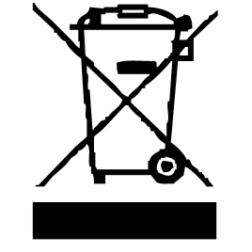

The symbol "CE" is the guarantee of compliance with harmonized European standards, voluntary, reflecting the essential requirements into technical specifications. These standards are not mandatory but are guarantees of compliance with essential requirements.


The symbol "STEAM" warns the user that steam can escape from the unit and to take all necessary precautions. (Risk of burns)

The symbol "GLASS / FORK" means that the device is compatible and can come into contact with foodstuffs.

The symbol ROHS (Restriction of use of some Hazardous Substances) on the Environmental Protection, certifies that for each of the five hazardous substances • Lead • Mercury • (hexavalent) chromium • products for protection against flames PBB and PBDE, the peak concentration is equal to or less than 0.1% of the weight of homogeneous material, and 0.01% for the 6th • cadmium.


The symbol "TRIMAN" indicates that the consumer is invited to dispose the product as part of a separate collection (eg recycling bin, waste, voluntary intake point).


For more information : http://www.quefairedemesdechets.fr

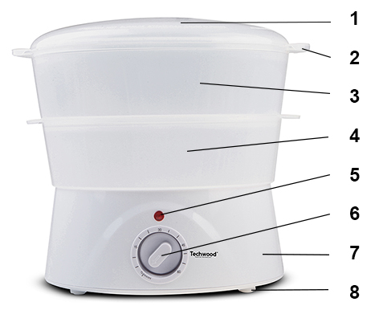
DESCRIPTION

1. cover

2. Carrying handles

3. Big basket

4. Small basket

5. Pilot Lamp

6. Timer

7. Base and water tank

8. Anti-slip feet

BEFORE THE FIRST USE

Before first use, remove the unit and all accessories carefully.

Clean with soap and water, bowls and all accessories. Rinse and dry thoroughly. Clean the outside and inside of the machine cabinet with a damp cloth and wipe dry.

USE

- Unroll the power cord completely.
- Check that the tension in force in the country where you are, corresponds to that indicated on the apparatus.
- Connect the apparatus in a correct socket-outlet, (and connected to the ground if the unit is Class I), to avoid any danger.
- Disconnect the power source cable before any operation of cleaning of maintenance and accessories assembly.
- Never modify the appliance in anyway.

- Check that the timer on / off button is turned off.
- Ensure that the unit is far enough away from other objects horizontally or vertically (shelves, cupboards, etc ...).
- Connect the apparatus in a correct socket-outlet, (and connected to the ground if the unit is Class I), to avoid any danger.
- Place the desired amount of cold water in the tank of the electrical base.
Always ensure that the water level does not exceed the line "Max" and is not less than the line "Mini" as shown in the tank.
- Never pour other liquid than water in the tank.
- Never cook food directly in the water tank.
- Assemble containers and cover.
Check the removable containers are assembled correctly and that the side handles are aligned, to avoid accidental leakage of steam.
- The power base must be only used with provided containers.
- Place food, vegetables or meat, (evenly sliced) in the different removable containers.
NOTE: It is recommended not to cut food directly into the containers so as not to damage them and always use utensils wooden or heat resistant plastic.
- Do not overfill the containers for better cooking.
- Check that the food does not obstruct the steam outlet openings of the containers.
- Set the timer knob to the desired time.
The lamp lights up to signal that the unit is heating.
Cooking stops when the timer reaches 0.
- Monitor the food during cooking.
- Do not move the device during operation and after use to avoid scalding.
- Always handle container or the lid by the handles provided for this purpose.
- Never use the device without the cover.
- By opening the lid, be careful of steam and drops of boiling water.
- After use, turn the timer button on / off in the off position (position 0), unplug the appliance and let it cool down.
- Carefully remove the removable containers handling by the side handles.
- It's best to add herbs or spices to food when cooking is completed.
- Clean containers after each use.
- Always unplug the appliance when not in use.

Long cooking

- If it is necessary to add water during cooking (long cooking), first place the timer knob in off position.
- Remove the containers and add water into the tank of the electrical base,
by taking the necessary precautions to avoid being scalded.
- Put the containers on the Powerbase again. Then replace the timer knob to the desired position.

COOKING GUIDE | WATER | LEVEL TIME (MIN.)
ASPARAGUS 450 g | MINIMUM | 10-12
BROCCOLI 225 g | MINIMUM | 06-10
CABBAGE 225 g | MINIMUM | 08-11
SLICED CARROT 225g | MINIMUM | 08-10
CAULIFLOWER 1 head | MINIMUM | 11-14
WHITE CHICKEN 2 pieces | MINIMUM | 25-35
CLAMS SHELL 450g | MINIMUM | 08-12
CORN 3 pieces | MINIMUM | 18-20
CRAB 2 | MINIMUM | 38-40
EGGS (TO BE HARD) 6 | MINIMUM | 12-22
FISH FILET 225 g | MINIMUM | 18-35
PEAS 280 g | MINIMUM | 12-15
CUT POTATOES 225g | MINIMUM | 08-10
SAUSAGES 5 | MINIMUM | 18-22
GAMBAS 450 g | MINIMUM | 08-12
WHITE RICE ½ cup of rice | MINIMUM + ½ glass of water | 08-12

NOTES : - This guide is for information only. It's worth doing your own
experiment for more accurate results.
- Fill with cold water required before connecting the device.

CLEANING AND MAINTENANCE

Before cleaning, always: switch off the appliance, disconnect the apparatus and let it cool.
Clean the outside of the apparatus with a sponge or slightly wet linen.
The parts (removable) in contact with food like plate, bowl, forks, Spatula etc. can be washed in hot water with sponge and soft detergent or put in the dishwasher.
Never plunge the apparatus in water or all other liquid!
Do not use abrasive cleaners, gritting, or metal brush or another cutting object.

- It is advisable to descale the appliance regularly (twice a year minimum).
Be sure to rinse the inside of the heating base with clear water after the operation.
STORAGE

-Ensure the unit is completely cool and dry.
-Do not wrap the cord around the appliance, as this will cause damage.
-Keep the appliance in a cool, dry place and out of reach from children.

GUARANTEE

Before being delivered, all our products are subjected to a rigorous control.

This apparatus is guaranteed 24 months starting from the date of purchase by the consumer.

The documents in proof of guarantee are:

• The invoice and

• The filled and stamped warrantee plate (located on side or bottom of the gift box). Without these documents in proof, no free replacement, nor no free repair, can be carried out.

During the warranty period, we deal for free, the defects of the apparatus or the accessories, rising from a defect of materials or manufacture by repair or, replacement. The services within the framework of the guarantee do not involve any extension of the warranty period and does not give right to a new guarantee!

In the event of recourse to the guarantee, bring back the complete apparatus to your retailer, in its original packing, accompanied by the proofs of purchase.

The breakage of parts out of glass or plastic is, in all the cases, not warranted. Defects on the accessories or the wearing parts (for example: coals of engines, hooks, drive belts, remote control of replacement, teeth brushes of replacement, webs etc) as well as cleaning, maintenance or it replacement of wearing parts are not guaranteed and are thus to pay!

In the event of foreign intervention, the guarantee becomes null and void.

After flow of the warranty period, repairs can be carried out, against payment, by a specialized trade or a repair service.

SPECIFICATIONS

Power supply 220-240V~ 50/60Hz
Power 400W
Norm Class I
Made in P.R.C

The characteristics can change without prior notice.

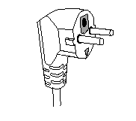
This unit is equipped with an electrical outlet with earth and must be earthed in an according plug.
Note : In the event of question concerning the earth or electric connection, please consult a qualified personnel.
In the event of short-circuit, earthing reduces the risk of electric shock while making possible the current to be evacuated by the wire of ground.

CAUTION: In order to minimize the risks of electric shock, In the event of breakdown, not to open the case but to call upon a qualified technician for repairs.

This device complies with EC directives, it was controlled according to all current European directives, applicable such as: electromagnetic compatibility (EMC) and low voltage (LVD).

This device has been designed and manufactured in compliance with the latest regulations and technical requirements for safety.

Imported by Sotech International
" LE PERIPOLE " N°A-107
33, Avenue du Marechal de Lattre de Tassigny
94120 Fontenay sous-bois - France

