TCV-1150


ELECTRIC STEAM COOKER

Instruction manual
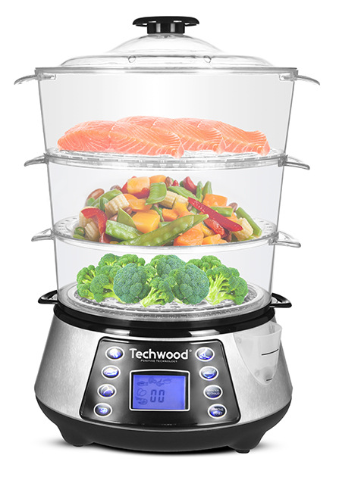

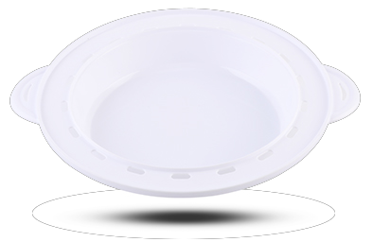
Dear consumer, Please read these instructions carefully before use in order to avoid damage due to incorrect use and to better understand the functions of this product. Please pay particular attention to the safety guide.
If you pass the device on to a third party, these Operating Instructions must also be handed over.
Please keep them for future references.

IMPORTANT SAFEGUARDS

- Please read these instructions carefully before use.
- Keep present instructions for future references.
- Check that your mains voltage corresponds to that stated on the appliance.
- Only use the appliance for domestic purposes and household or similar applications such as:
-staff kitchen areas, in shops, offices and other working environments;
-by clients in hotels, motels and other residential type environments;
- Environment type like :
• Farm Houses • Bed and Breakfast.
- Only use the appliance in the way indicated in these instructions.
- Never use this unit near bathtub, shower, wash-hand basins or other containers with water.
- Never use this apparatus near water projections.
- Never use this apparatus with the wet hands.
- If, unfortunately the apparatus is wet, immediately withdraw the cord of the socket-outlet.
- Inform potential users of these instructions.
- Never leave the appliance unsupervised when in use.
- The appliance must be used only for its intended purpose. No responsibility can be taken for any possible damage caused by incorrect use or improper handling.
- Children and persons with disabilities are not always aware of the danger posed by the use of appliances.
- This device can be used by children aged 8 years and older and adults, with reduced physical, sensory or mental capabilities or lack of experience and knowledge, if they have been given supervision or instruction concerning use of the appliance in a safe way and understand the hazards involved.
- Cleaning and user maintenance must not be made ​​by children unless they are older than 8 and supervised.
- Keep the appliance and its cord out of reach of children less than 8 years.
- This device is not a toy, do not leave children or people with disabilities to play with.
- In order to ensure your children‘s safety, please keep all packaging (plastic bags, boxes, polystyrene etc.) out of their reach.
- Caution ! Do not allow small children to play with the foil :
there is a danger of suffocation !
- From time to time check the cord for damages. Never use the appliance if cord or appliance shows any signs of damage.
- Never immerse the appliance in water or any other liquid for any reason whatsoever.
- Never place it into the dishwasher.
- Never use the appliance near hot surfaces.
- If the supply cord is damaged, it must be replaced by the manufacturer, its service agent or similarly Competent qualified person^{(*)} in order to avoid a hazard.
- Disconnect the power source cable before any operation of cleaning of maintenance and accessories assembly.
- Never use the appliance outside and always place it in a dry environment.
- Never use accessories, which are not recommended by the producer. They could constitute a danger to the user and risk to damage the appliance.
- Never use any other connector than the one provided.
- Never move the appliance by pulling the cord. Make sure the cord cannot get caught in any way.
- Never wind the cord around the appliance and do not bend it
- Ensure that the power cord does not come into contact with hot parts of this unit.
- Make sure the appliance has cooled down before cleaning and storing it.
- The temperature of accessible surfaces may be very high when the appliance is operating. Never touch these parts, of apparatus, to avoid burning itself.
- Make sure the appliance never comes into contact with flammable materials, such as curtains, cloth, etc...& the power cord and plug do not come in contact with water.
- Before cleaning, always unplug the appliance from the power supply and let it cool down.
- This appliance is not intended to be operated by means of an external timer or separate remote-control system.
- Always place the unit on a flat surface. Ensure, also, not to cover the device and not to put anything on it.
- Always remove the plug from the wall socket when the appliance is not in use.
- When using an extension lead always make sure that the entire cable is unwound from the reel. Use solely CE approved extension leads. Input power must be at least 16A, 250V, 3000W.
- Incorrect operation and improper use can damage the appliance and cause injury to the user.
- This device, designed for home use, complies with standards relating to this type of product.
- The item is not to be used, if it has been dropped or if there are visible signs of damage or if it is leaking.
- Regarding the instructions for cleaning, thanks to refer to the below paragraph of the manual.
- This appliance is only intended for household use.
- Avoid spillage on the connector.
- Potential injury from misuse
- The heating element surface is subject to residual heat after use.

^{(*)} Competent qualified person : after sales department of the producer or importer or any person who is qualified, approved and competent to perform this kind of repairs.
GENERAL INFORMATION

The symbol "OPEN BOOK" means a recommendation to read important things contained in the record.

The symbol "BIN" crossed out, abbreviation WEEE (Waste of Electrical and Electronic Equipment) means that at the end of life, it should not be discarded with household waste, but filed to the sorting of the locality. Waste recovery can help preserve our environment.
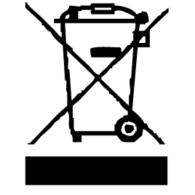

The symbol "CE" is the guarantee of compliance with harmonized European standards, voluntary, reflecting the essential requirements into technical specifications. These standards are not mandatory but are guarantees of compliance with essential requirements.


The symbol "STEAM" warns the user that steam can escape from the unit and to take all necessary precautions. (Risk of burns)

The symbol "GLASS / FORK" means that the device is compatible and can come into contact with foodstuffs.

The symbol ROHS (Restriction of use of some Hazardous Substances) on the Environmental Protection, certifies that for each of the five hazardous substances • Lead • Mercury • (hexavalent) chromium • products for protection against flames PBB and PBDE, the peak concentration is equal to or less than 0.1% of the weight of homogeneous material, and 0.01% for the 6th • cadmium.


The symbol "TRIMAN" indicates that the consumer is invited to dispose the product as part of a separate collection (eg recycling bin, waste, voluntary intake point).


For more information : http://www.quefairedemesdechets.fr

DESCRIPTION
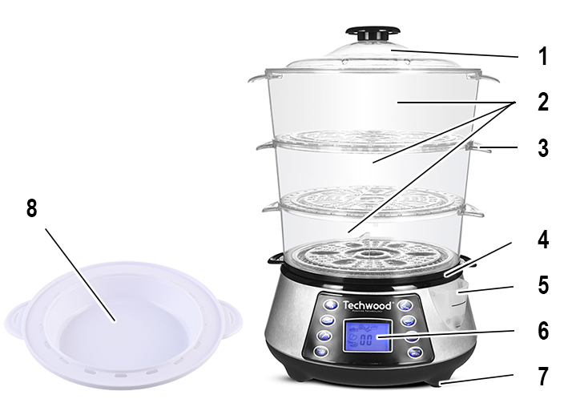

cover

Carrying handles

Baskets (3) usable separately

Tray between Basket & base

Filler aperture (during cooking)

Control panel with screen

Base and water tank

with Anti-slip feet
- Rice bowl

BEFORE THE FIRST USE

Before first use, remove the unit and all accessories carefully.

Clean with soap and water, bowls and all accessories. Rinse and dry thoroughly. Clean the outside and inside of the machine cabinet with a damp cloth and wipe dry.

USE

- Unroll the power cord completely.
- Check that the tension in force in the country where you are, corresponds to that indicated on the apparatus.
- Connect the apparatus in a correct socket-outlet, (and connected to the ground if the unit is Class I), to avoid any danger.
- Disconnect the power source cable before any operation of cleaning of maintenance and accessories assembly.
- Never modify the appliance in anyway.
Check that the appliance is in the OFF position.
- Make sure the unit is far enough away from other objects. (shelves, cupboards, etc ...).
- Connect the device.
- Put the desired amount of cold water in the tank of the base.
Note : 1 litre of water is enough to steam for 1 hour.
Always make sure that the water level does not exceed the "Max" mark.
- Never pour any other liquid than clear water into the tank.
- Never cook food directly in the water tank.
- Fit the connecting plate on the base. Then 1, 2 or 3 baskets. The baskets are numbered, always start with Number 1, then 2, then 3.
Notes : Only the required basket or baskets should be used.
The cooking time is also dependent on the number of baskets
used.
Always put the lid on.
Check that the removable baskets are assembled correctly, and that the side handles are aligned, to prevent accidental steam leakage.
- The electric base must only be used with the supplied containers.
- Place the food, vegetables and/or meat, possibly minced, in the different removable containers.
NOTE: It is recommended not to cut food directly into containers to avoid
damaging them and always use utensils made of wood or heat-resistant
plastic.
- Do not overfill the containers for better cooking.
- Monitor food during cooking.
- Do not move the device during operation or immediately after use to avoid burns.
- Always handle the containers or lid by the handles provided for this purpose.
- Never use the appliance without the lid.
- When opening the lid, take care with the steam and the drops of boiling water.
- After use, press the On / Off button, unplug the appliance and allow it to cool down.
- Carefully remove the removable containers by handling them by the side handles.
- It is better to add herbs or spices to the food once the cooking is over.
- Clean the containers after each use.
- Always unplug the appliance when not in use.

COOKING

Plug the unit into a wall outlet that is in good condition and has a ground connection.
The screen displays 00.
The buttons around the screen are pre-set cooking programs.

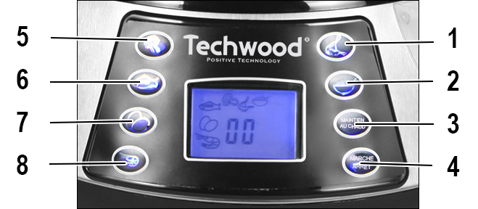

1. Chicken 35 min
2. Rice 45 min
3. Setting the cooking time from 0 to 99 min
4. On / Off To turn on or off the device
5. Vegetables 25 min
6. Fish 23 min
7. Eggs 21 min
8. Gambas 15 min

Note: When a program is chosen, the program symbol appears on the screen.
To set the cooking time, press the (3) button. The display shows 00.
Each press of the button increases the cooking time by one minute.
The setting is from 1 to 99 minutes.
When the cooking time is set, press the Start button to begin cooking.

IMPORTANT INFORMATION : 10 seconds before the end of programmed cooking, the device will beep and the display will flash. After this time, the unit will automatically go into "Keep Warm" mode for 1 hour.
If you wish to interrupt the keep warm function, press the On / Off button, then unplug the unit and let it cool down.

Long cooking

To add water during cooking, Pour lukewarm or hot water through the opening (5) provided for this purpose.
Do not exceed the maximum to avoid an overflow.

COOKING EXAMPLES

PRODUCT | WATER LEVEL | TIME (MIN.)
ASPARAGUS 500 g | 50% FILLED IN | 10-12
BROCCOLI 500 g | 50% FILLED IN | 15-20
CABBAGE 1 PIECE | 75% FILLED IN | 20-30
CARROT 500 g | 75% FILLED IN | 08-10
CAULIFLOWER 1 head | 50% FILLED IN | 15-20
WHITE CHICKEN 2 pieces | 50% FILLED IN | 20-25
CLAMS SHELL 500 g | 50% FILLED IN | 08-12
CORN 3 pieces | 50% FILLED IN | 18-20
CRAB 2 | 50% FILLED IN | 38-40
EGGS (TO BE HARD) 6 | 50% FILLED IN | 12-15
FISH FILET 500 g | 50% FILLED IN | 18-22
PEAS 500 g | 50% FILLED IN | 12-15
POTATOES 6 to 8 pieces | MAXIMUM | 20-30
SAUSAGES UNTIL 12 | 50% FILLED IN | 10-15
GAMBAS 500 g | 50% FILLED IN | 08-12
ARTICHOKE 4 pieces | MAXIMUM | 40-60
FROZEN VEGETABLE 500 g | 50% FILLED IN | 40-45
WHITE RICE 15cl or 1 big cup * | MAXIMUM | 20-30
BRAUN RICE 15cl or 1 big cup * | MAXIMUM | 30-40
* Mix the rice with 1 cup of water (and possibly spices) before putting it in the rice bowl, to cook it.

This guide is for information only. It's worth doing your own experiment for more accurate results.
Fill with the amount of cold water required before connecting the appliance.

EXAMPLES OF RECIPES

VEGETABLE GRATIN (4 servings)

1 cup of raw carrots
1 cup celery
¼ cup butter or margarine
¼ cup grated cheddar cheese
2 raw potatoes
Salt and pepper

Peel the vegetables and cut into pieces. Place in a basket. Fill the water tank to the MAX level. Steam for 15 minutes then remove from the basket. Although very hot, drizzle with butter or margarine and sprinkle with cheese. Add salt and pepper to taste.

PEAS FRENCH MODE (4 servings)

2 cups frozen peas
2 tablespoons butter or margarine
1 big onion
1 tablespoon thyme
Salt and pepper

Chop onion and add to frozen peas. Stir in thyme with peas and onion. Place in a basket. Fill the water tank to the MAX level. Steam for 15 minutes.
Keep the liquid from the drip tray and mix it with the peas, if you wish.
Mix the butter with hot peas. Add salt and pepper to taste.

SALMON STEAKS WITH FENNEL (4 servings)

4 salmon steaks (150 g each)
2 tablespoons of fennel seeds
2 fennels cut in 2 (on the length)
½ cup of butter or margarine
Salt and pepper
Juice of 1 lemon

In one basket, place the fennels (already cut in 2)
Fill the water tank to the MAX level.
Steam for 10 to 15 minutes.
During this time, Season the salmon steaks with salt and pepper. Sprinkle with fennel seeds.
Place them in a second basket, remove the lid and place the basket over the fennels. Replace the cover.
Steam again for 10 to 15 minutes.

Melt the butter separately in a saucepan and add the lemon juice.
Gently remove the skin from the cooked salmon.
Spread on plates with fennel.
Serve with melted butter & lemon.

SHRIMP CREAM WITH RICE (4 servings)

1 cup uncooked white or wild rice
2 tablespoons green onions cut into small cubes.
1 ¼ cup chicken broth
2 cups frozen cooked shrimp
1 ¾ cup potato soup in a bag
2 tablespoons toasted flaked almonds
½ cup grated Swiss cheese
Salt and pepper

Mix the rice, chicken broth, potato soup, onions, cheese, shrimp, salt and pepper in the rice cooker. Mix well.
Fill the water tank to the MAX level.
Steam for 60 minutes. Stir once during cooking. Garnish with flaked almonds.

RICE PUDDING WITH MILK (4 servings)

½ cup of quick-cooking white rice
1 tablespoon vanilla extract
1 cup of milk
Raisins (optional)
½ cup of sugar

Combine rice, milk, sugar, vanilla extract and raisins in a bowl. Pour the mixture into the rice bowl cooker. Fill the water tank to the MAX level.
Steam for 35 minutes and stir once during cooking.

PEARS WITH CHOCOLATE SAUCE (4 servings)

4 whole pears
½ cup of cream
½ lemon
½ cup of chocolate in pieces

Peel the pears and rub with lemon. Steam the pears in a steamer basket for 15 minutes, then let cool.
In the rice cooker (covered with aluminum foil). Melt the pieces of chocolate.
Discover, then add the cream and steam for 2-3 minutes uncovered.
Sprinkle the pears with the chocolate sauce and serve.

CLEANING AND MAINTENANCE

Before cleaning, Always : switch off the appliance, disconnect the apparatus and let it cool.
Clean the outside of the apparatus with a sponge or slightly wet linen.
The parts (removable) in contact with food like plate, bowl, forks, Spatula etc. can be washed in hot water with sponge and soft detergent or put in the dishwasher.
Never plunge the apparatus in water or all other liquid !
Do not use abrasive cleaners, gritting, or metal brush or another cutting object.

- It is advisable to descale the appliance regularly (twice a year minimum).
Be sure to rinse the inside of the heating base with clear water after the operation.

STORAGE

-Ensure the unit is completely cool and dry.
-Do not wrap the cord around the appliance, as this will cause damage.
-Keep the appliance in a cool, dry place and out of reach from children.

GUARANTEE

Before being delivered, all our products are subjected to a rigorous control.

This apparatus is guaranteed 24 months starting from the date of purchase by the consumer.

The documents in proof of guarantee are :

• The invoice and

• The filled and stamped warrantee plate (located on side or bottom of the gift box). Without these documents in proof, no free replacement, nor no free repair, can be carried out.

During the warranty period, we deal for free, the defects of the apparatus or the accessories, rising from a defect of materials or manufacture by repair or, replacement. The services within the framework of the guarantee do not involve any extension of the warranty period and does not give right to a new guarantee !

In the event of recourse to the guarantee, bring back the complete apparatus to your retailer, in its original packing, accompanied by the proofs of purchase.

The breakage of parts out of glass or plastic is, in all the cases, not warranted. Defects on the accessories or the wearing parts (for example: coals of engines, hooks, drive belts, remote control of replacement, teeth brushes of replacement, webs etc) as well as cleaning, maintenance or it replacement of wearing parts are not guaranteed and are thus to pay !

In the event of foreign intervention, the guarantee becomes null and void.

After flow of the warranty period, repairs can be carried out, against payment, by a specialized trade or a repair service.

SPECIFICATIONS

Power supply 220-240V~ 50/60Hz
Power 800W
Norm Class I
Made in P.R.C

The characteristics can change without prior notice.

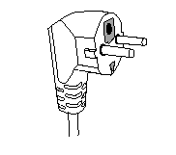
This unit is equipped with an electrical outlet with earth and must be earthed in an according plug.
Note : In the event of question concerning the earth or electric connection, please consult a qualified personnel.
In the event of short-circuit, earthing reduces the risk of electric shock while making possible the current to be evacuated by the wire of ground.

CAUTION: In order to minimize the risks of electric shock, In the event of breakdown, not to open the case but to call upon a qualified technician for repairs.

This device complies with EC directives, it was controlled according to all current European directives, applicable such as: electromagnetic compatibility (EMC) and low voltage (LVD).

This device has been designed and manufactured in compliance with the latest regulations and technical requirements for safety.

Imported by Sotech International
" LE PERIPOLE " N°A-107
33, Avenue du Marechal de Lattre de Tassigny
94120 Fontenay sous-bois - France

