TBC-226L



SMOOTHING BRUSH CERAMIC*

Instruction manual
* Ceramic coating
IMPORTANT SAFEGUARDS

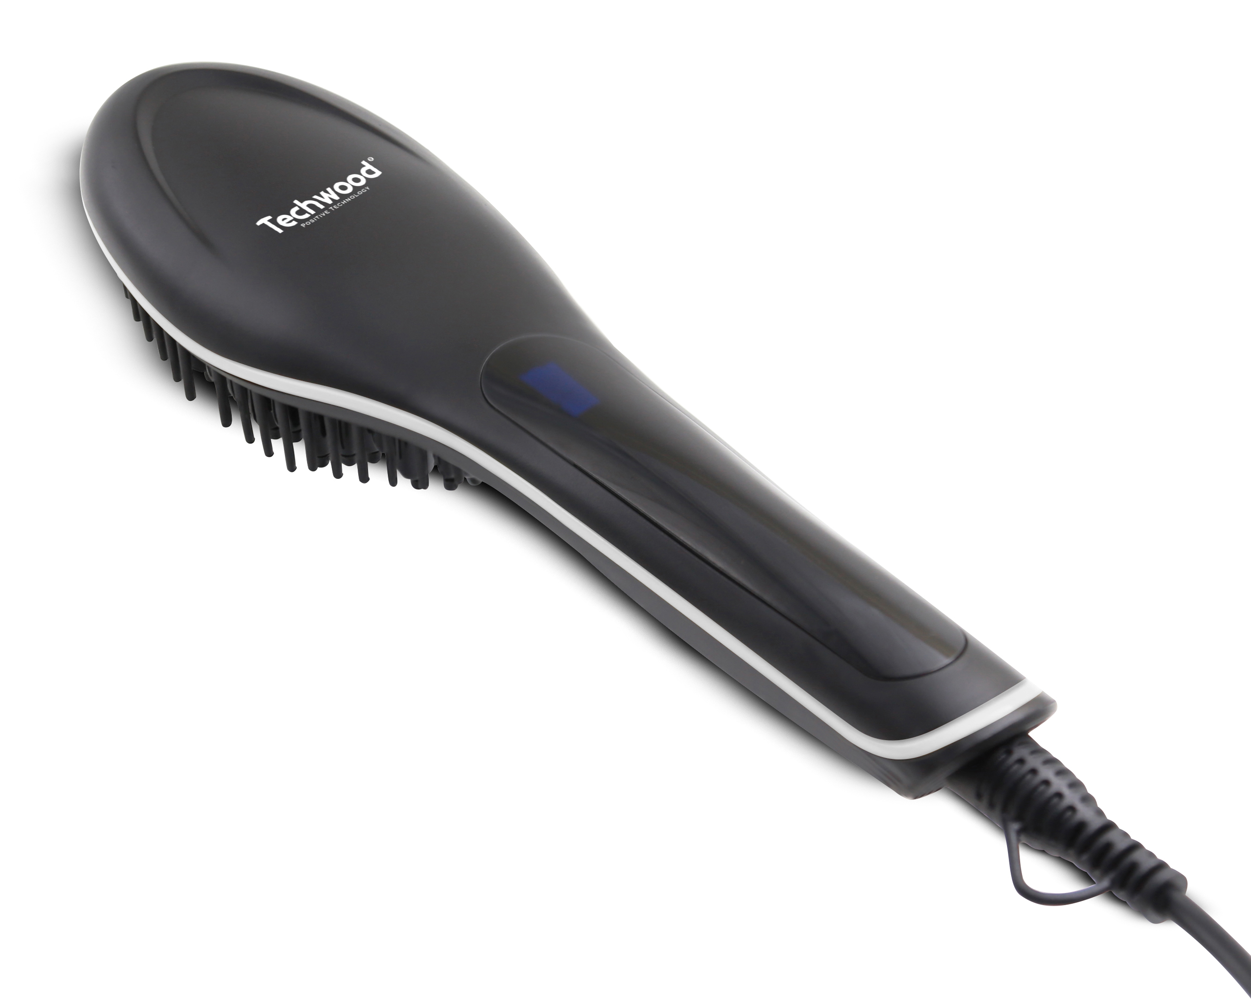
Dear consumer, Please read these instructions carefully before use in order to avoid damage due to incorrect use and to better understand the functions of this product. Please pay particular attention to the safety guide.
If you pass the device on to a third party, these Operating Instructions must also be handed over.
Please keep them for future references.

- Please read these instructions carefully before use.
- Keep present instructions for future references.
- Check that your mains voltage corresponds to that stated on the appliance.
- Only use the appliance for domestic purposes and household or similar applications such as:
- staff kitchen areas, in shops, offices and other working environments;
- By clients in hotels, motels and other residential type environments;
- Environment type like :
• Farm Houses • Bed and Breakfast.
- Only use the appliance in the way indicated in these instructions.
- Never use this unit near bathtub, shower, wash-hand basins or other containers with water.
- Never use this apparatus near water projections.
- Never use this apparatus with the wet hands.
- If, unfortunately the apparatus is wet, immediately withdraw the cord of the socket-outlet.
- Inform potential users of these instructions.
- Never leave the appliance unsupervised when in use.
- The appliance must be used only for its intended purpose. No responsibility can be taken for any possible damage caused by incorrect use or improper handling.
- Children and persons with disabilities are not always aware of the danger posed by the use of appliances.
- This appliance can be used by children aged from 8 years and above and persons with reduced physical, sensory or mental capabilities, or lack of experience and knowledge if they have been given supervision or instruction concerning use of the appliance in a safe way and understand the hazards involved.
- Children shall not play with the appliance.
- Cleaning and user maintenance shall not be made by children without supervision.
- In order to ensure your children‘s safety, please keep all packaging (plastic bags, boxes, polystyrene etc.) out of their reach.
- Caution ! Do not allow small children to play with the foil :
there is a danger of suffocation !
- burn hazard. Keep appliance out of reach from young children, particularly during use and cool down;
- From time to time check the cord for damages. Never use the appliance if cord or appliance shows any signs of damage.
- Never immerse the appliance in water or any other liquid for any reason whatsoever.
- Never place it into the dishwasher.
- Never use the appliance near hot surfaces.
- Do not operate the appliance with a damaged cord or plug, or after the appliance has been damaged in any manner.
- If the supply cord or appliance is damaged, it must be replaced by the manufacturer or its service agent or a similarly qualified person in order to avoid a hazard.
- Disconnect the power source cable before any operation of cleaning of maintenance and accessories assembly.
- Never use the appliance outside and always place it in a dry environment.
- Never use accessories, which are not recommended by the producer. They could constitute a danger to the user and risk to damage the appliance.
- Never use any other connector than the one provided.
- Never move the appliance by pulling the cord. Make sure the cord cannot get caught in any way.
- Never wind the cord around the appliance and do not bend it
- Ensure that the power cord does not come into contact with hot parts of this unit.
- Make sure the appliance has cooled down before cleaning and storing it.
- The temperature of accessible surfaces may be very high when the appliance is operating. Never touch these parts, of apparatus, to avoid burning itself.
- Make sure the appliance never comes into contact with flammable materials, such as curtains, cloth, etc...& the power cord and plug do not come in contact with water.
- Before cleaning, always unplug the appliance from the power supply and let it cool down.
- This appliance is not intended to be operated by means of an external timer or separate remote-control system.
- Always place the unit on a flat surface. Ensure, also, not to cover the device and not to put anything on it.
- Always remove the plug from the wall socket when the appliance is not in use.
- When using an extension lead always make sure that the entire cable is unwound from the reel. Use solely CE approved extension leads. Input power must be at least 16A, 250V, 3000W.
- Incorrect operation and improper use can damage the appliance and cause injury to the user.
- This device, designed for home use, complies with standards relating to this type of product.
- The appliance must be used and rested on a table or flat & stable surface.
- The item must not be left unattended when it is connected to main supply.
- The item is not to be used, if it has been dropped or if there are visible signs of damage or if it is leaking.
- Regarding the instructions for cleaning, thanks to refer to the below paragraph of the manual.
- This appliance is only intended for household use.

^{(*)} Competent qualified person : after sales department of the producer or importer or any person who is qualified, approved and competent to perform this kind of repairs.
GENERAL INFORMATION

The symbol "OPEN BOOK" means a recommendation to read important things contained in the record.

The symbol "BIN" crossed out, abbreviation WEEE (Waste of Electrical and Electronic Equipment) means that at the end of life, it should not be discarded with household waste, but filed to the sorting of the locality. Waste recovery can help preserve our environment.
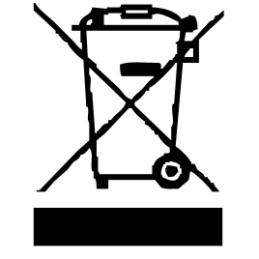

The symbol "CE" is the guarantee of compliance with harmonized European standards, voluntary, reflecting the essential requirements into technical specifications. These standards are not mandatory but are guarantees of compliance with essential requirements.


The symbol ROHS (Restriction of use of some Hazardous Substances) on the Environmental Protection, certifies that for each of the five hazardous substances • Lead • Mercury • (hexavalent) chromium • products for protection against flames PBB and PBDE, the peak concentration is equal to or less than 0.1% of the weight of homogeneous material, and 0.01% for the 6th • cadmium.


The symbol "DOUBLE SQUARE" means a double insulated. A basic insulation and supplementary insulation. This device requires no connection to the mass of a protective conductor grounded. The materials are said : double insulation class II.


The symbol "TUB / SHOWER" crossed out means to

WARNING Do not use this appliance near bathtubs,
showers, basins or other vessels containing water.
(IP20 Minimum distance 3M.)

The symbol "CMIM marking" is the guarantee of compliance with the harmonized Moroccan Standards, optional, which translate the essential requirements into technical specifications. These standards are not mandatory but guarantee compliance with the essential requirements.

The symbol "TRIMAN" indicates that the consumer is invited to dispose the product as part of a separate collection (eg recycling bin, waste, voluntary intake point).


For more information : http://www.quefairedemesdechets.fr

PARTICULAR WARNING FOR PRODUCT USE IN A BATHROOM

- Switch off when not in use, even if for a moment.
- Unplug it after use, since the proximity of water presents a hazard, even when the unit is switched off.
- Do not use this product while taking a shower or bath. Always unplug the device even close between 2 uses.
- When the unit is used in a bathroom unplug it after use since the proximity of water presents a risk, even when the power is off.

To provide additional protection, in the electrical circuit supplying the bathroom, a residual current device (RCD) with a rated residual current not exceeding 30mA operation, is recommended. Consult your installer.
NOTE: A thermal fuse, is not a residual current device (RCD).

Do not use this product while taking a shower or bath.

Always unplug the unit itself between two closely spaced uses.

For example: Stop the machine and unplug it if you drop it while you dry.

CLEANING AND MAINTENANCE

Before cleaning, always: switch off the appliance, disconnect the apparatus and let it cool.
Clean the outside of the apparatus with a sponge or slightly wet linen.
Never plunge the apparatus in water or all other liquid!
Do not use abrasive cleaners, gritting, or metal brush or another cutting object.

BEFORE THE FIRST USE

Before first use, remove the device and all accessories.

Clean the apparatus according to the instructions in "Cleaning and maintenance" paragraph.

Place the machine on a suitable flat, stable surface.
- Remove the appliance from the packaging
- Remove all plastics and stickers (except the nameplate)
- Clean the exterior with a dry cloth.
- Read all instructions in this manual.

TO KNOW THE APPLIANCE
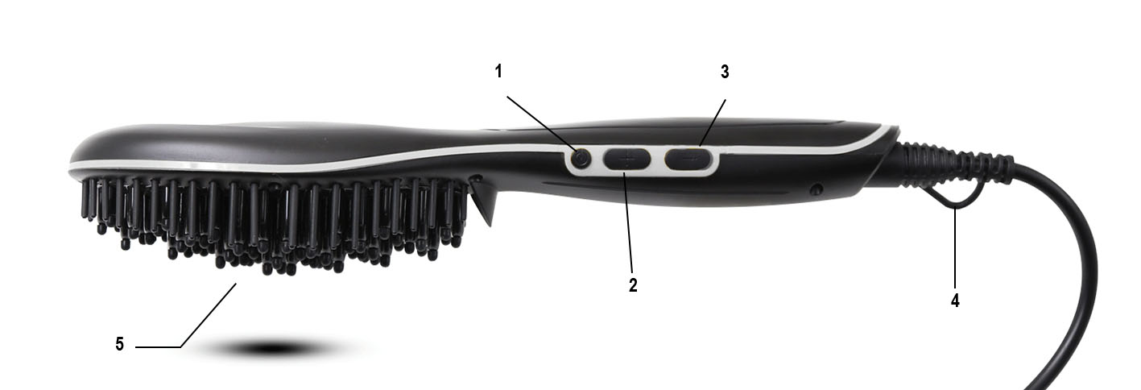

- On / Off button
- Temperature increase button
- Temperature decrease button
- 360 ° rotating cord
- Brush pins

USE

- Unroll the power cord completely.
- Check that the tension in force in the country where you are corresponds to that indicated on the apparatus.
- Connect the apparatus in a correct socket-outlet, (and connected to the ground if the unit is Class I), to avoid any danger.
- Disconnect the power source cable before any operation of cleaning of maintenance and accessories assembly.
- Never modify the appliance in anyway.

USE ON DRY HAIR AND DEMELS

- Connect your smoothing brush
- Press and hold the power button for 3 seconds. The digital display lights up.
- Preheat your brush to a temperature of 230 ° C by pressing the "+" and "-" buttons and let it warm for 2 minutes.
- Once the 230 ° C reaches, select the temperature of your choice. The minimum temperature is 80 ° C while the maximum temperature is 230 ° C.

TEMPERATURE SELECTION

Adjusting the temperature allows you to adjust the heat of your brush. To choose the ideal temperature for your hair type, follow the instructions below:

- Adjustment For fine, dry and discoloured hair, it is preferable to use low temperatures: 80 ° C to 160 ° C
- It is important to find the ideal temperature for your hair, know that a temperature too low will have no effect and that a temperature too high could burn your hair.
- We advise you to start with a low temperature then to see the result on your hair and if need to gradually increase the temperature.

OPERATION

- Hold your hair with one hand and hold the brush with the other.
- Brush your hair slowly from top to bottom.
- Repeat the operation.

After use, press the stop button, unplug the appliance, place it on a heat resistant surface. Always wait for it to cool before storing it.

STORAGE

-Ensure the unit is completely cool and dry.
-Do not wrap the cord around the appliance, as this will cause damage.
-Keep the appliance in a cool, dry place and out of reach from children.

GUARANTEE IN ACCORDANCE WITH REGULATIONS

Before being delivered, all our products are subjected to rigorous checks.
This device is guaranteed for 24 months from the date of purchase of the product by the consumer.
The warranty documents are:
• the invoice and
• the warranty certificate (located on the side or the bottom of the box) stamped and completed.
Without these supporting documents, no free replacement or free repair can be made.
During the warranty period, we take charge, free of charge, for defects in the device or accessories, resulting from a defect in materials or workmanship by repair or replacement.
Services under the legal guarantee do not entail any extension of the guarantee period and do not give the right to a new guarantee.
In the event of a warranty claim, return the complete device to your dealer,
in its original packaging, accompanied by proof of purchase.
The breakage of glass or plastic parts is, in all cases, your responsibility.
Wearing parts (for example: motor brushes, hooks, drive belts, spare remote control, spare toothbrushes, saw blades etc.) as well as their cleaning, maintenance or replacement, are not guaranteed. , and are therefore at your expense.
In the event of foreign intervention, the guarantee lapses.

After expiry of the warranty period, repairs can be carried out, against payment, by a specialist dealer or a repair service.

SPECIFICATIONS

Power supply 220-240V~ 50-60Hz
Power 55W
Norm Class II
Made in P.R.C

The characteristics can change without prior notice.

CAUTION: In order to minimize the risks of electric shock, In the event of breakdown, not to open the case but to call upon a qualified technician for repairs.
This device complies with EC directives, it was controlled according to all current European directives, applicable such as: electromagnetic compatibility (EMC) and low voltage (LVD).
This device has been designed and manufactured in compliance with the latest regulations and technical requirements for safety.

Imported by Sotech International
" LE PERIPOLE "
33, Avenue du Marechal de Lattre de Tassigny
94120 Fontenay sous-Bois - France

