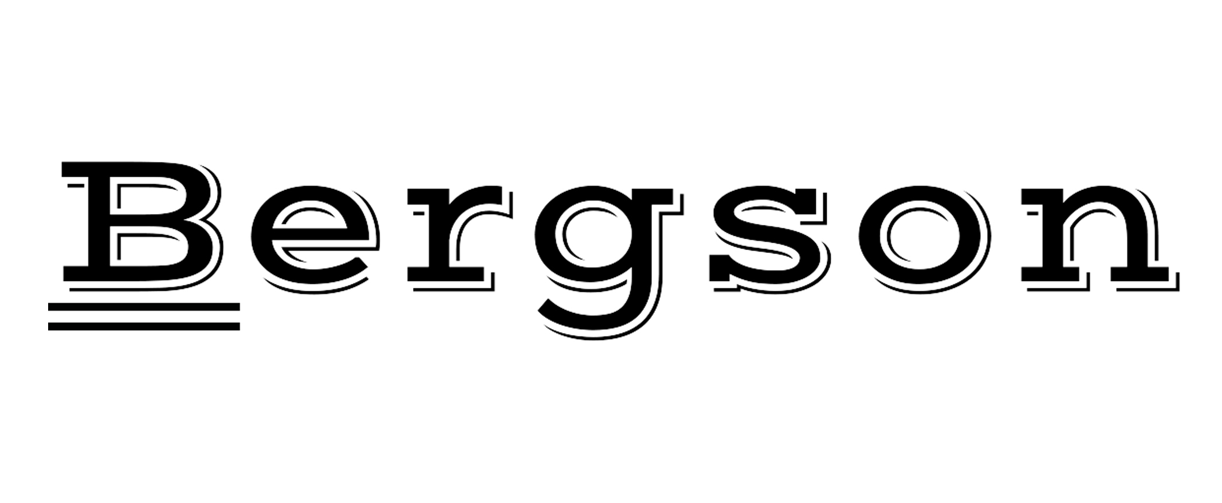

BSC-013

TSC-2106

HAIR DRYER

INSTRUCTION MANUAL

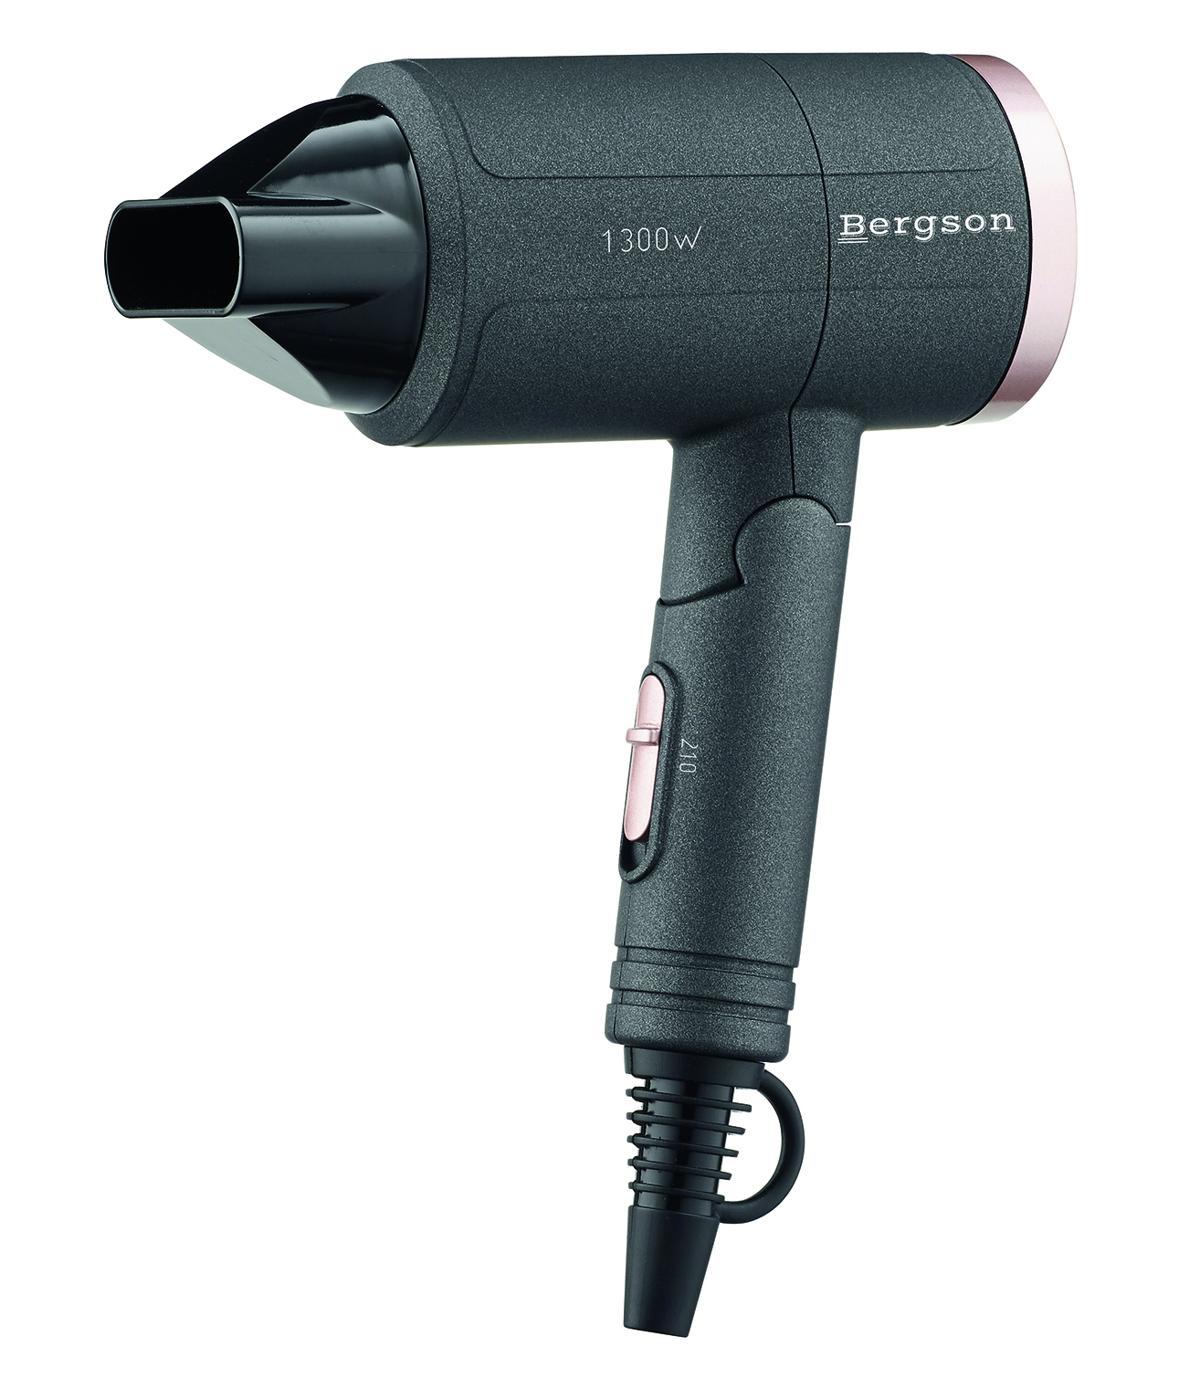
IMPORTANT SAFEGUARDS
Dear consumer, Please, read these instructions carefully before use in order to avoid damage due to incorrect use and to better understand the functions of this product. Please pay particular attention to the safety guide.
If you pass the device on to a third party, these Operating Instructions must also be handed over.
Please keep them for future references.

- Please read these instructions carefully before use.
- Keep present instructions for future references.
- Check that your mains voltage corresponds to that stated on the appliance.
- Only use the appliance for domestic purposes and household or similar applications such as:
-staff kitchen areas, in shops, offices and other working environments;
-by clients in hotels, motels and other residential type environments;
- Environment type like :
• Farm Houses • Bed and Breakfast.
- Only use the appliance in the way indicated in these instructions.
- Never use this unit near bathtub, shower, wash-hand basins or other containers with water.
- Never use this apparatus near water projections.
- Never use this apparatus with the wet hands.
- If, unfortunately the apparatus is wet, immediately withdraw the cord of the socket-outlet.
- Inform potential users of these instructions.
- Never leave the appliance unsupervised when in use.
- The appliance must be used only for its intended purpose. No responsibility can be taken for any possible damage caused by incorrect use or improper handling.
- Children and persons with disabilities are not always aware of the danger posed by the use of appliances.
- when the hairdryer is used in a bathroom, unplug it after use since the proximity of water presents a hazard even when the hairdryer is switched off;
- for additional protection, the installation of a residual current device (RCD) having a rated residual operating current not exceeding 30 mA is advisable in the electrical circuit supplying the bathroom. Ask your installer for advice
- This appliance can be used by children aged from 8 years and above and persons with reduced physical, sensory or mental capabilities or lack of experience and knowledge, if they have been given supervision or instruction concerning use of the appliance in a safe way and understand the hazards involved.
- Children shall not play with the appliance.
- Cleaning and maintenance shall not be made ​​by children without supervision.
- Keep the appliance and its cord out of reach of children aged less than 8 years.
- This device is not a toy, do not leave small children or people with disabilities to play with.
- WARNING: Do not use this appliance near bathtubs, showers, basins or other vessels containing water.
- In order to ensure your children‘s safety, please keep all packaging (plastic bags, boxes, polystyrene etc.) out of their reach.
- Caution ! Do not allow small children to play with the foil :
there is a danger of suffocation !
- From time to time check the cord for damages. Never use the appliance if cord or appliance shows any signs of damage.
- Never immerse the appliance in water or any other liquid for any reason whatsoever.
- Never place it into the dishwasher.
- Never use the appliance near hot surfaces.
- If the supply cord is damaged, it must be replaced by the manufacturer, its service agent or similarly qualified persons in order to avoid a hazard.
- Disconnect the power source cable before any operation of cleaning of maintenance and accessories assembly.
- Never use the appliance outside and always place it in a dry environment.
- Never use accessories, which are not recommended by the producer. They could constitute a danger to the user and risk to damage the appliance.
- Never use any other connector than the one provided.
- Never move the appliance by pulling the cord. Make sure the cord cannot get caught in any way.
- Never wind the cord around the appliance and do not bend it
- Ensure that the power cord does not come into contact with hot parts of this unit.
- Make sure the appliance has cooled down before cleaning and storing it.
- The temperature of accessible surfaces may be very high when the appliance is operating. Never touch these parts, of apparatus, to avoid burning itself.
- Make sure the appliance never comes into contact with flammable materials, such as curtains, cloth, etc...& the power cord and plug do not come in contact with water.
- Before cleaning, always unplug the appliance from the power supply and let it cool down.
- This appliance is not intended to be operated by means of an external timer or separate remote-control system.
- Always place the unit on a flat surface. Ensure, also, not to cover the device and not to put anything on it.
- Always remove the plug from the wall socket when the appliance is not in use.
- When using an extension lead always make sure that the entire cable is unwound from the reel. Use solely CE approved extension leads. Input power must be at least 16A, 250V, 3000W.
- Incorrect operation and improper use can damage the appliance and cause injury to the user.
- This device, designed for home use, complies with standards relating to this type of product.

GENERAL INFORMATION

The symbol "OPEN BOOK" means a recommendation to read important things contained in the record.

The symbol "BIN" crossed out, abbreviation WEEE (Waste of Electrical and Electronic Equipment) means that at the end of life, it should not be discarded with household waste, but filed to the sorting of the locality. Waste recovery can help preserve our environment.
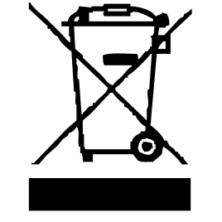

The symbol "CE" is the guarantee of compliance with harmonized European standards, voluntary, reflecting the essential requirements into technical specifications. These standards are not mandatory but are guarantees of compliance with essential requirements.


The symbol ROHS (Restriction of use of some Hazardous Substances) on the Environmental Protection, certifies that for each of the five hazardous substances • Lead • Mercury • (hexavalent) chromium • products for protection against flames PBB and PBDE, the peak concentration is equal to or less than 0.1% of the weight of homogeneous material, and 0.01% for the 6th • cadmium.
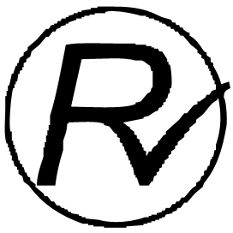

The symbol "DOUBLE SQUARE" means a double insulated. A basic insulation and supplementary insulation. This device requires no connection to the mass of a protective conductor grounded. The materials are said : double insulation class II.


The symbol "TUB / SHOWER" crossed out means to never use the unit in a bathroom, a shower in or near water spray.
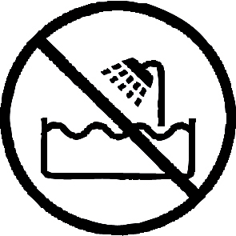

The symbol "TRIMAN" indicates that the consumer is invited to dispose the product as part of a separate collection (eg recycling bin, waste, voluntary intake point).

The symbol "CMIM marking" is the guarantee of compliance with the harmonized Moroccan Standards, optional, which translate the essential requirements into technical specifications. These standards are not mandatory but guarantee compliance with the essential requirements.

For more information : http://www.quefairedemesdechets.fr

CAUTION: RISK OF BURN.
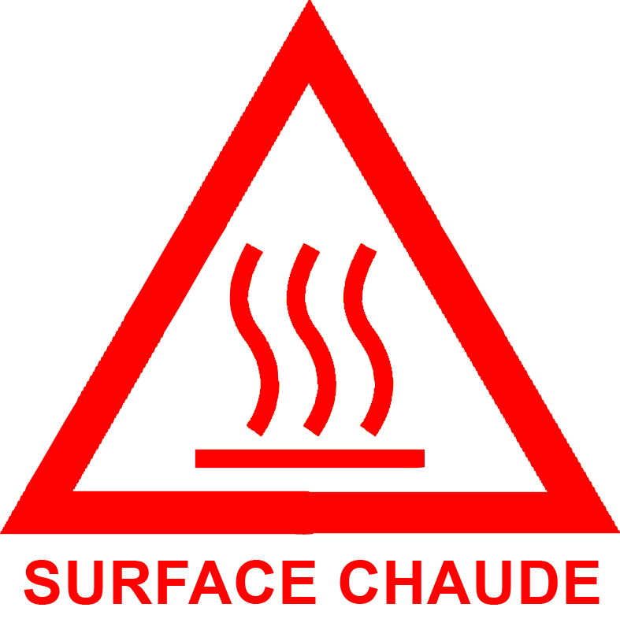
• During operation, the surface temperature of the unit may be hot.
• The heating elements remain warm for a long time after the appliance is switched off.

WARNING

Switch off when not in use, even if for a moment
When the hairdryer is used in a bathroom, unplug it after use since the proximity of water presents a hazard even when the hairdryer is switched off.
When hand is wet it don’t use the appliance
When the appliance is on use, don’t jam in wind-in lid, so as towel, clothing.
CLEANING AND MAINTENANCE

Always disconnect your dryer before cleaning.
Do not put the appliance into water.
Clean the dust and hair by brush thermally.
Clean the appliance with a slightly damp cloth and dry it up with a dry cloth.
Never use gritting, of metal brush or another cutting object.
Do not use abrasive cleaners.

PARTICULAR WARNING FOR PRODUCT USE IN A BATHROOM

- Switch off when not in use, even if for a moment.
- when the hairdryer is used in a bathroom, unplug it after use since the proximity of water presents a hazard even when the hairdryer is switched off.
- • Do not use this product while taking a shower or bath. Always unplug the device even close between 2 uses.

• When the unit is used in a bathroom unplug it after use since the proximity of water presents a risk, even when the power is off.

For additional protection, the installation of a residual current device (RCD) having a rated residual operating current not exceeding 30 mA is advisable in the electrical circuit supplying the bathroom. Ask your installer for advice.
NOTE: A thermal fuse, is not a residual current device (RCD).

• Do not use this product while taking a shower or bath.

• Always unplug the unit itself between two closely spaced uses.

• For example: Stop the machine and unplug it if you drop it while you dry.

FIRST USE

Before first use, remove the unit and all accessories carefully.

Clean the outside and inside of the machine cabinet with a damp cloth and wipe dry.

Location
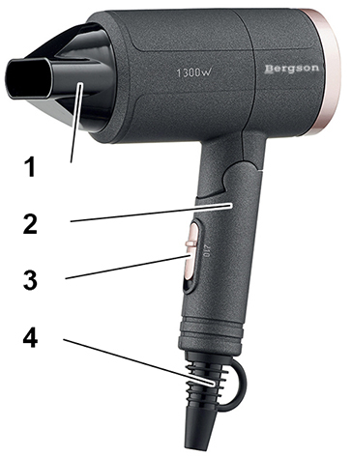
- Concentrator
- Foldable handle
- On / Off switch & Speed selector
- Loop and wire protection

- Make sure that your hands are completely dry before plugging in.
- Plug in and set switch to the required position
- Once your hair is dry set the switch off and unplug the dryer.

USE

- Unroll the power cord completely.
- Check that the tension in force in the country where you are, corresponds to that indicated on the apparatus.
- Connect the apparatus in a correct socket-outlet, (and connected to the ground if the unit is Class I), to avoid any danger.
- Disconnect the power source cable before any operation of cleaning of maintenance and accessories assembly.

Place the appliance on a table or flat & stable surface.
- The item must not be left unattended when it is connected to main supply.
- The item is not to be used, if it has been dropped or if there are visible signs of damage.
- Never modify the appliance in anyway.
- This appliance is only intended for household use.
- Do not use or keep this product outside.
- Certain parts of the appliance can get hot. Do not touch them, as you may burn yourself.
- Push the On / Off switch to speed 1 or 2, as needed, to turn it on.
- Approach the hair dryer to the hair to dry.
- Move the hair dryer quickly to avoid burning hair and use the hand to move hair during drying.
- Push the On / Off switch to Off (or (0) depending on the model) to stop the unit.

STORAGE

-Ensure the unit is completely cool and dry.
-Do not wrap the cord around the appliance, as this will cause damage.
-Keep the appliance in a cool, dry place and out of reach from children.

GUARANTEE IN ACCORDANCE WITH REGULATIONS

Before being delivered, all our products are subjected to rigorous checks.
This device is guaranteed for 24 months from the date of purchase of the product by the consumer.
The warranty documents are:
• the invoice and
• the warranty certificate (located on the side or the bottom of the box) stamped and completed.
Without these supporting documents, no free replacement or free repair can be made.
During the warranty period, we take charge, free of charge, for defects in the device or accessories, resulting from a defect in materials or workmanship by repair or replacement.
Services under the legal guarantee do not entail any extension of the guarantee period and do not give the right to a new guarantee.
In the event of a warranty claim, return the complete device to your dealer,
in its original packaging, accompanied by proof of purchase.
The breakage of glass or plastic parts is, in all cases, your responsibility.
Wearing parts (for example: motor brushes, hooks, drive belts, spare remote control, spare toothbrushes, saw blades etc.) as well as their cleaning, maintenance or replacement, are not guaranteed. , and are therefore at your expense.
In the event of foreign intervention, the guarantee lapses.
After expiry of the warranty period, repairs can be carried out, against payment, by a specialist dealer or a repair service.

SPECIFICATIONS

Power supply 220-240V~ 50-60Hz
Power 1100-1300W
Norm Class II
Made in PRC

The characteristics can change without prior notice.

CAUTION: In order to minimize the risks of electric shock, In the event of breakdown, not to open the case but to call upon a qualified technician for repairs.

This apparatus satisfied EC directives, it was controlled according to all the European current directives, like: electromagnetic compatibility (EMC) and low tension (LVD).

This apparatus was designed and manufactured in respect of the last safety regulations and technical specifications.

Imported by Sotech International
" LE PERIPOLE "
33, Avenue du Marechal de Lattre de Tassigny
94120 Fontenay sous-bois - France

