TTN-038



RECHARGEABLE GROMMING KIT - 5 IN 1

INSTRUCTION MANUAL
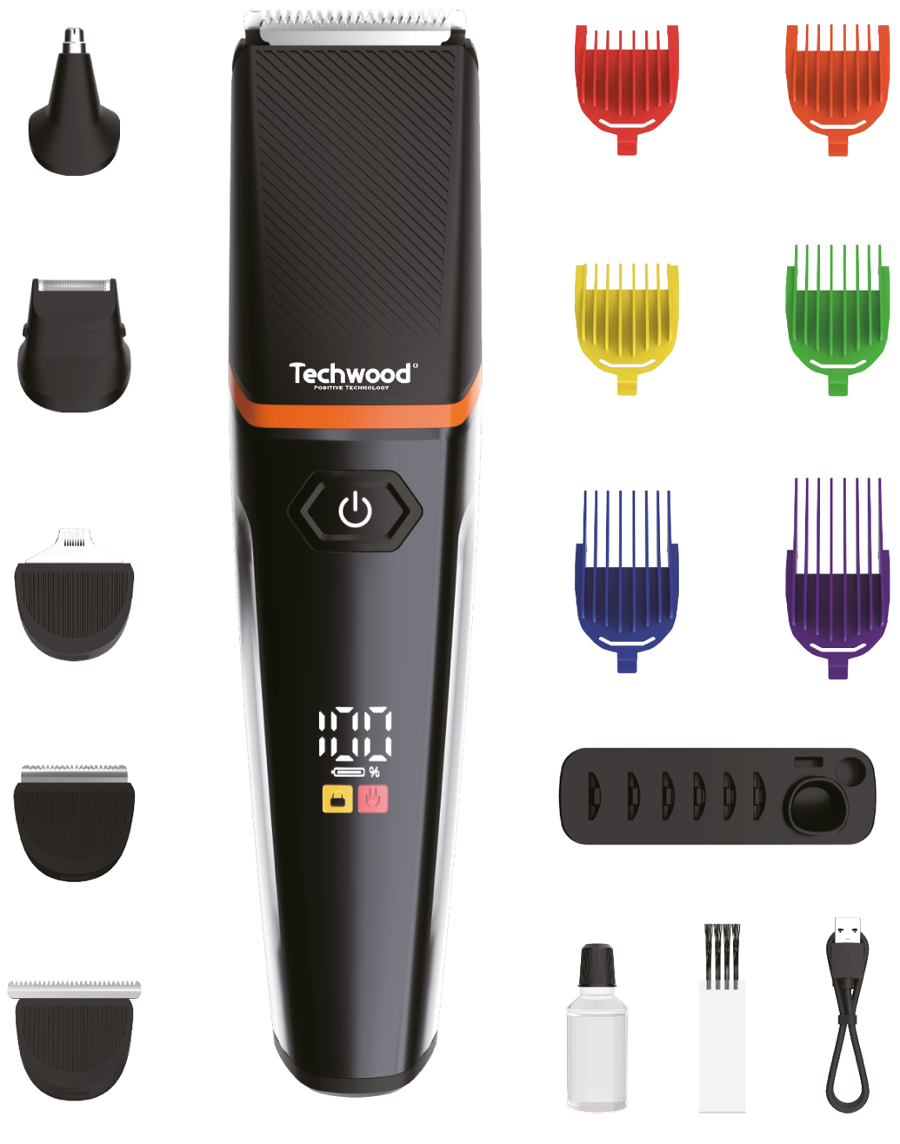
IMPORTANT SAFEGUARDS
Dear consumer, Please read these instructions carefully before use in order to avoid damage due to incorrect use and to better understand the functions of this product. Please pay particular attention to the safety guide.
If you pass the device on to a third party, these Operating Instructions must also be handed over.
Please keep them for future references.

- Please read these instructions carefully before use.
- Keep present instructions for future references.
- Check that your mains voltage corresponds to that stated on the appliance.
- Only use the appliance for domestic purposes and household or similar applications such as:
-staff kitchen areas, in shops, offices and other working environments;
-by clients in hotels, motels and other residential type environments;
- Environment type like :
• Farm Houses • Bed and Breakfast.
- Only use the appliance in the way indicated in these instructions.
- WARNING: Do not use this appliance near bathtubs, showers, basins or other vessels containing water.
- Never use this apparatus near water projections.
- Never use this apparatus with the wet hands.
- If, unfortunately the apparatus is wet, immediately withdraw the cord of the socket-outlet.
- Inform potential users of these instructions.
- Never leave the appliance unsupervised when in use.
- The appliance must be used only for its intended purpose. No responsibility can be taken for any possible damage caused by incorrect use or improper handling.
- Children and persons with disabilities are not always aware of the danger posed by the use of appliances.
- This appliance can be used by children aged from 8 years and above and persons with reduced physical, sensory or mental capabilities or lack of experience and knowledge, if they have been given supervision or instruction concerning use of the appliance in a safe way and understand the hazards involved.
- Children shall not play with the appliance.
- Cleaning and maintenance must not be made ​​by children without supervision.
- The appliance can be used by children aged from 3 years under supervision.
- Keep the appliance and its cord out of reach of children aged less than 8 years.
- This device is not a toy, do not leave small children or people with disabilities to play with.
- WARNING: Keep the appliance dry.
The appliance is only to be used with the power supply unit
provided with the appliance.
- The appliance must only be supplied at safety extra low
voltage corresponding to the marking on the appliance.
- In order to ensure your children‘s safety, please keep all packaging (plastic bags, boxes, polystyrene etc.) out of their reach.
- Do not allow small children to play with the foil :
there is a danger of suffocation !
- From time to time check the cord for damages. Never use the appliance if cord or appliance shows any signs of damage.
- Never immerse the appliance in water or any other liquid for any reason whatsoever.
- Never place it into the dishwasher.
- Never use the appliance near hot surfaces.
- Disconnect the power source cable before any operation of cleaning of maintenance and accessories assembly.
- Never use the appliance outside and always place it in a dry environment.
- Never use accessories, which are not recommended by the producer. They could constitute a danger to the user and risk to damage the appliance.
- Never use any other connector than the one provided.
- Never move the appliance by pulling the cord. Make sure the cord cannot get caught in any way.
- Never wind the cord around the appliance and do not bend it
- Ensure that the power cord does not come into contact with hot parts of this unit.
- Make sure the appliance has cooled down before cleaning and storing it.
- The temperature of accessible surfaces may be very high when the appliance is operating. Never touch these parts, of apparatus, to avoid burning itself.
- Make sure the appliance never comes into contact with flammable materials, such as curtains, cloth, etc...& the power cord and plug do not come in contact with water.
- Before cleaning, always unplug the appliance from the power supply and let it cool down.
- This appliance is not intended to be operated by means of an external timer or separate remote-control system.
- Always place the unit on a flat surface. Ensure, also, not to cover the device and not to put anything on it.
- Always remove the plug from the wall socket when the appliance is not in use.
- When using an extension lead always make sure that the entire cable is unwound from the reel. Use solely CE approved extension leads. Input power must be at least 16A, 250V, 3000W.
- Incorrect operation and improper use can damage the appliance and cause injury to the user.
- This device, designed for home use, complies with standards relating to this type of product.
- Regarding the instructions for cleaning, thanks to refer to the below paragraph of the manual.
- This appliance is only intended for household use.
- CAUTION: The adaptor is not is provided.
- This device contains batteries which can only be replaced by qualified persons.
- The external flexible cable (Type-C cable) or cord can be replaced. If the cord is damaged the appliance should be scrapped.

PARTICULAR WARNING FOR PRODUCT USE IN A BATHROOM

- Switch off when not in use, even if for a moment.
- Unplug it after use, since the proximity of water presents a hazard, even when the unit is switched off.
- Do not use this product while taking a shower or bath. Always unplug the device even close between 2 uses.
- When the unit is used in a bathroom unplug it after use since the proximity of water presents a risk, even when the power is off.

To provide additional protection, in the electrical circuit supplying the bathroom, a residual current device (RCD) with a rated residual current not exceeding 30mA operation, is recommended. Consult your installer.
NOTE: A thermal fuse, is not a residual current device (RCD).

• Do not use this product while taking a shower or bath.

• Always unplug the unit itself between two closely spaced uses.

• For example: Stop the machine and unplug it if you drop it while you dry.

GENERAL INFORMATION

The symbol "OPEN BOOK" means a recommendation to read important things contained in the record.

The symbol "BIN" crossed out, abbreviation WEEE (Waste of Electrical and Electronic Equipment) means that at the end of life, it should not be discarded with household waste, but filed to the sorting of the locality. Waste recovery can help preserve our environment.
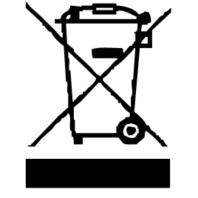

The symbol "CE" is the guarantee of compliance with harmonized European standards, voluntary, reflecting the essential requirements into technical specifications. These standards are not mandatory but are guarantees of compliance with essential requirements.


The symbol ROHS (Restriction of use of some Hazardous Substances) on the Environmental Protection, certifies that for each of the five hazardous substances • Lead • Mercury • (hexavalent) chromium • products for protection against flames PBB and PBDE, the peak concentration is equal to or less than 0.1% of the weight of homogeneous material, and 0.01% for the 6th • cadmium.


The symbol "TUB / SHOWER" crossed out means to never use the unit in a bathroom, a shower in or near water spray.


The symbol "TRIMAN" indicates that the consumer is invited to dispose the product as part of a separate collection (eg recycling bin, waste, voluntary intake point).


For more information : http://www.quefairedemesdechets.fr

The symbol " CMIM " is the guarantee of compliance with optional harmonized Moroccan Standards, which reflect the essential requirements in terms of technical specifications.
These standards are not mandatory but ensuring compliance with the essential requirements.
WARNING FOR THIS TYPE OF DEVICE

- NEVER TOUCH THE ROTATING HEAD, IN MOTION, WITH YOUR FINGER OR ANY OTHER PART OF THE BODY TO AVOID INJURY YOURSELF.
- DO NOT INSERT ANY OBJECT INTO THE HEAD OF THE DEVICE, THIS WILL DAMAGE IT.

CLEANING AND MAINTENANCE

Before cleaning always switch off the appliance.
Always disconnect the apparatus and to let it cool before cleaning.
Clean the outside of the apparatus with a sponge or slightly wet linen.
Never plunge the apparatus in water or all other liquid !
Do not use abrasive cleaners, gritting, or metal brush or another cutting object.
- Take off the guide comb, remove the cutting unit to clean the hair between the top-blade and lower blade with cleaning brush.
- Wash the guide comb or the cutting unit with running water if necessary.
- Dry the guide comb or the cutting unit.
- The cutting unit should be oiled frequently in order to maintain its good cutting performance and thus ensure a long service life. Put 2 or 3 drops of oil on the cutting unit.
- To replace the cutting blades position it with the hook in the slot on the housing and press until it clicks into place.
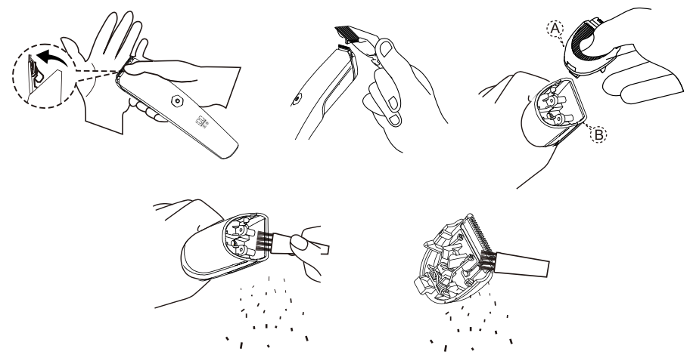
Cleaning up
The device requires a regular clean-up.
• Disconnect the device from the power source. The housing can be wiped with a slightly wet cloth. • Do not use chemically active or abrasive detergents to clean the device as it can damage its surface. The adapter can also be wiped with a slightly wet cloth; it should be unplugged during this operation.
• The detachable parts of the device should be washed in warm soapy water.
• The blades should be cleaned from hair with the brush supplied. Additionally, the blade unit should be removed from time to time for clean-up.
• Do not clean the hair clipper using tools.
• Never submerge the device in water or other liquid.

TO KNOW YOUR APPLIANCE

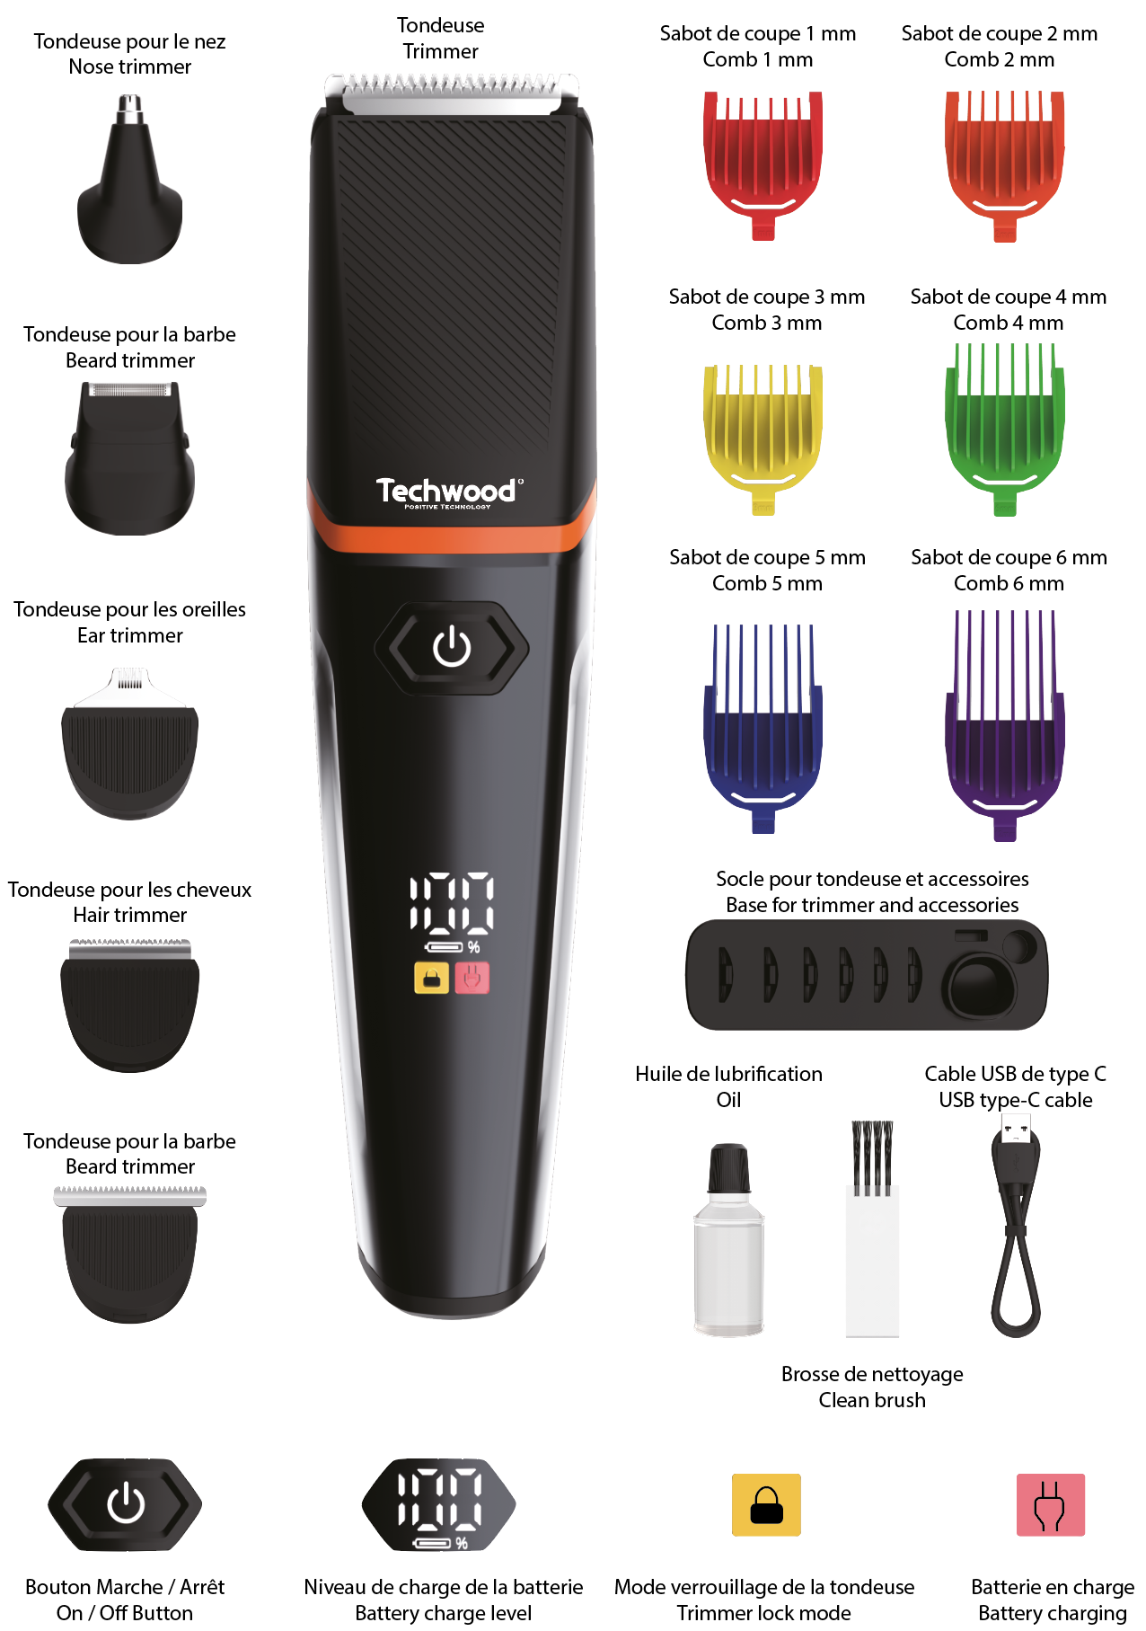

LED display instruction :
Battery Remaining Indicator
When the trimmer is turned on, the digital screen will indicate its battery remaining by numbers and the below battery symbol always alights.

Charging Indicator
- It light on while charging.
- It blinks while the power lowers to 15% to remind of recharging the device.

Lock Trimmer
Push on the button during 5 seconds the trimmer lock.
The logo blink 3 times.

Unlock Trimmer
Push on the button during 5 seconds the trimmer unlock.
The trimmer turn on directly.

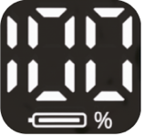

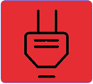

Charging

- Please get the trimmer fully charged before your first use or a long period of disuse.
- The applicable voltage of the adapter (not provide) is 100-240V,50/60Hz output DC 5V 1A (not supplied with the unit).
- When the battery remains less than 15%, the symbol  would is displayed to remind you to charge the device.
- Before and during charging, please make sure the device is switched off.
5. It takes less than 90 minutes to fully charged the device, and the battery remaining number would indicate 100%.
6. After charge please disconnect the device.
7. Do not leave the appliance plugged with is cable for more than 24 hours.

HOW TO CHOOSE THE PROPER ATTACHMENT
 | Precise trimmer | Nose trimmer | razor | Full-size trimmer
Beard | X |  | X
Moustache | X |  | X
Neck | X |  | X
Whiskers | X |  | X
Ears |  | X
Eyebrows |  | X
Nose |  | X
Head hair |  |  |  | X
HAIR CLIPPER OPERATION
1.Install the required clipping head. Replacement heads is made strictly when the unit is switched off. In order to disconnect the installed head, toughly press the locking buttons simultaneously and pull the head up. Then install a new head in its place until the typical click of locking is heard.
2. Install one of the attachments, if required. Replacement heads is made strictly when the unit is switched off. The attachment should be installed as follows: firstly, its front part should be matched, and then the lock in the rear part of the attachment should be lowered and latched. If the lock of the attachment does not fit the proper place without an effort, then its front part is installed incorrectly. The attachment should be removed inversely as follows: firstly, the lock in its rear part should be disengaged, and then the attachment can be completely removed.

3. In order to change the length of the shear layer of hair, you need to install one of the included attachments, with the required value. The beard attachment moves without a lock and it can be installed in one of the four positions indicated at the side of the head.
4. If you need a length exceeding 20 mm, remove the attachment and use the comb, or adjust the length with the fingers of your free hand.

5. Set the switch into the I position and start clipping. Change the attachments and clipping heads only when the device is switched off.

6. Firstly, handle a small section of hair to get used to the length of the hair being cut. Start to clip from the occipitals and at the sides, then clip in the front moving to the crown; all the movements should be performed against the hair growth direction.
7. Watch the speed of movement of the device when clipping. The best results can be achieved when the device moves with its internal speed without being manually accelerated.
8. The final treatment should be performed without an attachment by light stroking movements along the hair growth direction starting from the crown.
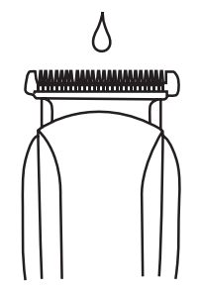

9. Upon completion of clipping, turn off the appliance.

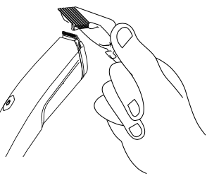
Using the comb attachment
- When load and unload the comb attachment, please ensure the power switch is on off status.
- Put the comb to the main unit as the reference picture.
Note : There are 6 guide combs with the cutting length as below.:
1. 1mm; 2. 2mm; 3. 3mm; 4. 6mm; 5. 9mm; 6. 12mm

Nasal hair remover
Replace the head in place with the nasal hair remover.
To shave hair from nostrils and ears,
Push the switch up.
Insert the rotating head of the epilator into the nostril, taking care not to touch the nasal wall.
Gently approach the rotating head to trim nose hair.
Note: The rotary epilator can also cut unwanted ear hair.

Maintenance
The hair clipper requires a regular lubrication of blades to ensure its proper and continuous operation.

• After cleaning, put 2 or 3 drops of oil on the cutting unit, switch on and switch off the device to distribute the oil and then remove surplus oil with a cloth.
• To avoid complete discharge of the battery, charging should continue for approximately 1.5 hours, but no longer than 24 hours. Otherwise, it may affect the life of battery.

NOTES
• The hair clipper can continuously operate for 90 minutes maximum to prevent from overheating of the engine. You can continue operation after a 10 minutes break.
• The device is designed for clipping dry hair; do not use it for clipping wet and soppy hair.
• The adapter can normally get warm during charging. Not provided.
• Do not leave the device connected on his type-c cable.
• The manufacturer reserves the right to make additional modifications in design of the hair clipper.
SAFETY PRECAUTIONS
• The hair clipper is intended for operation from the power source which performance is specified in the manual.
• Do not leave the device in running order. Switch the device off before you lay it down.
• The device is not intended for use by persons (including children) with reduced physical, sensory or mental ability or if they have no experience or knowledge, if they are not under control or not instructed on the use of the instrument the person responsible for their safety.
• In order to reduce the risk of fire or electric injury:
- store the unused device unplugged;
- do not use the device in wet areas;
- do not plug in the device if there is water on its surface;
- do not insert and remove the plug from the socket with wet hands;
- avoid plug overheating; ensure it is tightly and fully inserted in the socket;
- do not use the device if the power cord is damaged or wet;
- unplug the device prior to clean-up;
- never jerk the power cord to switch off the device; remove the plug from the socket carefully;
- store the device in a dry and cool place.

OILING BLADES

To maintain the mower in good condition, the blades should be oiled regularly.
Before using, oil first, put 2 or 3 drops of oil on the cutting unit.
Use the ON/OFF switch, to switch on or switch off the appliance.

STORAGE

-Ensure the unit is completely cool and dry.
-Do not wrap the cord around the appliance, as this will cause damage.
-Keep the appliance in a cool, dry place.

GUARANTEE IN ACCORDANCE WITH REGULATIONS

Before being delivered, all our products are subjected to rigorous checks.
This device is guaranteed for 24 months from the date of purchase of the product by the consumer.
The warranty documents are:
• the invoice and
• the warranty certificate (located on the side or the bottom of the box) stamped and completed.
Without these supporting documents, no free replacement or free repair can be made.
During the warranty period, we take charge, free of charge, for defects in the device or accessories, resulting from a defect in materials or workmanship by repair or replacement.
Services under the legal guarantee do not entail any extension of the guarantee period and do not give the right to a new guarantee.
In the event of a warranty claim, return the complete device to your dealer,
in its original packaging, accompanied by proof of purchase.
The breakage of glass or plastic parts is, in all cases, your responsibility.
Wearing parts (for example: motor brushes, hooks, drive belts, spare remote control, spare toothbrushes, saw blades etc.) as well as their cleaning, maintenance or replacement, are not guaranteed. , and are therefore at your expense.
In the event of foreign intervention, the guarantee lapses.
After expiry of the warranty period, repairs can be carried out, against payment,
by a specialist dealer or a repair service.

SPECIFICATIONS

Clipper
Battery 3,7V 600mAh Li-ion
Charging time 90 min
Using time 90 min (when fully charged)
Cable USB Type-C charging

Power supply Suggested (Not provided)
Input :100-240V~50/60Hz
Output : 5V 1A

Made in PRC

The characteristics can change without prior notice

In the case you use an adaptor:

To provide additional protection, the installation, in the electrical circuit supplying the bathroom, of residual current device (RCD) of rated residual operating current, not exceeding 30mA, is recommended. Ask your installer for advice.
NOTE: A circuit breaker is not a residual current device (RCD).

CAUTION: In order to minimize the risks of electric shock, In the event of breakdown, not to open the case but to call upon a qualified technician for repairs.

This device complies with EC directives, it was controlled according to all current European directives, applicable such as: electromagnetic compatibility (EMC) and low voltage (LVD).

This device has been designed and manufactured in compliance with the latest regulations and technical requirements for safety.

ENVIRONMENTAL PROTECTION
(Destruction of batteries)

To remove the battery:
The appliance must be disconnected from the main power, when the battery is removed.
• Open the battery compartment and retrieve the battery or batteries.
- THE BATTERY MUST BE REMOVED BEFORE THE UNIT IS GIVEN TO REBUS.
- BATTERY CONTAINS NICKEL CADMIUM AND / OR LITHIUM AND / OR NICKEL-METAL HYDRIDE, THE BATTERY MUST BE ELIMINATED IN A SAFE WAY.
DO NOT THROW IN A TRASH CAN, BUT GIVE IN CENTRE OF WASTE.
- The external flexible cable or cord can be replaced by similar cable. If the cord is damaged the cord should be scrapped.

FEVRIER 2024

