

TSB-026

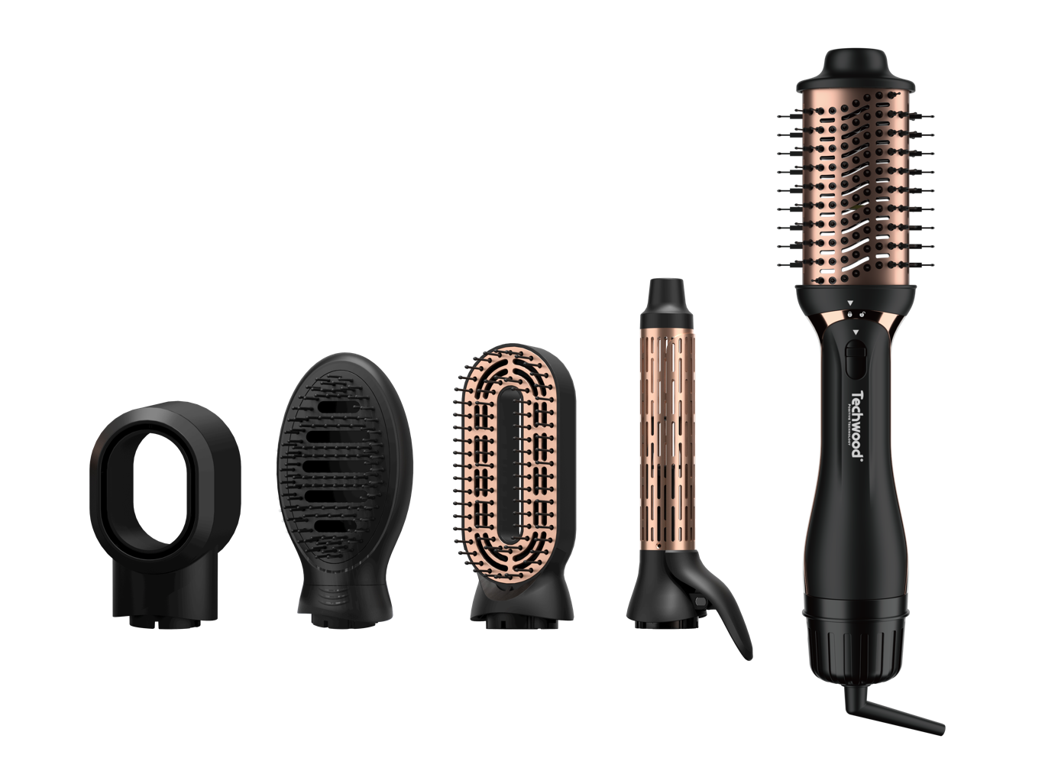
Dear consumer, Please read these instructions carefully before use in order to avoid damage due to incorrect use and to better understand the functions of this product. Please pay particular attention to the safety guide.
If you pass the device on to a third party, these Operating Instructions must also be handed over.
Please keep them for future references.

IMPORTANT SAFEGUARDS

- Please read these instructions carefully before use.
- Keep present instructions for future references.
- Check that your mains voltage corresponds to that stated on the appliance.
- Only use the appliance for domestic purposes and household or similar applications such as:
- staff kitchen areas, in shops, offices and other working environments;
- By clients in hotels, motels and other residential type environments;
- Environment type like :
• Farm Houses • Bed and Breakfast.
- Only use the appliance in the way indicated in these instructions.
- Never use this unit near bathtub, shower, wash-hand basins or other containers with water.
- Never use this apparatus near water projections.
- Never use this apparatus with the wet hands.
- If, unfortunately the apparatus is wet, immediately withdraw the cord of the socket-outlet.
- Inform potential users of these instructions.
- Never leave the appliance unsupervised when in use.
- The appliance must be used only for its intended purpose. No responsibility can be taken for any possible damage caused by incorrect use or improper handling.
- Children and persons with disabilities are not always aware of the danger posed by the use of appliances.
This appliance can be used by children aged from 8 years and above and persons with reduced physical, sensory or mental capabilities or lack of experience and knowledge if they have been given supervision or instruction concerning use of the appliance in a safe way and understand the hazards involved. Children shall not play with the appliance. Cleaning and user maintenance shall not be made by children without supervision.
- WARNING : Do not use this appliance near bathtubs, showers, basins or other vessels containing water.
- When the curling iron is used in a bathroom, unplug it after use since the proximity of water presents a hazard even when the curling iron is switched off.

- Burn Hazard. Keep appliance out of reach from young children, particularly during use cool down.
- When the appliance is connected to the power supply, never leave it attended.
- Always place the appliance with the stand, if any, on a heat-resistant, stable flat surface.

- This device is not a toy, do not leave small children or people with disabilities to play with.
- In order to ensure your children‘s safety, please keep all packaging (plastic bags, boxes, polystyrene etc.) out of their reach.
- Caution ! Do not allow small children to play with the foil :
there is a danger of suffocation !
- From time to time check the cord for damages. Never use the appliance if cord or appliance shows any signs of damage.
- Never immerse the appliance in water or any other liquid for any reason whatsoever.
- Never place it into the dishwasher.
- Never use the appliance near hot surfaces.
- Do not operate the appliance with a damaged cord or plug, or after the appliance has been damaged in any manner.
- If the supply cord or appliance is damaged, it must be replaced by the manufacturer or its service agent or a similarly qualified person* in order to avoid a hazard.
- Disconnect the power source cable before any operation of cleaning of maintenance and accessories assembly.
- Never use the appliance outside and always place it in a dry environment.
- Never use accessories, which are not recommended by the producer. They could constitute a danger to the user and risk to damage the appliance.
- Never use any other connector than the one provided.
- Never move the appliance by pulling the cord. Make sure the cord cannot get caught in any way.
- Never wind the cord around the appliance and do not bend it
- Ensure that the power cord does not come into contact with hot parts of this unit.
- Make sure the appliance has cooled down before cleaning and storing it.
- The temperature of accessible surfaces may be very high when the appliance is operating. Never touch these parts, of apparatus, to avoid burning itself.
- Make sure the appliance never comes into contact with flammable materials, such as curtains, cloth, etc...& the power cord and plug do not come in contact with water.
- Before cleaning, always unplug the appliance from the power supply and let it cool down.
- This appliance is not intended to be operated by means of an external timer or separate remote-control system.

- Always place the unit on a flat surface. Ensure, also, not to cover the device and not to put anything on it.
- Always remove the plug from the wall socket when the appliance is not in use.
- When using an extension lead always make sure that the entire cable is unwound from the reel. Use solely CE approved extension leads. Input power must be at least 16A, 250V, 3000W.
- Incorrect operation and improper use can damage the appliance and cause injury to the user.
- This device, designed for home use, complies with standards relating to this type of product.
- The appliance must be used and rested on a table or flat & stable surface.
- The item must not be left unattended when it is connected to main supply.
- The item is not to be used, if it has been dropped or if there are visible signs of damage or if it is leaking.
- Regarding the instructions for cleaning, thanks to refer to the below paragraph of the manual.
- This appliance is only intended for household use.

^{(*)} Competent qualified person : after sales department of the producer or importer or any person who is qualified, approved and competent to perform this kind of repairs.

PARTICULAR WARNING FOR PRODUCT USE IN A BATHROOM

- Switch off when not in use, even if for a moment.
- Unplug it after use, since the proximity of water presents a hazard, even when the unit is switched off.
- Do not use this product while taking a shower or bath. Always unplug the device even close between 2 uses.
- When the unit is used in a bathroom unplug it after use since the proximity of water presents a risk, even when the power is off.

To provide additional protection, in the electrical circuit supplying the bathroom, a residual current device (RCD) with a rated residual current not exceeding 30mA operation, is recommended. Consult your installer.

For additional protection, the installation of a residual current device (RCD) having a rated residual operating current not exceeding 30 mA is advisable in the electrical circuit supplying the bathroom. Ask your installer for advice.

NOTE: A thermal fuse, is not a residual current device (RCD).

Do not use this product while taking a shower or bath.

Always unplug the unit itself between two closely spaced uses.

For example: Stop the machine and unplug it if you drop it while you dry.

This new curling iron is the perfect tool to achieve suitable hair styling.
- Take care to avoid contact between the hot surface of the barrel and the skin of the face and neck, or any sensitive body surface.
- Only change brush attachment when the unit is unplugged and completely cool.
- Unplug the unit between 2 uses, even close, when this unit is used in a bathroom.

GENERAL INFORMATION

The symbol "OPEN BOOK" means a recommendation to read important things contained in the record.

The symbol "BIN" crossed out, abbreviation WEEE (Waste of Electrical and Electronic Equipment) means that at the end of life, it should not be discarded with household waste, but filed to the sorting of the locality. Waste recovery can help preserve our environment.
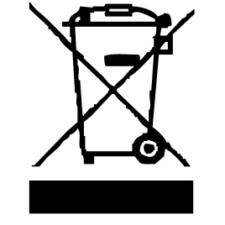

The symbol "CE" is the guarantee of compliance with harmonized European standards, voluntary, reflecting the essential requirements into technical specifications. These standards are not mandatory but are guarantees of compliance with essential requirements.

The symbol ROHS (Restriction of use of some Hazardous Substances) on the Environmental Protection, certifies that for each of the five hazardous substances • Lead • Mercury • (hexavalent) chromium • products for protection against flames PBB and PBDE, the peak concentration is equal to or less than 0.1% of the weight of homogeneous material, and 0.01% for the 6th • cadmium.
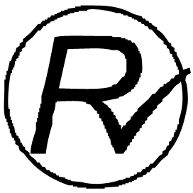

The symbol "DOUBLE SQUARE" means a double insulated. A basic insulation and supplementary insulation. This device requires no connection to the mass of a protective conductor grounded. The materials are said : double insulation class II.


The symbol "TRIMAN" indicates that the consumer is invited to dispose the product as part of a separate collection (eg recycling bin, waste, voluntary intake point).


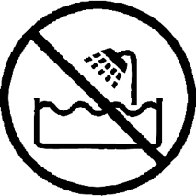
The symbol "TUB / SHOWER" crossed out means to never use the unit in a bathroom, a shower in or near water spray. (IP20 Minimum distance 3M.)

For more information : http://www.quefairedemesdechets.fr

When using an electrical appliance, basic safety precautions should always be observed, including the following:
- Check if the voltage indicated on the appliance corresponds to the local voltage before you connect the appliance.
- This appliance is not intended for use by persons (including children) with reduced physical, sensory or mental capabilities, or lack of experience and knowledge, unless they have been given supervision or instruction concerning use of the appliance by a person responsible for their safety.
Children should be supervised to ensure that they do not play with the appliance.
- WARNING – Do not use this appliance near water or bathtubs, basins or other vessels.
- When the hair dryer is used in a bathroom, unplug the appliance after use since the proximity of water presents a hazard, even when the hairdryer is switched off.
- For additional protection, we advise you to install a residual current device (RCD) with a rated residual operating current not exceeding 30mA in the electrical circuit supplying the bathroom. Ask your installer for advice.
- Close supervision is necessary when any appliance is used on or near children or some disabled people. Store out of children’s reach.
- Never block the air grilles.
- If the appliance overheats, it will switch off automatically. Unplug the appliance and let it cool down for a few minutes. Before you switch the appliance on again, check the grilles to make sure they are not blocked by fluff, hair, etc.
- Do not direct the airflow towards the eyes or other sensitive areas.
- Neither should the appliance be used with wet hands nor immersed in water, held in running water, or allowed to become wet.
- Do not use the hair dryer for purposes other than drying and styling human hair.
- Do not pull the cord with unnecessary force. Do not wrap the cord around the unit. Check cord regularly for any sign of damage. Damaged cords can be dangerous.
- If the supply cord is damaged, it must be replaced by the manufacturer or its service agent or a similarly qualified person in order to avoid a hazard.
- Always switch the appliance off before putting it down, even if it is only for a moment.
- Always unplug the appliance after use.
- Clean the appliance after use to avoid the accumulation of grease and other residues.

- This appliance can be used by children aged from 8 years and above and persons with reduced physical, sensory, or mental capabilities or lack of experience and knowledge if they have been given supervision or instruction concerning use of the appliance in a safe way and understand the hazards involved. Children shall not play with the appliance. Cleaning and user maintenance shall not be made by children without supervision.

HOW TO OPERATE UNIT
- Put the plug in the socket.
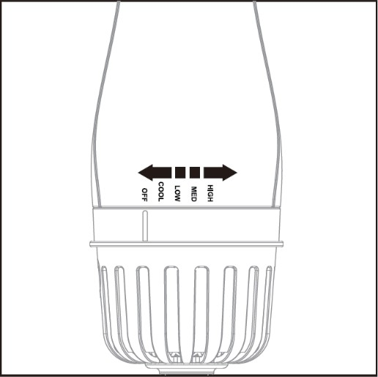
- To turn the appliance on, place fingers around the temperature control dial and rotate counterclockwise to the desired setting.

IMPORTANT NOTICE
This unique appliance uses a concentrated steam of hot air to dry your hair. Though it uses lower wattage than typical with most hair dryers, you may notice that the enclosure around the head of the brush may become very hot to the touch. Please be assured that this is consistent with normal operation of the appliance. Use caution when handling the appliance near the brush head.

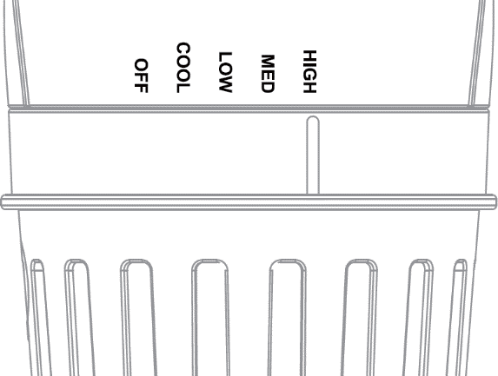
INSTRUCTION FOR SWITCH
OFF: appliance off COOL: cool wind
LOW : low wind & low heating MED : high wind & low heating HIGH : high wind & high heating

PARTS DESCRIPTION

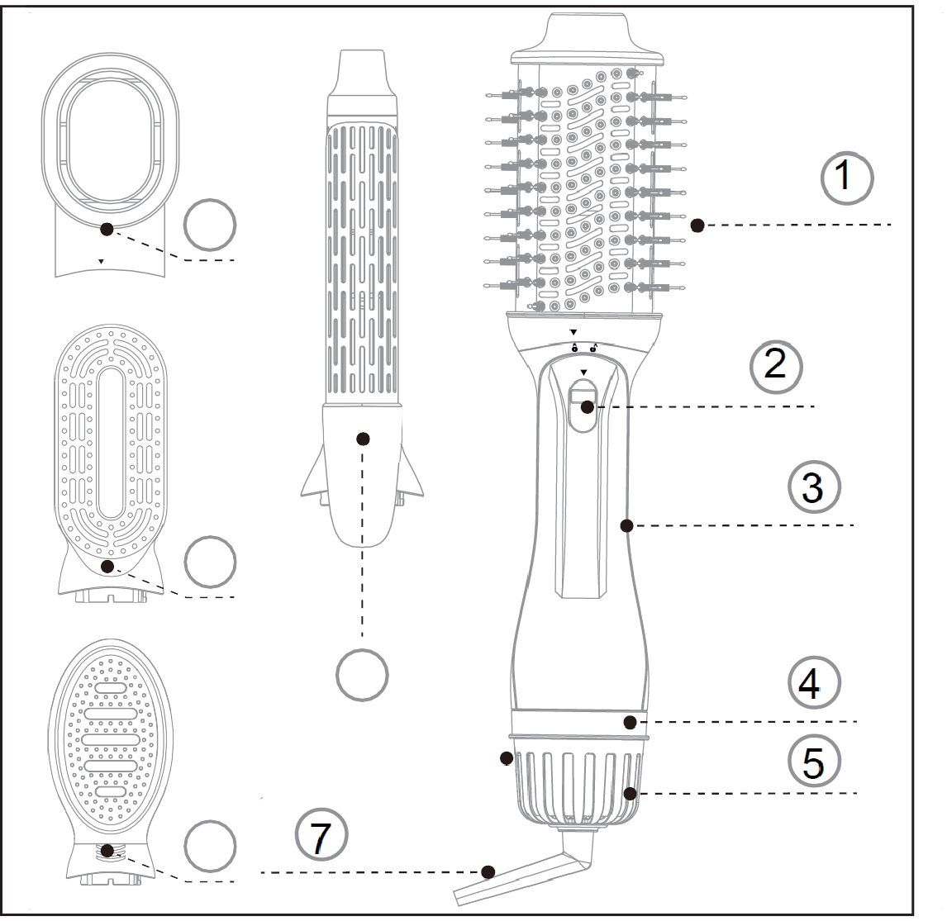
8
10
9
6

  - Hair Brush Head
  - Head Released Button
  - Main Body
  - Rotative Power Switch
  - Back Filter Cover
  - Concentrator Head
  - 360° Swivel Cord Protector
  - Hollow brush head
  - Straightener brush head
  - Hair curler head

ASSEMBLE & DISASSEMBLE THE ATTACHMENT
Assemble: Match the triangle mark and lock-open mark. Insert the attachment to the main unit vertically. Turn around the attachment as the below picture and let the triangle mark be matched with the locked mark.
Disassemble: Pull down the released button and turn around the attachment as the below picture. And then you can take out the attachment from the main unit directly.

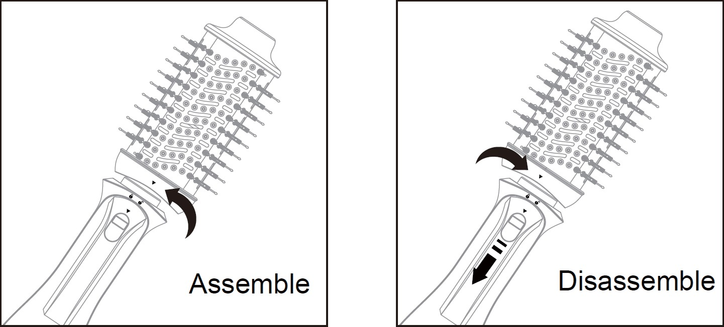
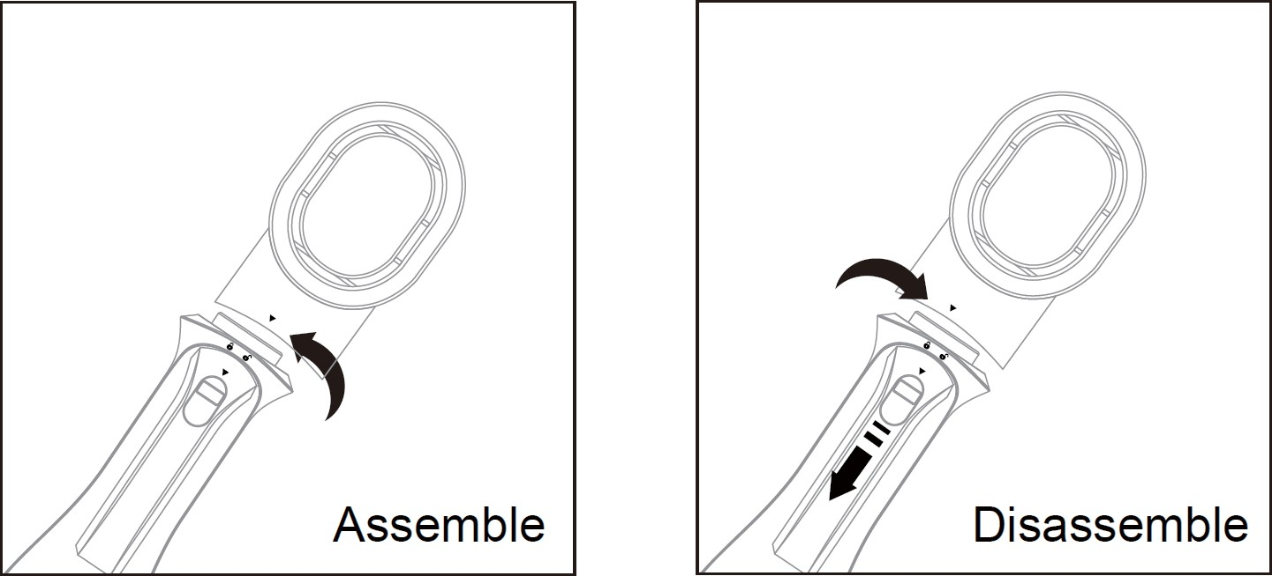
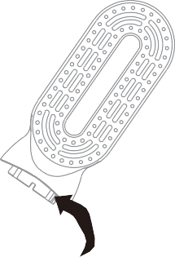
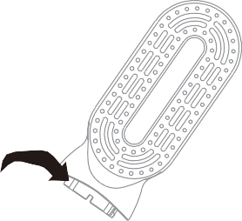

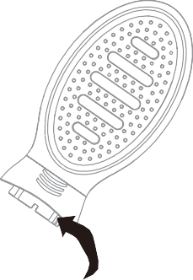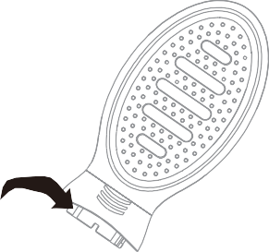
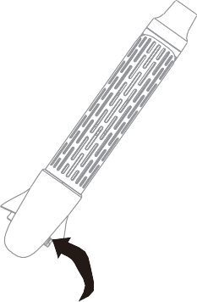
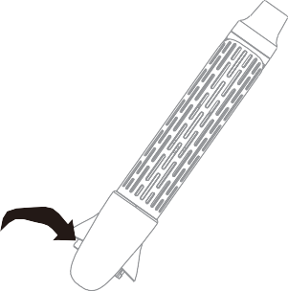

HELPFUL STYLING HINTS
- Towel-dry hair to remove excess water.
- Plug the appliance into an electrical outlet and adjust the switch into the selected setting. Use the medium setting on fine for thin hair and high settings on thick and coarse hair. Use the low setting to lock the style. For the best results, separate hair into manageable sections and dry individually.
- Place the one step hair brush close to the root and glide down towards the ends. The soft-cushioned bristles will help to detangle and smooth even the hard-to -reach areas on the back of the head.
- Repeat on remaining sections until hair has been dried into luxurious, soft, silky styles.
- Turn the appliance off when dry and styling compete. allow the unit to the cool completely before storing.

USER MAINTENANCE INSTRUCTIONS
This appliance is equipped with a thermostat that may cycle OFF if the temperature exceeds comfort level due to the partially blocked air inlet or air outlet openings. In the event that the appliance slows down during use, turn off the switch and allow the appliance

to cool down, at which time the thermostat will automatically reset.

MAINTENANCE
Your appliance is virtually maintenance-free. No lubrication is needed. Keep all vents and openings clean and free of dust, dirt, and hair spray. If the cord becomes twisted ,untwist prior to use .

CLEANING INSTRUCTIONS
If cleaning becomes necessary, unplug the appliance form the power source and wipe the exterior with a damp cloth. dust and lint can be removed from air intake openings with a small brush.
WARNING: if any malfunction occurs, do not attempt to repair it. This appliance has no user-serviceable parts .

CAUTION
NEVER wrap the power cord around the appliance. Any pulling, twisting, severe folding or bending can damage the cord, especially at the point of entry into the unit, which may rupture the cord and can cause an electrical short or other failure.
Regularly inspect the cord, DO NOT use an appliance with a twisted, bent or otherwise damaged cord, or if the appliance receive power irregularly. If cord is damaged, or for irregular power issues, refer to instructions in the WARNING section further below.

STORAGE
Unplug appliance when not in use.
Allow appliance to cool and store out of reach of children in a safe, dry location. Never wrap the cord around the appliance since this will cause the cord to wear prematurely and break. Handle cord carefully for longer life and avoid jerking, twisting, or straining, especially at plug connections.
Appliance should be disconnected and allowed to cool before storage .DO NOT apply stress or tension to the cord’s point of entry into the unit. During storage, cord should remain loose with no tight bends or folds, and appliance should be placed in a secure, dry location out of reach of children. For further details, refer to the STORAGE section of the operating instructions.

Correct Disposal of this product
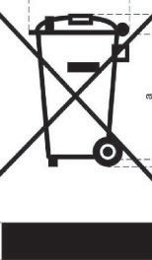 | This marking indicates that this product should not be disposed with other household wastes throughout the EU. To prevent possible harm to the environment or human health from uncontrolled waste disposal, recycle it responsibly to promote the sustainable reuse of material resources. To return your used device, please use the return and collec�on systems or contact the retailer where the product was purchased. They can take this product for  environmental safe recycling.
GUARANTEE IN ACCORDANCE WITH REGULATIONS

Before being delivered, all our products are subjected to rigorous checks.
This device is guaranteed for 24 months from the date of purchase of the product by the consumer.
The warranty documents are:
• the invoice and
• the warranty certificate (located on the side or the bottom of the box) stamped and completed.
Without these supporting documents, no free replacement or free repair can be made.
During the warranty period, we take charge, free of charge, for defects in the device or accessories, resulting from a defect in materials or workmanship by repair or replacement.
Services under the legal guarantee do not entail any extension of the guarantee period and do not give the right to a new guarantee.
In the event of a warranty claim, return the complete device to your dealer,
in its original packaging, accompanied by proof of purchase.
The breakage of glass or plastic parts is, in all cases, your responsibility.
Wearing parts as well as their cleaning, maintenance or replacement, are not guaranteed. , and are therefore at your expense.
In the event of foreign intervention, the guarantee lapses.

After expiry of the warranty period, repairs can be carried out, against payment, by a specialist dealer or a repair service.

SPECIFICATIONS

Power supply 220-240V~ 50/60Hz
Power 1200W
Norm Class II
Made in PRC
The characteristics can change without prior notice

CAUTION: In order to minimize the risks of electric shock, In the event of breakdown, not to open the case but to call upon a qualified technician for repairs.
This apparatus satisfied EC directives, it was controlled according to all the European current directives, like: electromagnetic compatibility (EMC) and low tension (LVD).
This apparatus was designed and manufactured in respect of the last safety regulations and technical specifications.

