

TFL-080L

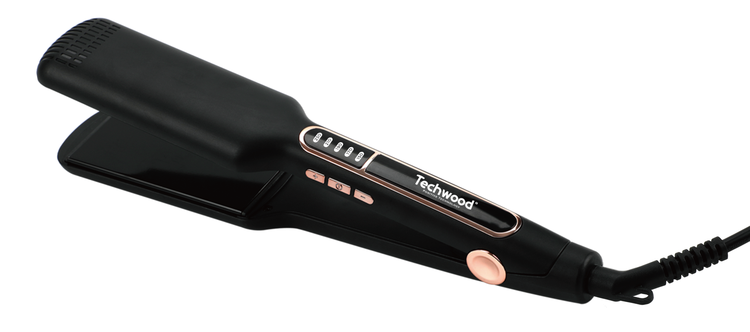
Dear consumer, Please read these instructions carefully before use in order to avoid damage due to incorrect use and to better understand the functions of this product. Please pay particular attention to the safety guide.
If you pass the device on to a third party, these Operating Instructions must also be handed over.
Please keep them for future references.

IMPORTANT SAFEGUARDS

- Please read these instructions carefully before use.
- Keep present instructions for future references.
- Check that your mains voltage corresponds to that stated on the appliance.
- Only use the appliance for domestic purposes and household or similar applications such as:
-staff kitchen areas, in shops, offices and other working environments;
- Environment type like :
• Farm Houses
• Bed and Breakfast.
-by clients in hotels, motels and other residential type environments;
- Only use the appliance in the way indicated in these instructions.
- WARNING Do not use this appliance near bathtubs, showers, basins or other vessels containing water.
- Never use this apparatus near water projections.
- Never use this apparatus with the wet hands.
- If, unfortunately the apparatus is wet, immediately withdraw the cord of the socket-outlet.
- Inform potential users of these instructions.
- Never leave the appliance unsupervised when in use.
- The appliance must be used only for its intended purpose. No responsibility can be taken for any possible damage caused by incorrect use or improper handling.
- Children and persons with disabilities are not always aware of the danger posed by the use of appliances.
- The appliance is not to be used by persons (including children) with reduced physical, sensory or mental capabilities, or lack of experience and knowledge, unless they have been given supervision or instruction.
- Children being supervised not to play with the appliance.
- This appliance can be used by children aged from 8 years and above and persons with reduced physical, sensory or mental capabilities or lack of experience and knowledge if they have been given supervision or instruction concerning use of the appliance in a safe way and understand the hazards involved. Children shall not play with the appliance. Cleaning and user maintenance shall not be made by children without supervision.
- Keep the appliance and its cord out of reach of children aged less than 8 years.
- This device is not a toy, do not leave small children or people with disabilities to play with.
- WARNING: Do not use this appliance near bathtubs, showers, basins or other vessels containing water.
- In order to ensure your children‘s safety, please keep all packaging (plastic bags, boxes, polystyrene etc.) out of their reach.
- Caution ! Do not allow small children to play with the foil :
there is a danger of suffocation !
- From time to time check the cord for damages. Never use the appliance if cord or appliance shows any signs of damage.
- Never immerse the appliance in water or any other liquid for any reason whatsoever.
- Never place it into the dishwasher.
- Never use the appliance near hot surfaces.
- If the supply cord is damaged, it must be replaced by the manufacturer, its service agent or similarly qualified persons in order to avoid a hazard.
- Disconnect the power source cable before any operation of cleaning of maintenance and accessories assembly.
- Never use the appliance outside and always place it in a dry environment.
- Never use accessories, which are not recommended by the producer. They could constitute a danger to the user and risk to damage the appliance.
- Never use any other connector than the one provided.
- Never move the appliance by pulling the cord. Make sure the cord cannot get caught in any way.
- Never wind the cord around the appliance and do not bend it.
- Ensure that the power cord does not come into contact with hot parts of this unit.
- Make sure the appliance has cooled down before cleaning and storing it.
- The temperature of accessible surfaces may be very high when the appliance is operating. Never touch these parts, of apparatus, to avoid burning itself.
- Make sure the appliance never comes into contact with flammable materials, such as curtains, cloth, etc ... & the power cord and plug do not come in contact with water.
- Before cleaning, always unplug the appliance from the power supply and let it cool down.
- This appliance is not intended to be operated by means of an external timer or separate remote-control system.
- Always place the unit on a flat surface. Ensure, also, not to cover the device and not to put anything on it.
- Always remove the plug from the wall socket when the appliance is not in use.
- When using an extension lead always make sure that the entire cable is unwound from the reel. Use solely CE approved extension leads. Input power must be at least 16A, 250V, 3000W.
- Incorrect operation and improper use can damage the appliance and cause injury to the user.
- This device, designed for home use, complies with standards relating to this type of product.

CAUTION : Plates warm when hair straighteners is on.
GENERAL INFORMATION

The symbol "OPEN BOOK" means a recommendation to read important things contained in the record.

The symbol "BIN" crossed out, abbreviation WEEE (Waste of Electrical and Electronic Equipment) means that at the end of life, it should not be discarded with household waste, but filed to the sorting of the locality. Waste recovery can help preserve our environment.
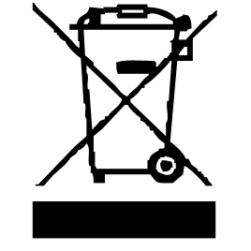

The symbol "CE" is the guarantee of compliance with harmonized European standards, voluntary, reflecting the essential requirements into technical specifications. These standards are not mandatory but are guarantees of compliance with essential requirements.


The symbol ROHS (Restriction of use of some Hazardous Substances) on the Environmental Protection, certifies that for each of the five hazardous substances • Lead • Mercury • (hexavalent) chromium • products for protection against flames PBB and PBDE, the peak concentration is equal to or less than 0.1% of the weight of homogeneous material, and 0.01% for the 6th • cadmium.
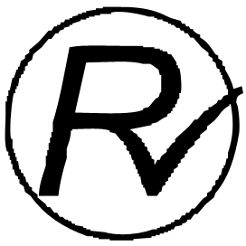

The symbol "DOUBLE SQUARE" means a double insulated. A basic insulation and supplementary insulation. This device requires no connection to the mass of a protective conductor grounded. The materials are said : double insulation class II.

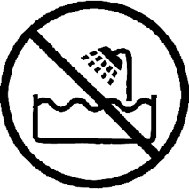
The symbol "TUB / SHOWER" crossed out means to never use the unit in a bathroom, a shower in or near water spray.

The symbol "TRIMAN" indicates that the consumer is invited to dispose the product as part of a separate collection (eg recycling bin, waste, voluntary intake point).


For more information : http://www.quefairedemesdechets.fr
These standards are not mandatory but ensuring compliance with the essential requirements.

CLEANING AND MAINTENANCE

Before cleaning, Always : switch off the appliance, disconnect the apparatus and let it cool before cleaning.
Clean the outside of the apparatus with a sponge or slightly wet linen.
Never plunge the apparatus in water or all other liquid !
Do not use abrasive cleaners, gritting, or metal brush or another cutting object.

Your hair straightener is equipped with coated ceramic plates for a better heat distribution on whole each plate.

ELECTRICAL SAFETY
- Switch off and unplug when not in use and before cleaning the appliance.
- Do not leave unattended whilst connected to the mains supply.
- Children should be supervised to ensure they do not play with the appliance, and the appliance and cables should be kept completely out of reach of young children.
- This appliance can be used by children aged from 8 years and above and persons with reduced physical, sensory or mental capabilities or lack of experience and knowledge if they have been given supervision or instruction concerning use of the appliance in a safe way and understand the hazards involved. Children shall not play with the appliance. Cleaning and user maintenance shall not be made by children without supervision.
- Keep cable, plug and appliance dry and away from areas where it is likely to get splashed. Never immerse in water.
- Do not pull on the cable to disconnect from mains supply.
- Do not operate the appliance if dropped, shows signs of damage or after it malfunctions. In the event the supply cord is damaged, if must only be replaced by a qualified service engineer, with a suitable approved part.
- This appliance must be positioned so that the plug is accessible and the plug socket is within easy reach of the power cord.

ADDITIONAL SAFETY PRECAUTIONS – WARNING!
- This appliance is intended exclusively for use in domestic households. It is not suitable for commercial use.
- Do not use for any other purpose other than that which it is intended, follow the “To use” instructions below.
- Do not use this appliance near bathtubs, showers, basins or other vessels containing water.
- Always ensure hands are dry before using the straightener, touching the plug or the socket. Do not use whilst bathing.
- Always check the cable carefully for kinks, fraying or damage (particularly where it enters the product and the plug) before plugging in the straightener. Do not use if the cable is damaged.
- The straightener becomes VERY HOT in use. Take care to avoid contact between the surface of the plates and the skin, particularly around the ears, face and neck. DO NOT exceed the recommended application times, or singeing or burning of hair may result.
- Do not rest the straightener on non-heat resistant surfaces or near flammable materials whilst the straightener is in use or cooling down.
- Do not cover and allow the straightener to cool fully (e.g. 30 mins) before storing. Do not wind the cable tightly around the straightener.

ADDITIONAL SAFETY PRECAUTIONS - WARNING! (continued)
- Do not use the straightener on artificial hair, wigs or pet hair.
- DO NOT exceed the recommended application times, or singeing or burning of hair may result.
- Trip hazard beware of trailing cables when in use and while in storage.
- Cord entanglement hazard. The cable of the appliance can give rise to risks of entanglement, strangulation or tripping if not correctly placed. Please make sure that the electric cable is positioned safely.
- NEVER leave the appliance unattended when young children are present in the room even when it is unplugged and cooling down.
- ALWAYS use the hinge lock to keep the heating plates closed together while the appliance is left to heat up or cool down, this is especially important if there are children in the household. An open unattended straightener can fall and latch onto a child’s arm causing serious burns.
- Do not touch the shaded areas when in use or right after use since they will be very hot. Doing so may cause serious burn.

STYLING TIPS
- To minimize heat damage to the hair, try the lowest temperature setting first, moving onto the higher settings if hair straightness is not satisfactory.
- For best effect, the section of hair to be straightened should not be more than 5cm wide and 1cm thick.
- For extra protection, use heat protection products before straightening.

TO USE
The straightener is suitable for use on dry hair. For best results wash, comb, dry and use heat protection products before straightening the hair.

WARNING: Do not use any hair treatment product prior to straightening other than heat protection products that clearly state they can be used before straightening with a hair straightener. When using a heat protection product be careful to use as instructed by the manufacturer and be sure not to make your hair too sticky otherwise it could cling to the heating plates causing burning or pulling of the hair.

- With dry hands, fully unwind the cable and plug in the straightener to the mains supply. (straightener arms are pressed together).
- Place the straightener onto a dry and flat heat resistant surface.
- Press the On/Off button and using the temperature (+ and -) buttons to select the temperature of choice (150 - 230°C). The temperature selected will be shown in the display by a white indicator and will flash when heating up. When the desired temperature has been reached the indicator will stop flashing and the straightener will be ready for use. It will take the straightener approximately 60 seconds to reach the Max temperature (230°C).
- Button Lock: All functional buttons will be locked after the button idle for 5 seconds. Press quickly the On/Off switch twice will unlock all buttons.
- Take a section of hair to be straightened and place the hair between the ceramic coated plates as close to the root as possible but do not touch the scalp. To prevent damage to the hair do not repeat on the same section of hair more than once.
- Close the ceramic coated plates firmly together and slide the straightener down the length of the hair in a single motion taking not more than 5 seconds from root to tip to prevent overheating / scorching the hair.
- Release the section of hair and repeat on the next section, straightening the lower sections of hair before the top ones.
- The hair straightener can be turned off any time by pressing and holding the On/Off button (for approx. 3 seconds) or switching off at the mains and unplugging.

Notes:
- The heat-up time from room temperature to 150°C is
approx. 20 seconds.
- The straightener will switch off automatically after one hour. To reactivate, press and hold the On/Off button again.

CLEANING & MAINTENANCE
Keep the straightener clean and free of styling products.
- Switch off, unplug and always allow the straightener to cool (at least 30 minutes) before storing or cleaning.
- Do not wrap the mains cable around the straightener when storing or hang by the cable as this may damage the cable in the long term.
- Wipe the outside of the straightener, the ceramic coated plates and cable with a damp cloth to remove any build-up of styling products. Wipe dry. Do not use detergent or abrasives as these may scratch the surface. Never immerse the straightener, cable or plug in water.
- Regularly check the mains cable for wear or damage, particularly where it enters the product and plug. Do not use if damaged.
GUARANTEE IN ACCORDANCE WITH REGULATIONS

Before being delivered, all our products are subjected to rigorous checks.
This device is guaranteed for 24 months from the date of purchase of the product by the consumer.
The warranty documents are:
• the invoice and
• the warranty certificate (located on the side or the bottom of the box) stamped and completed.
Without these supporting documents, no free replacement or free repair can be made.
During the warranty period, we take charge, free of charge, for defects in the device or accessories, resulting from a defect in materials or workmanship by repair or replacement.
Services under the legal guarantee do not entail any extension of the guarantee period and do not give the right to a new guarantee.
In the event of a warranty claim, return the complete device to your dealer,
in its original packaging, accompanied by proof of purchase.
The breakage of glass or plastic parts is, in all cases, your responsibility.
Wearing parts as well as their cleaning, maintenance or replacement, are not guaranteed. , and are therefore at your expense.
In the event of foreign intervention, the guarantee lapses.

After expiry of the warranty period, repairs can be carried out, against payment, by a specialist dealer or a repair service.

SPECIFICATIONS

Power supply 110-240V~ 50/60Hz
Power 65-80W
Norm Class II
Made in PRC
The characteristics can change without prior notice

CAUTION: In order to minimize the risks of electric shock, In the event of breakdown, not to open the case but to call upon a qualified technician for repairs.
This apparatus satisfied EC directives, it was controlled according to all the European current directives, like: electromagnetic compatibility (EMC) and low tension (LVD).
This apparatus was designed and manufactured in respect of the last safety regulations and technical specifications.

