

TFL-033D

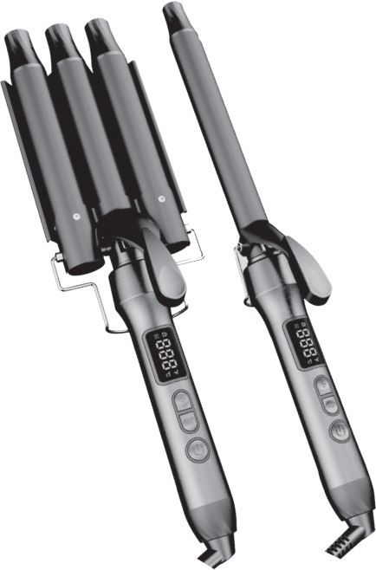


SALON WAVES AT HOME


ANTI SCALDING DESIGN


FAST
HEATING

TEMPERATURE 30s UP to MAX

Dear consumer, Please read these instructions carefully before use in order to avoid damage due to incorrect use and to better understand the functions of this product. Please pay particular attention to the safety guide.
If you pass the device on to a third party, these Operating Instructions must also be handed over.
Please keep them for future references.

IMPORTANT SAFEGUARDS

- Please read these instructions carefully before use.
- Keep present instructions for future references.
- Check that your mains voltage corresponds to that stated on the appliance.
- Only use the appliance for domestic purposes and household or similar applications such as:
-staff kitchen areas, in shops, offices and other working environments;
- Environment type like :
• Farm Houses
• Bed and Breakfast.
-by clients in hotels, motels and other residential type environments;
- Only use the appliance in the way indicated in these instructions.
- WARNING Do not use this appliance near bathtubs, showers, basins or other vessels containing water.
- Never use this apparatus near water projections.
- Never use this apparatus with the wet hands.
- If, unfortunately the apparatus is wet, immediately withdraw the cord of the socket-outlet.
- Inform potential users of these instructions.
- Never leave the appliance unsupervised when in use.
- The appliance must be used only for its intended purpose. No responsibility can be taken for any possible damage caused by incorrect use or improper handling.
- Children and persons with disabilities are not always aware of the danger posed by the use of appliances.
- The appliance is not to be used by persons (including children) with reduced physical, sensory or mental capabilities, or lack of experience and knowledge, unless they have been given supervision or instruction.
- Children being supervised not to play with the appliance.
- This appliance can be used by children aged from 8 years and above and persons with reduced physical, sensory or mental capabilities or lack of experience and knowledge if they have been given supervision or instruction concerning use of the appliance in a safe way and understand the hazards involved. Children shall not play with the appliance. Cleaning and user maintenance shall not be made by children without supervision.
- Keep the appliance and its cord out of reach of children aged less than 8 years.
- This device is not a toy, do not leave small children or people with disabilities to play with.
- WARNING: Do not use this appliance near bathtubs, showers, basins or other vessels containing water.
- In order to ensure your children‘s safety, please keep all packaging (plastic bags, boxes, polystyrene etc.) out of their reach.
- Caution ! Do not allow small children to play with the foil :
there is a danger of suffocation !
- From time to time check the cord for damages. Never use the appliance if cord or appliance shows any signs of damage.
- Never immerse the appliance in water or any other liquid for any reason whatsoever.
- Never place it into the dishwasher.
- Never use the appliance near hot surfaces.
- If the supply cord is damaged, it must be replaced by the manufacturer, its service agent or similarly qualified persons in order to avoid a hazard.
- Disconnect the power source cable before any operation of cleaning of maintenance and accessories assembly.
- Never use the appliance outside and always place it in a dry environment.
- Never use accessories, which are not recommended by the producer. They could constitute a danger to the user and risk to damage the appliance.
- Never use any other connector than the one provided.
- Never move the appliance by pulling the cord. Make sure the cord cannot get caught in any way.
- Never wind the cord around the appliance and do not bend it.
- Ensure that the power cord does not come into contact with hot parts of this unit.
- Make sure the appliance has cooled down before cleaning and storing it.
- The temperature of accessible surfaces may be very high when the appliance is operating. Never touch these parts, of apparatus, to avoid burning itself.
- Make sure the appliance never comes into contact with flammable materials, such as curtains, cloth, etc ... & the power cord and plug do not come in contact with water.
- Before cleaning, always unplug the appliance from the power supply and let it cool down.
- This appliance is not intended to be operated by means of an external timer or separate remote-control system.
- Always place the unit on a flat surface. Ensure, also, not to cover the device and not to put anything on it.
- Always remove the plug from the wall socket when the appliance is not in use.
- When using an extension lead always make sure that the entire cable is unwound from the reel. Use solely CE approved extension leads. Input power must be at least 16A, 250V, 3000W.
- Incorrect operation and improper use can damage the appliance and cause injury to the user.
- This device, designed for home use, complies with standards relating to this type of product.

CAUTION : Plates warm when hair straighteners is on.

GENERAL INFORMATION

The symbol "OPEN BOOK" means a recommendation to read important things contained in the record.

The symbol "BIN" crossed out, abbreviation WEEE (Waste of Electrical and Electronic Equipment) means that at the end of life, it should not be discarded with household waste, but filed to the sorting of the locality. Waste recovery can help preserve our environment.
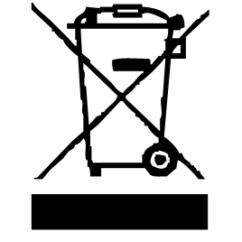

The symbol "CE" is the guarantee of compliance with harmonized European standards, voluntary, reflecting the essential requirements into technical specifications. These standards are not mandatory but are guarantees of compliance with essential requirements.


The symbol ROHS (Restriction of use of some Hazardous Substances) on the Environmental Protection, certifies that for each of the five hazardous substances • Lead • Mercury • (hexavalent) chromium • products for protection against flames PBB and PBDE, the peak concentration is equal to or less than 0.1% of the weight of homogeneous material, and 0.01% for the 6th • cadmium.
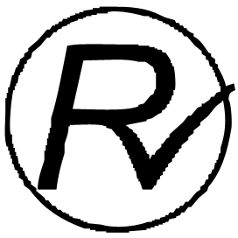

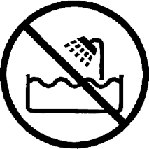
The symbol "DOUBLE SQUARE" means a double insulated. A basic insulation and supplementary insulation. This device requires no connection to the mass of a protective conductor grounded. The materials are said : double insulation class II.


The symbol "TUB / SHOWER" crossed out means to never use the unit in a bathroom, a shower in or near water spray.

The symbol "TRIMAN" indicates that the consumer is invited to dispose the product as part of a separate collection (eg recycling bin, waste, voluntary intake point).


For more information : http://www.quefairedemesdechets.fr

CLEANING AND MAINTENANCE

Before cleaning, Always : switch off the appliance, disconnect the apparatus and let it cool before cleaning.
Clean the outside of the apparatus with a sponge or slightly wet linen.
Never plunge the apparatus in water or all other liquid !
Do not use abrasive cleaners, gritting, or metal brush or another cutting object.

Your hair straightener is equipped with coated ceramic plates for a better heat distribution on whole each plate.

Keep the straightener clean and free of styling products.
- Switch off, unplug and always allow the straightener to cool (at least 30 minutes) before storing or cleaning.
- Do not wrap the mains cable around the straightener when storing or hang by the cable as this may damage the cable in the long term.
- Wipe the outside of the straightener, the ceramic coated plates and cable with a damp cloth to remove any build-up of styling products. Wipe dry. Do not use detergent or abrasives as these may scratch the surface. Never immerse the straightener, cable or plug in water.
- Regularly check the mains cable for wear or damage, particularly where it enters the product and plug. Do not use if damaged.

USE INSTRUCTION

1. Check the switch if it is in midst, this location is stop using, the power indicator winks, that is power off.
2. Plug appliance into suitable voltage then turn on switch to this locating
is operation location, the indicator bright that is on working.
3. When achieving use temperature then push switch to location
then you could use.
4. After blow-dry hair, then use appliance to curl up hair part by part
basipetally.
5. After using, be make sure cut off power, then stay it cooling
normally and store.

CAUTION:

1. Do not use appliance when plug or wire has damaged.
2. Do not use appliance in airtight room ,bed and sofa.
3. Do not use appliance close up water or use in bathroom. 4. When operating appliance ,do not place it on tinder for avoiding fire accident.
5. Do not use appliance close up fire or high temperature location.
6. Do not store appliance when turn on.

ATTENTION

THIS PRODUCT SUITS FOR CRIMP

1. Prohibiting children touching appliance for
avoiding scald.
2. Prohibiting using appliance with wet hands or wet hair.
3. Pls do not place appliance in bathroom or dank condition
for avoiding getting an electric shock or damaging parts.
4. Pls keep some distance between appliance and skin for
avoiding scald.
5. There is some waste heat after using, pls keep it to normal
temperature then store.
6. Pls not touch the surface of appliance for avoiding scald when working. 7. The merchant is not responsible for any equipment problems due to
inappropriate operation by the user.

After reading instruction pls keep a place where could findeasily

1.Pls do not knock down appliance yourselves.
2.Pls do not wash appliance or keep it in dank condition.

GUARANTEE IN ACCORDANCE WITH REGULATIONS

Before being delivered, all our products are subjected to rigorous checks.
This device is guaranteed for 24 months from the date of purchase of the product by the consumer.
The warranty documents are:
• the invoice and
• the warranty certificate (located on the side or the bottom of the box) stamped and completed.
Without these supporting documents, no free replacement or free repair can be made.
During the warranty period, we take charge, free of charge, for defects in the device or accessories, resulting from a defect in materials or workmanship by repair or replacement.
Services under the legal guarantee do not entail any extension of the guarantee period and do not give the right to a new guarantee.
In the event of a warranty claim, return the complete device to your dealer,
in its original packaging, accompanied by proof of purchase.
The breakage of glass or plastic parts is, in all cases, your responsibility.
Wearing parts as well as their cleaning, maintenance or replacement, are not guaranteed. , and are therefore at your expense.
In the event of foreign intervention, the guarantee lapses.

After expiry of the warranty period, repairs can be carried out, against payment, by a specialist dealer or a repair service.

SPECIFICATIONS

Power supply 110-240V~ 50/60Hz
Power 130W
Norm Class II
Made in PRC
The characteristics can change without prior notice

CAUTION: In order to minimize the risks of electric shock, In the event of breakdown, not to open the case but to call upon a qualified technician for repairs.
This apparatus satisfied EC directives, it was controlled according to all the European current directives, like: electromagnetic compatibility (EMC) and low tension (LVD).
This apparatus was designed and manufactured in respect of the last safety regulations and technical specifications.

