

TPF-1366i

CITRUS JUICER

INSTRUCTION MANUAL
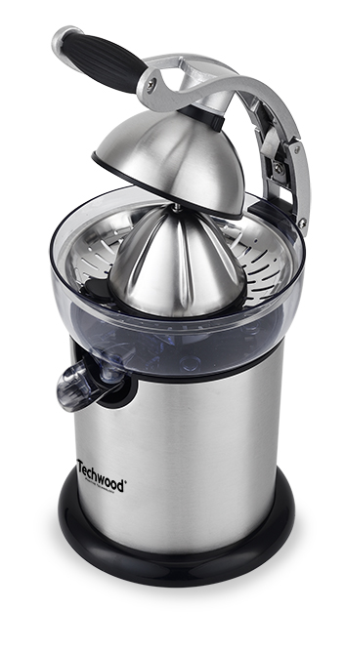

Dear consumer, Please read these instructions carefully before use in order to avoid damage due to incorrect use and to better understand the functions of this product. Please pay particular attention to the safety guide. If you pass the device on to a third party, these Operating Instructions must also be handed over.
Please keep them for future references.

IMPORTANT SAFEGUARDS

- Please read these instructions carefully before use.
- Keep present instructions for future references.
- Check that your mains voltage corresponds to that stated on the appliance.
- Only use the appliance for domestic purposes and household or similar applications such as:
-staff kitchen areas, in shops, offices and other working environments.
- Environment type like :
• Farm Houses • Bed and Breakfast.
- -by clients in hotels, motels and other residential type environments;
-bed and breakfast type environments
- Only use the appliance in the way indicated in these instructions.
- Never use this unit near bathtub, shower, wash-hand basins or other containers with water.
- Never use this apparatus near water projections.
- Never use this apparatus with the wet hands.
- If, unfortunately the apparatus is wet, immediately withdraw the cord of the socket-outlet.
- Inform potential users of these instructions.
- Never leave the appliance unsupervised when in use.
- The appliance must be used only for its intended purpose. No responsibility can be taken for any possible damage caused by incorrect use or improper handling.
- Children and persons with disabilities are not always aware of the danger posed by the use of appliances.
- This appliance can be used by children aged from 8 years and above if they have been given supervision or instruction concerning use of the appliance in a safe way and if they understand the hazards involved.
- This appliance can be used by persons with reduced physical, sensory or mental capabilities or lack of experience and knowledge if they have been given supervision or instruction concerning use of the appliance in a safe way and if they understand the hazards involved.
- Cleaning and user maintenance shall not be made by children unless they are older than 8 and supervised.
- Keep the appliance and its cord out of reach of children aged less than 8 years.
- This device is not a toy , do not leave children or people with disabilities to play with.
- In order to ensure your children‘s safety, please keep all packaging (plastic bags, boxes, polystyrene etc.) out of their reach.
- Caution ! Do not allow small children to play with the foil :
there is a danger of suffocation !
- From time to time check the cord for damages. Never use the appliance if cord or appliance shows any signs of damage.
- Never immerse the appliance in water or any other liquid for any reason whatsoever.
- Never place it into the dishwasher.
- Never use the appliance near hot surfaces.
- If the supply cord is damaged, it must be replaced by the manufacturer, its service agent or similarly Competent qualified person^{(*)} in order to avoid a hazard.
- Always disconnect the appliance from the supply if it is left unattended and before assembling, disassembling or cleaning.
- Never use the appliance outside and always place it in a dry environment.
- Never use accessories, which are not recommended by the producer. They could constitute a danger to the user and risk to damage the appliance.
- Never use any other connector than the one provided.
- Never move the appliance by pulling the cord. Make sure the cord cannot get caught in any way.
- Never wind the cord around the appliance and do not bend it
- Ensure that the power cord does not come into contact with hot parts of this unit.
- Make sure the appliance has cooled down before cleaning and storing it.
- The temperature of accessible surfaces may be very high when the appliance is operating. Never touch these parts, of apparatus, to avoid burning itself.
- Make sure the appliance never comes into contact with flammable materials, such as curtains, cloth, etc...& the power cord and plug do not come in contact with water.
- Before cleaning, always unplug the appliance from the power supply and let it cool down.
- This appliance is not intended to be operated by means of an external timer or separate remote-control system.
- Always place the unit on a flat surface. Ensure, also, not to cover the device and not to put anything on it.
- Always remove the plug from the wall socket when the appliance is not in use.
- When using an extension lead always make sure that the entire cable is unwound from the reel. Use solely CE approved extension leads. Input power must be at least 16A, 250V, 3000W.
- Incorrect operation and improper use can damage the appliance and cause injury to the user.
- This device, designed for home use, complies with standards relating to this type of product.
- WARNING: Potential risk of injuries from misuse.
- Switch off the appliance and disconnect from supply before changing accessories or approaching parts that move in use.
- Regarding the instructions for cleaning surfaces in contact with food or oil, thanks to refer to the below paragraph " CLEANING AND MAINTENANCE " in manual.
- Regarding the instructions for the use of accessories and operation times, please refer to the below paragraphs.

^{(*)} Competent qualified person : after sales department of the producer or importer or any person who is qualified, approved and competent to perform this kind of repairs.

GENERAL INFORMATION

The symbol "OPEN BOOK" means a recommendation to read important things contained in the record.

The symbol "BIN" crossed out, abbreviation WEEE (Waste of Electrical and Electronic Equipment) means that at the end of life, it should not be discarded with household waste, but filed to the sorting of the locality. Waste recovery can help preserve our environment.
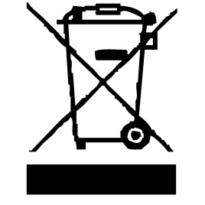

The symbol "CE" is the guarantee of compliance with harmonized European standards, voluntary, reflecting the essential requirements into technical specifications. These standards are not mandatory but are guarantees of compliance with essential requirements.


The symbol ROHS (Restriction of use of some Hazardous Substances) on the Environmental Protection, certifies that for each of the five hazardous substances • Lead • Mercury • (hexavalent) chromium • products for protection against flames PBB and PBDE, the peak concentration is equal to or less than 0.1% of the weight of homogeneous material, and 0.01% for the 6th • cadmium.


The symbol "DOUBLE SQUARE" means a double insulated. A basic insulation and supplementary insulation. This device requires no connection to the mass of a protective conductor grounded. The materials are said : double insulation class II.



The symbol "GLASS / FORK" means that the device is compatible and can come into contact with foodstuffs.

The symbol "TRIMAN" indicates that the consumer is invited to dispose the product as part of a separate collection (eg recycling bin, waste, voluntary intake point).


The symbol "CMIM marking" is the guarantee of compliance with the harmonized Moroccan Standards, optional, which translate the essential requirements into technical specifications. These standards are not mandatory but guarantee compliance with the essential requirements.

CLEANING AND MAINTENANCE

Before cleaning switch off the appliance, always disconnect the apparatus and to let it cool before cleaning.
Clean the outside of the apparatus with a sponge or slightly wet linen.
The parts (removable) in contact with food like plate, bowl, forks, Spatula etc. can be washed in hot water with sponge and soft detergent or put in the dishwasher.
Never plunge the apparatus in water or all other liquid !
Do not use abrasive cleaners, gritting, or metal brush or another cutting object.
Tip-off : Rinse removable parts immediately in clear water to prevent remaining fruits from drying.
Moreover, all removable plastic parts can be rinsed normally.

CLEANING AND MAINTENNCE

Open the storage compartment on the underside of the appliance and take out the juicer cone.

Place the filter in the juicer container.

Fit the juicer cone on to the drive shaft

Push the spout upwards to ensure that the extracted juice remains in the container.

However, the juice may also be collected straight into a suitable container placed under the spout: in this case, the spout must face downwards.

Insert the plug into a suitable wall socket.

Cut the citrus fruit in half and push one of the halves lightly down on to the cone with the cut section facing downwards.

The drive shaft will start rotating automatically once pressure is applied to the cone. The appliance switches off when pressure on the cone is lifted.

When processing larger quantities of fruit, the filter must be emptied from time to time as necessary.

To collect the juice, place a suitable container under the spout. Push the spout downwards. The extracted juice passes now straight into the container. once the desired amount of juice has been collected, push the spout upwards again.

Ensure the plug is removed from the wall socket after use.

GENERAL AND CARE AND CLEANING

Before cleaning the appliance, remove the plug from the wall socket.

To avoid the risk of electric shock, do not clean the Motor base or power cord with water, and DO NOT IMMERSE UNIT IN WATER.

Do not use abrasives, harsh cleaning solutions or hard brushes for cleaning.

Clean the surface of the motor base may be wiped with slightly damp, lint-free cloth.

The attachments should be thoroughly cleaned using warm, soapy water. Rinse well and wipe them dry.
Structure Illustration
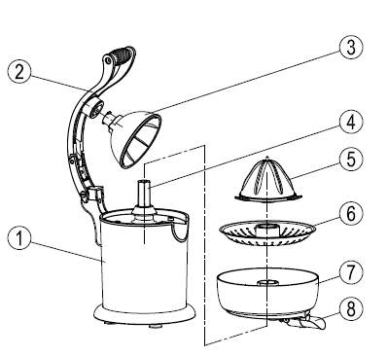

- Main machinery
- Pressure lever
- Cap
- Drive shaft
- Squeezer
- Filter
- Juice container
- Juice outlet

IMPORTANT INSTRUCTION

When using electrical appliances, In order to reduce the risk of fire, electric shock

or injury to persons, Basic safety precautions should also be followed, including the following: Please kindly pay your attention to below points:
- Read all instructions carefully, even if you are familiar with the appliance.
- The electric power supply should come from a properly wired outlet. also,
- Check the capacity of the out and use the appliance separately from other equipment.
Always ensure the voltage to be used corresponds to the voltage stated on the unit.
- Put the electric products in dry and stable flat. Using dried cloth when cleaning the machinery body.
- The appliance is suitable to soft fruits, such as orange etc. And can’t meet the hard fruits so as to avoid being broken because of the over.
- Shut off the electric power for the following happenings:
a. The turning blades working is not correct.
b. The uncommon voice when using.
c. Cleaning.
d. Finish using
- This appliance rate capacity，do not excess this scale on working
- After use unplug from the outlet. ( when unplug , always grasp the plug And unplug it from the outlet. )
- This appliance is designed only for household use

USE

- Unroll the power cord completely.
- Check that the tension in force in the country where you are corresponds to that indicated on the apparatus.
- Connect the apparatus in a correct socket-outlet, (and connected to the ground if the unit is Class I), to avoid any danger.
- Disconnect the power source cable before any operation of cleaning of maintenance and accessories assembly.

Stand the appliance on a table or flat surface.
- Never modify the appliance in anyway.

PRODUCT DISASSEMBLING

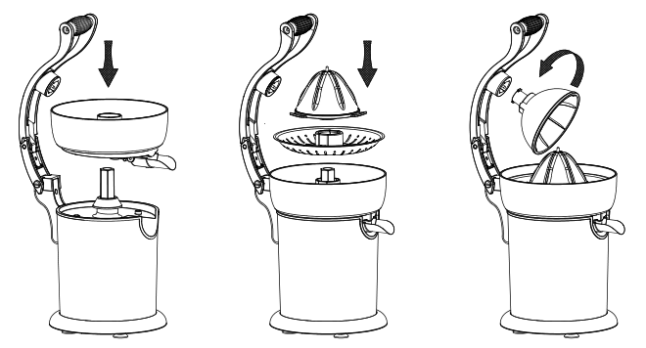

Operate
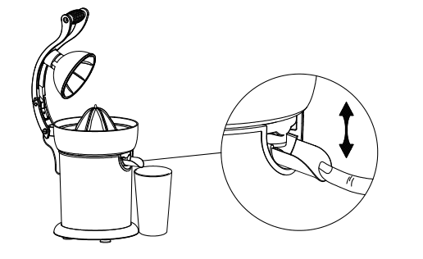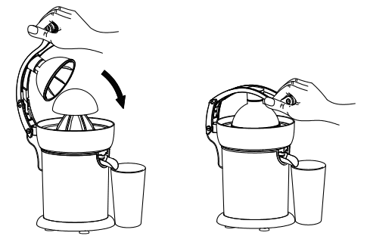
OPERATION

Plug in the appliance.
Cut citrus or Orange fruit in half and press on the cone. The juicer will switch on automatically.
Removal of the squeezed fruit switches off the appliance automatically.

IMPORTANT NOTE: the appliance turns on 15 seconds on and off 15 seconds as a small circle, Totally works 10 circles, then rest for 30 minutes.
Press on the pourer of The juice collector to pour the juice in glass or else posed beforehand below.
After using, the strainer and the cone can be removed.

STORAGE

- Ensure the unit is completely cool and dry.
- Do not wrap the cord around the appliance, as this will cause damage.
- Keep the appliance in a cool dry place.

For periods of non-use, attach the filter and the dust cover to the appliance after cleaning and place the juicer cone in its storage compartment.

GUARANTEE IN ACCORDANCE WITH REGULATIONS

Before being delivered, all our products are subjected to rigorous checks.
This device is guaranteed for 24 months from the date of purchase of the product by the consumer.
The warranty documents are:
• the invoice and
• the warranty certificate (located on the side or the bottom of the box) stamped and completed.
Without these supporting documents, no free replacement or free repair can be made.
During the warranty period, we take charge, free of charge, for defects in the device or accessories, resulting from a defect in materials or workmanship by repair or replacement.
Services under the legal guarantee do not entail any extension of the guarantee period and do not give the right to a new guarantee.
In the event of a warranty claim, return the complete device to your dealer,
in its original packaging, accompanied by proof of purchase.
The breakage of glass or plastic parts is, in all cases, your responsibility.
Wearing parts (for example: motor brushes, hooks, drive belts, spare remote control, spare toothbrushes, saw blades etc.) as well as their cleaning, maintenance or replacement, are not guaranteed. , and are therefore at your expense.
In the event of foreign intervention, the guarantee lapses.

After expiry of the warranty period, repairs can be carried out, against payment, by a specialist dealer or a repair service.

SPECIFICATIONS

Power supply 220-240V~ 50/60Hz
Power 130W
Capacity 400 ml
Norm Class II
Made in PRC

The characteristics can change without prior notice.

CAUTION: In order to minimize the risks of electric shock, In the event of breakdown, not to open the case but to call upon a qualified technician for repairs.

This device complies with EC directives, it was controlled according to all current European directives, applicable such as: electromagnetic compatibility (EMC) and low voltage (LVD).
This device has been designed and manufactured in compliance with the latest regulations and technical requirements for safety.

