

TCA-1386EXN

ELECTRIC AUTOMATIC EXPRESSO MACHINE

Instruction manual
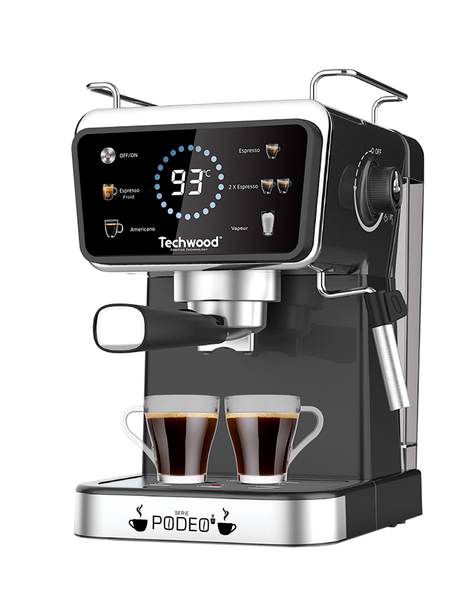

IMPORTANT SAFEGUARDS
Dear consumer, please read these instructions carefully before use in order to avoid damage due to incorrect use and to better understand the functions of this product. Please pay particular attention to the safety guide.
If you pass the device on to a third party, these Operating Instructions must also be handed over.
Please keep them for future references.

- Please read these instructions carefully before use.
- Keep present instructions for future references.
- Check that your mains voltage corresponds to that stated on the appliance.
- Only use the appliance for domestic purposes and household or similar applications such as:
- staff kitchen areas, in shops, offices and other working environments;
- By clients in hotels, motels and other residential type environments;
- Environment type like :
• Farm Houses • Bed and Breakfast.
- Only use the appliance in the way indicated in these instructions.
- Never use this unit near bathtub, shower, wash-hand basins or other containers with water.
- Never use this apparatus near water projections.
- Never use this apparatus with the wet hands.
- If, unfortunately the apparatus is wet, immediately withdraw the cord of the socket-outlet.
- Inform potential users of these instructions.
- Never leave the appliance unsupervised when in use.
- The appliance must be used only for its intended purpose. No responsibility can be taken for any possible damage caused by incorrect use or improper handling.
- Children and persons with disabilities are not always aware of the danger posed by the use of appliances.
- This appliance can be used by children aged from 8 years and above if they have been given supervision or instruction concerning use of the appliance in a safe way and if they understand the hazards involved.
- Cleaning and user maintenance shall not be made by children unless they are older than 8 and supervised.
- Keep the appliance and its cord out of reach of children aged less than 8 years.
- Appliances can be used by persons with reduced physical, sensory or mental capabilities or lack of experience and knowledge if they have been given supervision or instruction concerning use of the appliance in a safe way and understand the hazards involved.
- Children shall not play with the appliance.
- WARNING: The filling aperture must not be opened during use.
- In order to ensure your children’s safety, please keep all packaging (plastic bags, boxes, polystyrene etc.) out of their reach.
- Caution ! Do not allow small children to play with the foil :
there is a danger of suffocation !
- From time to time check the cord for damages. Never use the appliance if cord or appliance shows any signs of damage.
- Never immerse the appliance in water or any other liquid for any reason whatsoever.
- Never place it into the dishwasher.
- Never use the appliance near hot surfaces.
- Do not operate the appliance with a damaged cord or plug, or after the appliance has been damaged in any manner.
- If the supply cord is damaged, it must be replaced by the manufacturer, its service agent or similarly qualified persons* in order to avoid a hazard.
- Disconnect the power source cable before any operation of cleaning of maintenance and accessories assembly.
- Never use the appliance outside and always place it in a dry environment.
- Never use accessories, which are not recommended by the producer. They could constitute a danger to the user and risk to damage the appliance.
- Never use any other connector than the one provided.
- Never move the appliance by pulling the cord. Make sure the cord cannot get caught in any way.
- Never wind the cord around the appliance and do not bend it
- Ensure that the power cord does not come into contact with hot parts of this unit.
- Make sure the appliance has cooled down before cleaning and storing it.
- The temperature of accessible surfaces may be very high when the appliance is operating. Never touch these parts, of apparatus, to avoid burning itself.
- Make sure the appliance never comes into contact with flammable materials, such as curtains, cloth, etc...& the power cord and plug do not come in contact with water.
- Before cleaning, always unplug the appliance from the power supply and let it cool down.
- This appliance is not intended to be operated by means of an external timer or separate remote-control system.
- Always place the unit on a flat surface. Ensure, also, not to cover the device and not to put anything on it.
- Always remove the plug from the wall socket when the appliance is not in use.
- When using an extension lead always make sure that the entire cable is unwound from the reel. Use solely CE approved extension leads. Input power must be at least 16A, 250V, 3000W.
- Incorrect operation and improper use can damage the appliance and cause injury to the user.
- This device, designed for home use, complies with standards relating to this type of product.
- The appliance must be used and rested on a table or flat & stable surface.
- The item must not be left unattended when it is connected to main supply.
- The item is not to be used, if it has been dropped or if there are visible signs of damage or if it is leaking.
- Regarding the instructions for cleaning surfaces in contact with food, thanks to refer to the below paragraph of the manual.
- This appliance is only intended for household use.
- Warning: Potential injury from misuse.
- The heating element surface is subject to residual heat after use.
- The coffee-maker shall not be placed in a cabinet when in use.
- Cleaning and user maintenance shall not be made by children without supervision.

^{(*)} Competent qualified person : after sales department of the producer or importer or any person who is qualified, approved and competent to perform this kind of repairs.

GENERAL INFORMATION

The symbol "OPEN BOOK" means a recommendation to read important things contained in the record.

The symbol "BIN" crossed out, abbreviation WEEE (Waste of Electrical and Electronic Equipment) means that at the end of life, it should not be discarded with household waste, but filed to the sorting of the locality. Waste recovery can help preserve our environment.
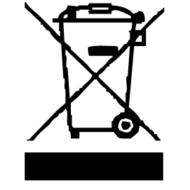
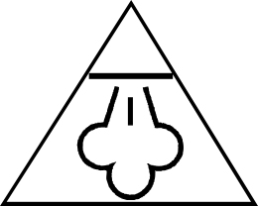
The “STEAM” symbol warns the user that the
steam may come out of the appliance and take all
the necessary precautions. (Risk of burns).

The symbol "CE" is the guarantee of compliance with harmonized European standards, voluntary, reflecting the essential requirements into technical specifications. These standards are not mandatory but are guarantees of compliance with essential requirements.



The symbol "GLASS / FORK" means that the device is compatible and can come into contact with foodstuffs.

The symbol ROHS (Restriction of use of some Hazardous Substances) on the Environmental Protection, certifies that for each of the five hazardous substances • Lead • Mercury • (hexavalent) chromium • products for protection against flames PBB and PBDE, the peak concentration is equal to or less than 0.1% of the weight of homogeneous material, and 0.01% for the 6th • cadmium.
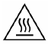
The HOT SURFACE" symbol warns the user that the walls or surface of the appliance can become very hot, and to take the necessary precautions.

The symbol "TRIMAN" indicates that the consumer is invited to dispose the product as part of a separate collection (eg recycling bin, waste, voluntary intake point).


The "CMIM Marking" symbol is the guarantee of compliance with the optional, harmonized Moroccan Standards, which translate the essential requirements into technical specifications. These standards are not mandatory but guarantee compliance with the essential requirements.

For more information : http://www.quefairedemesdechets.fr

CLEANING AND MAINTENANCE

• Always unplug the appliance and allow it to cool before cleaning.
• Clean the outside of the appliance with a slightly damp sponge or cloth.
• The (removable) parts in contact with food such as plate, bowl, fork, spatula etc. ; can be cleaned in warm water with a sponge and washing up liquid
• The accessories and the water tank are not compatible with the dishwasher.
• Never immerse the appliance in water or any other liquid!
• Never use abrasive products, metal brushes or other sharp objects.
• Do not place other parts of your coffee machine in the dishwasher.
• After each use, empty the coffee grounds left inside the collector, and clean it carefully.
• Dry all accessories.

SPECIFIC WARNING FOR THIS TYPE OF APPLIANCE

HIGH PRESSURE

When the machine is running, do not remove the water tank or the filter holder handle.
This is to prevent the steam and/or hot water from causing burns to the body or causing other injuries, and to prevent damage to the appliance.
Before adding water to the tank, turn off the coffee machine by pressing the power button.
When the lights are off, the device is powered off.

HIGH TEMPERATURE

When the machine is working, do not put your hand or other body part under the handle or under the nozzle of the steam tube to avoid burns.
Never touch the steam tube with your hands or other parts of the body. Turn the steam tube touching only the silicone sleeve that surrounds the steam tube.

KNOW YOUR COFFEE MACHINE

1. Tank cover
2. Water tank
3. Steam knob
4. Control panel
5. Top plate
6. Cup plate
7. Steam nozzle
8. Drip tray
9. 1 cup filter
10. 2 cup filter
11. Portafilter
12. Portafilter handle
13. Capsule portafilter
14. Capsule funnel
15. Capsule bracket
16. Coffee spoon

CONTROL PANEL

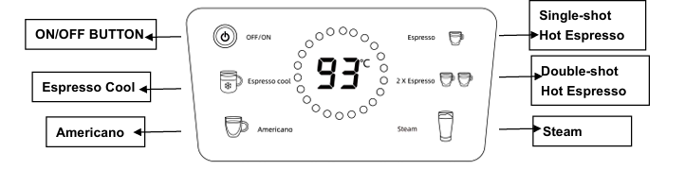

USE

Before operation:

- Ensure that the espresso machine is switched OFF and disconnected from main power socket.
- Hold the carrying handle on the water tank and remove the water tank upwards.
- Fill the tank with fresh and cold water. DO NOT exceed the maximum filing level mark ‘MAX’.
- Reinsert the water tank to ensure that the tank is plugged correctly.
- Insert the filter into the portafilter. Fill the espresso powder into the brewing filter. using the provided measuring spoon. The contact pressure in the brewing filter is as important as the coffee variety and the degree of coffee grinding for a good espresso, in addition to the coffee variety and the degree of grinding of the coffee. Therefore, always make sure that the espresso filter is clean and does not contain any powder residues.

- If the grind is too fine, over extraction and bitterness will occur with a spotted and uneven cream on the top.
- If the grind is too coarse, the water will pass through too rapidly and there will be an inadequate amount of cream on the top of the espresso.
- Add more espresso powder, if necessary, so that the brewing filter is filled up.
- Compress the espresso powder with the tamper again.
- Clean any excess coffee from the rim to ensure proper fit under brew head and avoid leaks.
- The compressing of the espresso powder is an important process for espresso preparation.
- If the espresso power is compressed very tightly, the espresso will run through slowly and there will be more cream.
- If the espresso power is not compressed very tightly, the espresso will run through more quickly and there will be less cream.

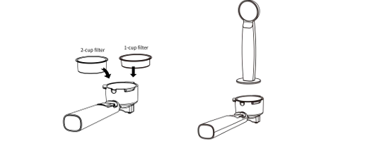

- Secure the portafilter into the brew head. Slide the handle towards to the left, then turn the handle to the right until it locks. Release the handle, the portafilter must seat securely in the brew head and point forwards at a 90° angle.

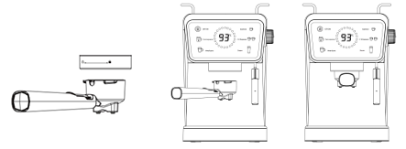

- Place one or two pre-heated cup(s) under the coffee spout.
- After you plug in, press the ON/OFF button, all indicators are stable.
- Cool Espresso: Drop the ice tubes in the water tank, press the “Cool Espresso”, the longest time is 19 seconds.
Tips: Always use iced water for best result.
- Single-shot hot espresso: Press the button, the light is flashing which indicates that the machine is preheating. When the light stops flashing and remains on steadily, the machine is ready to brew coffee and pour coffee, the longest time is 17 seconds.
- Double-shot hot espresso: Press the button, the flashing light indicates that the machine is preheating. When the light stops flashing and remains on steadily, the machine is ready to brew coffee and pour coffee, the longest time is 25 seconds.
Tips: The ideal pour is dark and caramel with reddish reflections.
Tips: After brewing hot espresso, allow machine to cool down for 15 minutes before making cold brew espresso.
- Americano: Press the button, the light is flashing which indicates that the machine is preheating. When the light stops flashing and remains on steadily, the machine is ready to brew coffee and pour coffee, the longest time is 41 seconds.
- Steam: Ability of doing two things with the use of “steam”. You can heat the milk and mix the air with the milk to form a foamy texture. It is needed to be patient in order to reach the perfect milk texturing process.

- Determine how much milk is needed based on the number of cups being made.
Tips: Keep in mind that the volume of milk will be increased during the texturing process.
- Pour cold refrigerated milk into the stainless frothing pitcher, approximately 1/3 full.
- When you press the steam button, it will be flashing. It will be stabilized when it’s ready to be used.
- Clean the water on the steam wand. The steam function will be activated by turning on the steam function and hot water control dial. You can turn the control dial to OFF position when there will be no more water.
- Turn the steam wand to the side of the espresso machine.
- Place the steam wand into the milk so that the nozzle is about a 1cm below the surface and activate the steam function by turning to ON position both the steam and hot water control dial.
- Turn the cup, so that the steam wand “touches” the nozzle of the cup and lower the cup until the tip of the steam nozzle is just below the surface of the milk. A frothing action 6 will be started in the milk.

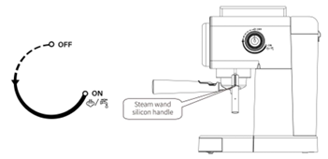

Note: Do not allow the steam to spurt unevenly, because it will create aerated froth/large bubbles. If this is happening, you should raise the cup so that the steam nozzle is lowered further into the milk.
- As the steam heats and textures the milk, the level of the milk in the cup will begin to rise. As this happens, follow the level of the milk by lowering the cup, always keeping the tip of the steam nozzle just below the surface.
- Once the foam is created, raise the cup until the steam nozzle is in the centre of the milk.
Tips: Each drink needs a specific amount of foam. As an example, a cappuccino requires more foam than a latte.
- You must turn off the steam and hot water control dial to stop the steam immediately.
IMPORTANT: Do not boil the milk.
- Remove the cup, wipe the steam nozzle and wand with a clean damp cloth and purge a small amount of steam immediately.

CAPSULE COFFEE MAKING
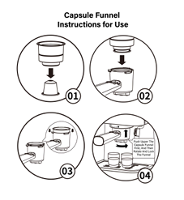

- Put the capsule inside the capsule filter and then press it tightly, set the capsule filter into the capsule portafilter, fix the portafilter into the machine firmly, by turning it right until it is at the LOCK position.
- Place the hot cup (which is your belonging) on removable cup shelf.
- After preheating is completed, you should touch 1-cup, wait for a moment, there will be coffee flowing out. Working time is Max 25s, unit will automatically stop working if no operation within 25s.
- After finishing making coffee, press power button, and all the indicators go out and the coffee maker stops working, your coffee is ready now.
- You can take the metal portafilter out by turning to left, then pour the capsule filter.
- Let them cool down completely, then rinse under running water.

CLEANING AND MAINTENANCE
You must turn off the espresso maker and remove the plug from the electrical outlet during the cleaning process. We highly recommend you not to sink a part of coffee maker in water or in other liquid. To clean, simply wipe with a clean damp cloth and dry before storing.

Filters, portafilter holder and brew head
You must clean well the stainless-steel filters.
The portafilter holder should be rinsed under water immediately after use to remove the coffee remains. Periodically run water through the machine with the portafilter holder in place, but without any ground coffee, to rinse out any lingering coffee remains.
You must use a damp clean cloth to clean and wipe well inside the brew head to remove any coffee remains.

Outer housing, cup warming plate
Do not use any common cleanser or harsh ones to clean the outer cover. You must use a soft and damp cloth to clean the outer cover and the cup warming plate.

Rack on the drip tray
You must remove, clean and empty frequently the little rack, particularly when the drip tray is full. The rack can be washed and rinsed thoroughly in warm soapy water.
Use a non-abrasive washing liquid (do not use abrasive cleansers, pads or cloths which can scratch the surface).

Drip tray
You must remove the drip tray when the rack is removed. And then you must clean it with a soft and damp cloth (do not use any harsh cleansers or scouring agents).
Note: Do not clean any of the parts or accessories in the dishwasher.

Steam wand
You must clean the steam wand, after the milk steaming process.
Use a damp cloth to wipe the steam wand and then turn the steam wand back into the drip tray, directed back into the drip tray, you must momentarily set the steam and hot water control dial to the hot water setting. At that time any remaining milk will be released from inside the steam wand. Make sure the steam wand and hot water control dial is in the OFF position. Turn off the machine, unplug the power cord and allow the machine to cool.
If the steam wand remains blocked, use pin to clean the opening.

Cooling function
You must let the machine cool down, if you want to make coffee again after the milk frothing process or to make coffee again immediately after frothing milk or steam pipe washing process. Otherwise, the coffee will be burnt and splashed. You can proceed in the making of a new coffee after the machine cooling down process. The temperature gets higher after the cleaning of steam pipe and the milk frothing process. To stop the steam function, you must press the specific button. Turn “Steam knob” to be ON and press the STEAM button to release hot water to cool down the appliance. After a while, press the button again and turn off “Steam Knob”. The coffee maker is ready to use it again.

TROUBLESHOOTING

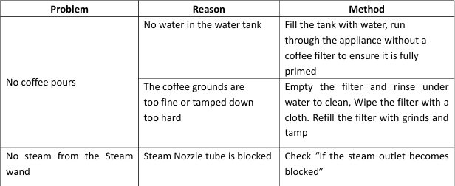

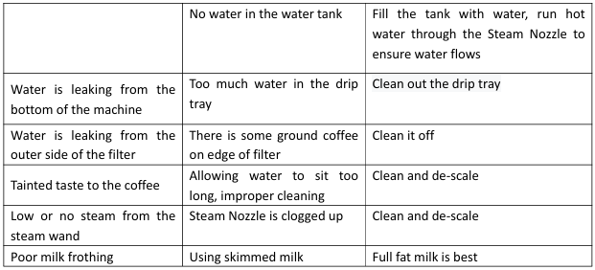

A clean coffee maker is essential for making tasty coffee. It is necessary to clean the coffee maker regularly, as specified in the section
" CLEANING AND MAINTENANCE ".

1. Always use cool or room temperature water when brewing coffee.
2. Store unopened ground coffee in a dry place.
3. After opening, put the ground coffee in an airtight container and store it in the refrigerator to keep its aroma.

STORAGE

-Ensure the unit is completely cool and dry.
-Do not wrap the cord around the appliance, as this will cause damage.
-Keep the appliance in a cool, dry place and out of reach from children.

GUARANTEE IN ACCORDANCE WITH REGULATIONS

Before being delivered, all our products are subjected to rigorous checks.
This device is guaranteed for 24 months from the date of purchase of the product by the consumer.
The warranty documents are:
• the invoice and
• the warranty certificate (located on the side or the bottom of the box) stamped and completed.
Without these supporting documents, no free replacement or free repair can be made.
During the warranty period, we take charge, free of charge, for defects in the device or accessories, resulting from a defect in materials or workmanship by repair or replacement.
Services under the legal guarantee do not entail any extension of the guarantee period and do not give the right to a new guarantee.
In the event of a warranty claim, return the complete device to your dealer,
in its original packaging, accompanied by proof of purchase.
The breakage of glass or plastic parts is, in all cases, your responsibility.
Wearing parts (for example: motor brushes, hooks, drive belts, spare remote control, spare toothbrushes, saw blades etc.) as well as their cleaning, maintenance or replacement, are not guaranteed. , and are therefore at your expense.
In the event of foreign intervention, the guarantee lapses.

After expiry of the warranty period, repairs can be carried out, against payment, by a specialist dealer or a repair service.

SPECIFICATIONS

Power supply 220-240V~ 50/60Hz
Pressure 20 Bar
Power 1350W
Norm Class I
Water capacity 1,5L

Made in PRC
The characteristics can change without prior notice.

EARTHING

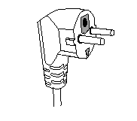
This unit is equipped with an electrical outlet with earth and must be earthed in an according plug.
Note : In the event of question concerning the earth or electric connection, please consult a qualified personnel.
In the event of short-circuit, earthing reduces the risk of
electric shock while making possible the current to be
evacuated by the wire of ground.
CAUTION: In order to minimize the risks of electric shock, In the event of breakdown, not to open the case but to call upon a qualified technician for repairs.
This device complies with EC directives, it was controlled according to all current European directives, applicable such as: electromagnetic compatibility (EMC) and low voltage (LVD).
This device has been designed and manufactured in compliance with the latest regulations and technical requirements for safety.

