

TCA-026N

MULTIPLE CAPSULE COFFEE MACHINE

Instruction manual

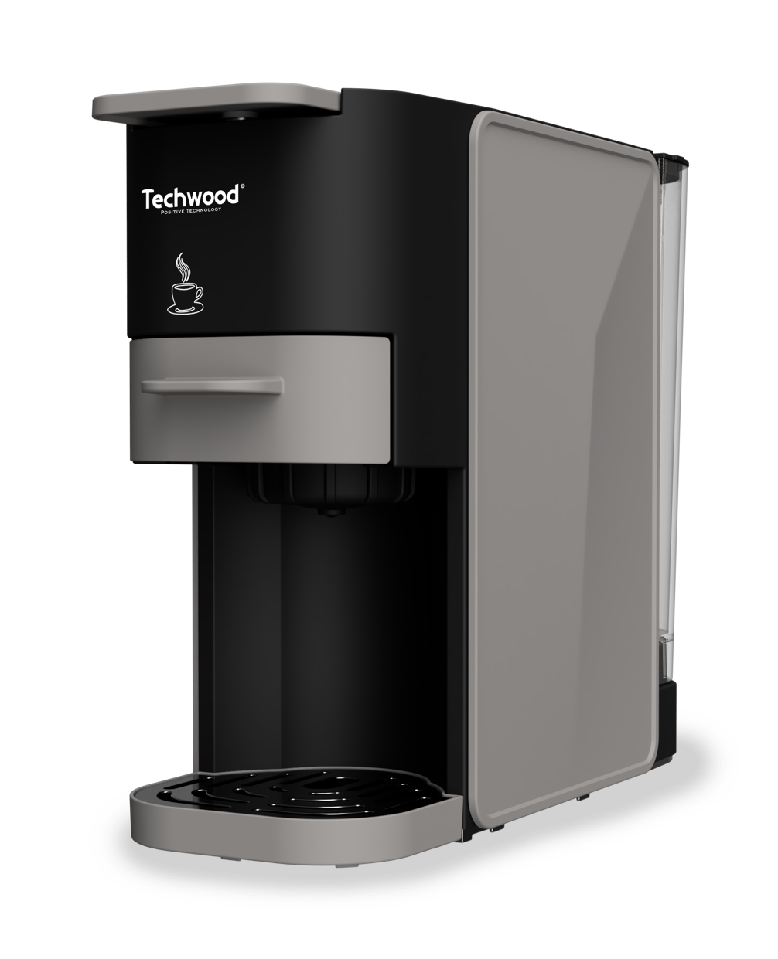
IMPORTANT SAFEGUARDS
Dear consumer, please read these instructions carefully before use in order to avoid damage due to incorrect use and to better understand the functions of this product. Please pay particular attention to the safety guide.
If you pass the device on to a third party, these Operating Instructions must also be handed over.
Please keep them for future references.

- Please read these instructions carefully before use.
- Keep present instructions for future references.
- Check that your mains voltage corresponds to that stated on the appliance.
- Only use the appliance for domestic purposes and household or similar applications such as:
- staff kitchen areas, in shops, offices and other working environments;
- By clients in hotels, motels and other residential type environments;
- Environment type like :
• Farm Houses • Bed and Breakfast.
- Only use the appliance in the way indicated in these instructions.
- Never use this unit near bathtub, shower, wash-hand basins or other containers with water.
- Never use this apparatus near water projections.
- Never use this apparatus with the wet hands.
- If, unfortunately the apparatus is wet, immediately withdraw the cord of the socket-outlet.
- Inform potential users of these instructions.
- Never leave the appliance unsupervised when in use.
- The appliance must be used only for its intended purpose. No responsibility can be taken for any possible damage caused by incorrect use or improper handling.
- Children and persons with disabilities are not always aware of the danger posed by the use of appliances.
- This appliance can be used by children aged from 8 years and above if they have been given supervision or instruction concerning use of the appliance in a safe way and if they understand the hazards involved.
- Cleaning and user maintenance shall not be made by children unless they are older than 8 and supervised.
- Keep the appliance and its cord out of reach of children aged less than 8 years.
- Appliances can be used by persons with reduced physical, sensory or mental capabilities or lack of experience and knowledge if they have been given supervision or instruction concerning use of the appliance in a safe way and understand the hazards involved.
- Children shall not play with the appliance.
- WARNING: The filling aperture must not be opened during use.
- In order to ensure your children’s safety, please keep all packaging (plastic bags, boxes, polystyrene etc.) out of their reach.
- Caution ! Do not allow small children to play with the foil :
there is a danger of suffocation !
- From time to time check the cord for damages. Never use the appliance if cord or appliance shows any signs of damage.
- Never immerse the appliance in water or any other liquid for any reason whatsoever.
- Never place it into the dishwasher.
- Never use the appliance near hot surfaces.
- Do not operate the appliance with a damaged cord or plug, or after the appliance has been damaged in any manner.
- If the supply cord is damaged, it must be replaced by the manufacturer, its service agent or similarly qualified persons* in order to avoid a hazard.
- Disconnect the power source cable before any operation of cleaning of maintenance and accessories assembly.
- Never use the appliance outside and always place it in a dry environment.
- Never use accessories, which are not recommended by the producer. They could constitute a danger to the user and risk to damage the appliance.
- Never use any other connector than the one provided.
- Never move the appliance by pulling the cord. Make sure the cord cannot get caught in any way.
- Never wind the cord around the appliance and do not bend it
- Ensure that the power cord does not come into contact with hot parts of this unit.
- Make sure the appliance has cooled down before cleaning and storing it.
- The temperature of accessible surfaces may be very high when the appliance is operating. Never touch these parts, of apparatus, to avoid burning itself.
- Make sure the appliance never comes into contact with flammable materials, such as curtains, cloth, etc...& the power cord and plug do not come in contact with water.
- Before cleaning, always unplug the appliance from the power supply and let it cool down.
- This appliance is not intended to be operated by means of an external timer or separate remote-control system.
- Always place the unit on a flat surface. Ensure, also, not to cover the device and not to put anything on it.
- Always remove the plug from the wall socket when the appliance is not in use.
- When using an extension lead always make sure that the entire cable is unwound from the reel. Use solely CE approved extension leads. Input power must be at least 16A, 250V, 3000W.
- Incorrect operation and improper use can damage the appliance and cause injury to the user.
- This device, designed for home use, complies with standards relating to this type of product.
- The appliance must be used and rested on a table or flat & stable surface.
- The item must not be left unattended when it is connected to main supply.
- The item is not to be used, if it has been dropped or if there are visible signs of damage or if it is leaking.
- Regarding the instructions for cleaning surfaces in contact with food, thanks to refer to the below paragraph of the manual.
- This appliance is only intended for household use.
- Warning: Potential injury from misuse.
- The heating element surface is subject to residual heat after use.
- The coffee-maker shall not be placed in a cabinet when in use.
- Cleaning and user maintenance shall not be made by children without supervision.
- If the power cord is damaged, it must be replaced by a professional from the manufacturer's maintenance department or other relevant departments to avoid danger.

^{(*)} Competent qualified person : after sales department of the producer or importer or any person who is qualified, approved and competent to perform this kind of repairs.

GENERAL INFORMATION

The symbol "OPEN BOOK" means a recommendation to read important things contained in the record.

The symbol "BIN" crossed out, abbreviation WEEE (Waste of Electrical and Electronic Equipment) means that at the end of life, it should not be discarded with household waste, but filed to the sorting of the locality. Waste recovery can help preserve our environment.
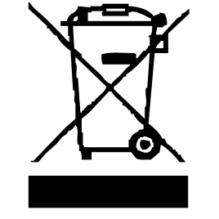

The “STEAM” symbol warns the user that the
steam may come out of the appliance and take all
the necessary precautions. (Risk of burns).

The symbol "CE" is the guarantee of compliance with harmonized European standards, voluntary, reflecting the essential requirements into technical specifications. These standards are not mandatory but are guarantees of compliance with essential requirements.



The symbol "GLASS / FORK" means that the device is compatible and can come into contact with foodstuffs.

The symbol ROHS (Restriction of use of some Hazardous Substances) on the Environmental Protection, certifies that for each of the five hazardous substances • Lead • Mercury • (hexavalent) chromium • products for protection against flames PBB and PBDE, the peak concentration is equal to or less than 0.1% of the weight of homogeneous material, and 0.01% for the 6th • cadmium.

The HOT SURFACE" symbol warns the user that the walls or surface of the appliance can become very hot, and to take the necessary precautions.

The symbol "TRIMAN" indicates that the consumer is invited to dispose the product as part of a separate collection (eg recycling bin, waste, voluntary intake point).


The "CMIM Marking" symbol is the guarantee of compliance with the optional, harmonized Moroccan Standards, which translate the essential requirements into technical specifications. These standards are not mandatory but guarantee compliance with the essential requirements.
For more information : http://www.quefairedemesdechets.fr
CLEANING AND MAINTENANCE

• Always unplug the appliance and allow it to cool before cleaning.
• Clean the outside of the appliance with a slightly damp sponge or cloth.
• The (removable) parts in contact with food such as plate, bowl, fork, spatula etc. ; can be cleaned in warm water with a sponge and washing up liquid
• The accessories and the water tank are not compatible with the dishwasher.
• Never immerse the appliance in water or any other liquid!
• Never use abrasive products, metal brushes or other sharp objects.
• Do not place other parts of your coffee machine in the dishwasher.
• After each use, empty the coffee grounds left inside the collector, and clean it carefully.
• Dry all accessories.

After each use, always make sure plug is removed from the wall outlet. We recommend that the following is performed on a periodical basis.

Cleaning the water tank:
- Hold both sides of the water tank and lift it upward to remove it from the machine.
- Clean and wash with a mild detergent solution, rinse thoroughly and dry with a soft, clean cloth. The water tank and adaptors should be cleaned at least once a week.
Warning: The water tank and adaptors are not dishwasher-safe.

Descaling:
To keep the coffee machine operating efficiently, it’s advisable to descale the machine regularly.
- The coffee machine can be descaled regularly according to personal needs.
- Put the appropriate descaler (about 10g) into the water tank, and fill water up to the "max" limit.
- Turn on the machine by pressing On/off button and wait till the preheat is complete. Position a large capacity cup under the outlet.
- Press and hold the "Small cup" and "Large cup" buttons simultaneously for 3 seconds. The machine starts the descaling mode, water with descaler will go through the internal pipe of the machine and comes out from the outlet. The descaling mode will be stopped until the water tank is empty.
Notice: You could pause the descaling process by pressing the On/off button (there will have a beep sound). Press and hold the On/off button for around 1.5 seconds could return to the standby mode.
- After descaling is completed, if need to repeat, press “Small cup” and “Large cup” buttons simultaneously for 3 seconds to continue descaling.
- Refill the water tank with clean water. Press the large cup button, the pump will starts working and water will begin to dispense to the internal pipe of the machine for cleaning and comes out from the outlet. Repeat the operation 5 times, always with clean water. The descaling cycle is completed.

Cleaning the machine:
- Unplug the machine and let it cool down before cleaning.
- Use a clean, damp cloth or cleaning sponge to wipe down the exterior of the machine and its accessories.
Warning: Never use an alcohol or solvent to clean the machine, and do not immerse it in water for cleaning.

RESET TO FACTORY SETTINGS:
- Make sure the coffee machine is plugged in and turned on.
- Press and hold the small cup button for 5 seconds. All the indicator light will blink intermittently for 5 times, indicating that the machine has been reset.

KNOW YOUR COFFEE MACHINE

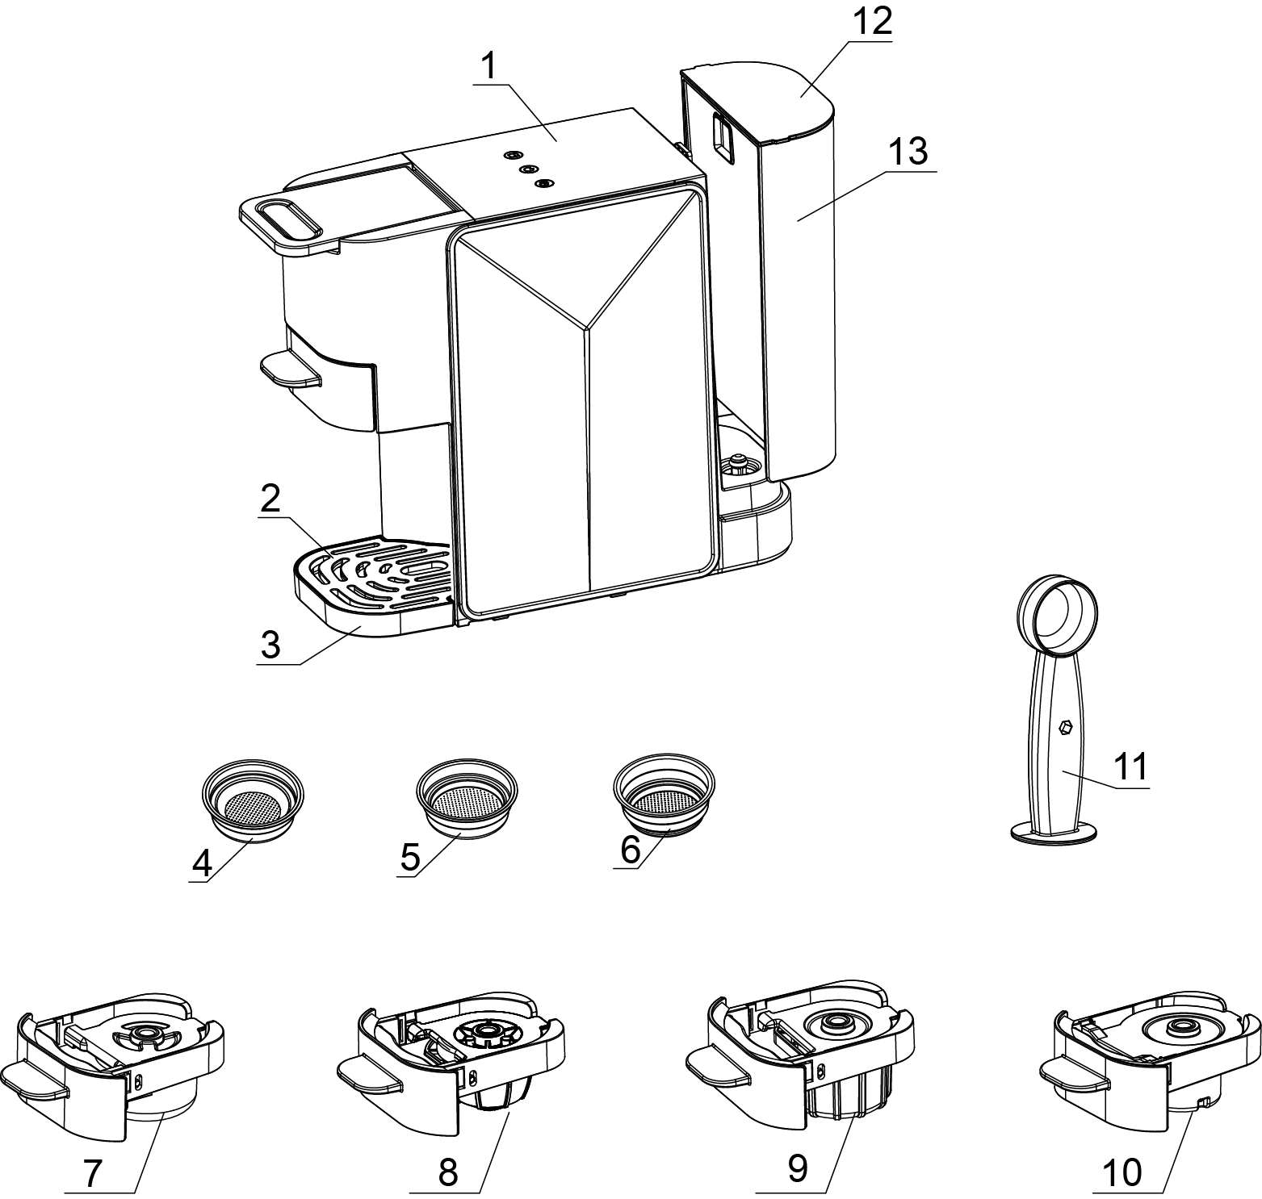
1. Control button
2. Cup mat
3. Drip tray
4. ESE coffee pod filter
5. One cup filter
6. Two cups filter
7. Ground coffee adaptor
8. Dolce Gusto capsule® adaptor
9. Nespresso® capsule adaptor
10. Soft coffee pod adaptor
11. Spoon with tamper
12. Water tank cover
13. Water tank
CONTROL BUTTON INTRODUCTION
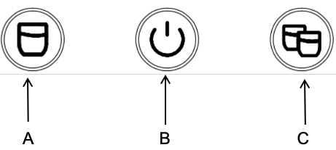

- Small cup B. On/Off C. Large cup

PREPARATION FOR THE FIRST USE:

- Place the machine on a flat and heat-resistant surface.
- Unlock the machine by lifting the handle. Position one of the adaptors at the front of the machine and insert it until the front panels are aligned. Lock the machine by pressing down the handle.
- Fill the water tank with drinkable water at room temperature. Respecting the maximum limit indicated.Or remove the tank from the machine and fill it with water.
Note: When the water tank is removed and inserted, it should be kept vertically up and down. Gently press down the water tank when inserting to ensure that the tank is tightly and correctly connected on to the base.
- Position a large-capacity cup under the outlet.
- Plug the power cord into the outlet. Turn the unit on by pressing the On/off button  to enter into preheat mode, the On/off indicator light will blink intermittently.
- After preheating is complete, all the indicator lights remain lit continuously.The brewing function is activated.
- Press small or large cup button, the pump will start working and water will begin to come out from the outlet.

Cleaning: For first use or after a long period of non-use, it’s advisable to run several times of the brewing function only with water (without adding capsule/coffee powder/pod) to clean the internal pipe of the machine.
- Press the large cup button, the pump will starts working and water will begin to dispense to the internal pipe of the machine for cleaning and comes out from the outlet.
- Pour the waste water out of the cup.
- Repeat the operation as many times as necessary to obtain clean water at the outlet.
- After finishing the cleaning of machine, empty the waster water in the drip tray.
USE
OPERATION：
- Fill the water tank with drinkable water, respecting the maximum limit indicated.
- Plug the power cord into the outlet. Press the On/off button, the On/off indicator light will blink intermittently, indicating the machine is under preheating mode. After preheating is complete, all the indicator lights remain lit continuously.
Each adaptor is associated with a type of capsule, coffee powder or pod.
- Unlock the machine by lifting the handle. Depending on the coffee powder, pod or capsule used, take the appropriate adaptor and position it at the front of the machine and insert it until the front panels are aligned. Then lock the machine by pressing down the handle. Position a cup under the outlet according to below diagram.

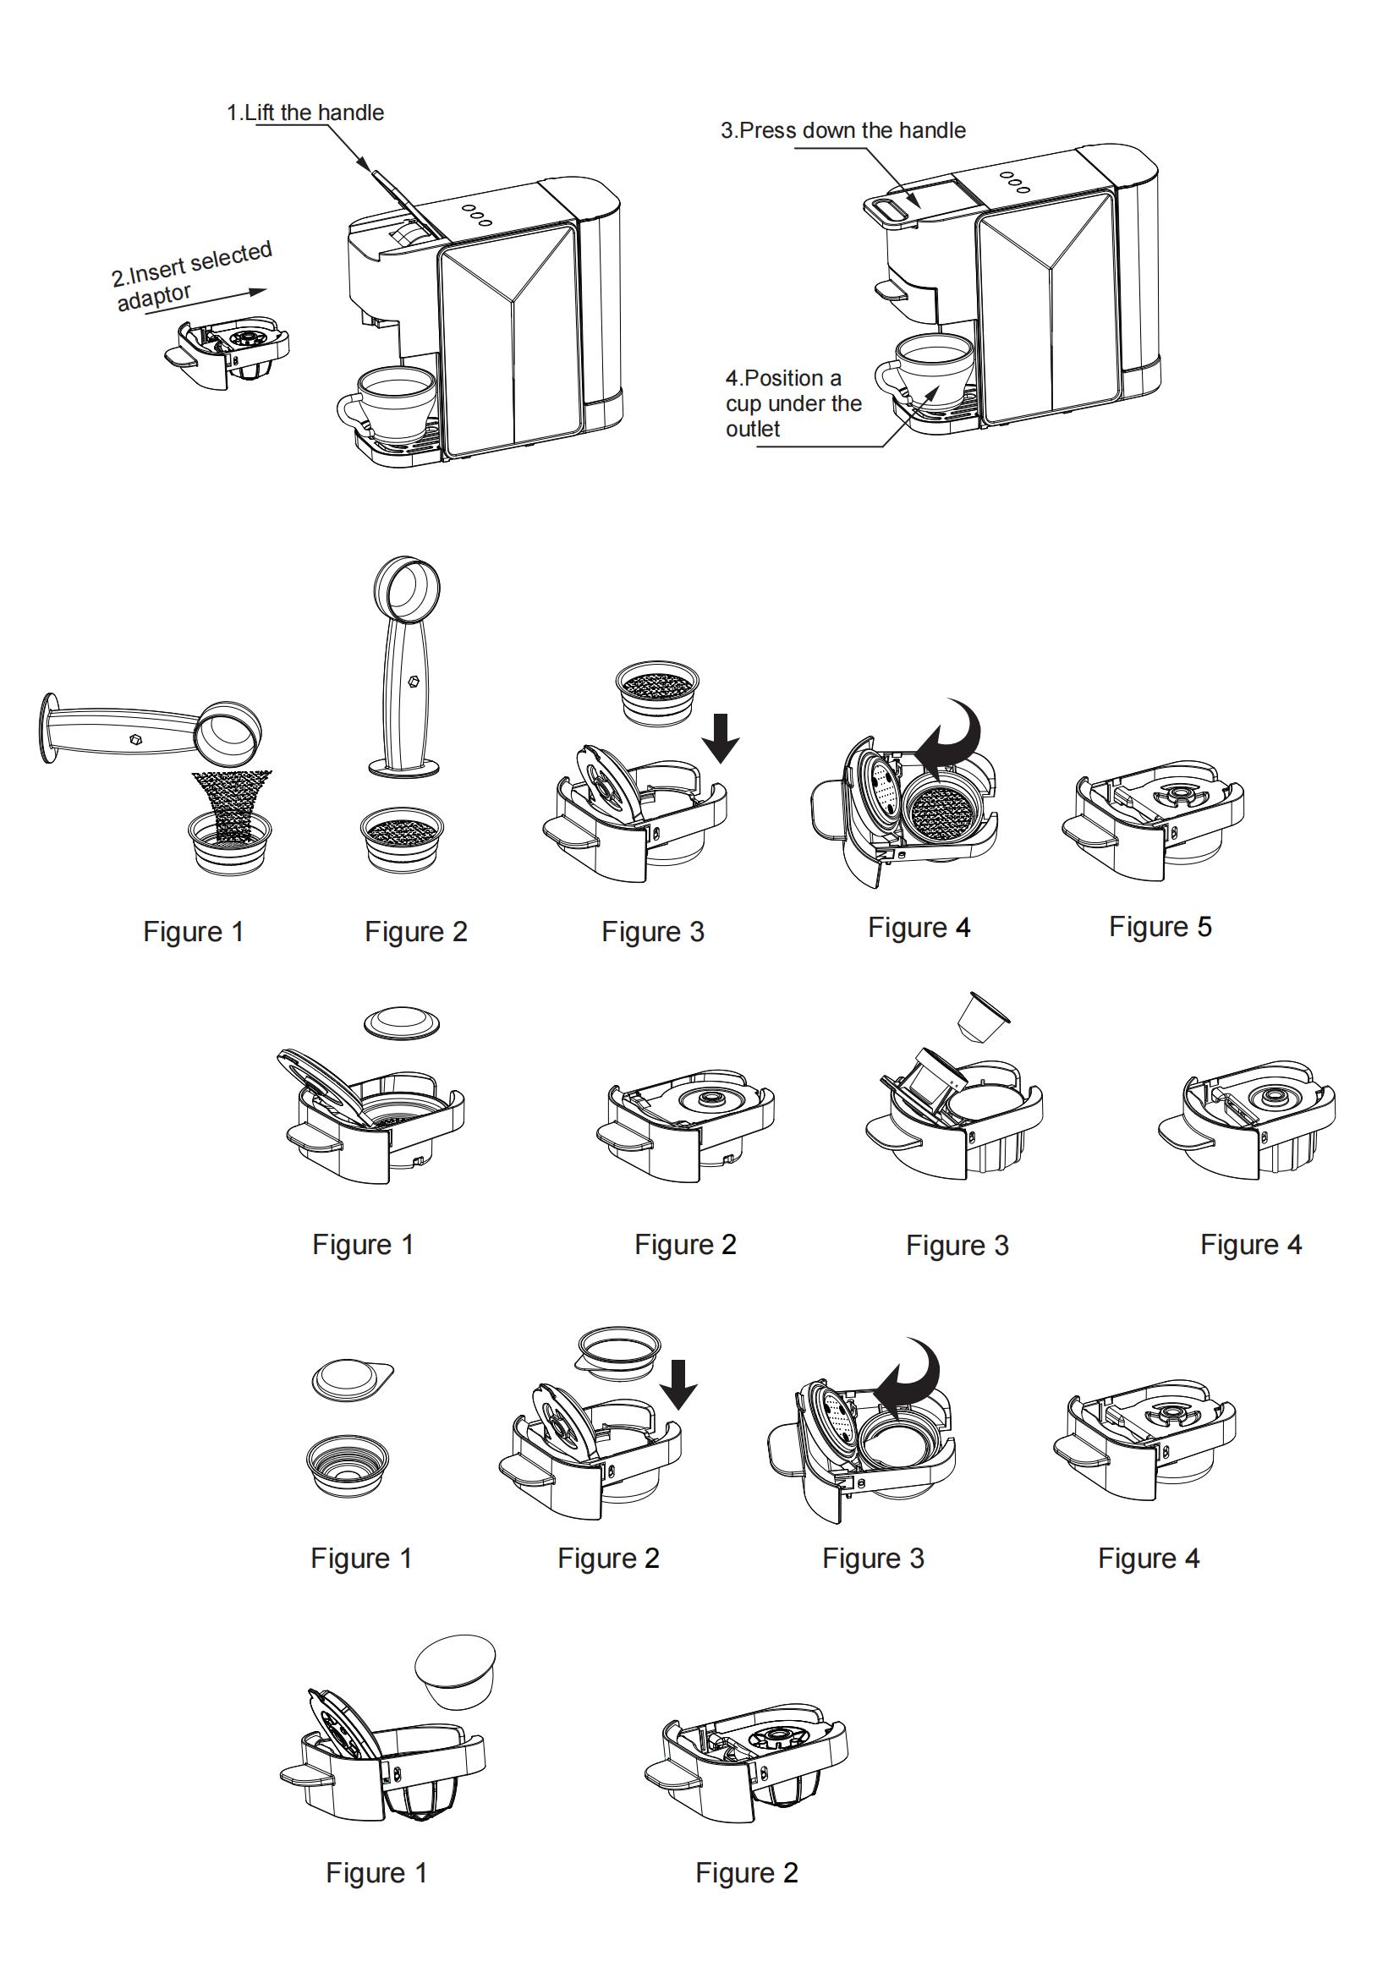
- Press the small or large cup button to start brewing. (By pressing again the selected coffee button could interrupt the brewing process.)
- Press the Small cup button once: If there is no operation within 1.5 seconds after pressing the small cup button once, the machine will start brewing small capacity of small cup as per factory's default setting.
- (Notice: The Small cup indicator light will be fast blinking, the On/off and Large cup indicator lights will remain lit continuously.)
- Press the Small cup button twice continuously: Press the small cup button once and press again within 1.5 seconds （means continuously press for twice）, the machine will start brewing large capacity of small cup as per factory's default setting.
- (Notice: The Small cup indicator light will be slow blinking, the On/off and Large cup indicator lights will remain lit continuously.)
- Press the Large cup button once: If there is no operation within 1.5 seconds after pressing the large cup button once, the machine will start brewing small capacity of large cup as per factory's default setting.
- (Notice: The Large cup indicator light will be fast blinking, the On/off and Small cup indicator lights will remain lit continuously.)
- Press the Large cup button twice continuously: Press the Large cup button once and press again within 1.5 seconds （means continuously press for twice）, the machine will start brewing large capacity of large cup as per factory's default setting.
- (Notice: The Large cup indicator light will be slow blinking, the On/off and Small cup indicator lights will remain lit continuously.)
- Do not lift the handle during the brew cycle to avoid injury. Only lift the handle when all the indicator lights remain lit continuously.
USE OF ADAPTORS:

Use of Ground coffee adaptor:
- Select one cup or two cup filter and fill with certain quantity of ground coffee. (Figure 1)
- Compress the ground coffee by using the tamper. Do not overfill the filter. This might cause clogging or overflow. (Figure 2)
Notice: The maximum amount of ground coffee for one cup filter is 7g. The maximum amount of ground coffee for two cup filter is is 14g.
- Place the filled filter inside the adaptor by aligning the notch of the filter with the notch at the bottom left of the adaptor. Then rotate the filter clockwise. (Figure 3 & 4)
Notice: If the filter is properly inserted, you should be able to turn your adaptor over without the filter falling out.
- Close the adaptor lid. (Figure 5)

Use of ESE coffee pod filter with ground coffee adaptor:
- Place a ESE coffee pod inside the ESE coffee pod filter.
- Place the filled filter inside the adaptor by aligning the notch of the filter with the notch at the bottom left of the adaptor. Then rotate the filter clockwise. (Figure 2 & 3)
Notice: If the filter is properly inserted, you should be able to turn your adaptor over without the filter falling out.
- Close the adaptor lid. (Figure 4)

Use of Nespresso capsule adaptor:
- Open the adaptor lid, insert the capsule to the chamber and press down the capsule by hand to ensure the capsule has been pierced. (Figure 1)
- Close the adaptor lid. (Figure 2)
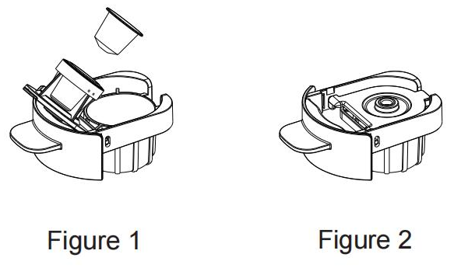
Use of Dolce Gusto capsule adaptor
- Open the adaptor lid, place the capsule into the brewing chamber. (Figure 1)
- Close the adaptor lid, be sure to press firmly when closing the adaptor lid to pierce the capsule. (Figure 2)
Use of Soft Coffee pod adaptor
- Open the adaptor lid, place the coffee soft pod into the brewing chamber. (Figure 1)
- Close the adaptor lid. (Figure 2)

PROGRAMMING THE VOLUME:
- Press and hold the large cup button for more than 1.5 seconds, it will automatically enter the programming mode,the machine rings three times,then release the button. When the desire volume is reached, press the large cup button again, the machine rings once, new volume will be stored. You could adjust the volume according to your personal taste, the settings could stored permanently .
- Press the large cup button again, the programming function will be activated automatically and you can make coffee as your customized volume.

Notice:
- If the large cup button has been pressed and hold for less than 10 seconds, the machine will identify that the programming of volume is unsuccessful, and will return the default factory volume settings.
- Minimum programming time: 10 seconds, maximum programming time: 60 seconds.
- Only the large cup button has the function of programming the volume.
- The programming mode will be canceled when the machine is restored to factory settings, the large cup button will return the default factory volume settings.

RESET TO FACTORY SETTINGS:
- Make sure the coffee machine is plugged in and turned on.
- Press and hold the small cup button for 5 seconds. All the indicator light will blink intermittently for 5 times, indicating that the machine has been reset.

TROUBLESHOOTING

Problem | Cause | Solution
Coffee doesn’t come out. | -There hasn’t enough water in the water tank.  -The water tank hasn’t been installed properly. | -Fill the water tank again.  -Check if it has been installed to the base properly.
Coffee doesn’t come out. | Machine preheating isn’t complete. | Wait for the preheating to complete. All the indicator lights will remain lit continuously.
Coffee doesn’t come out. | The device isn’t turned on. | Check if the machine is plugged in  and press the On/off button.
No coffee grease when brewing espresso | The ground coffee is too thick or too fine. And haven’t been press flattened by tamper. | Replace other kind of ground coffee and press flattened by tamper.
The coffee output is weak or too strong | -Overfill or fill too less of ground coffee.  -There has difference of the capsules of the same batch.  -The coffee pod isn’t positioned correctly. | -Fill the ground coffee according to the standard amount: One cup = 1 spoon, and press it with tamper. The ground coffee should not be too thick or too fine.  - It is normal to have differences in the same batch of coffee capsules.  -Re-position the coffee pod correctly.

STORAGE

-Ensure the unit is completely cool and dry.
-Do not wrap the cord around the appliance, as this will cause damage.
-Keep the appliance in a cool, dry place and out of reach from children.

GUARANTEE IN ACCORDANCE WITH REGULATIONS

Before being delivered, all our products are subjected to rigorous checks.
This device is guaranteed for 24 months from the date of purchase of the product by the consumer.
The warranty documents are:
• the invoice and
• the warranty certificate (located on the side or the bottom of the box) stamped and completed.
Without these supporting documents, no free replacement or free repair can be made.
During the warranty period, we take charge, free of charge, for defects in the device or accessories, resulting from a defect in materials or workmanship by repair or replacement.
Services under the legal guarantee do not entail any extension of the guarantee period and do not give the right to a new guarantee.
In the event of a warranty claim, return the complete device to your dealer,
in its original packaging, accompanied by proof of purchase.
The breakage of glass or plastic parts is, in all cases, your responsibility.
Wearing parts (for example: motor brushes, hooks, drive belts, spare remote control, spare toothbrushes, saw blades etc.) as well as their cleaning, maintenance or replacement, are not guaranteed. , and are therefore at your expense.
In the event of foreign intervention, the guarantee lapses.

After expiry of the warranty period, repairs can be carried out, against payment, by a specialist dealer or a repair service.

SPECIFICATIONS

Power supply : 220-240V~ 50/60Hz
Power : 1350W
Pressure : ≤ 20 Bar
Tank capacity : 700ml
Ambient temperature : 10°C to 40°C
Dimension (l,W,H) : 300 x 135 x 256.5 mm
Net weight : 3,4kg
Norm : Class I
Off mode power consumption: 0.232 W
NOTE: This appliance automatically switches to off mode after 4 minutes and 40 seconds of inactivity.

Made in PRC
The characteristics can change without prior notice.

EARTHING
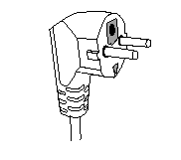
This unit is equipped with an electrical outlet with earth and must be earthed in an according plug.
Note : In the event of question concerning the earth or electric connection, please consult a qualified personnel. In the event of short-circuit, earthing reduces the risk of electric shock while making possible the current to be evacuated by the wire of ground.
CAUTION: In order to minimize the risks of electric shock, In the event of breakdown, not to open the case but to call upon a qualified technician for repairs.
This device complies with EC directives, it was controlled according to all current European directives, applicable such as: electromagnetic compatibility (EMC) and low voltage (LVD).
This device has been designed and manufactured in compliance with the latest regulations and technical requirements for safety.

