

TAN-7055V
TAN-7066V

CARPET AND UPHOLSTERY CLEANER

Instruction manual

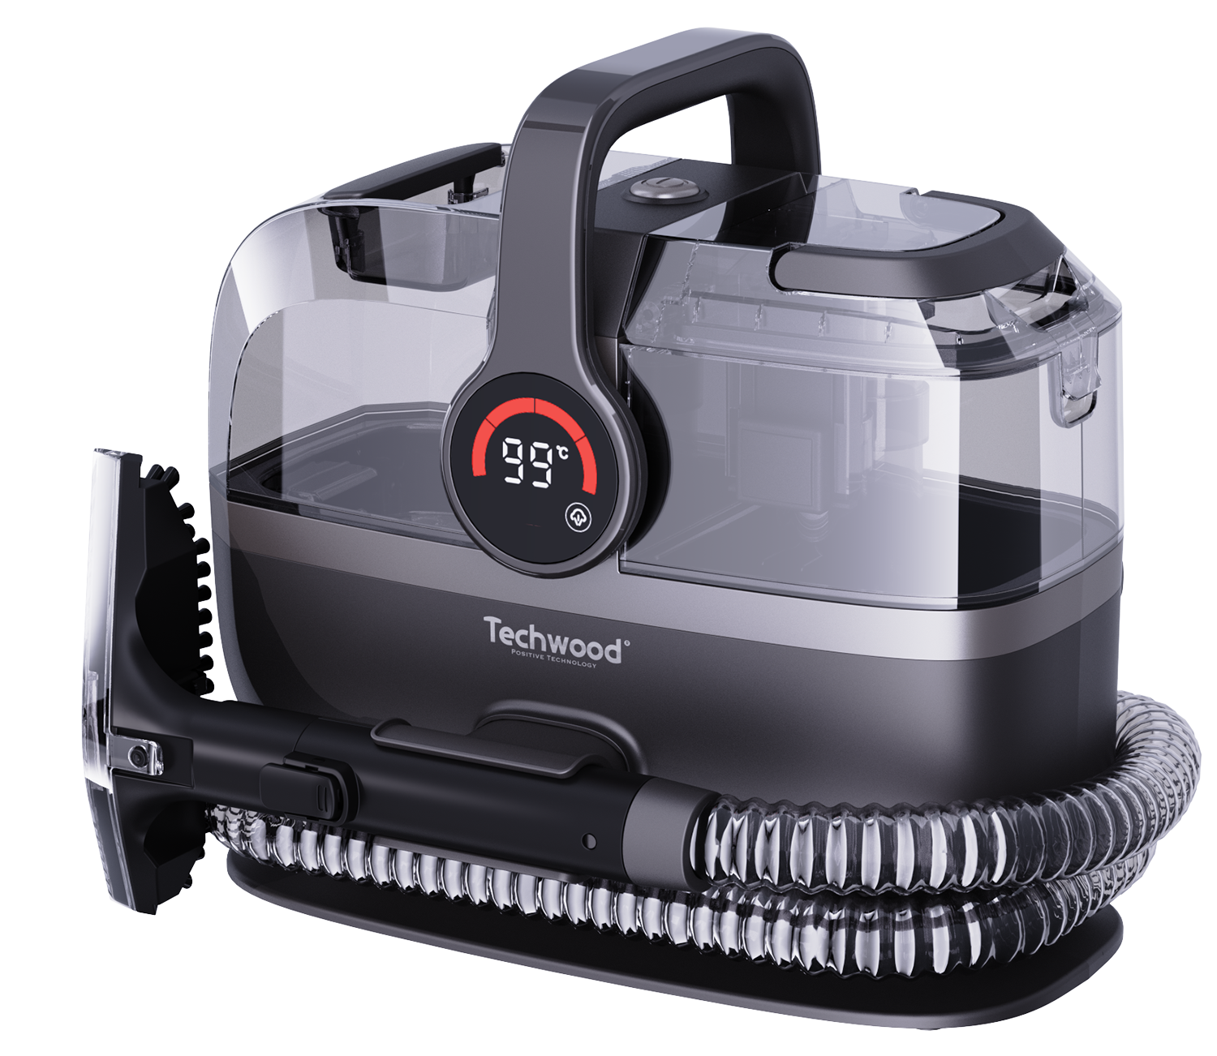
IMPORTANT SAFEGUARDS
Dear consumer, Please read these instructions carefully before use in order to avoid damage due to incorrect use and to better understand the functions of this product. Please pay particular attention to the safety guide.
If you pass the device on to a third party, these Operating Instructions must also be handed over.
Please keep them for future references.

- Please read these instructions carefully before use.
- Keep present instructions for future references.
- Check that your mains voltage corresponds to that stated on the appliance.
- Only use the appliance for domestic purposes and household or similar applications such as:
- Staff kitchen areas, in shops, offices and other working environments;
- By clients in hotels, motels and other residential type environments;
- Environment type like :
• Farm Houses • Bed and Breakfast.
- Only use the appliance in the way indicated in these instructions.
- Never use this unit near bathtub, shower, wash-hand basins or other containers with water.
- Never use this apparatus near water projections.
- Never use this apparatus with the wet hands.
- If, unfortunately the apparatus is wet, immediately withdraw the cord of the socket-outlet.
- Inform potential users of these instructions.
- Never leave the appliance unsupervised when in use.
- The appliance must be used only for its intended purpose. No responsibility can be taken for any possible damage caused by incorrect use or improper handling.
- Children and persons with disabilities are not always aware of the danger posed by the use of appliances.
- This appliance can be used by persons with reduced physical, sensory or mental capabilities or lack of experience and knowledge if they have been given supervision or instruction concerning use of the appliance in a safe way and understand the hazards involved.
- Children shall not play with the appliance.
A hazard may occur if the appliance runs over the supply cord.
- - If the supply cord is damaged, it must be replaced by the manufacturer, its service agent or similarly qualified persons in order to avoid a hazard.
- - The filling aperture must not be opened during use. Follow the manual instructions for the safe refilling of the water reservoir.
- - The appliance has to be unplugged after use and before carrying out user maintenance on the appliance.
- - The liquid or steam must not be directed towards equipment containing electrical components, such as the interior of ovens.
- - The appliance shall not be left unattended while it is connected to the supply mains;
- - The appliance is not to be used if it has been dropped, if there are visible signs of damage or if it is leaking;
- - Keep the appliance out of reach of children when it is energized or cooling down.
- In order to ensure your children‘s safety, please keep all packaging (plastic bags, boxes, polystyrene etc.) out of their reach.
- Caution ! Do not allow small children to play with the foil :
there is a danger of suffocation !
- From time to time check the cord for damages. Never use the appliance if cord or appliance shows any signs of damage.
- Never immerse the appliance in water or any other liquid for any reason whatsoever.
- Never place it into the dishwasher.
- Never use the appliance near hot surfaces.
- Do not operate the appliance with a damaged cord or plug, or after the appliance has been damaged in any manner.
- Disconnect the power source cable before any operation of cleaning of maintenance and accessories assembly.
- Never use the appliance outside and always place it in a dry environment.
- Never use accessories, which are not recommended by the producer. They could constitute a danger to the user and risk to damage the appliance.
- Never use any other connector than the one provided.
- Never move the appliance by pulling the cord. Make sure the cord cannot get caught in any way.
- Never wind the cord around the appliance and do not bend it.
- Ensure that the power cord does not come into contact with hot parts of this unit.
- Make sure the appliance has cooled down before cleaning and storing it.
- The temperature of accessible surfaces may be very high when the appliance is operating. Never touch these parts, of apparatus, to avoid burning itself.
- Make sure the appliance never comes into contact with flammable materials, such as curtains, cloth, etc...& the power cord and plug do not come in contact with water.
- Before cleaning, always unplug the appliance from the power supply and let it cool down.
- This appliance is not intended to be operated by means of an external timer or separate remote-control system.
- Always remove the plug from the wall socket when the appliance is not in use.
- When using an extension lead always make sure that the entire cable is unwound from the reel. Use solely CE approved extension leads. Input power must be at least 16A, 250V, 3000W.
- Incorrect operation and improper use can damage the appliance and cause injury to the user.
- This device, designed for home use, complies with standards relating to this type of product.
- The item must not be left unattended when it is connected to main supply.
- The item is not to be used, if it has been dropped or if there are visible signs of damage or if it is leaking.
- The plug must be removed from the socket-outlet before cleaning or maintaining the appliance.
- Liquid used in water tank: 1700ML max, clean water.
- Regarding the instructions for cleaning, thanks to refer to the below paragraph of the manual.
- This appliance is only intended for household use.

GENERAL INFORMATION

The symbol "OPEN BOOK" means a recommendation to read important things contained in the record.

The symbol "BIN" crossed out, abbreviation WEEE (Waste of Electrical and Electronic Equipment) means that at the end of life, it should not be discarded with household waste, but filed to the sorting of the locality. Waste recovery can help preserve our environment.
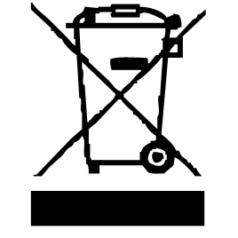

The symbol "CE" is the guarantee of compliance with harmonized European standards, voluntary, reflecting the essential requirements into technical specifications. These standards are not mandatory but are guarantees of compliance with essential requirements.


The symbol ROHS (Restriction of use of some Hazardous Substances) on the Environmental Protection, certifies that for each of the five hazardous substances • Lead • Mercury • (hexavalent) chromium • products for protection against flames PBB and PBDE, the peak concentration is equal to or less than 0.1% of the weight of homogeneous material, and 0.01% for the 6th • cadmium.

WARNING: BURN HAZARD.

• During operation, the temperature of the appliance surface may be hot.
• The heating parts remain hot, long time after stopping the machine.
• The symbol "Hot Surface" warns the user that the apparatus walls may become hot, and to take precautions.

The symbol "STEAM" warns the user that steam can escape from the unit and to take all necessary precautions. (Risk of burns)
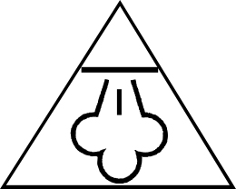

The symbol "TRIMAN" indicates that the consumer is invited to dispose the product as part of a separate collection (eg recycling bin, waste, voluntary intake point).

For more information : http://www.quefairedemesdechets.fr

WARNING

- Please switch off the appliance before filling it with water.
- This product is used to remove dirt by scrubbing. The water tank should not be filled with tap water of more than 40 degrees and aqueous solution of alkaline ions
- Art crafts, water-weak fibers (silk, models, rayon and copper-ammonia silk fabrics, etc.), water-weak products (fur, leather products, soft clothing, solid wood furniture, lacquered wood products, lacquerware, etc.),
Other easily scratched surfaces (floor, tabletop, etc.) should not be used
- Do not tilt or drop the host when it is filled with water. This may cause water leakage and wet the floor
- There are too many bubbles in the recycling box, please stop using it when it exceeds the water level and dump the sewage, otherwise it may lead to failure
- When using detergent (not include), the low foaming detergent (not include) can be used 20 times diluted, smeared on the cleaning object after use
- When using detergent (not include), please confirm whether it will affect the cleaning object before using
- If the body is placed on a woolen blanket, it may cause the vent to be blocked and the machine to stop running
- Do not inhale the following objects
- lots of garbage
- Lots of sand and pebbles
- Dry dust
- Sharp gold, as of a pin or tack Genus, glass, etc
- Large volume of garbage
- Plastic bags, stockings, silk stockings, etc
- An object that is easily plugged internally
- Do not inhale dry dust. The vacuum of this product is wet, so it may cause failure
- After use in cold areas, be sure to discharge the residual water in the recycling box, cleaning tank, vacuum area and hose. Please keep the cloth frozen, such as frozen May damage the product
- In the process of inhalation, if the recycled material in the hose is blocked, please directly turn off the power and remove the blockage, otherwise it may lead to failure

About Consumables
- Be sure to install it before use
- If damaged, lost, please replace the new consumables

About Protection Device
- Continuous use, in the case of blocked exhaust leads to motor overheating when the protection device starts, even when the power will be switched on
- After the protection device works
- Power switch [off] on the host, unplug the power cord
- Place in shade
- About 1 hour later, the protective device is removed and can continue to use

SAFETY INSTRUCTIONS

To prevent injury to persons and/or property, please ensure that the following safety instructions are read and followed carefully.

- Keep hair, loose clothing, and fingers away from moving parts of the machine to avoid injury.
- In the event of a machine malfunction, stop using it immediately and turn off the power.
- Refer to the manual or consult customer service if you notice any abnormal sounds or odors.
- DO NOT touch the appliance with wet hands.
- DO NOT use pesticides, hair dyes, lubricants, or any other liquids other than the recommended YDC cleaning detergent.
- DO NOT damage the appliance in any way.
- DO NOT be used by children or disabled persons.
- DO NOT use the machine if there is any sign of damage to the electrical outlet. • DO NOT use the machine without both the detergent tank and the dirty water tank attached.
- DO NOT allow the machine to get wet.
- DO NOT use the machine if the electrical cable is damaged.
- DO NOT disassemble or attempt to repair it yourself.
- DO NOT modify the machine in any way.

Symbol | Explain |  | Symbol | Explain
 | Caution |  |  | Please check the manufacturer’s label before cleaning the fabric. The label has the world ‘W’ indicating that you can use this cleaning machine.
 | Refer to the user manual |  |  | This symbol on the product and/or accompanying documents indicates that used alactrical and electronic products should not be mixed with general household waste. For proper handling, recycling, and reuse, plese bring this product to the designated collection point.  Please contact the local government for detailed information on the designed collection point closest to you
 | Fire risk
 | Electric shock risk
 | Do not get wet |  |  | 10 seconds steam preparation is complete.
 | Please store indoors |  |  | Warning: Risk of burns, steam.
 | Do not let the carpet become excessively damp |  |  | Steam + water combination
 | Please cut off the power before repairing |  |  | Liquid
 | Attention : surface high temperature |  |  | Small arear carpets, Small area cleaning mode.
 | Dry the components |  | 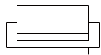 | Upholstered furniture
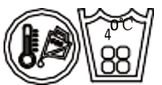 | Use warm water that does not exceed 40°C |  | 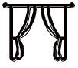 | Curtain
 | Locked |  |  | Clean tiles and tile joints
 | Do not freeze |  |  | Clean your sneakers

CAUTION

- Do not use this device to remove flammable or combustible liquids (such as gasoline) or in areas where flammable or combustible liquids may be present.

- Do not pick up hard or sharp objects, such as glass, nails, screws, coins, etc. Always connect to a properly grounded power outlet. Do not modify the ground plug.

- Do not use to remove toxic substances (chlorine bleach, ammonia, sewer cleaner, etc.).
- Do not use this device in a confined space filled with vapors from oil-based paints, paint thinners or certain mothproof substances, combustible dust or other explosive or toxic vapors.

- Do not use to clean burning or smoking objects, such as cigarettes, matches, or hot ash.

- Stay away from the rain. Please store it indoors.

- Do not introduce liquids into equipment containing electrical components

- Use only the type of liquid specified in the operation section of this manual, and the dosage should comply with the regulations.

- Always install a float before performing any wet pickup operation.

- Liquids and vapors must not enter directly into people, animals or equipment containing electrical components, such as the inside of ovens.

- Do not use on sanitizer leather, wax-polished furniture or floors, synthetic fabrics, velvet or other fragile steam-sensitive materials.

- Do not immerse in water. Use this device only on surfaces that are wet during cleaning. Use only the best cleaning products specially designed for this device.

- Prevent accidental start-up. Before picking up or moving the device, ensure that the switch is turned off. Holding finger on switch or turning on powered device while picking up or handling can cause an accident

- Danger may occur if the device depresses the power cord.
When using steam cleaning, do not turn over the steam nozzle or touch the nozzle surface.

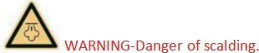
- Do not touch the steam nozzle or its adjacent surface while steam cleaning or heating.
- Do not open the filling hole when using.
- Do not use when the power cord or plug is damaged. Keep the device on a level surface.
Beware of slippery ground.
- Please keep this safety notice for future reference
Original specification
It is only suitable for operation under 220-240V 50/60Hz AC power supply.
- This model is for home use only. Important information
- To reduce the risk of leakage, do not store in areas where freezing may occur which may cause damage to internal components.
- Store in a dry area of the room where the product is unlikely to be damaged.
- Plastic water tank is not suitable for dishwasher, do not put the water tank in the dishwasher.
DESCRIPTION

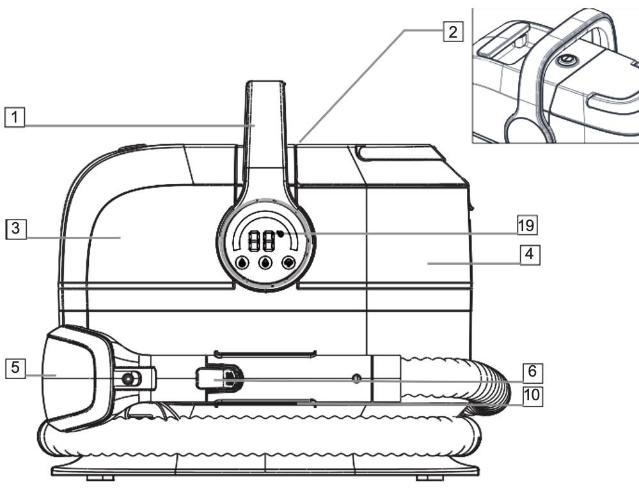  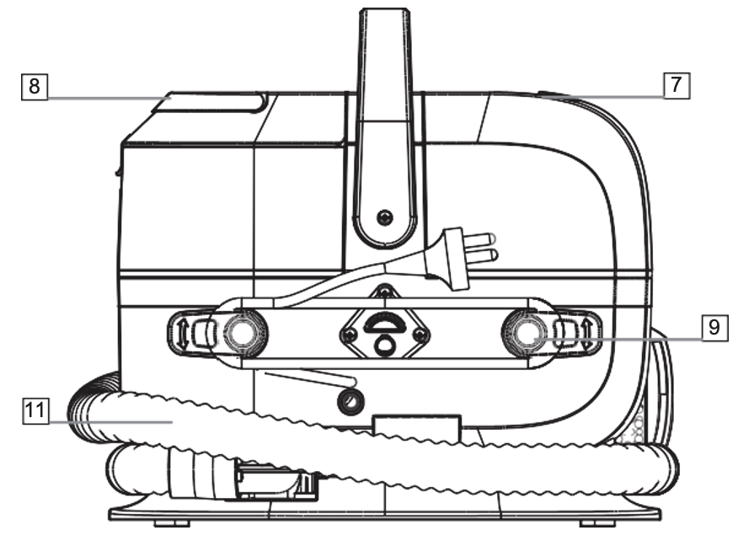 | - Carry handle  - ON/OFF button  (located under handle)  - Clean water/solution tank  - Dirty water tank  - Wash tool  - Wash tool release button  - Dirty water tank handle  - Clean water tank handle  - Quick cord release hook  - Handle storage clip  - Hose  - Crevice tool (don’t use when turn to steam function)  - Large window brush assembly  (Optional) (Not provided)  - Seven inch 2-in-1 brush  Assembly (Optional)  - Handle storage clip  - Digital Display
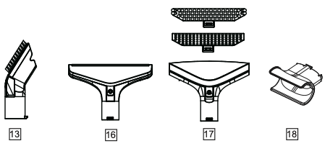

QUICK START

1 Assembly  Slide the wash tool into the hose end until it clicks properly  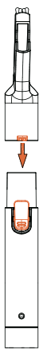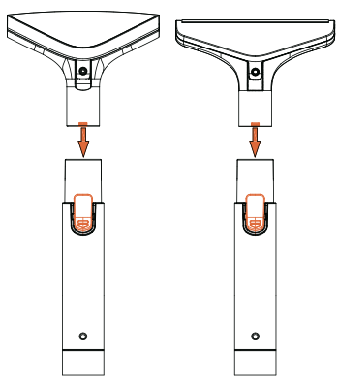 | 2 Assembly  Take the holder and position it in the recess on the front of the unit then push it in hard until it locks in place.  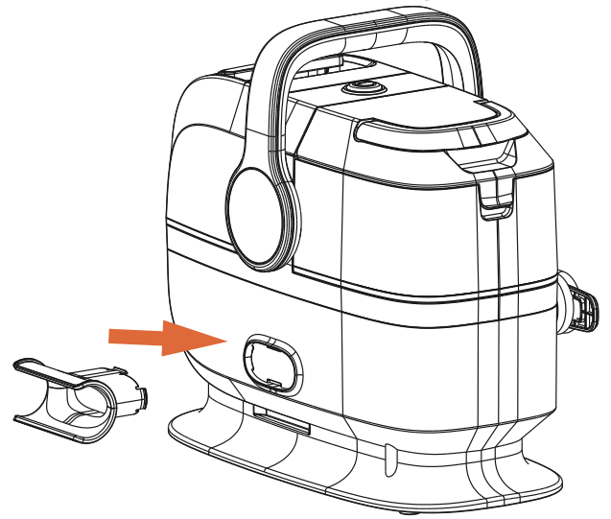
3 Getting started  Fill the clean water tank with warm water (max 40°C) and with soap.  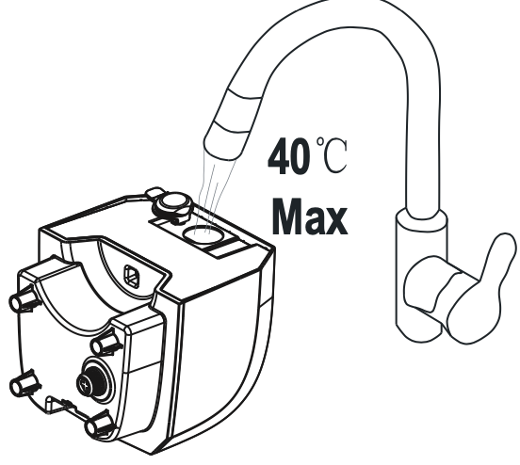 | 4 Operation  Press On/Off button to switch the machine on.  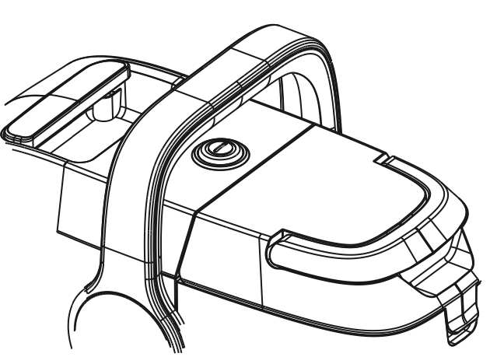

IMPORTANT

- Read this instruction booklet carefully.
- Before using the appliance, check that the mains power voltage corresponds to the voltage shown on the rating plate.
- Always remove the plug from the power sock before opening the appliance.
- Never use methylated spirits or other solvents to clean the appliance.
- Never leave the appliance unattended when it is switched on.
- Keep the device out of reach of children and persons with disabilities.
- This unit is for household use only. Use as described in this instruction booklet.
- Never use the device if it appears to be defective in any way.
- For repairs or accessories. Contact your dealer or an authorized service centre.

IMPORTANT: TEST all carpets/rugs/upholstery/hard floors before use. Before using the machine to clean dried on stains and dirt, the surface should be vacuumed thoroughly.
Test for colorfastness - Wet a white absorbent cloth with the solution. In a small hidden area of
the surfaces to be cleaned, gently rub with the dampened cloth. Wait ten minutes and check for colour removal or bleeding with a white paper towel or cloth. Check all surfaces to be cleaned and if the surface has more than one colour, check all colours.
Test the spot washer on a small hidden area - If no damage or pile distortion occurs continue cleaning. When using the spot washer, basic safety precautions should always be observed
and don't oversaturate your carpets/rugs/upholstery/hard floors. Not suitable for use on water sensitive flooring/surfaces. Only use with Spot Washer Cleaning Solution or Spot Washer Antibacterial Cleaning Solution. Using other solutions may cause excess foaming and will invalidate the guarantee. The clean water/solution tank should only be filled with warm water (max 40°C). Filling the clean water/solution tank with hot/boiling water will damage the spot washer and invalidate the guarantee.

Otherwise, take a soft bristle brush (sold commercially) and add water and a solution for carpets and hard floors (you can find out in stores) and rub manually to remove hard stains and vacuum with the Cleaner/Stain Remover.

USE

• Unwind the power cord completely.
• Check that the voltage in the country where you are, corresponds to the voltage indicated on the device.
• Connect the appliance to a good electrical outlet, (earthed if the appliance is class I), to avoid any danger.
• Disconnect the power cable from the power supply before performing any maintenance cleaning and accessory fitting.
• Never modify the device.

ASSEMBLY

FILLING THE CLEAN WATER / SOLUTION TANK

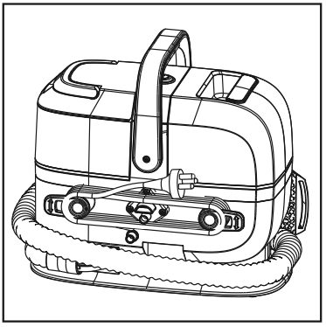 | 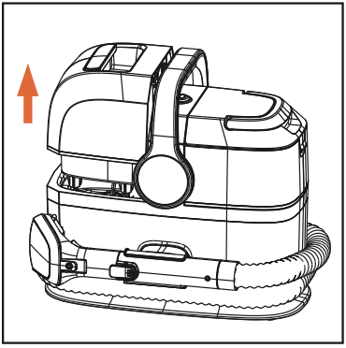 | 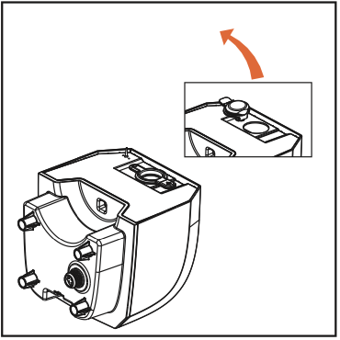
Wrap the cord around the quick cord release hooks | Remove the Clean Water Tank by grasping the handle with your fingertips then slide  the water tank straight up and out. | Rotate the Water Tank so that the water filling hole is facing upward then remove the rubber plug from the filling hole.

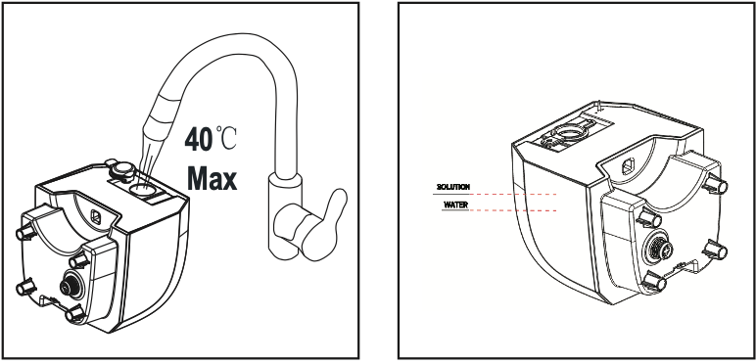 | 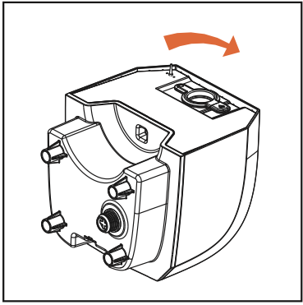 | 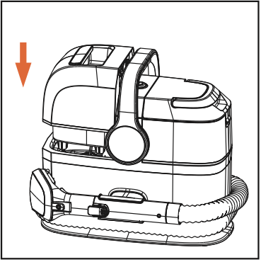
Fill the tank with warm water (max 40°C) and solution to the desired clean level, indicated by the lines on the tank. | Push the Rubber plug back it to the filling hole ensuring it is sealed properly. | Refit the clean water/ solution tank onto the machine so it clicks into place.
USING YOUR MACHINE

FUNCTION INTRODUCTION

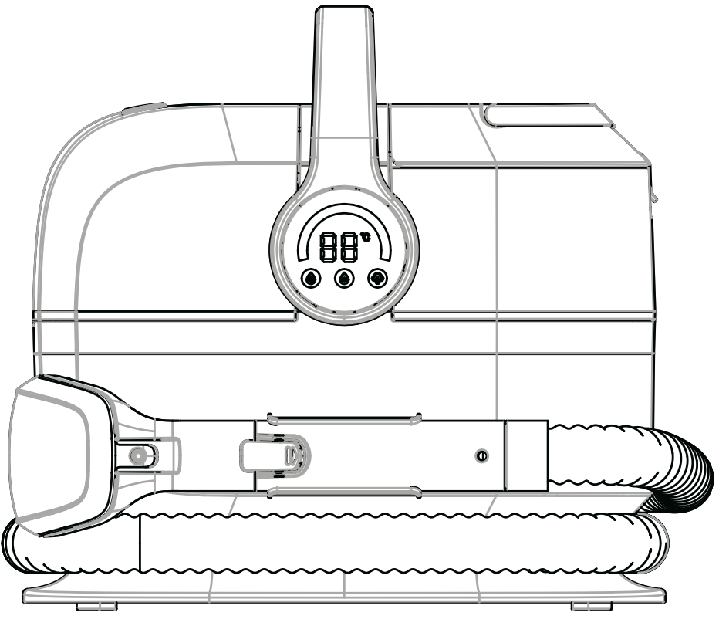

Cleaning mode |   Cold water cleaning mode |   Warm water cleaning mode |   Steam cleaning mode
Cleaning method | Spray normal temperature water | Spray warm water | Spray steam
Button display description | The green light is constantly on, displaying real-time temperature; | During preheating, the yellow light shows a breathing state, displaying a preheating temperature of 50°C; The yellow light remains on after preheating is completed | During preheating, the red light shows a breathing state, displaying a preheating temperature of 99°CThe red light remains on after preheating is completed;
Button function description | Water and low-foaming detergent (not included).. wash away daily stains and dirt. | Quickly and effectively remove stains,  rejuvenate and clean carpets and indoor fabric decorations. | Steam quickly and effectively  penetrates stubborn stains and removes them.
USING YOUR MACHINE

OPERATION

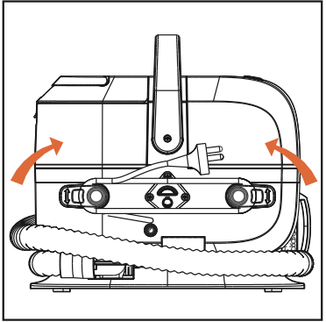 | 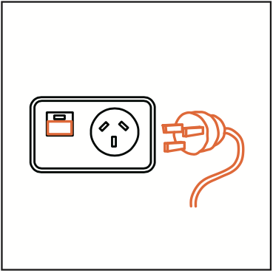 | 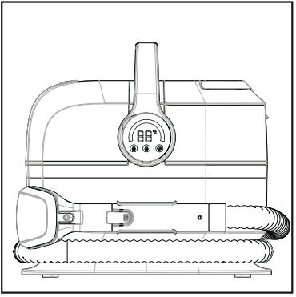
Turn the quick release hooks and remove the cord from the clips. | Plug the machine into the mains and switch on. | Pull to remove the wash tool and hose from the storage clip.

USING THE TOOLS

- 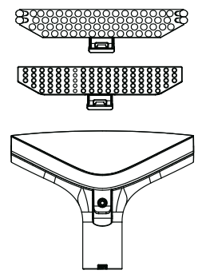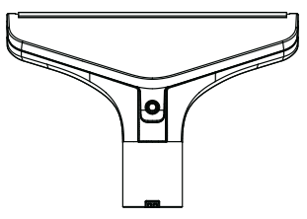
Select a tool/attachment.

Large window brush assembly A Used for cleaning tiles and sealing wooden floors glass doors and Windows

Seven inch 2-in-1 brush assembly

A) multipurpose brush for cleaning carpets, rugs, sofas and upholstery.
B) Pet hair cleaning

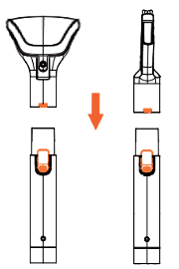 | 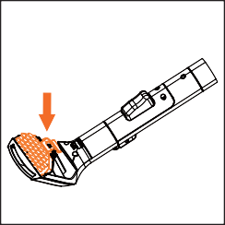 | 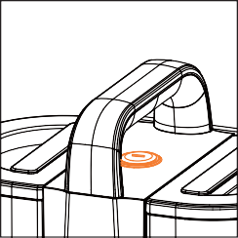
Press the tool lock button and slide the tool onto the end of the hose, over the nib. Release the button when in place. | To fit an attachment to the wash tool, fit the front of the selected attachment into the front of the wash tool and push the clip down to click into place. | Press the on/off button to switch the machine on.
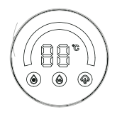 |  | Normal temperature water
 |  | Hot water
 |  | Steam
 |  | Touching the desired mode

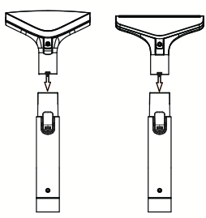 | 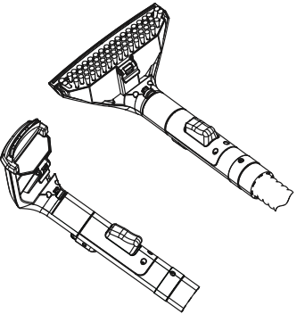
Press the tool lock button and slide the tool onto the end of the hose, over the nib. Release the button when in place. | To fit an attachment to the wash tool, fit the front of the selected attachment into the front of the wash tool and push the clip down to click into place.

USING THE EXTRA WIDE 2-IN-1 WASH TOOL / MESSY CLEAN UP TOOL

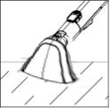 | 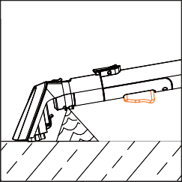 | 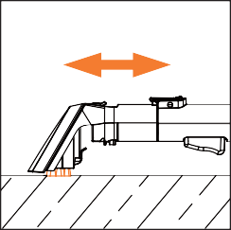 | 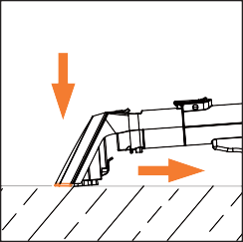
For spills, always pick up the excess liquid before using water/solution.  Tilt the tool forward onto the spill and pull back. | Press the trigger on the wash tool to release water and solution. | Use the brush to agitate any stubborn stains, scrubbing back and forth. | Tilt the nozzle forward so the nozzle is in contact with the surface. Pull back to recover the water and solution.

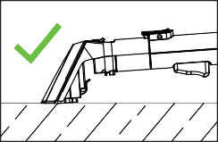 | 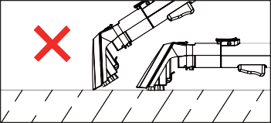 | IMPORTANT: Over or under tilting the hand tool may result in poor water pick up.

USING THE CREVISE TOOL

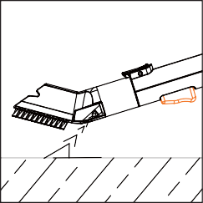 | 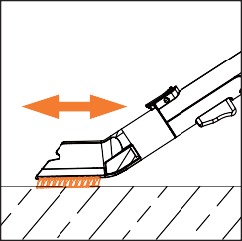 | 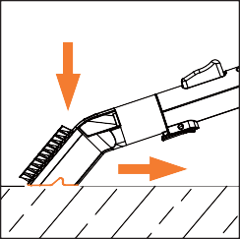
Press the trigger on the crevice tool to release water and solution. | Use the brush to agitate any stubborn stains, scrubbing back and forth. | Turn the tool over and tilt the nozzle forwards so the nozzle is in contact with the surface. Pull back to recover the water and solution.

IMPORTANT: DO NOT USE THE CREVICE NOZZLE WHEN TURN TO STEAM FUNTION!

SMALL WINDOW BRUSH ASSEMBLY

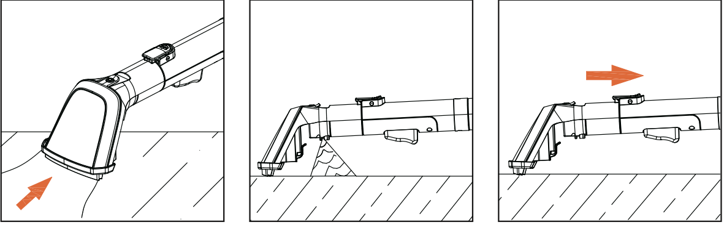
For spills, always pick up the excess liquid before using water/solution.  Tilt the tool forward onto the spill and pull back. | Press the trigger on the wash tool to release water and solution. | Use the brush to agitate any stubborn stains, scrubbing back and forth.

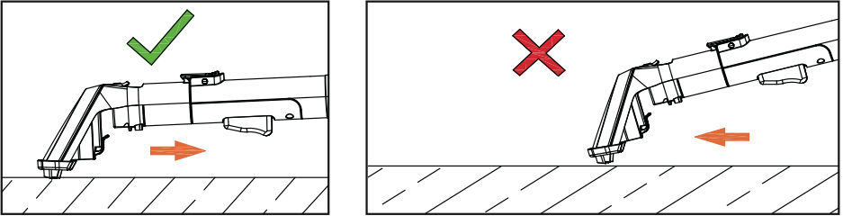 | IMPORTANT: DURING USE, INCORRECT BRUSH ANGLE MAY CAUSE SPRAYING ISSUES.

LARGE WINDOW BRUSH ASSEMBLY

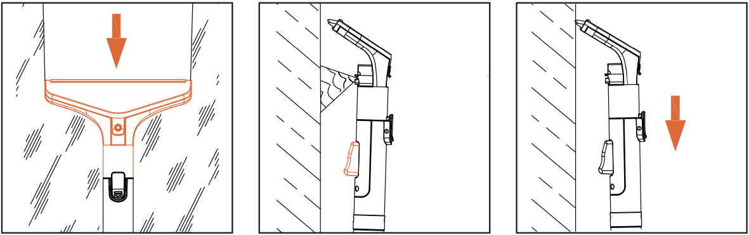
For spills,always pick up the excess liquid before using water/solution.  Tilt the tool forward onto the spill and pull back. | Press the trigger on the wash tool to release water and solution. | Use the brush to agitate any stubborn stains, scrub in the direction of the arrow.

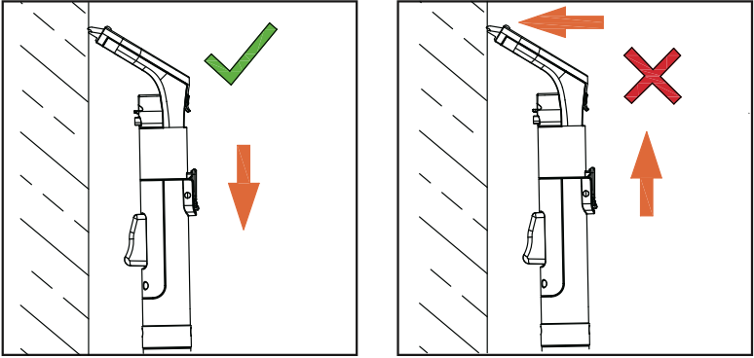 | IMPORTANT: DURING USE, INCORRECT BRUSH ANGLE MAY CAUSE SPRAYING ISSUES.

SEVEN INCH 2-IN-1 BUSH ASSEMBLY

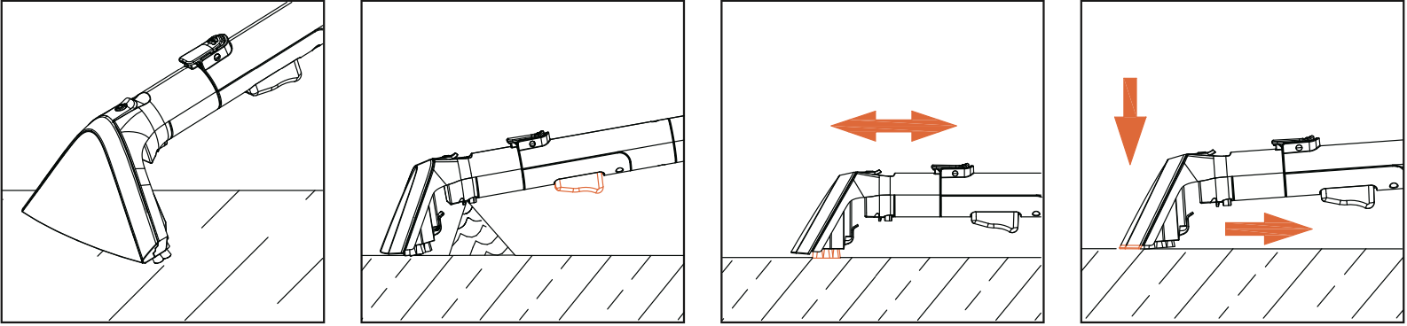
For spills, always pick up the excess liquid before using water/solution.  Tilt the tool forward onto the spill and pull back. | Press the trigger on the wash tool to release water and solution. | Use the brush to agitate any stubborn stains, scrub in the direction of the arrow. | Tilt the nozzle forward so the nozzle is in contact with the surface. Pull back to recover the water and solution.

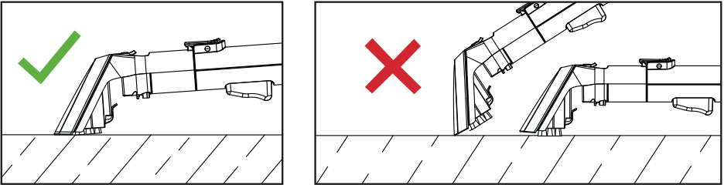 | IMPORTANT: DURING USE, INCORRECT BRUSH ANGLE MAY CAUSE SPRAYING ISSUES.

CLEANING AND MAINTENANCE

Before cleaning, always switch off the appliance, disconnect the apparatus and let it cool.
Clean the outside of the apparatus with a sponge or slightly wet linen. (possibly with household product). Once dry, reattach it in the dust container.
Never plunge the apparatus in water or all other liquid!
Do not use abrasive cleaners, gritting, or metal brush or another cutting object.
Notes: Do not clean the outside of the vacuum cleaner with gasoline oil or any
other liquid.
If necessary clean the accessories with a soft cloth.

WARNING :
    - When maintaining, please be sure to stop running and pull out the power plug
    - Do not water the machine, which may cause electric shock, injury or failure
    - Do not use detergent, thinner, volatile oil, bleach, etc
    - Do not use chemical rags

MAIN BODY WHEN THE POLLUTION
- Use a soft cloth soaked in warm water (below 40 degrees) and wring dry, wipe dirt
- When the dirt is difficult to clean, please use a small amount of kitchen detergent to wipe the dirt, in order not to let the detergent residue, and then dry the water stains with a wring cloth

EMPTYING AND CLEANING THE DIRTY WATER TANK

IMPORTANT: Unplug and switch off the machine before performing maintenance or troubleshooting checks.
The dirty water tank is fitted with a float. When the water reach the MAX line, the float will shut off the suction on the machine. You will be able to hear if this has happened as the motor noise on the machine will increase. Once the float is activated, empty the dirty water tank.
If the dirty water tank is not full then turn off your machine at the power switch and wait for the float to settle.
Empty and rinse out the clean water/solution tank and dirty water tank and leave to air dry before refitting to store.

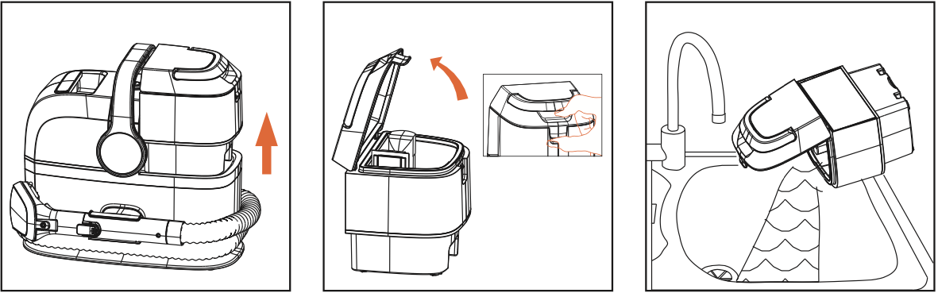
Press the dirty water tank release button. Pull to release the tank and lift by the carry handle to remove. | Pull and lift the lid to remove from the dirty water tank. | Empty the dirty water into the sink or toilet.

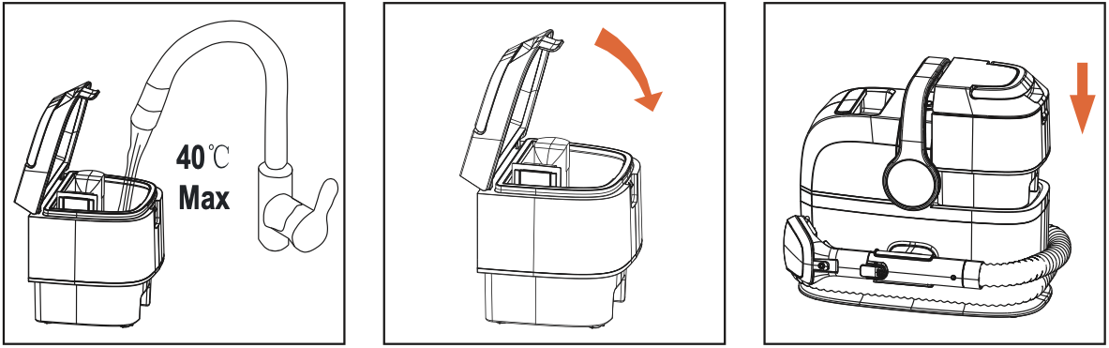
Rinse the dirty water tank and lid under water (max 40 C) to remove dirt/debris. | To refit the lid align the lid to the tank and firmly push Into place. | Refit the dirty water tank onto the machine so it clicks into place.

CLEANING THE HOSE

IMPORTANT: Clean the hose after each use to remove any debris or water left in the hose.

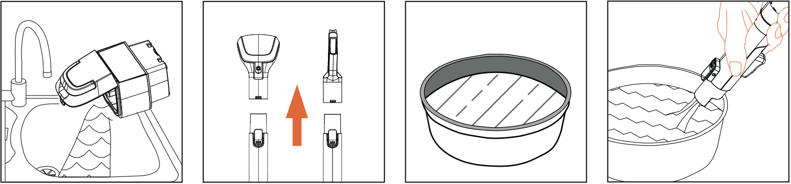
Empty the dirty water into the sink or toilet. | Press the tool lock button and pull to remove the tool from the hose. | Fill a bowl with 500ml of warm water (no solution). | Aim the head of the handle of the straw at the water surface to absorb the water to be recovered. Stop absorbing water at the MAX line of the tank.

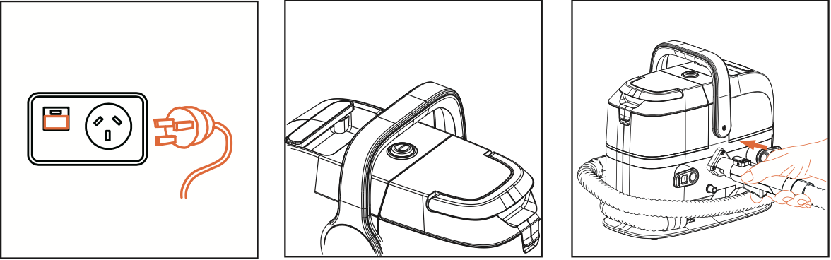
Plug the machine into the mains and switch on. | Press the on/off button to switch the machine on. | straw handle into the semicircle of the body and then press the handle button to clean the hose.

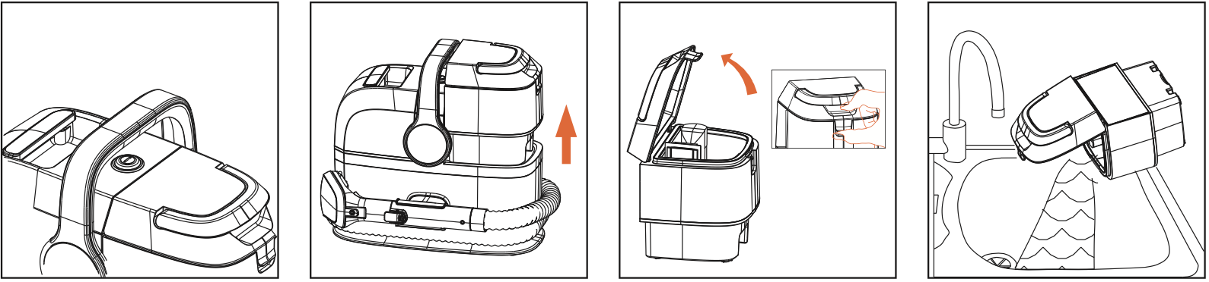
Press the on/off button to switch the machine off. Unplug the machine from the mains. | Press the dirty water tank release button. Pull to release the tank and lift by the carry handle to remove. | Pull and Lift the lid to remove from the dirty water tank. | Empty the dirty water into the sink or toilet.  Stop absorbing water at the MAX WATER line of the tank.
REMOVING AND CLEANING THE WASH TOOL AND ATTACHMENTS

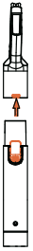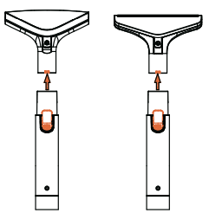 | 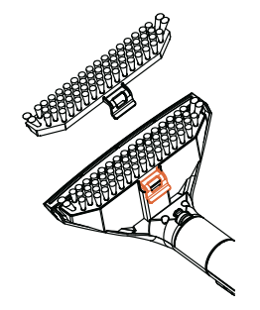
Press the tool lock button and pull to remove the tool from the hose. | Pull and lift the clip to remove the attachment from the wash tool.

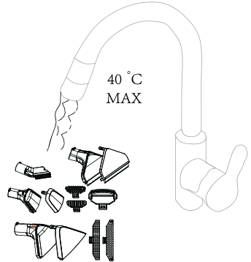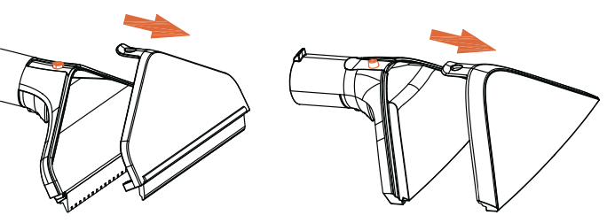
Rinse the tools, attachments and the nozzle under warm water (max 40°C) to remove  dirt/debris. | To remove the nozzle on the wash tool，push and lift the clear plastic clip up over the button on the end of the hose.

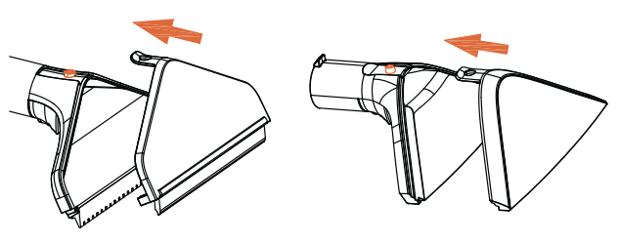
To refit the nozzle, slide the nozzle into the wash tool until it clicks into place.

REMOVING AND CLEANING THE WASH TOOL AND ATTACHMENTS

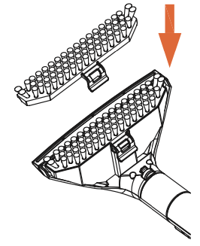
To refit, fit the front of the attachment into the front of the wash tool and push the clip down to click into place.

CLEANING THE FILTER

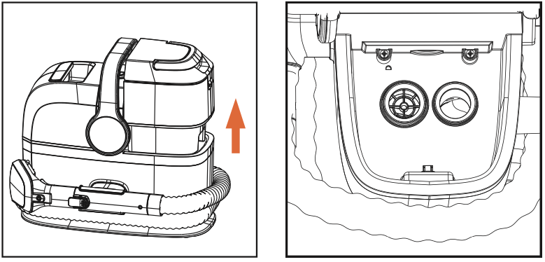
Press the dirty water tank release button. Pull and lift to remove the tank. | Remove any dirt and debris from the filter grill located underneath the dirty water tank.

TROUBLESHOOTING

WARNING: Always switch off and unplug the machine before performing any checks or maintenance.

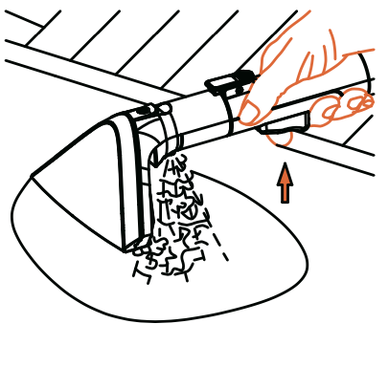 | Place the brush head over the stain and press and hold the water spray button to spray warm water or steam to clean.

Thermostat
Your fabric cleaning machine is equipped with a built-in thermostat to prevent it from overheating. When the thermal protector is activated, the motor will stop running. If this situation occurs, please follow the steps below: turn off the switch and unplug the power outlet. Let the motor cool for about 30 minutes, and the thermal protector will automatically reset. Restarting can continue cleaning.
Attention: If the thermal protector continues to activate after performing the above steps, your cleaner may require repair.
Please contact customer service or after-sales service.

Common fault diagnosis

Here are some issues you may encounter. Additionally, please contact customer service or after-sales.

Issues | Possible reasons | Resolvent
No water spraying/reduced water spraying volume | Water shortage in the clean water tank | Add water to the clean water tank
No water spraying/reduced water spraying volume | The clean water tank is not installed properly | Make sure the clean water tank is installed in place
No water spraying/reduced water spraying volume | The nozzle may be blocked | Wash the nozzles
When the watering button is pressed, there is no little or no water | The water tank is full | Empty the sewage tank
 | The filter at the bottom of  the sewage tank may be clogged | Clean the filter
 | The sewage tank is not installed in place | Make sure there are no obstructions preventing the sewage tank from being fully secured in its grooves
 | The water tank cover is not installed in place | Make sure the lid is fully aligned with the sewage tank and that the lid is locked with the handle.
 | The brush head or hose is clogged with hair or fabric | Clear the blockage
Leaking | Water leakage from the bottom: The water or foam in the sewage tank exceeds the "MAX" line | Do not allow the effluent to exceed the "MAX" line. Make sure to use only little or no foam cleaning solution to prevent excessive foaming.
Leaking | Water leakage from pipe/brush head: After the shutdown, there is still residual water in the pipe | After stopping the suction, opening the machi for a few seconds to ensure that the water is sucked into the dirty water tank.
No steam spraying/low steam volume | There is a shortage of water in the clean water tank. | Add water to the clean water tank.
No steam spraying/low steam volume | The warm-up is not yet complete | Wait for the indicator light to flash and turn to solid before the water comes out
No steam spraying/low steam volume | The brush head sprays water instead of steam | This is normal and when steam is not in use, a small amount  of condensate will form in the steam line. Keep holding down the water spray button for 5-10 seconds and the steam will come out.
In steam mode, the indicator light and temperature flash at the same time | The thermostat is activated | Turn off the device and wait for the temperature cool down
The indicator light always flashes during the warm-up to state | Thermal protection is activated | Contact after-sales repair

STORAGE

-Ensure the unit is completely cool and dry.
-Do not wrap the cord around the appliance, as this will cause damage.
-Keep the appliance in a cool, dry place and out of reach from children.

GUARANTEE

Before being delivered, all our products are subjected to a rigorous control.
This apparatus is guaranteed 24 months starting from the date of purchase by the consumer.
The documents in proof of guarantee are:
• The invoice and
• The filled and stamped warrantee plate (located on side or bottom of the gift box). Without these documents in proof, no free replacement, nor no free repair, can be carried out.
During the warranty period, we deal for free, the defects of the apparatus or the accessories, rising from a defect of materials or manufacture by repair or, replacement. The services within the framework of the guarantee do not involve any extension of the warranty period and does not give right to a new guarantee!
In the event of recourse to the guarantee, bring back the complete apparatus to your retailer, in its original packing, accompanied by the proofs of purchase.
The breakage of parts out of glass or plastic is, in all the cases, not warranted. Defects on the accessories or the wearing parts (for example: coals of engines, hooks, drive belts, remote control of replacement, teeth brushes of replacement, webs etc) as well as cleaning, maintenance or it replacement of wearing parts are not guaranteed and are thus to pay!
In the event of foreign intervention, the guarantee becomes null and void.
After flow of the warranty period, repairs can be carried out, against payment, by a specialized trade or a repair service.

In the event of third-party intervention, the warranty becomes void.
The following items are not covered:
• Functional parts, tools, and accessories after 12 months that may fail prematurely due to daily wear and tear.
• Consumables after 3 months, such as belts, filters, brushes, fuses, etc.
• Accidental damage.
• Cosmetic damage that does not affect the product's functionality.
• Damage resulting from use not in accordance with the user manual.
• Damage caused by lack of regular maintenance.
• Cable damage.
• Blockages; please refer to the user manual.
• Poor product performance caused by:
o Careless use, misuse, or careless operation of the machine.
o Failure to clean or maintain the product in accordance with the user manual.
o Use of the machine not in accordance with the user manual. o Use of a product for purposes other than normal domestic use in the country where it was purchased.
o Use of non-original parts, accessories, and consumables.
o Faulty installation or repairs - unless carried out by a qualified electrician or engineer.

SPECIFICATIONS

Power supply 220-240V~ 50/60Hz
Total rated power 1580W - 1800W
Power 600W
Power steam mode 800W
Dirt water tank capacity 1100ml (1,1L)
Clean water tank capacity 1700ml (1,7L) max.
Noise ≤ 85dB(A)
Tool end vacuum Max ≥ 13 KPA
Flow rate 2 in 1 tool Max: 500ml/min
Min : 300ml/min
Norm IPX4
Class I
Off mode power consumption: 0.00 W
NOTE: This appliance automatically switches to off mode when the OFF button is pressed.

Made in PRC

The characteristics can change without prior notice.

The general-purpose for this vacuum cleaner (models TAN-7066V, TAN-7055V), has been tested according standard EN 50563 : 2011A1 :2013 + 2019/1782 and complies with the essential requirements of regulation (EU) 2019/1782 for vacuum cleaners.

Disconnect the power cable from the electrical main power before any maintenance cleaning and fitting of accessories.
The device should not be exposed to humidity or rain.

CAUTION: In order to minimize the risks of electric shock, In the event of breakdown, not to open the case but to call upon a qualified technician for repairs.

This device complies with EC directives, it was controlled according to all current European directives, applicable such as: electromagnetic compatibility (EMC) and low voltage (LVD).

This device has been designed and manufactured in compliance with the latest regulations and technical requirements for safety.

Avril 2025

