TO-007



ELECTRIC EGG BOILER

Instruction manual

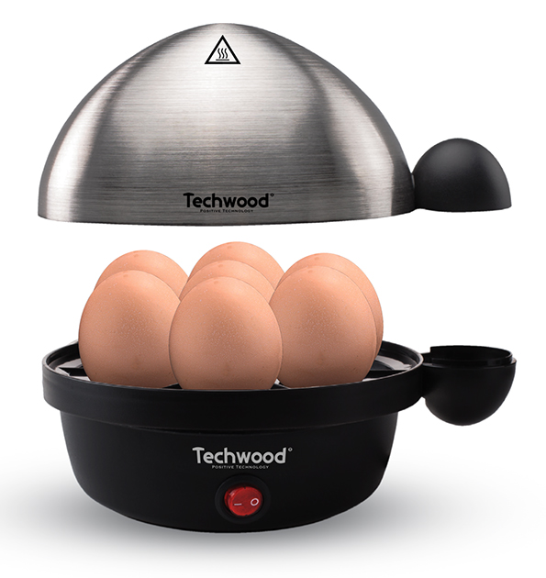
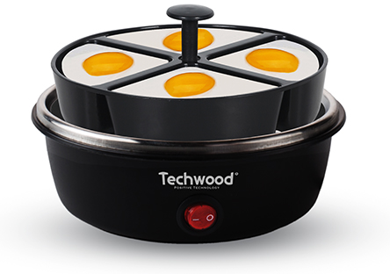
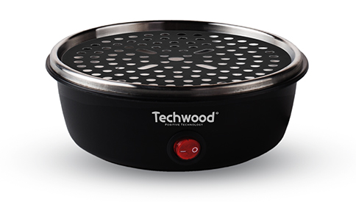
IMPORTANT SAFEGUARDS
Dear consumer, Please read these instructions carefully before use in order to avoid damage due to incorrect use and to better understand the functions of this product. Please pay particular attention to the safety guide.
If you pass the device on to a third party, these Operating Instructions must also be handed over.
Please keep them for future references.

- Please read these instructions carefully before use.
- Keep present instructions for future references.
- Check that your mains voltage corresponds to that stated on the appliance.
- Only use the appliance for domestic purposes and household or similar applications such as:
- staff kitchen areas, in shops, offices and other working environments;
- By clients in hotels, motels and other residential type environments;
- Environment type like :
• Farm Houses • Bed and Breakfast.
- Only use the appliance in the way indicated in these instructions.
- Warning: Avoid spillage on the connector.
- There is a potential risk of injuries from misuse.
- The heating element surface is subject to residual heat after use.
- 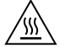 surfaces are liable to get hot during use.
- The appliance must not be immersed.
- Regarding the instructions for cleaning the surfaces which come in contact with food, please refer to the paragraph “CLEANING AND MAINTENANCE” of the manual.
- Never use this unit near bathtub, shower, wash-hand basins or other containers with water.
- Never use this apparatus near water projections.
- Never use this apparatus with the wet hands.
- If, unfortunately the apparatus is wet, immediately withdraw the cord of the socket-outlet.
- Inform potential users of these instructions.
- Never leave the appliance unsupervised when in use.
- The appliance must be used only for its intended purpose. No responsibility can be taken for any possible damage caused by incorrect use or improper handling.
- Children and persons with disabilities are not always aware of the danger posed by the use of appliances.
- This appliance can be used by children aged from 8 years and above if they have been given supervision or instruction concerning use of the appliance in a safe way and if they understand the hazards involved.
- Cleaning and user maintenance shall not be made by children unless they are older than 8 and supervised.
- Keep the appliance and its cord out of reach of children aged less than 8 years.
- Appliances can be used by persons with reduced physical, sensory or mental capabilities or lack of experience and knowledge if they have been given supervision or instruction concerning use of the appliance in a safe way and understand the hazards involved.
- Children shall not play with the appliance.
- In order to ensure your children‘s safety, please keep all packaging (plastic bags, boxes, polystyrene etc.) out of their reach.
- Caution ! Do not allow small children to play with the foil :
there is a danger of suffocation !
- From time to time check the cord for damages. Never use the appliance if cord or appliance shows any signs of damage.
- Never immerse the appliance in water or any other liquid for any reason whatsoever.
- Never place it into the dishwasher.
- Never use the appliance near hot surfaces.
- Do not operate the appliance with a damaged cord or plug, or after the appliance has been damaged in any manner.
- If the supply cord or appliance is damaged,
- it must be replaced by the manufacturer or its service agent or a similarly qualified person in order to avoid a hazard.
- Disconnect the power source cable before any operation of cleaning of maintenance and accessories assembly.
- Never use the appliance outside and always place it in a dry environment.
- Never use accessories, which are not recommended by the producer. They could constitute a danger to the user and risk to damage the appliance.
- Never use any other connector than the one provided.
- Never move the appliance by pulling the cord. Make sure the cord cannot get caught in any way.
- Never wind the cord around the appliance and do not bend it
- Ensure that the power cord does not come into contact with hot parts of this unit.
- Make sure the appliance has cooled down before cleaning and storing it.
- The temperature of accessible surfaces may be very high when the appliance is operating. Never touch these parts, of apparatus, to avoid burning itself.
- Make sure the appliance never comes into contact with flammable materials, such as curtains, cloth, etc...& the power cord and plug do not come in contact with water.
- Before cleaning, always unplug the appliance from the power supply and let it cool down.
- This appliance is not intended to be operated by means of an external timer or separate remote-control system.
- Always place the unit on a flat surface. Ensure, also, not to cover the device and not to put anything on it.
- Always remove the plug from the wall socket when the appliance is not in use.
- When using an extension lead always make sure that the entire cable is unwound from the reel. Use solely CE approved extension leads. Input power must be at least 16A, 250V, 3000W.
- Incorrect operation and improper use can damage the appliance and cause injury to the user.
- This device, designed for home use, complies with standards relating to this type of product.
- The appliance must be used and rested on a table or flat & stable surface.
- The item must not be left unattended when it is connected to main supply.
- The item is not to be used, if it has been dropped or if there are visible signs of damage or if it is leaking.
- Regarding the instructions for cleaning, thanks to refer to the below paragraph of the manual.
- This appliance is only intended for household use.

^{(*)} Competent qualified person : after sales department of the producer or importer or any person who is qualified, approved and competent to perform this kind of repairs.

GENERAL INFORMATION

The symbol "OPEN BOOK" means a recommendation to read important things contained in the record.

The symbol "BIN" crossed out, abbreviation WEEE (Waste of Electrical and Electronic Equipment) means that at the end of life, it should not be discarded with household waste, but filed to the sorting of the locality. Waste recovery can help preserve our environment.
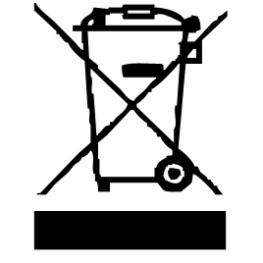

The symbol "CE" is the guarantee of compliance with harmonized European standards, voluntary, reflecting the essential requirements into technical specifications. These standards are not mandatory but are guarantees of compliance with essential requirements.


The symbol ROHS (Restriction of use of some Hazardous Substances) on the Environmental Protection, certifies that for each of the five hazardous substances • Lead • Mercury • (hexavalent) chromium • products for protection against flames PBB and PBDE, the peak concentration is equal to or less than 0.1% of the weight of homogeneous material, and 0.01% for the 6th • cadmium.


The symbol "GLASS / FORK" means that the device is compatible and can come into contact with foodstuffs.

The symbol "TRIMAN" indicates that the consumer is invited to dispose the product as part of a separate collection (eg recycling bin, waste, voluntary intake point).


For more information : http://www.quefairedemesdechets.fr

BEFORE THE FIRST USE

Before first use, remove the device and all accessories and being careful with sharp accessories.

• Clean the apparatus according to the instructions in "Cleaning" paragraph.

• Place the machine on a suitable flat, stable surface.

USE

Unroll the power cord completely.

Check that the tension in force in the country where you are, corresponds to that indicated on the apparatus.

Connect the apparatus in a correct socket-outlet, (and connected to the ground if the unit is Class I), to avoid any danger.

Disconnect the power source cable before any operation of cleaning of maintenance and accessories assembly.

Never modify the appliance in anyway.

Fill the measuring cup with water, according to the number of eggs and the degree of cooking required.
Remove the lid and the egg basket and pour the water into the appliance.
Place the egg basket inside the base.
Stitch each egg (to avoid bursting).
- CAUTION : The egg-spade is very spicy. Be very careful to avoid injury.
Place the eggs in the basket.
Replace the cover.
Plug the unit into a grounded outlet.
Set the On / Off switch to On. The power indicator lights up and the water starts to heat up.
- CAUTION : Beware of the steam emitted by the steam vent on the lid.
When all the water has evaporated, the unit automatically shuts off, a beep sounds and the power indicator goes out.
Turn off the device and unplug it.
Use the handle to remove the lid. Take out the basket and pass the eggs under cold water to stop completely the cooking.

CLEANING AND MAINTENANCE

Before cleaning, Always : switch off the appliance, disconnect the apparatus and let it cool.
Clean the outside of the apparatus with a sponge or slightly wet linen.
The parts (removable) in contact with food like plate, bowl, forks, Spatula etc. can be washed in hot water with sponge and soft detergent or put in the dishwasher.
Never plunge the apparatus in water or all other liquid !
Do not use abrasive cleaners, gritting, or metal brush or another cutting object.

SCALING
How to remove scale deposits :
- Make sure the unit is turned off and unplugged.
- Prepare a solution of 1/10 of white vinegar and 9/10 of water.
- Pour the solution into the device.
- Let stand for 5 minutes.
- Empty the solution.
- Wipe the inside of the appliance with a humid cloth or sponge.
- Dry the appliance before storing it.

STORAGE

-Ensure the unit is completely cool and dry.
-Do not wrap the cord around the appliance, as this will cause damage.
-Keep the appliance in a cool, dry place and out of reach from children.

LEGAL GUARANTEE

Before being delivered, all our products are subjected to a rigorous control.

In accordance with the duration of the legal guarantee of conformity, this device is guaranteed 24 months from the date of purchase by the consumer.

The proof of warranty is the purchase invoice.

Without this proof, no free replacement or free repair can be made.

During the period of the legal guarantee of conformity, we take, free of charge, the defects of the device or the accessories, resulting from a defect of materials or manufacturing by repair or replacement.

However, these services, within the framework of the legal guarantee of conformity, do not entail any extension of the duration of guarantee and gives no right to a new guarantee !

In case of recourse to the guarantee, bring back the complete apparatus to your retailer,

in its original packaging, accompanied by proof of purchase.

Defects in accessories, wear parts, glass or plastic parts resulting from breakage or misuse remain the responsibility of the consumer. In this case, cleaning, maintenance or replacement would not be guaranteed and would therefore be paid !

In case of foreign intervention, the warranty becomes void.

After expiration of the warranty period, repairs may be made, against payment, by the specialized trade or a repair service.

SPECIFICATIONS

Power supply 220-240V~ 50Hz
Power 350W
Norm Class I
Made in PRC

The characteristics can change without prior notice

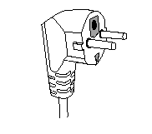
This unit is equipped with an electrical outlet with earth and must be earthed in an according plug.
Note : In the event of question concerning the earth or electric connection, please consult a qualified personnel.
In the event of short-circuit, earthing reduces the risk of electric shock while making possible the current to be evacuated by the wire of ground.
CAUTION: In order to minimize the risks of electric shock, In the event of breakdown, not to open the case but to call upon a qualified technician for repairs.
This device complies with EC directives, it was controlled according to all current European directives, applicable such as: electromagnetic compatibility (EMC) and low voltage (LVD).
This device has been designed and manufactured in compliance with the latest regulations and technical requirements for safety.

Imported by Sotech International
" LE PERIPOLE " N°C107
33, Avenue du Marechal de Lattre de Tassigny
94120 Fontenay sous bois - France

