
TMS-9600
TMS-9666

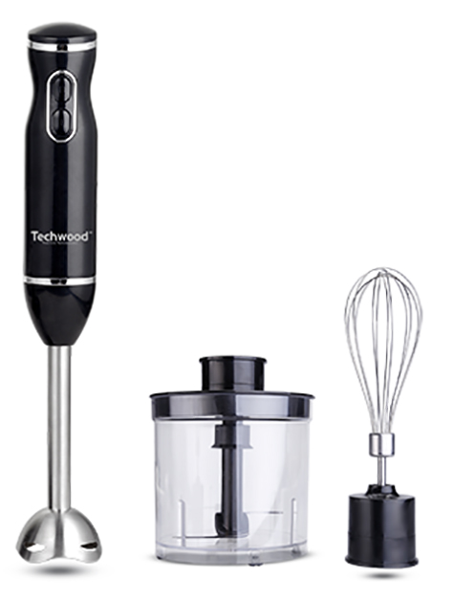

TMS-9666

TMS-9600

SET MIXER /BLENDER

INSTRUCTION MANUAL

IMPORTANT SAFEGUARDS
Dear consumer,
Please read these instructions carefully before use in order to avoid damage due to incorrect use and to better understand the functions of this product. Please pay particular attention to the safety guide. If you pass the device on to a third party, these Operating Instructions must also be handed over. Please keep them for future references.

- Please read these instructions carefully before use.
- Keep present instructions for future references.
- Check that your mains voltage corresponds to that stated on the appliance.
- Only use the appliance for domestic purposes and household or similar applications such as:
-staff kitchen areas, in shops, offices and other working environments;
-by clients in hotels, motels and other residential type environments;
- Environment type like :
• Farm Houses • Bed and Breakfast.
- Only use the appliance in the way indicated in these instructions.
- Never use this unit near bathtub, shower, wash-hand basins or other containers with water.
- Never use this apparatus near water projections.
- Never use this apparatus with the wet hands.
- If, unfortunately the apparatus is wet, immediately withdraw the cord of the socket-outlet.
- Inform potential users of these instructions.
- Never leave the appliance unsupervised when in use.
- The appliance must be used only for its intended purpose. No responsibility can be taken for any possible damage caused by incorrect use or improper handling.
- Children and persons with disabilities are not always aware of the danger posed by the use of appliances.
- Always disconnect the appliance from the supply if it left unattended and before assembling, disassembling, or cleaning.
- This appliance must not be used by children.
- This appliance can be used by persons with reduced physical, sensory or mental capabilities or lack of experience and knowledge if they have been given supervision or instruction concerning use of the appliance in a safe way and if they understand the hazards involved.
- Cleaning and maintenance must not be made ​​by children.
- Keep the appliance and its cord out of reach of children.
- This device is not a toy, do not leave small children or people with disabilities to play with.
- In order to ensure your children‘s safety, please keep all packaging (plastic bags, boxes, polystyrene etc.) out of their reach.
- Caution ! Do not allow small children to play with the foil :
there is a danger of suffocation !
- From time to time check the cord for damages. Never use the appliance if cord or appliance shows any signs of damage.
- Never immerse the appliance in water or any other liquid for any reason whatsoever.
- Never place it into the dishwasher.
- Never use the appliance near hot surfaces.
- If the supply cord is damaged, it must be replaced by the manufacturer, its service agent or similarly Competent qualified person(*) in order to avoid a hazard.
- Disconnect the power source cable before any operation of cleaning of maintenance and accessories assembly.
- Never use the appliance outside and always place it in a dry environment.
- Never use accessories, which are not recommended by the producer. They could constitute a danger to the user and risk to damage the appliance.
- Never use any other connector than the one provided.
- Never move the appliance by pulling the cord. Make sure the cord cannot get caught in any way.
- Never wind the cord around the appliance and do not bend it
- Ensure that the power cord does not come into contact with hot parts of this unit.
- Make sure the appliance has cooled down before cleaning and storing it.
- The temperature of accessible surfaces may be very high when the appliance is operating. Never touch these parts, of apparatus, to avoid burning itself.
- Make sure the appliance never comes into contact with flammable materials, such as curtains, cloth, etc...& the power cord and plug do not come in contact with water.
- Before cleaning, always unplug the appliance from the power supply and let it cool down.
- This appliance is not intended to be operated by means of an external timer or separate remote-control system.
- Always place the unit on a flat surface. Ensure, also, not to cover the device and not to put anything on it.
- Always remove the plug from the wall socket when the appliance is not in use.
- When using an extension lead always make sure that the entire cable is unwound from the reel. Use solely CE approved extension leads. Input power must be at least 16A, 250V, 3000W.
- Incorrect operation and improper use can damage the appliance and cause injury to the user.
- This device, designed for home use, complies with standards relating to this type of product.
- The appliance must be used and rested on a table or flat & stable surface.
- The item must not be left unattended when it is connected to main supply.
- The item is not to be used, if it has been dropped or if there are visible signs of damage or if it is leaking.
- Regarding the instructions for cleaning, thanks to refer to the below paragraph of the manual.
- This appliance is only intended for household use.

(*) Competent qualified person: after sales department of the producer or importer or any person who is qualified, approved and competent to perform this kind of repairs.

SPECIAL WARNING FOR FOOD CHOPPER & STICK BLENDER

Caution !
- Always disconnect from power supply if it is left unattended and before assembling, disassembling or during cleaning.
- Switch off the appliance and disconnect from supply before changing accessories approaching parts that move in use.
- Potential injuries can occur with misuse. Care shall be taken when handling the sharp cutting blades, emptying the bowl and during cleaning, as they are extremely sharp.
- Regarding the instructions for cleaning surfaces in contact with food or oil, thanks to refer to the below paragraph "cleaning" in manual.
- Regarding the instructions for the use of accessories, operation times and speed settings, refer to the below paragraphs.

GENERAL INFORMATION

The symbol "OPEN BOOK" means a recommendation to read important things contained in the record.

The symbol "BIN" crossed out, abbreviation WEEE (Waste of Electrical and Electronic Equipment) means that at the end of life, it should not be discarded with household waste, but filed to the sorting of the locality. Waste recovery can help preserve our environment.
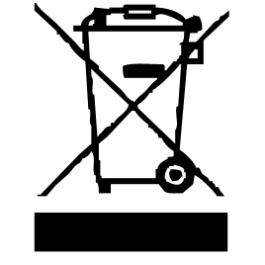

The symbol "CE" is the guarantee of compliance with harmonized European standards, voluntary, reflecting the essential requirements into technical specifications. These standards are not mandatory but are guarantees of compliance with essential requirements.


The symbol ROHS (Restriction of use of some Hazardous Substances) on the Environmental Protection, certifies that for each of the five hazardous substances • Lead • Mercury • (hexavalent) chromium • products for protection against flames PBB and PBDE, the peak concentration is equal to or less than 0.1% of the weight of homogeneous material, and 0.01% for the 6th • cadmium.


The symbol "DOUBLE SQUARE" means a double insulated. A basic insulation and supplementary insulation. This device requires no connection to the mass of a protective conductor grounded. The materials are said : double insulation class II.


The symbol "GLASS / FORK" means that the device is compatible and can come into contact with foodstuffs.

The symbol "TRIMAN" indicates that the consumer is invited to dispose the product as part of a separate collection (eg recycling bin, waste, voluntary intake point).

For more information : http://www.quefairedemesdechets.fr

TO KNOW ITS UNIT

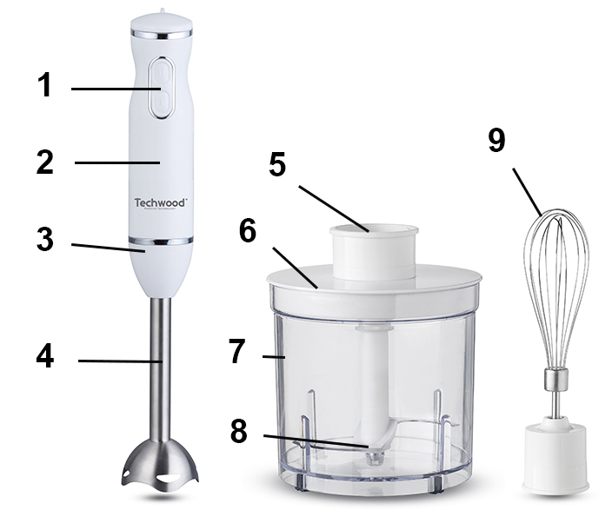
Stick blender
- Speed selector 1 and 2
- Handle
- Connection Body / Foot
- Removable Stainless-steel foot

Chopper
- Connection Lid / Handle
- Lid
- Bowl
- Blade set

Whisk
- Metal Whisk

BEFORE THE FIRST USE

Before first use, remove the device and all accessories and being careful with sharp accessories.

Clean the apparatus according to the instructions in "Cleaning" paragraph.

Place the machine on a suitable flat, stable surface.

BEFORE PLUGING

- Unroll the power cord completely.
- Check that the tension in force in the country where you are, corresponds to that indicated on the apparatus.
- Connect the apparatus in a correct socket-outlet, (and connected to the ground if the unit is Class I), to avoid any danger.
- Disconnect the power source cable before any operation of cleaning of maintenance and accessories assembly.

Stand the appliance on a table or flat surface.
- Never modify the appliance in anyway.

IMPORTANT :
Not to use the apparatus more than one minute.
Let cool it for 30 seconds between each operation.
At the end of 7 min maximum use, Let cool the apparatus 5 minutes before re-using it.
Don’t touch the sharp blades.
Remove the chopper blade before emptying the bowl.
Never remove the cover until the blade has completely stopped.
With heavy mixtures, don’t use your hand blender for longer than 50 seconds in any four minutes period, otherwise, it will overheat.

BLENDING

Note : Take the pan off the heat and let it cool slightly. Otherwise the foot of the hand blender could overheat and can be damaged.
- Mount the power handle on the removable foot, turn and lock.
- Plug in.
Notes : to avoid splashing, place the blade in the food before switching on.
Do not let liquid rise above the joint between the handle and the foot
mixer.
- If your blender is stuck, Stop pressing the speed selector and unplug the blender before cleaning the cutting set.
- After use, unplug and disassemble the unit for cleaning.
Notes : Always pay attention to the blade that is sharp and can cause injuries.
Always clean the foot after each use.

CHOPPER USING

The chopper is perfect for chopping food such as meat, cheese, onions, herbs, garlic, carrots, nuts, hazelnuts, almonds, prunes, etc.
Do not chop hard food such as coffee, wheat, nutmeg, ice cubes ... This can damage the cutting blade.
1. Remove any bones and cut food into 1-2cm cubes.
2. Fit the chopper blade over the pin in the bowl
3. Add your food.
4. Fit the chopper cover, turn and lock
5. Fit the power handle, turn and lock
6. Plug in, hold the bowl steady, then press speed 1 or 2.
7. After use, unplug and dismantle.

WHISK USING

You can whip light ingredients such as egg whites, cream, instant desserts and eggs and sugar for whisked sponges.
Don’t whisk heavier mixtures such as margarine and sugar, you will damage the whisk.
- Fit the power handle inside the whisk collar, turn and lock
- Push the whisk into one bowl with ingredients to blend.
Note : Don’t whisk more than 4 egg whites or 400ml (0.75pt) cream.
- Plug in.
To avoid splashing, start on speed 1, Move the whisk clockwise in the bowl.
- Don’t let liquid get above the whisk wires.
- After use, unplug and dismantle the mixer.

PROCESSING GUIDE (given as a suggestion)

HAND MIXER
Food | Speed | Time
Milk & milk-shake
Soup | Position 1 ou 2 | Maximum 3 mn
Emulsion / vinaigrette
WHISK
Whip the cream
Fit the white eggs | Position 1 ou 2 | Maximum 3 mn
To do sauce ou mayonnaise
Make a cookie dough

CHOPPER
Food |  | Maximum Amount | Times (seconds) | Thickness
MEAT |  | 600g | 15-30 | 1 or 2 cm
HERBS |  | 100g | 20
WALNUTS |  | 400g | 25
HAZELNUTS |  | 400g | 30
ALMONDS |  | 400g | 20
CHEESE |  | 400g | 10 | 1 or 2 cm
BREAD |  | 200g | 50 | 2 cm
GARLIC/OIGNON |  | 100g | 20 | Half or pieces
CARROTS |  | 200g | 15 | 1 or 2 cm
BOILLED EGGS | 300g |  | 10 | Cut in pieces

CLEANING AND MAINTENANCE

Before cleaning switch off the appliance, Always disconnect the apparatus and to let it cool before cleaning.
Clean the outside of the apparatus with a sponge or slightly wet linen.
The parts (removable) in contact with food like whisk, bowl, forks, Spatula etc. can be washed in hot water with sponge and soft detergent or put in the dishwasher.
Never plunge the apparatus in water or all other liquid !
Do not use abrasive cleaners, gritting, or metal brush or another cutting object.
Don’t touch the sharp blades.
Take special care when preparing food for babies, the elderly and infirm. Always ensure that the hand blender shaft is thoroughly sterilized. Use a sterilizing solution in accordance with the sterilizing solution manufactures instructions.
Some foods, eg. carrot, may discolour the plastic. Rubbing with a cloth dipped in vegetable oil helps remove discolouring.

STORAGE

- Ensure the unit is completely cool and dry.
- Do not wrap the cord around the appliance, as this will cause damage.
- Keep the appliance in a cool, dry place.

GUARANTEE

Before being delivered, all our products are subjected to a rigorous control.

This apparatus is guaranteed 24 months starting from the date of purchase by the consumer.

The documents in proof of guarantee are :

• The invoice and

• The filled and stamped warrantee plate (located on side or bottom of the gift box). Without these documents in proof, no free replacement, nor no free repair, can be carried out.

During the warranty period, we deal for free, the defects of the apparatus or the accessories, rising from a defect of materials or manufacture by repair or, replacement. The services within the framework of the guarantee do not involve any extension of the warranty period and does not give right to a new guarantee !

In the event of recourse to the guarantee, bring back the complete apparatus to your retailer, in its original packing, accompanied by the proofs of purchase.

The breakage of parts out of glass or plastic is, in all the cases, not warranted. Defects on the accessories or the wearing parts (for example: coals of engines, hooks, drive belts, remote control of replacement, teeth brushes of replacement, webs etc) as well as cleaning, maintenance or it replacement of wearing parts are not guaranteed and are thus to pay !

In the event of foreign intervention, the guarantee becomes null and void.

After flow of the warranty period, repairs can be carried out, against payment, by a specialized trade or a repair service.

SPECIFICATIONS

Power supply 220-240V~ 50/60Hz
Power 200W
Norm Class II
Made in PRC

The characteristics can change without preliminary preventing

CAUTION: In order to minimize the risks of electric shock, In the event of breakdown, not to open the case but to call upon a qualified technician for repairs.

This apparatus satisfied EC directives, it was controlled according to all the European current directives, like: electromagnetic compatibility (EMC) and low tension (LVD).

This apparatus was designed and manufactured in respect of the last safety regulations and technical specifications.

Imported by Sotech International
" LE PERIPOLE " N°C107
33, Avenue du Marechal de Lattre de Tassigny
94120 Fontenay sous bois - France

