TB-1717V



GLASS CORDLESS KETTLE

POSABLE ON 360° BASE

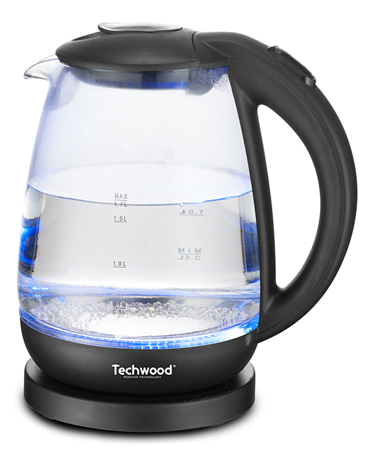
INSTRUCTION MANUAL

IMPORTANT SAFEGUARDS
Dear consumer, Please read these instructions carefully before use in order to avoid damage due to incorrect use and to better understand the functions of this product.
Please, pay particular attention to the safety guide. If you pass the device on to a third party, these Operating Instructions must also be handed over.
Keep them for future references.

- Please read these instructions carefully before use.
- Keep present instructions for future references.
- Check that your mains voltage corresponds to that stated on the appliance.
- Only use the appliance for domestic purposes and household or similar applications such as:
-staff kitchen areas, in shops, offices and other working environments;
-by clients in hotels, motels and other residential type environments;
- Environment type like :
• Farm Houses • Bed and Breakfast.
- Only use the appliance in the way indicated in these instructions.
- Never use this unit near bathtub, shower, wash-hand basins or other containers with water.
- Never use this apparatus near water projections.
- Never use this apparatus with the wet hands.
- If, unfortunately the apparatus is wet, immediately withdraw the cord of the socket-outlet.
- Inform potential users of these instructions.
- Never leave the appliance unsupervised when in use.
- The appliance must be used only for its intended purpose. No responsibility can be taken for any possible damage caused by incorrect use or improper handling.
- Children and persons with disabilities are not always aware of the danger posed by the use of appliances.
- This appliance can be used by children aged from 8 years and above if they have been given supervision or instruction concerning use of the appliance in a safe way and if they understand the hazards involved.
- This appliance can be used by persons with reduced physical, sensory or mental capabilities or lack of experience and knowledge if they have been given supervision or instruction concerning use of the appliance in a safe way and if they understand the hazards involved.
- Children shall not play with the appliance.
- Cleaning and user maintenance shall not be made by children unless they are older than 8 and supervised.
- Keep the appliance and its cord out of reach of children aged less than 8 years.
- This device is not a toy, do not leave small children or people with disabilities to play with.
- In order to ensure your children‘s safety, please keep all packaging (plastic bags, boxes, polystyrene etc.) out of their reach.
- Caution ! Do not allow small children to play with the foil :
there is a danger of suffocation !
- From time to time check the cord for damages. Never use the appliance if cord or appliance shows any signs of damage.
- Never immerse the appliance in water or any other liquid for any reason whatsoever.
- Never place it into the dishwasher.
- Never use the appliance near hot surfaces.
- If the supply cord is damaged, it must be replaced by the manufacturer, its service agent or similarly qualified person^{(*)} in order to avoid a hazard.
- Disconnect the power source cable before any operation of cleaning of maintenance and accessories assembly.
- Never use the appliance outside and always place it in a dry environment.
- Never use accessories, which are not recommended by the producer. They could constitute a danger to the user and risk to damage the appliance.
- Never use any other connector than the one provided.
- Never move the appliance by pulling the cord. Make sure the cord cannot get caught in any way.
- Never wind the cord around the appliance and do not bend it
- Ensure that the power cord does not come into contact with hot parts of this unit.
- Make sure the appliance has cooled down before cleaning and storing it.
- The temperature of accessible surfaces may be very high when the appliance is operating. Never touch these parts, of apparatus, to avoid burning itself.
- Make sure the appliance never comes into contact with flammable materials, such as curtains, cloth, etc...& the power cord and plug do not come in contact with water.
- Before cleaning, always unplug the appliance from the power supply and let it cool down.
- This appliance is not intended to be operated by means of an external timer or separate remote-control system.
- Always place the unit on a flat surface. Ensure, also, not to cover the device and not to put anything on it.
- Always remove the plug from the wall socket when the appliance is not in use.
- When using an extension lead always make sure that the entire cable is unwound from the reel. Use solely CE approved extension leads. Input power must be at least 16A, 250V, 3000W.
- Incorrect operation and improper use can damage the appliance and cause injury to the user.
- This device, designed for home use, complies with standards relating to this type of product.
- WARNING : Avoid spillage on the connector.
- WARNING : Warning of potential injury from misuse.
- The heating element surface is subject to residual heat after use.
- Regarding the instructions for cleaning surfaces in contact with food, thanks to refer to the below paragraph “CLEANING AND MAINTENANCE” in manual

^{(*)} Competent qualified person : after sales department of the producer or importer or any person who is qualified, approved and competent to perform this kind of repairs.

SPECIFIC WARNING FOR KETTLES

WARNING:
- If the water is overfilled, boiling water may be rejected.
- Do not remove the lid while the water is boiling.
- Always use cold water to fill the device
- Never exceed the maximum level (MAX).
Note: When the water level reaches the minimum mark (Mini) Refill the unit.
- Always unplug the appliance before filling it with water.
- After filling, make sure the cap is in place and closed.
- The base and outside of the unit must not be wet. Otherwise, disconnect the device and wipe with a dry cloth.
- The kettle should only be used with the base associated with it!

GENERAL INFORMATION

The symbol "OPEN BOOK" means a recommendation to read important things contained in the record.

The symbol "BIN" crossed out, abbreviation WEEE (Waste of Electrical and Electronic Equipment) means that at the end of life, it should not be discarded with household waste, but filed to the sorting of the locality. Waste recovery can help preserve our environment.
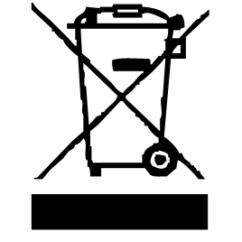

The symbol "CE" is the guarantee of compliance with harmonized European standards, voluntary, reflecting the essential requirements into technical specifications. These standards are not mandatory but are guarantees of compliance with essential requirements.


The symbol ROHS (Restriction of use of some Hazardous Substances) on the Environmental Protection, certifies that for each of the five hazardous substances • Lead • Mercury • (hexavalent) chromium • products for protection against flames PBB and PBDE, the peak concentration is equal to or less than 0.1% of the weight of homogeneous material, and 0.01% for the 6th • cadmium.


The symbol "GLASS / FORK" means that the device is compatible and can come into contact with foodstuffs.

The symbol "TRIMAN" indicates that the consumer is invited to dispose the product as part of a separate collection (eg recycling bin, waste, voluntary intake point).
For more information : http://www.quefairedemesdechets.fr

CAUTION: RISK OF BURN.

• During operation, the surface temperature of the unit may be hot.
• The heating elements remain warm for a long time after the appliance is switched off.

CLEANING AND MAINTENANCE

Before cleaning, switch off the appliance, Always disconnect the apparatus and to let it cool.
Clean the outside of the apparatus with a sponge or slightly wet linen.
The Inside can be cleaned with sponge to remove limestone deposits. Rinse with fresh water.
Never plunge the apparatus in water or all other liquid!
Do not use abrasive cleaners, gritting, or metal brush or another cutting object.

First use of the machine

Before using the machine for the first time :
- Put the electric charger base on a flat surface.
- Fill the kettle with fresh water (without any additives.).
note : Do not overfill! Use the water level indicator.
- Place the kettle on the base.
- Only connect the machine to a properly installed safety socket.
check whether the electrical voltage that you intend to use is the same as that of the machine.
- switch the machine to position “ON”. The control lamp on the kettle light showing that the water is heating.
- When boiling the machine switches off automatically.
- Take the Kettle and pour genteelly the water in a sink. Take care to ovoid any burn.
Notes: Do not press up the lid when pouring.
The unit is ready to be used.

USING

- Fill the kettle with fresh water (Do not overfill!) fill under the Max mark.
- Place the kettle on the connected base.
- switch the machine to position “ON”. The control lamp on the kettle shows in blue that the water is heating.
- When boiling the machine switches off automatically.
- Take the Kettle and pour genteelly the water in cups or what ever. Take care to avoid any burn and Do not press up the lid when pouring.

STORAGE

-Ensure the unit is completely cool and dry.
-Do not wrap the cord around the appliance, as this will cause damage.
-Keep the appliance in a cool, dry place.

GUARANTEE IN ACCORDANCE WITH REGULATIONS

Before being delivered, all our products are subjected to rigorous checks.
This device is guaranteed for 24 months from the date of purchase of the product by the consumer.
The warranty documents are:
• the invoice and
• the warranty certificate (located on the side or the bottom of the box) stamped and completed.
Without these supporting documents, no free replacement or free repair can be made.
During the warranty period, we take charge, free of charge, for defects in the device or accessories, resulting from a defect in materials or workmanship by repair or replacement.
Services under the legal guarantee do not entail any extension of the guarantee period and do not give the right to a new guarantee.
In the event of a warranty claim, return the complete device to your dealer,
in its original packaging, accompanied by proof of purchase.
The breakage of glass or plastic parts is, in all cases, your responsibility.
Wearing parts (for example: motor brushes, hooks, drive belts, spare remote control, spare toothbrushes, saw blades etc.) as well as their cleaning, maintenance or replacement, are not guaranteed. , and are therefore at your expense.
In the event of foreign intervention, the guarantee lapses.

After expiry of the warranty period, repairs can be carried out, against payment, by a specialist dealer or a repair service.

SPECIFICATIONS

Power supply 220-240V~ 50/60Hz
Power 1850-2200W
Norm Class I
Capacity 1,7L maximum
Made in PRC

The characteristics can change without preliminary preventing

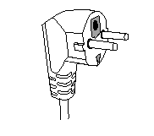
This unit is equipped with an electrical outlet with earth and must be earthed in an according plug.
Note: In the event of question concerning the earth or electric connection, please consult a qualified personnel.
In the event of short-circuit, earthing reduces the risk of electric shock while making possible the current to be evacuated by the wire of ground.

CAUTION: In order to minimize the risks of electric shock, In the event of breakdown, not to open the case but to call upon a qualified technician for repairs.

This apparatus satisfied EC directives, it was controlled according to all the European current directives, like: electromagnetic compatibility (EMC) and low tension (LVD).

This apparatus was designed and manufactured in respect of the last safety regulations and technical specifications.

Imported by Sotech International
" LE PERIPOLE "
33, Avenue du Marechal de Lattre de Tassigny
94120 Fontenay sous bois - France

The symbol " CMIM " is the guarantee of compliance with optional harmonized Moroccan Standards, which reflect the essential requirements in terms of technical specifications.
These standards are not mandatory but ensuring compliance with the essential requirements.

