TDV-1204F



HANDHELD GARMENT STEAMER

INSTRUCTION MANUAL
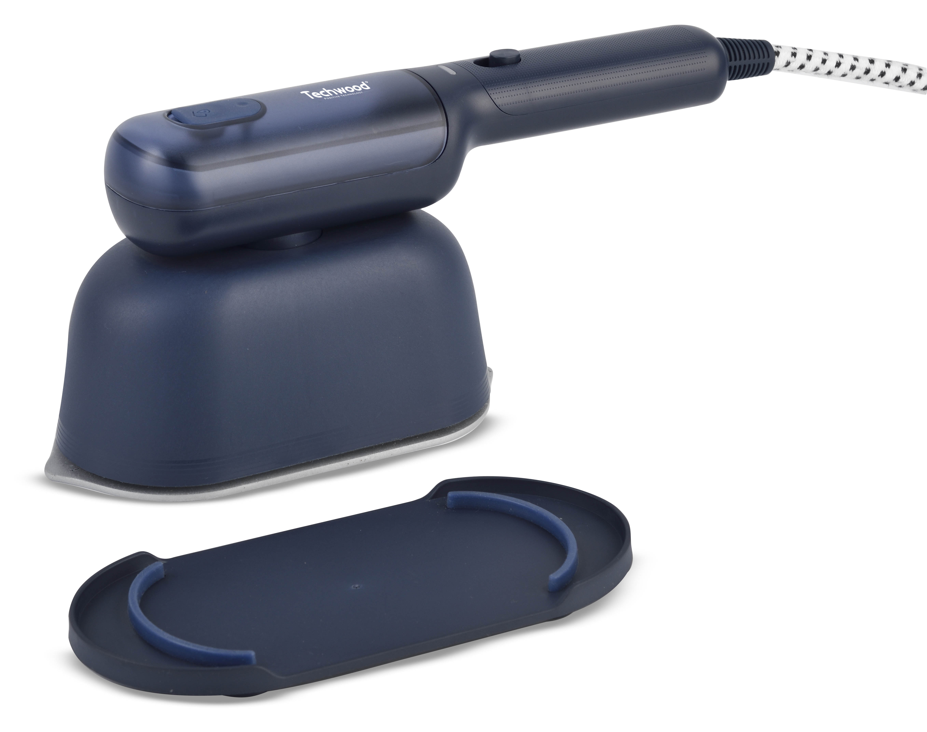

IMPORTANT SAFEGUARDS
Dear consumer, Please read these instructions carefully before use in order to avoid damage due to incorrect use and to better understand the functions of this product.Please pay particular attention to the safety guide. If you pass the device on to a third party,these Operating Instructions must also be handed over.
Please keep them for future references.

- Please read these instructions carefully before use.
- Keep present instructions for future references.
- Check that your mains voltage corresponds to that stated on the appliance.
- Only use the appliance for domestic purposes and household or similar applications such as:
-staff kitchen areas, in shops, offices and other working environments;
-by clients in hotels, motels and other residential type environments;
- Environment type like :
• Farm Houses • Bed and Breakfast.
- Only use the appliance in the way indicated in these instructions.
- Never use this unit near bathtub, shower, wash-hand basins or other containers with water.
- Never use this apparatus near water projections.
- Never use this apparatus with the wet hands.
- If, unfortunately the apparatus is wet, immediately withdraw the cord of the socket-outlet.
- Inform potential users of these instructions.
- Never leave the appliance unsupervised when in use.
- The appliance must be used only for its intended purpose. No responsibility can be taken for any possible damage caused by incorrect use or improper handling.
- Children and persons with disabilities are not always aware of the danger posed by the use of appliances.
- This appliance can be used by children aged from 8 years and above and persons with reduced physical, sensory or mental capabilities or lack of experience and knowledge if they have been given supervision or instruction concerning use of the appliance in a safe way and understand the hazards involved. Children shall not play with the appliance. Cleaning and user maintenance shall not be made by children without supervision.
- Care should be taken when using the appliance due to the emission of steam;
- Unplug the appliance during filling and cleaning.
- Regarding the instructions for filling, cleaning and descaling, thanks to refer to the below paragraph of the manual.
- In order to ensure your children‘s safety, please keep all packaging (plastic bags, boxes, polystyrene etc.) out of their reach.
- Caution ! Do not allow small children to play with the foil :
there is a danger of suffocation !
- From time to time check the cord for damages. Never use the appliance if cord or appliance shows any signs of damage.
- Never immerse the appliance in water or any other liquid for any reason whatsoever.
- Never place it into the dishwasher.
- Never use the appliance near hot surfaces.
- If the supply cord is damaged, it must be replaced by the manufacturer, its service agent or similarly Competent qualified person(*) in order to avoid a hazard.
- Disconnect the power source cable before any operation of cleaning of maintenance and accessories assembly.
- The apparatus must not be left unattended while it is connected to the supply mains.
- The plug must be removed from the socket-outlet before the water reservoir is filled with water.
- The apparatus is not to be used if it has been dropped, if there are visible signs of damage or if it is leaking.
- The filling aperture must not be opened during use.
- When placing the apparatus on its stand, ensure that the surface on which the stand is placed is stable.
- The apparatus must be used and rested on a flat and stable surface.
- When the apparatus is put back on its stand, make sure that the surface that supports the apparatus-rest is stable.
- Never use the appliance outside and always place it in a dry environment.
- Never use accessories, which are not recommended by the producer. They could constitute a danger to the user and risk to damage the appliance.
- Never use any other connector than the one provided.
- Never move the appliance by pulling the cord. Make sure the cord cannot get caught in any way.
- Never wind the cord around the appliance and do not bend it
- Ensure that the power cord does not come into contact with hot parts of this unit.
- Make sure the appliance has cooled down before cleaning and storing it.
- The temperature of accessible surfaces may be very high when the appliance is operating. Never touch these parts, of apparatus, to avoid burning itself.
- Make sure the appliance never comes into contact with flammable materials, such as curtains, cloth, etc...& the power cord and plug do not come in contact with water.
- Before cleaning, always unplug the appliance from the power supply and let it cool down.
- This appliance is not intended to be operated by means of an external timer or separate remote-control system.
- Always place the unit on a flat surface. Ensure, also, not to cover the device and not to put anything on it.
- Always remove the plug from the wall socket when the appliance is not in use.
- When using an extension lead always make sure that the entire cable is unwound from the reel. Use solely CE approved extension leads. Input power must be at least 16A, 250V, 3000W.
- Incorrect operation and improper use can damage the appliance and cause injury to the user.
- This device, designed for home use, complies with standards relating to this type of product.
- The fabric steamer must not be left unattended while it is connected to the supply mains.
- The fabric steamer is not to be used if it has been dropped, if there are visible signs of damage or if it is leaking.
- Keep the fabric steamer and its cord out of reach of children less than 8 years of age when it is energized or cooling down.

(*) Competent qualified person: after sales department of the producer or importer or any person who is qualified, approved and competent to perform this kind of repairs

SPECIFIC WARNING FOR THIS UNIT

• Always place the unit on a flat & stable surface.
• Always unplug the unit before filling
• The unit must not be left unattended when it is connected to the main power.
• When using the appliance, pay attention to the emission of steam.

WARNING: BURN HAZARD.

• During operation, the temperature of the appliance surface may be hot.
• The heating parts remain hot, long time after stopping the machine.
• The symbol "Hot Surface" warns the user that the apparatus walls may become hot, and to take precautions.

GENERAL INFORMATION

The symbol "OPEN BOOK" means a recommendation to read important things contained in the record.

The symbol "BIN" crossed out, abbreviation WEEE (Waste of Electrical and Electronic Equipment) means that at the end of life, it should not be discarded with household waste, but filed to the sorting of the locality. Waste recovery can help preserve our environment.
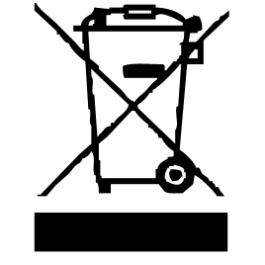

The symbol "STEAM" warns the user that steam can escape from the unit and to take all necessary precautions. (Risk of burns)
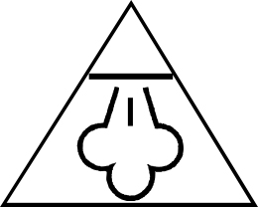

The symbol "CE" is the guarantee of compliance with harmonized European standards, voluntary, reflecting the essential requirements into technical specifications. These standards are not mandatory but are guarantees of compliance with essential requirements.


The symbol ROHS (Restriction of use of some Hazardous Substances) on the Environmental Protection, certifies that for each of the five hazardous substances • Lead • Mercury • (hexavalent) chromium • products for protection against flames PBB and PBDE, the peak concentration is equal to or less than 0.1% of the weight of homogeneous material, and 0.01% for the 6th • cadmium.

The symbol "TRIMAN" indicates that the consumer is invited to dispose the product as part of a separate collection (eg recycling bin, waste, voluntary intake point).


The symbol " CMIM " is the guarantee of compliance with optional harmonized Moroccan Standards, which reflect the essential requirements in terms of technical specifications.
These standards are not mandatory but ensuring compliance with the essential requirements.

For more information : http://www.quefairedemesdechets.fr

CLEANING AND MAINTENANCE

- Always unplug the unit and allow it to cool before cleaning.
- Clean the outside of the appliance with a sponge or slightly damp cloth.
- Never immerse the appliance in water or any other liquid!
- Never use abrasive products, wire brush or other sharp objects.
- Remove the fabric brush from its steam head and clean using with a damp cloth.
- Do not drop, throw or try and bend the steamer.
- The garment steamer is designed to be used with normal tap water.
- do not put perfume, vinegar, or other chemicals in the tank.
Note : the appliance is not designed to work with chemicals.
- Always empty the water tank after each use and rinse with clean water.
- Wipe outer surfaces with a damp cloth.
- Avoid operating the appliance in humid or moist places.
- Always ensure the steam outlet hole is clean and free from scaling and not blocked.

CLEAN AND RECEIVE

      - Do not dip the product into water or other solutions.
      - Do not put vinegar, detergent, brine solution and other chemicals in the tank.
      - Do not use wire balls and abrasive detergent to clean this product.
When the product is fully cooled, the wet cloth and non-corrosive liquid cleaner are cleaned, and the dirt and sediment in the steam nozzle are cleaned.

KNOW YOUR DEVICE

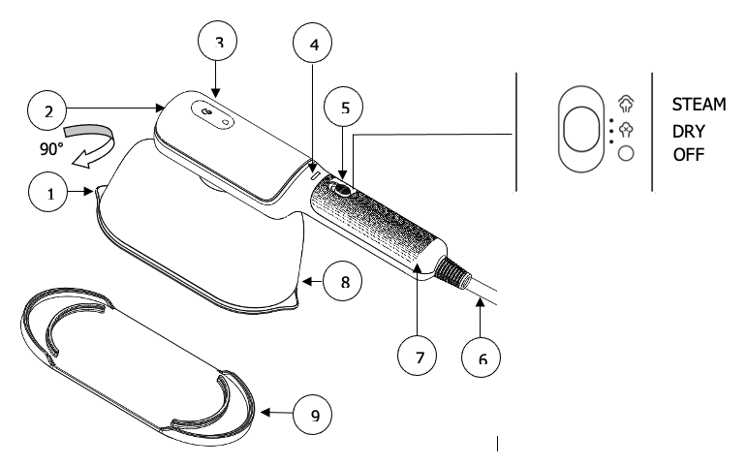

  - Soleplate
  - Water tank
  - Inlet cover
  - Indicator lights
  - Switch button
  - Power cord
  - Handle
  - Main body
  - Stand

FIRST USE

Remove any sticker or protection from the steam diffuser.
Unroll and straighten the cord before use.
When using for the first time, let the steam escape for a few minutes. This will remove any impurities and odours that may have been left over from the manufacturing process.
It is best to try it on a piece of fabric before using it on clothing.

USE

      - Check if the item is switch off and unplug.
      - Open the water tank.
      - Fill the tank 2/3 full with fresh water.
      - Note: Always make sure the water tank is at least 1/3 full.
      - Close the water tank.
      - Hold the appliance with one hand by the handle of the steamer, And this, in a vertical position.
      - (If necessary,) Use the other hand to attach the brush to the steam diffuser.
      - Note: the brush can be attached in either direction and locks with an audible “click”.
      - The product is plugged into the power socket indicator, and then switch button is in “DRY” position. The indicator lights is bright at the same time, which means that the product is heated up. The steam is used, when switch button is in “STEAM” position after the heating time, and the specific operation is as follows.
      - The head is plugged into the power socket indicator, which means that the product is heated up.
      - This product has no temperature indicator, so it is recommended that the heating time will be over 30 seconds.
      - When the first use of the water may be used with a water ball next to the steam plate hole, the condensation water belongs to the normal phenomenon.
      - Switch button is in “STEAM” position and the pump starts working, and the steam is from the evaporator hole.
      - When vertical steaming, need to rotate the main body 90 degrees clockwise.
      - The unplastic panel is not used in the use of the desktop.
      - When hot, the collection is not used, it is recommended to heat a cycle and remove the internal water from the pipe.
      - Please pull out the power supply when used.

STEAMING TIPS

- To prepare your fabric for steaming, brush it with another soft cushion brush not provided with the item. This will loosen the fibers and allow better steam penetration.
- Hang your garment or fabric. Note: Avoid using metal clothes hangers, if possible.
- Pass the steam jets just above the fabric where the wrinkles are .It may take a few passes to remove the wrinkles completely.
- After use, unplug steamer and empty any remaining water from the tank to avoid leakage.
- CAUTION: When hanging garment on a door while steaming, be careful not to damage the door with steam.
- First test unit on an inconspicuous area of the item to ensure fabric can tolerate the effects of steam. If there is no evidence of damage, you can proceed to use the steamer on that item.

GENERAL INSTRUCTIONS

It is possible to use purified water, however, this appliance is designed to work perfectly with tap water, regardless of the water hardness.

STORAGE

-Ensure the unit is completely cool and dry.
- Empty the reservoir by turning the apparatus upside down and gently shaking it.
-Do not wrap the cord around the appliance, as this will cause damage.
- Always put the apparatus away in a vertical position.
-Keep the appliance in a cool, dry place out of reach of children.

GUARANTEE IN ACCORDANCE WITH REGULATIONS

Before being delivered, all our products are subjected to rigorous checks.

This device is guaranteed for 24 months from the date of purchase of the product by the consumer.

The warranty documents are:

• the invoice and

• the warranty certificate (located on the side or the bottom of the box) stamped and completed.

Without these supporting documents, no free replacement or free repair can be made.

During the warranty period, we take charge, free of charge, for defects in the device or accessories, resulting from a defect in materials or workmanship by repair or replacement.

Services under the legal guarantee do not entail any extension of the guarantee period and do not give the right to a new guarantee.

In the event of a warranty claim, return the complete device to your dealer,

in its original packaging, accompanied by proof of purchase.

The breakage of glass or plastic parts is, in all cases, your responsibility.

Wearing parts (for example: motor brushes, hooks, drive belts, spare remote control, spare toothbrushes, saw blades etc.) as well as their cleaning, maintenance or replacement, are not guaranteed, and are therefore at your expense.

In the event of foreign intervention, the guaranteed lapses.

After expiry of the warranty period, repairs can be carried out, against payment, by a specialist dealer or a repair service.

SPECIFICATIONS

Power supply 220-240V~ 50-60Hz
Power 1200 W
Norm Class I
Made In P.R.C

The characteristics can change without prior notice.

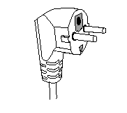
This unit is equipped with an electrical outlet with earth and must be earthed in an according plug.
Note: In the event of question concerning the earth or electric connection, please consult qualified personnel.
In the event of short-circuit, earthing reduces the risk of electric shock while making possible the current to be evacuated by the wire of ground.

CAUTION: In order to minimize the risks of electric shock, In the event of breakdown, not to open the case but to call upon a qualified technician for repairs.

This apparatus satisfied EC directives, it was controlled according to all the European current directives, like: electromagnetic compatibility (EMC) and low tension (LVD).

This apparatus was designed and manufactured in respect of the last safety regulations and technical specifications.

DECEMBRE 2024

