
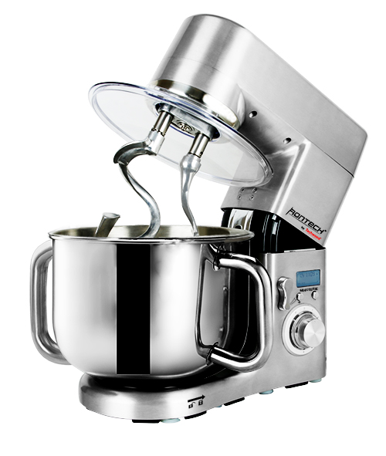
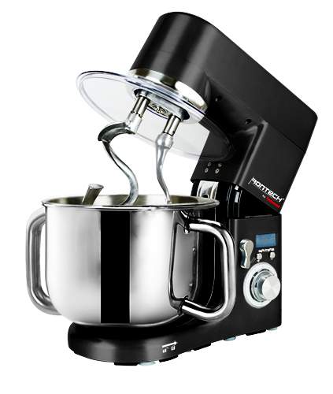

RT-4372

RT-4376

RT-4372

RT-4376

PROFESSIONAL STAND MIXER

Instruction manual

IMPORTANT SAFEGUARDS
Dear consumer, Please read these instructions carefully before use in order to avoid damage due to incorrect use and to better understand the functions of this product. Please pay particular attention to the safety guide.
If you pass the device on to a third party, these Operating Instructions must also be handed over.
Please keep them for future references.

- Please read these instructions carefully before use.
- Keep present instructions for future references.
- Check that your mains voltage corresponds to that stated on the appliance.
- Only use the appliance for domestic purposes and household or similar applications such as:
-staff kitchen areas, in shops, offices and other working environments;
- Environment type like :
• Farm Houses • Bed and Breakfast.
-by clients in hotels, motels and other residential type environments;
Only use the appliance in the way indicated in these instructions.
- Never use this unit near bathtub, shower, wash-hand basins or other containers with water.
- Never use this apparatus near water projections.
- Never use this apparatus with the wet hands.
- If, unfortunately the apparatus is wet, immediately withdraw the cord of the socket-outlet.
- Inform potential users of these instructions.
- Never leave the appliance unsupervised when in use.
- The appliance must be used only for its intended purpose. No responsibility can be taken for any possible damage caused by incorrect use or improper handling.
- Children and persons with disabilities are not always aware of the danger posed by the use of appliances.
- This appliance shall not be used by children.
- This appliance can be used by persons with reduced physical, sensory or mental capabilities or lack of experience and knowledge if they have been given supervision or instruction concerning use of the appliance in a safe way and if they understand the hazards involved.
- Cleaning and maintenance must not be made ​​by children.
- Keep the appliance and its cord out of reach of children.
- This device is not a toy, do not leave children or people with disabilities to play with.
- In order to ensure your children‘s safety, please keep all packaging (plastic bags, boxes, polystyrene etc.) out of their reach.
- Caution ! Do not allow small children to play with the foil :
there is a danger of suffocation !
- From time to time check the cord for damages. Never use the appliance if cord or appliance shows any signs of damage.
- Never immerse the appliance in water or any other liquid for any reason whatsoever.
- Never place it into the dishwasher.
- Never use the appliance near hot surfaces.
- If the supply cord is damaged, it must be replaced by the manufacturer, its service agent or similarly Competent qualified person^{(*)} in order to avoid a hazard.
- Disconnect the power source cable before any operation of cleaning of maintenance and accessories assembly.
- Never use the appliance outside and always place it in a dry environment.
- Never use accessories, which are not recommended by the producer. They could constitute a danger to the user and risk to damage the appliance.
- Never use any other connector than the one provided.
- Never move the appliance by pulling the cord. Make sure the cord cannot get caught in any way.
- Never wind the cord around the appliance and do not bend it
- Ensure that the power cord does not come into contact with hot parts of this unit.
- Make sure the appliance has cooled down before cleaning and storing it.
- The temperature of accessible surfaces may be very high when the appliance is operating. Never touch these parts, of apparatus, to avoid burning itself.
- Make sure the appliance never comes into contact with flammable materials, such as curtains, cloth, etc...& the power cord and plug do not come in contact with water.
- Before cleaning, always unplug the appliance from the power supply and let it cool down.
- This appliance is not intended to be operated by means of an external timer or separate remote-control system.
- Always place the unit on a flat surface. Ensure, also, not to cover the device and not to put anything on it.
- Always remove the plug from the wall socket when the appliance is not in use.
- When using an extension lead always make sure that the entire cable is unwound from the reel. Use solely CE approved extension leads. Input power must be at least 16A, 250V, 3000W.
- Incorrect operation and improper use can damage the appliance and cause injury to the user.
- This device, designed for home use, complies with standards relating to this type of product.

^{(*)} Competent qualified person : after sales department of the producer or importer or any person who is qualified, approved and competent to perform this kind of repairs.

SPECIFIC WARNINGS FOR KITCHEN MACHINES
Warning !
• Always disconnect the appliance from the supply if it is left unattended and before assembling, disassembling or cleaning.
• Switch off the appliance and disconnect from supply before changing accessories or approaching parts that move in use.
• Potential injury may occur during misuse. Care should be taken when handling, emptying the bowl and during cleaning.
• For instructions on cleaning surfaces in contact with food or oil, please refer to the "cleaning" paragraph in the manual.
• For instructions on the use of accessories, operating time and speed settings, refer to the paragraphs below.

GENERAL INFORMATION

The symbol "OPEN BOOK" means a recommendation to read important things contained in the record.

The symbol "BIN" crossed out, abbreviation WEEE (Waste of Electrical and Electronic Equipment) means that at the end of life, it should not be discarded with household waste, but filed to the sorting of the locality. Waste recovery can help preserve our environment.
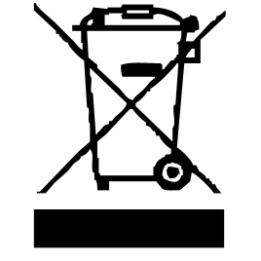

The symbol "CE" is the guarantee of compliance with harmonized European standards, voluntary, reflecting the essential requirements into technical specifications. These standards are not mandatory but are guarantees of compliance with essential requirements.


The symbol ROHS (Restriction of use of some Hazardous Substances) on the Environmental Protection, certifies that for each of the five hazardous substances • Lead • Mercury • (hexavalent) chromium • products for protection against flames PBB and PBDE, the peak concentration is equal to or less than 0.1% of the weight of homogeneous material, and 0.01% for the 6th • cadmium.

The symbol "GLASS / FORK" means that the device is compatible and can come into contact with foodstuffs.


The symbol "TRIMAN" indicates that the consumer is invited to dispose the product as part of a separate collection (eg recycling bin, waste, voluntary intake point).

For more information : http://www.quefairedemesdechets.fr

PRECAUTIONS

• Do not attempt to remove the accessories kneading arms flat beaters or whips after the start of the unit.
• Robot cannot be used to mix dry and hard foods. it may damage the used accessory.
• The whip is to be used only for whites egg or liquid culinary preparations consistency. In use for a hard paste, it may be permanently damaged.
• Before removing the ingredients and or the bowl, the unit's motor must be completely stopped, and unit unplugged.
• Always use the head-lift button to control the opening or closing of the robot arm.
• Keep hands & clothing, moved away from the unit during operation to reduce the risk of injury and damage.
• Use a spatula to remove the food.

USING FOR THE FIRST TIME

- Read this handbook to familiarize yourself with all the parts of your new food processor.
- Clean all the parts and accessories in contact with food before using the appliance for the first time (see paragraph “Cleaning”).

TO KNOW IT’S UNIT

- Lifting part of the robot
- Opening in the lid to add ingredients
- Clear splash-proof lid
- Stainless steel bowl of 10L
- Stainless steel carrying handles
- De / lock button on the upper part of the robot.
- Control LCD screen
- Timer setting buttons
- Gear selector
- Indication of de / blocking of the bowl
- Non-slip feet.

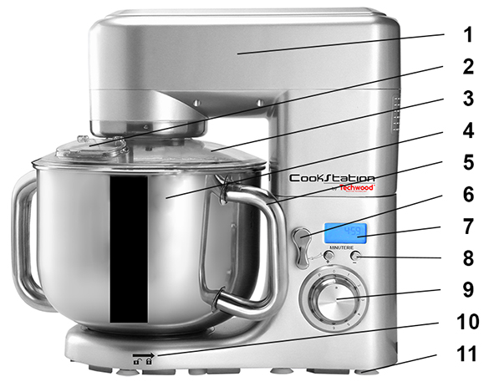

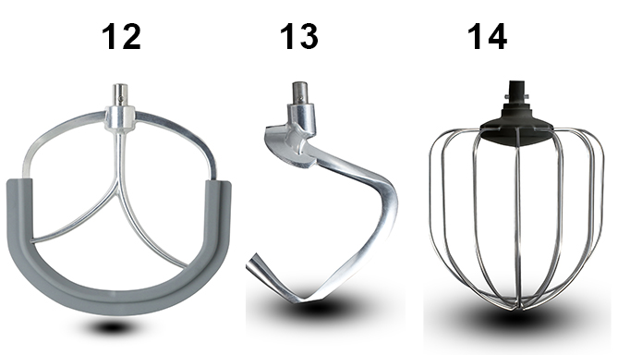

- Flat Beater
- Dough hook
13Bis Second hook
- Whip

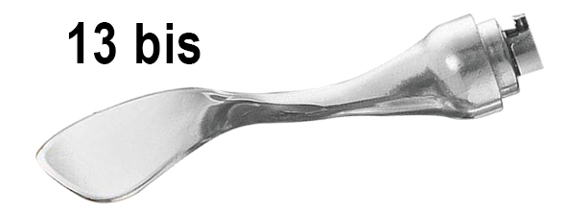

BEFORE FIRST USE

Before using your kneader for the first time
1. Place the mixer on a flat, dry surface such as a bench.
2. Make sure the power cord is unplugged and the speed selector is in the '0' position.
3. Remove all packaging materials and promotional labels.
4. Wash the lid and accessories : flat beater, whisk and dough hook with hot, soapy water. Rinse and dry thoroughly.
Note: these parts can be put in the dishwasher.

IMPLEMENTATION

- Unroll the power cord completely.
- Check that the tension in force in the country where you are corresponds to that indicated on the apparatus.
- Connect the apparatus in a correct socket-outlet, (and connected to the ground if the unit is Class I), to avoid any danger.
- Disconnect the power source cable before any operation of cleaning of maintenance and accessories assembly.
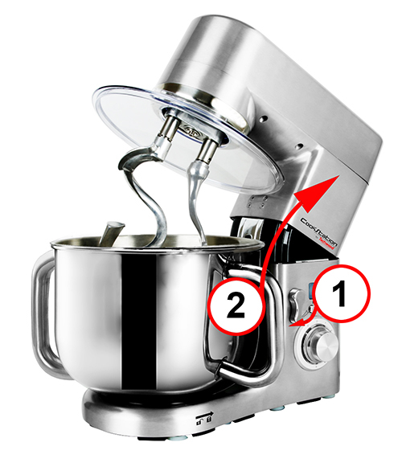
- Never modify the appliance in anyway.

Attaching the mixing bowl

1. Check that the power cord is unplugged and that the speed selector is in the '0' position.
2. Press the unlock button (1).
3. Raise the arm until the top of the unit is in the open position (2).

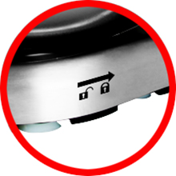

Put the bowl on the base and turn to the left (counter clockwise) until it locks into place. (picture)
Note: Turn the bowl to the right (clockwise) to release it from the base.

Choice and attachment of the accessory
Notes: The device must be in the open position.
Always secure the cover before inserting the accessories.
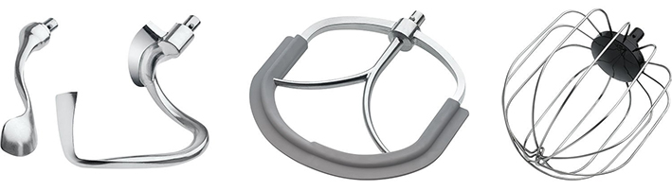

ACCESSORIES | PHOTO | EXAMPLE OF USE
Hook Kneader | 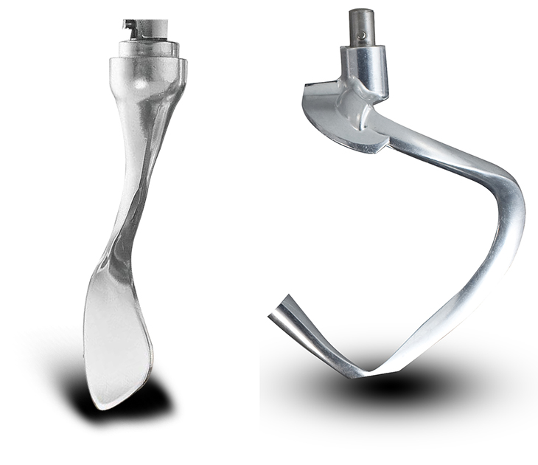 | FLOUR AND DOUG.
Flat Beater | 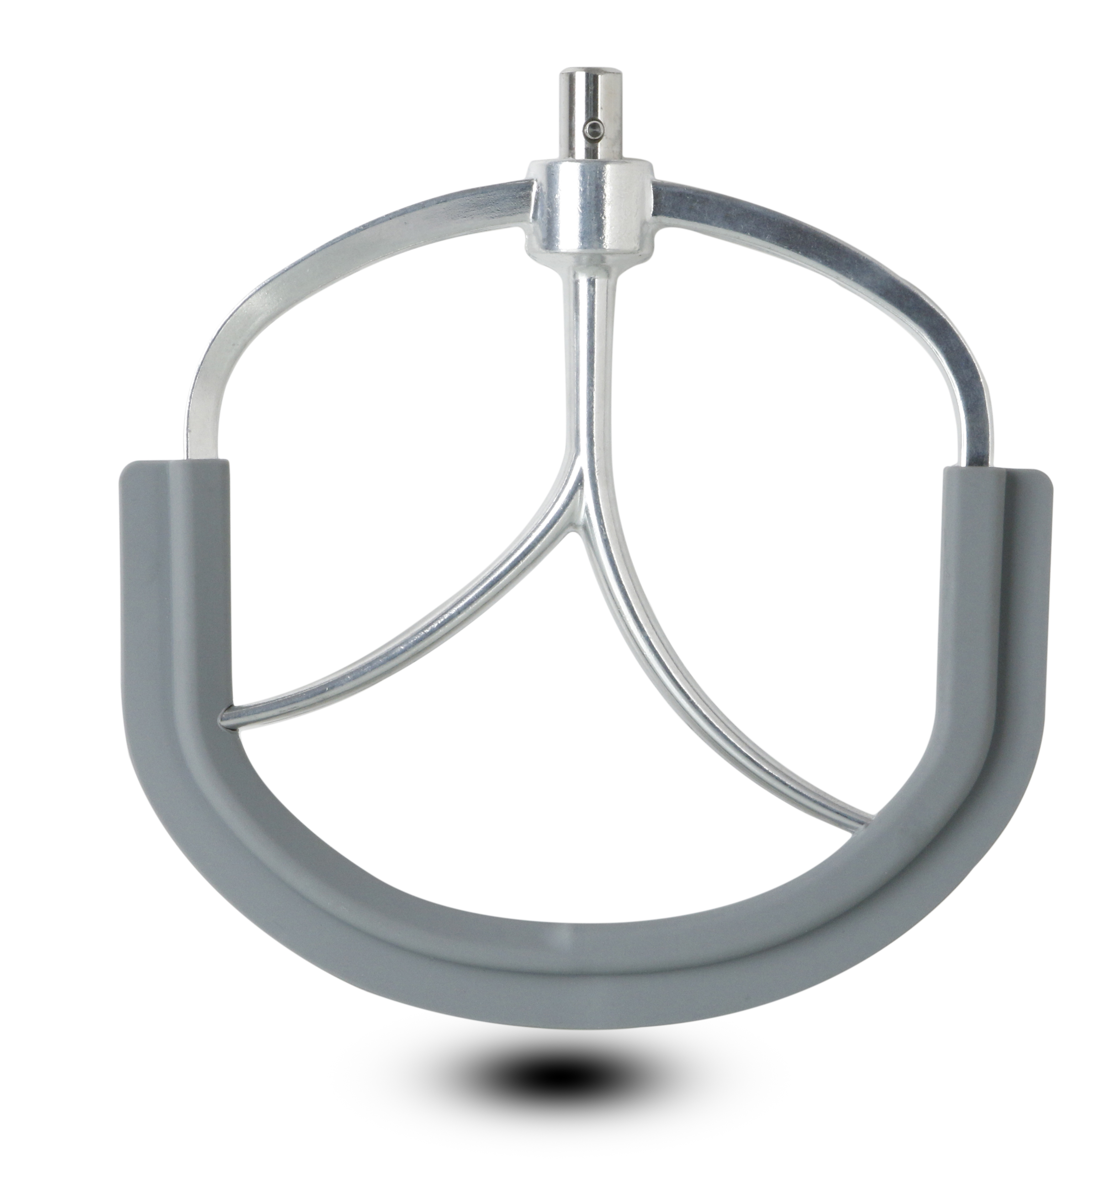 | CREAM AND ENTREMETS.
Whisk | 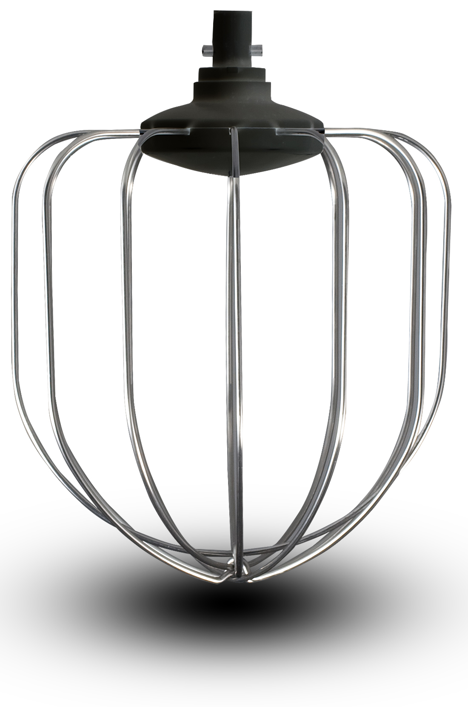 | MIX, WHITE EGGS IN SNOW.
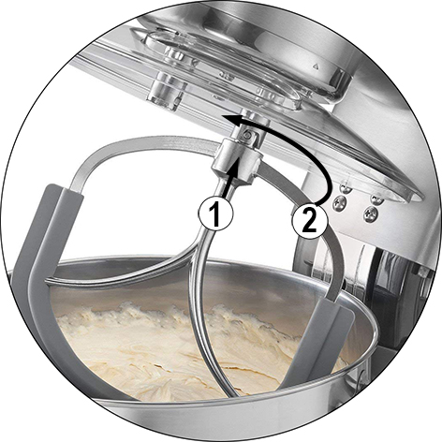
To fix the accessory (s) on the device :
Push the accessory spindle up, (1) onto the protruding protrusion on the protective cover, (attached to the swivel arm) and turn the accessory anticlockwise (to the left) (2), that the accessory snaps properly.

NOTES: The 2 kneading hooks should be used for heavy dough, minced meat or other kneading.
The device comes with 2 hooks. The 2 kneading hooks
are of different shapes and can be used together.
The large hook can be used alone.

The flat beater is used to mix lighter types of pasta.
The whip is used to whip cream, egg whites, etc.

Removing the accessory
1. Make sure the power cord is unplugged and the speed selector on the '0' position.
2. Press the release button, Raise the arm until the top of the device is in the open position.
3. Push the accessory up and turn clockwise (to the right) until the fastener releases from the shaft.
4. Remove the accessory from the attachment shaft.

To start the unit
Note : Never use the appliance without the lid on the bowl to avoid splashing.
1. Check that the speed selector is in '0' position.
2. Plug the unit into a wall outlet.
3. Turn the speed selector to the desired speed.
4. By turning the selector, the mixer starts working.
Note : It is recommended to always start at the lowest speed, then to increase
speed as needed.

To stop the unit
1. Turn the speed selector to '0' position - the robot stops.
2. Unplug the robot.

Guide of Speed and Use of Mixing Accessory
The guide below provides speed settings as an example. It is advisable to make one's own experiment for more precision.
Start at the MIN speed and then increase the speed according to the recipe.

ACCESSORIES | PHOTO | SPEED | TIME | CAPACITY
Hook Kneader | 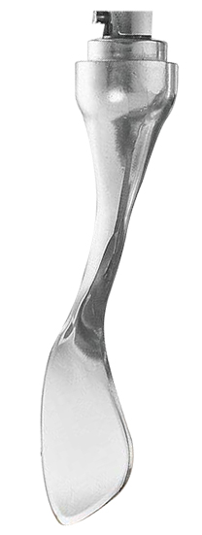  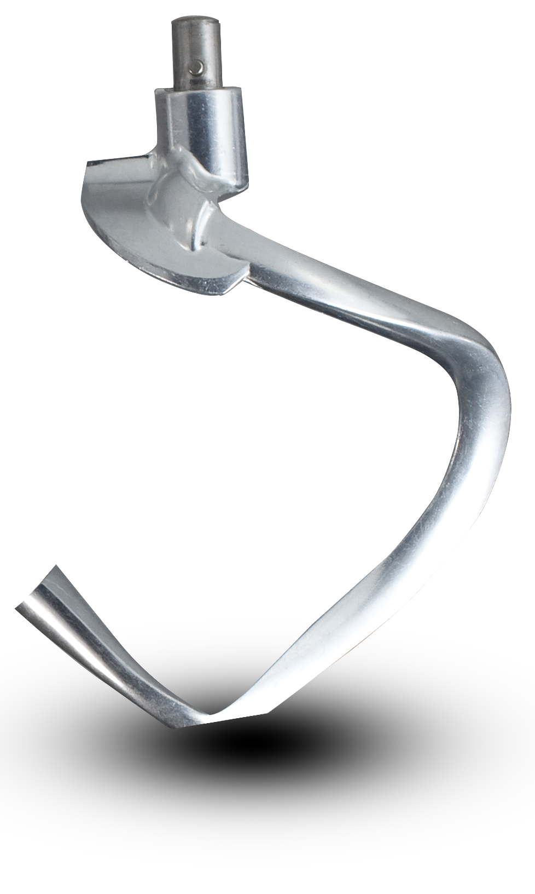 | 1-2 | 30 sec to Speed 1  3-5min to Speed 3 | 1000 g of flour and  600 ml of water
Flat Beater |  | 2-4 | 5-7 min
Whisk |  | 5-6 | 5-7 min | At least 3 white eggs

USE AND TIPS

Do not forget to put the lid on.
Put all the liquid ingredients in the bowl, then add the solid ingredients.
Always stay close to the device during use.
Add the ingredients to the edges of the bowl and not directly to the centre.
Watch out for the rotating accessory.
Start at low speed until the ingredients are well mixed. This will reduce the risk of splashing.
When baking cakes, use speed 1 or 2 for low speed, speed 3/4 for medium speed, and speed 5/6 for high speed.
For best results, blends should be processed within the time indicated in the recipes.
Mixtures containing large amounts of liquid should be processed at low speed to avoid splashing. Increase the speed when the mixture has thickened.
For the mixture of fine dough choose a medium speed.
Regularly, shut down the unit to clean the sides with a rubber spatula.
Pastry dough is one of the thickest, it can be mixed more easily by :
• Adding butter or margarine at room temperature
• Adding ingredient by ingredient while mixing
• Adding a cup of flour at a time
If mixing the dough is difficult, increase the speed. Or, reduce the amount in the bowl.
If, by mistake, something gets stuck in the unit, or if the engine stops, turn off the power and remove the power plug.
Fix the problem and allow the engine to cool down for 5 minutes before restarting the unit.
Notes: Use whisk to whip egg whites or cream.
The whisk is not suitable for thick mixtures such as dough and mashed potatoes.
The device can whip at least 2 or 3 large egg whites with 1 cup of cream.
The whip is most effective when completely immersed in the liquid.

Hand mixer is recommended for small quantities.

Knead or mix dough
Suggested proportion : 5 measures of flour + 3 measures of water.
• Mix at speed 1 for 10 seconds, at speed 2 for 10 seconds, then at speed 3 for 3 minutes.
When filling the bowl, take care not to exceed the maximum amount.
Maximum quantity of flour : 3000g.
Use, preferably, as an accessory the dough hook or the whisk.
Maximum usage time : 5 minutes continuously, at medium speed.

Beat white eggs or whipped cream
1. Select the speed of 4 or 5, Beat the eggs for about 5 minutes without interruption, depending on the size of the eggs, until you obtain a firm mixture. (Put a pinch of salt at the beginning, to harden the mixture)
• Maximum amount of eggs : 30.
2. For the whipped cream, beat 250ml of cream at speed 4 to 5 for about 5 minutes.
When filling the bowl with milk, cream or any other ingredient, take care not to exceed the maximum volume of the kneader.
Preferably use as an accessory : the whisk.
Maximum operating time : 10 minutes continuously, at medium speed.

CLEANING AND MAINTENANCE

Before cleaning, always: switch off the appliance, disconnect the apparatus and let it cool.
Clean the outside of the apparatus with a sponge or slightly wet linen.
The parts (removable) in contact with food like plate, bowl, forks, Spatula etc. can be washed in hot water with sponge and soft detergent or put in the dishwasher.
Never plunge the apparatus in water or all other liquid !
Do not use abrasive cleaners, gritting, or metal brush or another cutting object.

STORAGE

-Ensure the unit is completely cool and dry.
-Do not wrap the cord around the appliance, as this will cause damage.
-Keep the appliance in a cool, dry place and out of reach from children.
GUARANTEE

Before being delivered, all our products are subjected to a rigorous control.
This apparatus is guaranteed 24 months starting from the date of purchase by the consumer.
The documents in proof of guarantee are :
• The invoice and
• The filled and stamped warranty plate (located on side or bottom of the gift box). Without these documents in proof, no free replacement, nor no free repair, can be carried out.
During the warranty period, we deal for free, the defects of the apparatus or the accessories, rising from a defect of materials or manufacture by repair or, replacement. The services within the framework of the guarantee do not involve any extension of the warranty period and does not give right to a new guarantee !
In the event of recourse to the guarantee, bring back the complete apparatus to your retailer, in its original packing, accompanied by the proofs of purchase.
The breakage of parts out of glass or plastic is, in all the cases, not warranted. Defects on the accessories or the wearing parts (for example: coals of engines, hooks, drive belts, remote control of replacement, teeth brushes of replacement, webs etc) as well as cleaning, maintenance or it replacement of wearing parts are not guaranteed and are thus to pay !
In the event of foreign intervention, the guarantee becomes null and void.
After flow of the warranty period, repairs can be carried out, against payment, by a specialized trade or a repair service.

SPECIFICATIONS

Power supply 220-240V~ 50/60Hz
Power 1500W
Norm Class I
Bowl Capacity 10 L
Made in PRC

The characteristics can change without prior notice.

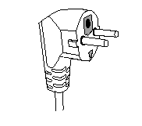
This unit is equipped with an electrical outlet with earth and must be earthed in an according plug.
Note : In the event of question concerning the earth or electric connection, please consult a qualified personnel.
In the event of short-circuit, earthing reduces the risk of electric shock while making possible the current to be evacuated by the wire of ground.

CAUTION: In order to minimize the risks of electric shock, In the event of breakdown, not to open the case but to call upon a qualified technician for repairs.

This device complies with EC directives, it was controlled according to all current European directives, applicable such as: electromagnetic compatibility (EMC) and low voltage (LVD).

This device has been designed and manufactured in compliance with the latest regulations and technical requirements for safety.

Imported by Sotech International
" LE PERIPOLE " N°A-107
33, Avenue du Marechal de Lattre de Tassigny
94120 Fontenay-sous-Bois - France

