TPE-209


STAINLESS STEEL DOUBLE HOT PLATE

INSTRUCTION MANUAL

IMPORTANT SAFEGUARDS
TPE-204
Dear consumer, Please read these instructions carefully before use in order to avoid damage due to incorrect use and to better understand the functions of this product. Please pay particular attention to the safety guide. If you pass the device on to a third party, these Operating Instructions must also be handed over. Please keep them for future references.

- Please read these instructions carefully before use.
- Keep present instructions for future references.
- Check that your mains voltage corresponds to that stated on the appliance.
- Only use the appliance for domestic purposes and household or similar applications such as:
-staff kitchen areas, in shops, offices and other working environments;
-by clients in hotels, motels and other residential type environments;
- Environment type like :
• Farm Houses • Bed and Breakfast.
- Only use the appliance in the way indicated in these instructions.
- Never use this unit near bathtub, shower, wash-hand basins or other containers with water.
- Never use this apparatus near water projections.
- Never use this apparatus with the wet hands.
- If, unfortunately the apparatus is wet, immediately withdraw the cord of the socket-outlet.
- Inform potential users of these instructions.
- Never leave the appliance unsupervised when in use.
- The appliance must be used only for its intended purpose. No responsibility can be taken for any possible damage caused by incorrect use or improper handling.
- Children and persons with disabilities are not always aware of the danger posed by the use of appliances.
- This appliance can be used by children aged from 8 years and above and persons with reduced physical, sensory or mental capabilities or lack of experience and knowledge if they have been given supervision or instruction concerning use of the appliance in a safe way and understand the hazards involved.
- Children shall not play with the appliance.
- Cleaning and user maintenance shall not be made by children unless they are older than 8 and supervised.
- Keep the appliance and its cord out of reach of children aged less than 8 years of age when it is energized or cooling down.
- This device is not a toy, do not leave children or people with disabilities to play with.
- In order to ensure your children‘s safety, please keep all packaging (plastic bags, boxes, polystyrene etc.) out of their reach.
- Caution ! Do not allow small children to play with the foil :
there is a danger of suffocation !
- From time to time check the cord for damages. Never use the appliance if cord or appliance shows any signs of damage.
- Never immerse the appliance in water or any other liquid for any reason whatsoever.
- Never place it into the dishwasher.
- Never use the appliance near hot surfaces.
- If the supply cord is damaged, it must be replaced by the manufacturer, its service agent or similarly Competent qualified person^{(*)} in order to avoid a hazard.
- Disconnect the power source cable before any operation of cleaning of maintenance and accessories assembly.
- Never use the appliance outside and always place it in a dry environment.
- Never use accessories, which are not recommended by the producer. They could constitute a danger to the user and risk to damage the appliance.
- Never use any other connector than the one provided.
- Never move the appliance by pulling the cord. Make sure the cord cannot get caught in any way.
- Never wind the cord around the appliance and do not bend it
- Ensure that the power cord does not come into contact with hot parts of this unit.
- Make sure the appliance has cooled down before cleaning and storing it.
- The temperature of accessible surfaces may be very high when the appliance is operating. Never touch these parts, of apparatus, to avoid burning itself.
- Make sure the appliance never comes into contact with flammable materials, such as curtains, cloth, etc...& the power cord and plug do not come in contact with water.
- Before cleaning, always unplug the appliance from the power supply and let it cool down.
- This appliance is not intended to be operated by means of an external timer or separate remote-control system.
- Always place the unit on a table or flat surface. Ensure, also, not to cover the device and not to put anything on it.
- Always remove the plug from the wall socket when the appliance is not in use.
- When using an extension lead always make sure that the entire cable is unwound from the reel. Use solely CE approved extension leads. Input power must be at least 16A, 250V, 3000W.
- Incorrect operation and improper use can damage the appliance and cause injury to the user.
- This device complies with standards relating to this type of product.
- The appliance must be used and rested on a table or flat & stable surface.
- The item must not be left unattended when it is connected to main supply.
- During operation, the surface temperature of the unit may be hot.
- The heating elements remain warm for a long time after the appliance is switched off.
- The item is not to be used, if it has been dropped or if there are visible signs of damage or if it is leaking.
- This appliance is only intended for household use.
- Regarding the instructions for cleaning, thanks to refer to the below paragraph of the manual.

^{(*)} Competent qualified person : after sales department of the producer or importer or any person who is qualified, approved and competent to perform this kind of repairs

GENERAL INFORMATION

The symbol "OPEN BOOK" means a recommendation to read important things contained in the record.

The symbol "BIN" crossed out, abbreviation WEEE (Waste of Electrical and Electronic Equipment) means that at the end of life, it should not be discarded with household waste, but filed to the sorting of the locality. Waste recovery can help preserve our environment.
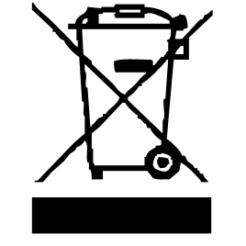

The symbol "CE" is the guarantee of compliance with harmonized European standards, voluntary, reflecting the essential requirements into technical specifications. These standards are not mandatory but are guarantees of compliance with essential requirements.


The symbol ROHS (Restriction of use of some Hazardous Substances) on the Environmental Protection, certifies that for each of the five hazardous substances • Lead • Mercury • (hexavalent) chromium • products for protection against flames PBB and PBDE, the peak concentration is equal to or less than 0.1% of the weight of homogeneous material, and 0.01% for the 6th • cadmium.


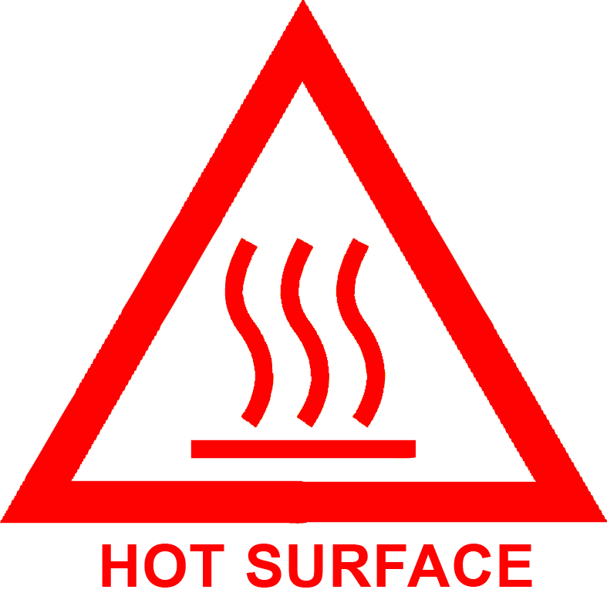
The symbol "HOT WALL" warns the user that the walls of the unit can become very hot, and to take precautions as required.

The symbol "TRIMAN" indicates that the consumer is invited to dispose the product as part of a separate collection (eg recycling bin, waste, voluntary intake point).


For more information : http://www.quefairedemesdechets.fr

FIRST USE

• Unroll the power cord.

• Check the voltage in the country where you are matches that indicated on the unit.

• Ensure that the unit is in the off position before plugging in.

• Plug into a power outlet in good condition, and grounded, to avoid any danger.

• Disconnect the mains power cable before maintenance cleaning operation and installation of accessories.

• Always place the unit on a table or horizontal flat surface.

• Never modify the device.

• Warm up the plate for about 5 minutes to remove the protective product.

Note: There may be a little smoke clears, this is normal and will pass soon.

• Remember to ventilate the room.

• The cooking utensil used (pot, pan etc.) must under no circumstances be larger in diameter than the plate.

OPERATION INSTRUCTIONS

Before plugging in your new hot plate, check to see that the electric circuit is not overloaded with other appliances.
Be certain that your unit is resting level on the countertop.
Avoid using pans that are unstable and easily tipped.
Place pan on heating element.
Turn the Thermostat out of the end of “ MIN” position. The pilot light will glow indicating the heating element is energized and heating will begin immediately. The degree of heating is adjustable with the thermostat, with
“ MIN” = LOW
“MAX” = HIGH
The metal surfaces will become hot. Do not touch while is use. When cooking is finished, turn the thermostat back to the end of “ MIN” position. If the hotplate is not to be in use for a long period of time, it is recommended to unplug unit from the outlet. This helps to prevent accidental burns.

CLEANING

Always unplug unit from electrical outlet and allow cooling before cleaning.
Never immerse in water.
Use damp soapy cloth or sponge to clean surface of hotplate, chrome burner ring, drip pan and base. The sponge or cloth should only be damp without water dripping to avoid water leaking into the hotplate.
Never use harsh abrasives or steel wool pads on any part of unit.
Caution : This appliance must be earthed.

STORAGE

-Ensure the unit is completely cool and dry.
-Do not wrap the cord around the appliance, as this will cause damage.
-Keep the appliance in a cool, dry place.

GUARANTEE

Before being delivered, all our products are subjected to a rigorous control.
This apparatus is guaranteed 24 months starting from the date of purchase by the consumer.
The documents in proof of guarantee are :
• The invoice and
• The filled and stamped warrantee plate (located on side or bottom of the gift box). Without these documents in proof, no free replacement, nor no free repair, can be carried out.
During the warranty period, we deal for free, the defects of the apparatus or the accessories, rising from a defect of materials or manufacture by repair or, replacement. The services within the framework of the guarantee do not involve any extension of the warranty period and does not give right to a new guarantee !
In the event of recourse to the guarantee, bring back the complete apparatus to your retailer, in its original packing, accompanied by the proofs of purchase.
The breakage of parts out of glass or plastic is, in all the cases, not warranted. Defects on the accessories or the wearing parts (for example: coals of engines, hooks, drive belts, remote control of replacement, teeth brushes of replacement, webs etc) as well as cleaning, maintenance or it replacement of wearing parts are not guaranteed and are thus to pay !
In the event of foreign intervention, the guarantee becomes null and void.
After flow of the warranty period, repairs can be carried out, against payment, by a specialized trade or a repair service.

SPECIFICATIONS

Power supply 220-240V~ 50/60Hz
Power 2500W (= 1000+1500W)
Norm Class I
Made in PRC

The characteristics can change without prior notice.

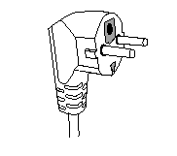
This unit is equipped with an electrical outlet with earth and must be earthed in an according plug.
Note : In the event of question concerning the earth or electric connection, please consult a qualified personnel.
In the event of short-circuit, earthing reduces the risk of electric shock while making possible the current to be evacuated by the wire of ground.

CAUTION: In order to minimize the risks of electric shock, In the event of breakdown, not to open the case but to call upon a qualified technician for repairs.

This apparatus satisfied EC directives, it was controlled according to all the European current directives, like: electromagnetic compatibility (EMC) and low tension (LVD).

This apparatus was designed and manufactured in respect of the last safety regulations and technical specifications.

Imported by Sotech International
" LE PERIPOLE " N°A-107
33, Avenue du Marechal de Lattre de Tassigny
94120 Fontenay sous-bois – France

