TFO-381
TFO-386



ELECTRIC OVEN

WITH ROTISSERIE AND CONVECTION

INSTRUCTION MANUAL
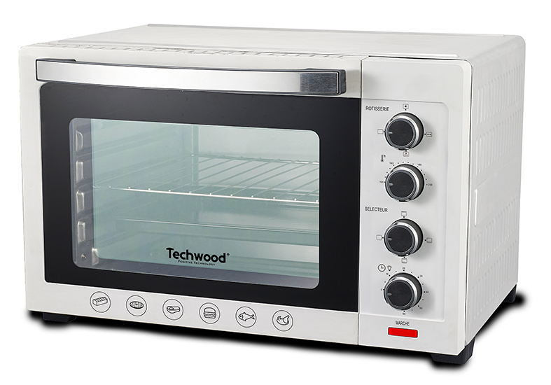
TFO-386
TFO-381
Dear consumer, Please read these instructions carefully before use in order to avoid damage due to incorrect use and to better understand the functions of this product. Please pay particular attention to the safety guide. If you pass the device on to a third party, these Operating Instructions must also be handed over.
Please keep them for future references.

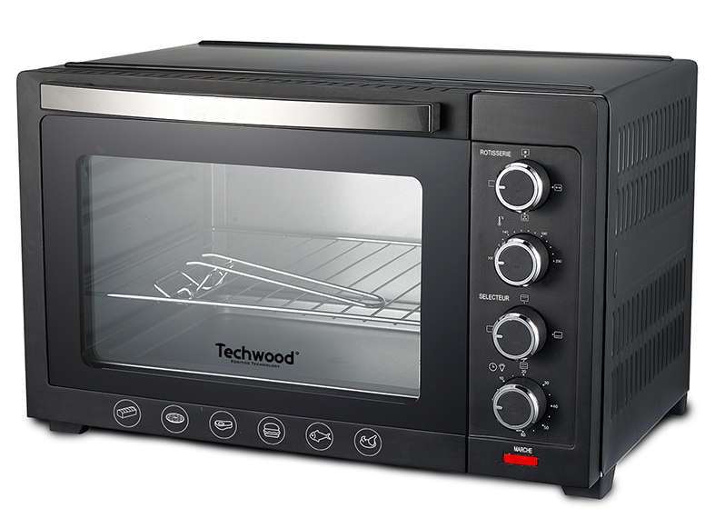
IMPORTANT SAFEGUARDS

- Please read these instructions carefully before use.
- Keep present instructions for future references.
- Check that your mains voltage corresponds to that stated on the appliance.
- Only use the appliance for domestic purposes and household or similar applications such as:
- staff kitchen areas, in shops, offices and other working environments;
- By clients in hotels, motels and other residential type environments;
- Environment type like :
• Farm Houses • Bed and Breakfast.
- Only use the appliance in the way indicated in these instructions.
- Never use this unit near bathtub, shower, wash-hand basins or other containers with water.
- Never use this apparatus near water projections.
- Never use this apparatus with the wet hands.
- If, unfortunately the apparatus is wet, immediately withdraw the cord of the socket-outlet.
- Inform potential users of these instructions.
- Never leave the appliance unsupervised when in use.
- The appliance must be used only for its intended purpose. No responsibility can be taken for any possible damage caused by incorrect use or improper handling.
- Children and persons with disabilities are not always aware of the danger posed by the use of appliances.
- This device can be used by children aged 8 years and older and adults, with reduced physical, sensory or mental capabilities or lack of experience and knowledge, if they have been given supervision or instruction concerning use of the appliance in a safe way and understand the hazards involved.
- Cleaning and user maintenance shall not be made by children unless they are older than 8 and supervised.
- Children shall not play with the appliance.
- Keep the appliance and its cord out of reach of children aged less than 8 years.
- This device is not a toy, do not leave small children or people with disabilities to play with.
- In order to ensure your children‘s safety, please keep all packaging (plastic bags, boxes, polystyrene etc.) out of their reach.
- Caution ! Do not allow small children to play with the foil :
there is a danger of suffocation !
- From time to time check the cord for damages. Never use the appliance if cord or appliance shows any signs of damage.
- Never immerse the appliance in water or any other liquid for any reason whatsoever.
- Never place it into the dishwasher.
- Never use the appliance near hot surfaces.
- Do not operate the appliance with a damaged cord or plug, or after the appliance has been damaged in any manner.
- If the supply cord or appliance is damaged, it must be replaced by the manufacturer or its service agent or a similarly qualified person in order to avoid a hazard.
- Disconnect the power source cable before any operation of cleaning of maintenance and accessories assembly.
- Never use the appliance outside and always place it in a dry environment.
- Never use accessories, which are not recommended by the producer. They could constitute a danger to the user and risk to damage the appliance.
- Never use any other connector than the one provided.
- Never move the appliance by pulling the cord. Make sure the cord cannot get caught in any way.
- Never wind the cord around the appliance and do not bend it
- Ensure that the power cord does not come into contact with hot parts of this unit.
- Make sure the appliance has cooled down before cleaning and storing it.
- The temperature of accessible surfaces may be very high when the appliance is operating. Never touch these parts, of apparatus, to avoid burning itself.
- Make sure the appliance never comes into contact with flammable materials, such as curtains, cloth, etc...& the power cord and plug do not come in contact with water.
- Before cleaning, always unplug the appliance from the power supply and let it cool down.
- This appliance is not intended to be operated by means of an external timer or separate remote-control system.
- Always place the unit on a flat surface. Ensure, also, not to cover the device and not to put anything on it.
- Always remove the plug from the wall socket when the appliance is not in use.
- When using an extension lead always make sure that the entire cable is unwound from the reel. Use solely CE approved extension leads. Input power must be at least 16A, 250V, 3000W.
- Incorrect operation and improper use can damage the appliance and cause injury to the user.
- This device, designed for home use, complies with standards relating to this type of product.
- The appliance must be used and rested on a table or flat & stable surface.
- The item must not be left unattended when it is connected to main supply.
- The item is not to be used, if it has been dropped or if there are visible signs of damage or if it is leaking.
- This appliance is only intended for household use.
- Regarding the instructions for cleaning, thanks to refer to the below paragraph of the manual.
- Regarding the details on how to clean surfaces in contact with food, refer to the below paragraphs.

GENERAL INFORMATION

The symbol "OPEN BOOK" means a recommendation to read important things contained in the record.

The symbol "BIN" crossed out, abbreviation WEEE (Waste of Electrical and Electronic Equipment) means that at the end of life, it should not be discarded with household waste, but filed to the sorting of the locality. Waste recovery can help preserve our environment.
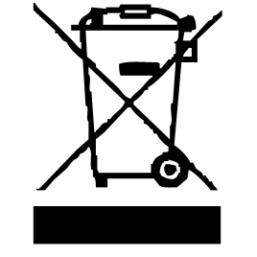

The symbol "CE" is the guarantee of compliance with harmonized European standards, voluntary, reflecting the essential requirements into technical specifications. These standards are not mandatory but are guarantees of compliance with essential requirements.


The symbol ROHS (Restriction of use of some Hazardous Substances) on the Environmental Protection, certifies that for each of the five hazardous substances • Lead • Mercury • (hexavalent) chromium • products for protection against flames PBB and PBDE, the peak concentration is equal to or less than 0.1% of the weight of homogeneous material, and 0.01% for the 6th • cadmium.


The symbol "HOT SURFACE" warns the user that the walls of the unit can become very hot, and to take precautions as required.

The symbol "TRIMAN" indicates that the consumer is invited to dispose the product as part of a separate collection (eg recycling bin, waste, voluntary intake point).

For more information : http://www.quefairedemesdechets.fr

COMMAND LOCATION

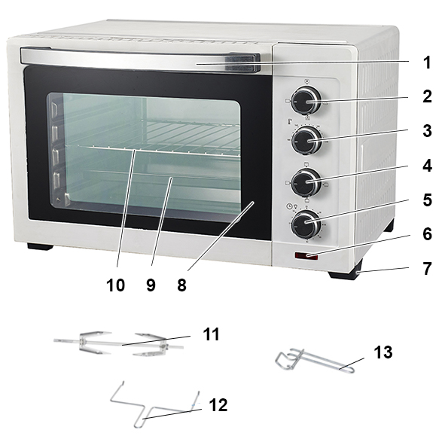

- Door handle
- Function selector
- Temperature selector
- Heating selector
- Timer + interior lamp
- Indicator light
- Non-slipping feet

Glass Door
- Bake tray
- Wire rack
- Rotisserie
- Rotisserie handle

Tray handle

FIRST USE

Before using the oven for the first time, remove the unit and all accessories carefully and paying attention to the sharp accessories.
1. Wash all accessories from the oven with mild detergent and rinse with clean water. Dry all accessories.
2. Preheat the oven to HIGHEST temperature for 15 minutes to remove any packing odour may remain after shipping.

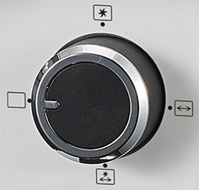
FUNCTION SELECTOR

- Oven in Stop mode
* Convection
<-> Rotisserie
* Rotisserie + Convection
<->

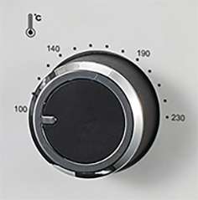
TEMPERATURE CONTROL

To choose the desired temperature from 100 °C to 230°C for baking broiling or toasting.

HEATING SELECTOR
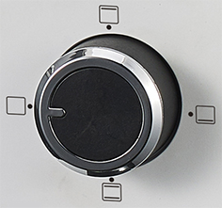
Off / upper / lower / upper + lower

- 0 = STOP
- Grill (upper heating)
For broiling fish, steak, poultry, pork chops, etc.
- Bake (lower heating)
For cakes, pies, cookies,
- Oven Roaster (upper & lower heating )
For bread, muffins, frozen waffles, pizza, rotisserie, Meat etc.
also can be for poultry, beef, pork, etc.

TIMER
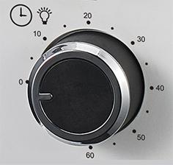
To activate the timer, turn the knob to the right (clockwise).
Notes : Pilot light will illuminate whenever the oven is turned on.
The interior light will also light during the cooking.
The handle supplied with the oven is used to exit
the grid, and the baking tray when they are hot.

CAUTION : Always use extreme care when removing bake tray, wire rack or any hot container from a hot oven.
Always use the rack handle, or an oven mitt when removing or entering hot items from & in the oven.
Note: The rotisserie is automatically activated in position 2 “ Grill ” and 4 “ Oven ”.

USE

- Unroll the power cord completely.
- Check that the tension in force in the country where you are, corresponds to that indicated on the apparatus.
- Connect the apparatus in a correct socket-outlet, (and connected to the ground if the unit is Class I), to avoid any danger.
- Disconnect the power source cable before any operation of cleaning of maintenance and accessories assembly.

Stand the appliance on a table or flat surface.
- Never modify the appliance in anyway.

About Convection Cooking

Convection cooking combines hot air movement by means of a fan with the regular features (broil, bake and toast).
Convection cooking provides faster cooking in many cases than regular radiant types toaster oven. The fan gently sends air to every area of the food, quickly browning, crisping and sealing in moisture and flavour. It produces more even temperature all around the food by air movement, so that food cooks/bakes/broils evenly versus the normal ovens hot and cold spots.
The convection feature allows cooking/baking at lower temperatures, which saves energy and helps keep the kitchen cooler.
Convection air is superheated and it circulates around the food so it cooks food significantly faster than conventional ovens.

HOW TO USE CONVECTION FUNCTION

Set the Heater Selector to “ON”.
Set the Temperature Selector to desire temperature.
Select only : “ Chaleur tournante ” (Convection) for one thing cooking.
Select : “ Chaleur tournante & Tournebroche ” (Convection & rotisserie) If you need to cock 2 different things at the same time.
Note : This function allow to cock 2 different dish without mixing the tastes.

HOW TO BAKE

1. Place the removable grill into the desired position
2. Place the tray on the grill, close the oven door.
3. Turn the timer dial to the desired cooking time.
4. Turn the Heater Selector dial on the position.
5. Turn the Temperature Selector dial for the desired temperature.
6. When finished baking, turn the Timer Selector dial till position "0", to switch off the oven

HOW TO BROIL

1. Insert the removable grill with food and the all-purpose pan
2. Keep the door half-open
3. Turn the Heater Selector dial to the position .
4. Turn the Temperature Selector dial to the desired temperature.
5. When finished broiling, turn the Timer Selector dial till position"0",to switch off the oven

HOW TO USE THE ROTISSERIE FUNCTION

1. Set the Temperature Selector to desire temperature.
2. Set the Heater Selector to “ON”.
3. Set the Function switch to “Grill” or to “Oven”
let the oven preheat and during this time, (+/- 10 minutes)
Inset the pointed end of SPIT through skewer, making sure the points of skewer face in the same direction as pointed end of the spit. Slide skewer towards
square of the spit and secure with thumbscrew.
4. Place food to be cooked on the spit by running the spit directly through the Centre of the food.
5. Place the second skewer into the other end of the roast of poultry and secure skewer with the thumbscrew.
6. Check the food is centred on the SPIT.
7. Set the Function switch to “0”
8. Insert the point end of the spit into the DRIVE SOCKET. make sure the square
end of the spit rests on the spit support.
9. Set again the Function switch to “Grill” or to “Oven”
10. Turn the Timer Selector to the desired cooking time.
11. When cooking is completed, turn the Timer Selector till “O” to switch off and turn the Function switch to the “OFF” position.
Remove the spit by placing the hooks of the rotisserie handle under the grooves on either side of the spit.
Lift the left side of the spit first by lifting it up and out. Then pull the spit out of the oven.

CLEANING AND MAINTENANCE

Before cleaning switch off the appliance, always disconnect the apparatus and to let it cool before cleaning.
Clean the outside of the apparatus with a sponge or slightly wet linen.
The parts (removable) in contact with food like plate, Grid, bowl, forks, Spatula etc. can be washed in hot water with sponge and soft detergent or put in the dishwasher.
Never plunge the apparatus in water or all other liquid !
Do not use abrasive cleaners, gritting, or metal brush or another cutting object.

STORAGE

-Ensure the unit is completely cool and dry.
-Do not wrap the cord around the appliance, as this will cause damage.
-Keep the appliance in a cool, dry place.

GUARANTEE

Before being delivered, all our products are subjected to a rigorous control.
This apparatus is guaranteed 24 months starting from the date of purchase by the consumer.
The documents in proof of guarantee are :
• The invoice and
• The filled and stamped warrantee plate (located on side or bottom of the gift box). Without these documents in proof, no free replacement, nor no free repair, can be carried out.
During the warranty period, we deal for free, the defects of the apparatus or the accessories, rising from a defect of materials or manufacture by repair or, replacement. The services within the framework of the guarantee do not involve any extension of the warranty period and does not give right to a new guarantee !
In the event of recourse to the guarantee, bring back the complete apparatus to your retailer, in its original packing, accompanied by the proofs of purchase.
The breakage of parts out of glass or plastic is, in all the cases, not warranted. Defects on the accessories or the wearing parts (for example: coals of engines, hooks, drive belts, remote control of replacement, teeth brushes of replacement, webs etc) as well as cleaning, maintenance or it replacement of wearing parts are not guaranteed and are thus to pay !
In the event of foreign intervention, the guarantee becomes null and void.
After flow of the warranty period, repairs can be carried out, against payment, by a specialized trade or a repair service.

SPECIFICATIONS

Power supply 220-240V~ 50-60Hz
Power 1600W
Norms Class I
Made in PRC

The characteristics can change without preliminary preventing

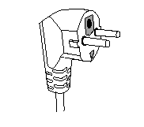
This unit is equipped with an electrical outlet with earth and must be earthed in an according plug.
Note : In the event of question concerning the earth or electric connection, please consult a qualified personnel.
In the event of short-circuit, earthing reduces the risk of electric shock while making possible the current to be evacuated by the wire of ground.
Always unplug the appliance before any cleaning or maintenance operation and accessories assembly.
CAUTION: In order to minimize the risks of electric shock, In the event of breakdown, not to open the case but to call upon a qualified technician for repairs.

This apparatus satisfied EC directives, it was controlled according to all the European current directives, like: electromagnetic compatibility (EMC) and low tension (LVD).

This apparatus was designed and manufactured in respect of the last safety regulations and technical specifications.

Imported by Sotech International
" LE PERIPOLE " N°A-107
33, Avenue du Marechal de Lattre de Tassigny
94120 Fontenay sous bois – France
Made in P.R.C

