
TGPI-1416

TOASTER

INSTRUCTION MANUAL
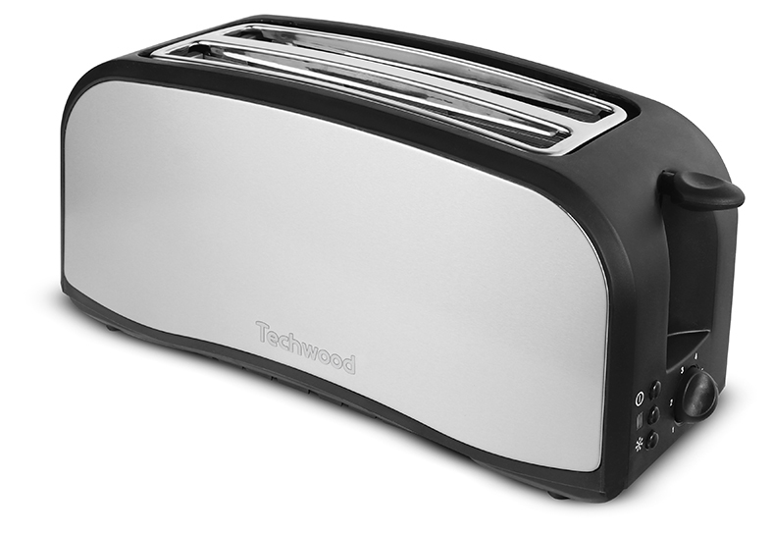
IMPORTANT SAFEGUARDS
Dear consumer, Please read these instructions carefully before use in order to avoid damage due to incorrect use and to better understand the functions of this product. Please pay particular attention to the safety guide.
If you pass the device on to a third party, these Operating Instructions must also be handed over.
Please keep them for future references.

- Please read these instructions carefully before use.
- Keep present instructions for future references.
- Check that your mains voltage corresponds to that stated on the appliance.
- Only use the appliance for domestic purposes and household or similar applications such as:
-staff kitchen areas, in shops, offices and other working environments;
-by clients in hotels, motels and other residential type environments;
- Environment type like :
• Farm Houses • Bed and Breakfast.
- Only use the appliance in the way indicated in these instructions.
- Never use this unit near bathtub, shower, wash-hand basins or other containers with water.
- Never use this apparatus near water projections.
- Never use this apparatus with the wet hands.
- If, unfortunately the apparatus is wet, immediately withdraw the cord of the socket-outlet.
- Inform potential users of these instructions.
- Never leave the appliance unsupervised when in use.
- The appliance must be used only for its intended purpose. No responsibility can be taken for any possible damage caused by incorrect use or improper handling.
- Children and persons with disabilities are not always aware of the danger posed by the use of appliances.
- This appliance can be used by children aged from 8 years and above and persons with reduced physical, sensory or mental capabilities or lack of experience and knowledge if they have been given supervision or instruction concerning use of the appliance in a safe way and understand the hazards involved.
- Cleaning and user maintenance shall not be made by children unless they are older than 8 and supervised.
- Keep the appliance and its cord out of reach of children aged less than 8 years.
- This device is not a toy; do not leave children or people with disabilities to play with.
- In order to ensure your children‘s safety, please keep all packaging (plastic bags, boxes, polystyrene etc.) out of their reach.
- Caution ! Do not allow small children to play with the foil :
there is a danger of suffocation !
- From time to time check the cord for damages. Never use the appliance if cord or appliance shows any signs of damage.
- Never immerse the appliance in water or any other liquid for any reason whatsoever.
- Never place it into the dishwasher.
- Never use the appliance near hot surfaces.
- If the supply cord is damaged, it must be replaced by the manufacturer, its service agent or similarly Competent qualified person^{(*)} in order to avoid a hazard.
- Disconnect the power source cable before any operation of cleaning of maintenance and accessories assembly.
- Never use the appliance outside and always place it in a dry environment.
- Never use accessories, which are not recommended by the producer. They could constitute a danger to the user and risk to damage the appliance.
- Never use any other connector than the one provided.
- Never move the appliance by pulling the cord. Make sure the cord cannot get caught in any way.
- Never wind the cord around the appliance and do not bend it
- Ensure that the power cord does not come into contact with hot parts of this unit.
- Make sure the appliance has cooled down before cleaning and storing it.
- The temperature of accessible surfaces may be very high when the appliance is operating. Never touch these parts, of apparatus, to avoid burning itself.
- The bread may burn, therefore do not use the toaster near or below combustible material, such as curtains.
- Before cleaning, always unplug the appliance from the power supply and let it cool down.
- This appliance is not intended to be operated by means of an external timer or separate remote-control system.
- Always place the unit on a flat surface. Ensure, also, not to cover the device and not to put anything on it.
- Always remove the plug from the wall socket when the appliance is not in use.
- When using an extension lead always make sure that the entire cable is unwound from the reel. Use solely CE approved extension leads. Input power must be at least 16A, 250V, 3000W.
- Incorrect operation and improper use can damage the appliance and cause injury to the user.
- This device, designed for home use, complies with standards relating to this type of product.
- Regarding the instructions for cleaning surfaces in contact with food or and the removal of breadcrumbs, thanks to refer to the below paragraph " MAINTENANCE AND CLEANING " in manual

^{(*)} Competent qualified person : after sales department of the producer or importer or any person who is qualified, approved and competent to perform this kind of repairs.

SPECIFIC SAFETY FOR THIS UNIT

Do not leave the appliance unattended (very dry bread can
sometimes begin to burn in the toaster)
CAUTION: metal parts become hot!
Never insert fork, knife or any other object in the toaster!

GENERAL INFORMATION

The symbol "OPEN BOOK" means a recommendation to read important things contained in the record.

The symbol "BIN" crossed out, abbreviation WEEE (Waste of Electrical and Electronic Equipment) means that at the end of life, it should not be discarded with household waste, but filed to the sorting of the locality. Waste recovery can help preserve our environment.
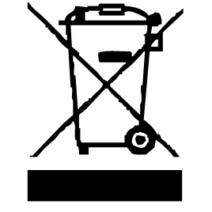

The symbol "CE" is the guarantee of compliance with harmonized European standards, voluntary, reflecting the essential requirements into technical specifications. These standards are not mandatory but are guarantees of compliance with essential requirements.


The symbol ROHS (Restriction of use of some Hazardous Substances) on the Environmental Protection, certifies that for each of the five hazardous substances • Lead • Mercury • (hexavalent) chromium • products for protection against flames PBB and PBDE, the peak concentration is equal to or less than 0.1% of the weight of homogeneous material, and 0.01% for the 6th • cadmium.


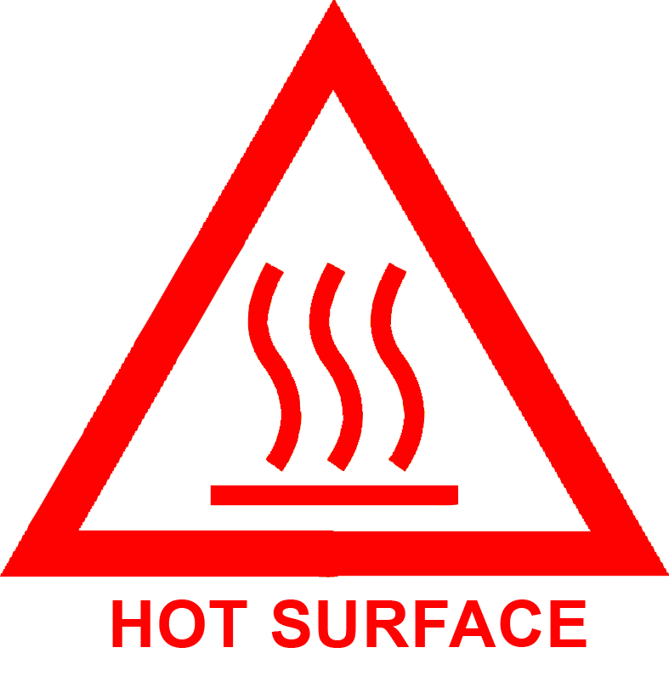
The symbol "HOT WALL" warns the user that the walls of the unit can become very hot, and to take precautions as required.

The symbol "GLASS / FORK" means that the device is compatible and can come into contact with foodstuffs.

The symbol "TRIMAN" indicates that the consumer is invited to dispose the product as part of a separate collection (eg recycling bin, waste, voluntary intake point).

For more information : http://www.quefairedemesdechets.fr

MAINTENANCE AND CLEANING

- Before attempting any cleaning operation, make sure the toaster is unplugged from the supply socket and fully cooled down.
- To remove bread crumbs, slide the crumb tray situated on the side of the appliance.
- Never use sharp objects to clean. Doing so could damage the appliance.
- To clean the exterior surfaces, simply wipe over with a soft damp cloth.
- All other maintenance and repair should be performed by a qualified technician.

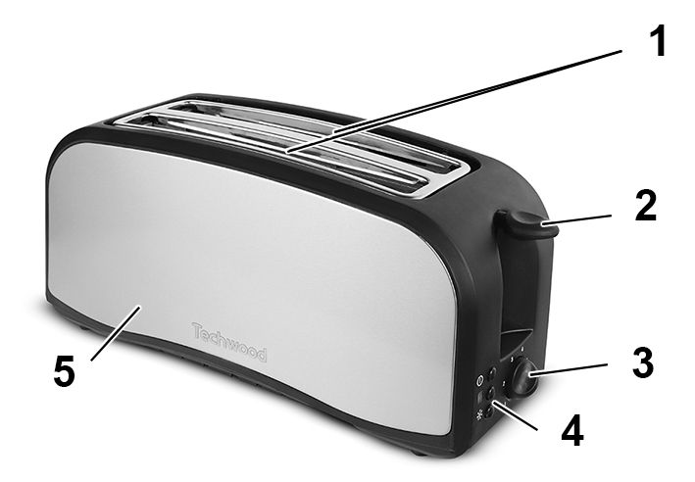
TO KNOW IT’S UNIT

- 2 Large slots
- Bread carriage handle
- Browning control selector
- Functions (see detail below)
- Stainless steel decor

Crumb tray (under the device)

BEFORE FIRST USE

Select the longest heating time and let the device run empty, about 3 minutes, in order to remove the protective layer that factory set on the heating element.

Note : The slight emission of smoke and odour is normal and will stop at

after a few minutes. Remember to well ventilate the room.

USE

- Unroll the power cord completely.
- Check that the tension in force, in the country where you are, corresponds to that indicated on the apparatus.
- Connect the apparatus in a correct socket-outlet, (and connected to the ground if the unit is Class I), to avoid any danger.
- Disconnect the power source cable before any operation of cleaning of maintenance and accessories assembly.

Stand the appliance on a table or flat surface.
- The item must not be left unattended when it is connected to main supply.
- Never modify the appliance in anyway.
- Do not use or keep this product outside.
- Certain parts of the appliance can get hot. Do not touch them, as you may burn yourself.

Functions
Press the corresponding key
- Defrost : to defrost and toast frozen bread.
- Reheat : to reheat already toasted bread.
- Browning : To choose the degree of browning of your toast or your bread,
turn the timer clockwise.
Notes : Position 1 for slightly grilled to position 5 for the most grilled.
If in doubt, start with a lower setting.

OPERATION

Note : Your appliance is provided to receive French bread and pieces of toast
or other bread slices if their thickness and their length are shorter than
the slot.
- Check if any object has fallen into the slot.
- Place one or two slices of bread in the slot (s) of the appliance.
- Lower the bread by pressing the lever until it clicks.
Notes : The bread will start toasting and the appliance will stop automatically.
Toast (s) will go up on their own.
- Let the appliance cool down before putting it away.
- The STOP key is used to interrupt the operation of the device, at any time.

STORAGE

-Ensure the unit is completely cool and dry.
-Do not wrap the cord around the appliance, as this will cause damage.
-Keep the appliance in a cool, dry place.

GUARANTEE

Before being delivered, all our products are subjected to a rigorous control.

This apparatus is guaranteed 24 months starting from the date of purchase by the consumer.

The documents in proof of guarantee are:

• The invoice and

• The filled and stamped warrantee plate (located on side or bottom of the gift box). Without these documents in proof, no free replacement, nor no free repair, can be carried out.

During the warranty period, we deal for free, the defects of the apparatus or the accessories, rising from a defect of materials or manufacture by repair or, replacement. The services within the framework of the guarantee do not involve any extension of the warranty period and does not give right to a new guarantee!

In the event of recourse to the guarantee, bring back the complete apparatus to your retailer, in its original packing, accompanied by the proofs of purchase.

The breakage of parts out of glass or plastic is, in all the cases, not warranted. Defects on the accessories or the wearing parts (for example: coals of engines, hooks, drive belts, remote control of replacement, teeth brushes of replacement, webs etc) as well as cleaning, maintenance or it replacement of wearing parts are not guaranteed and are thus to pay!

In the event of foreign intervention, the guarantee becomes null and void.

After flow of the warranty period, repairs can be carried out, against payment, by a specialized trade or a repair service.

SPECIFICATIONS

Power supply 220-240V~ 50/60Hz
Power 1400W
Norm Class I
Made in PRC

The characteristics can change without prior notice

This unit is equipped with an electrical outlet with earth and must be earthed in an according plug.
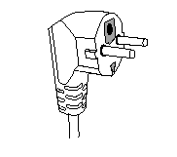
Note: In the event of question concerning the earth or electric connection, please consult a qualified personnel.
In the event of short-circuit, earthing reduces the risk of electric shock while making possible the current to be evacuated by the wire of ground.

CAUTION: In order to minimize the risks of electric shock, In the event of breakdown, not to open the case but to call upon a qualified technician for repairs.

This apparatus satisfied EC directives, it was controlled according to all the European current directives, like: electromagnetic compatibility (EMC) and low tension (LVD).

This apparatus was designed and manufactured in respect of the last safety regulations and technical specifications.

Imported by SoTech International
" LE PERIPOLE " N°A-017
33, Avenue du Marechal de Lattre de Tassigny
94120 Fontenay sous-bois - France

