TGPI-715

TGPI-716



TOASTER
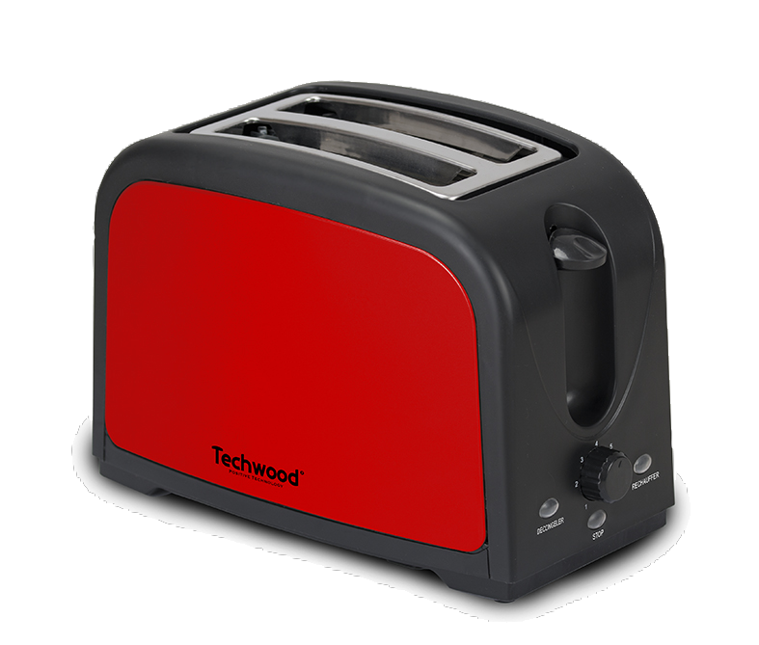

TGPI-715

TGPI-716

INSTRUCTION MANUAL

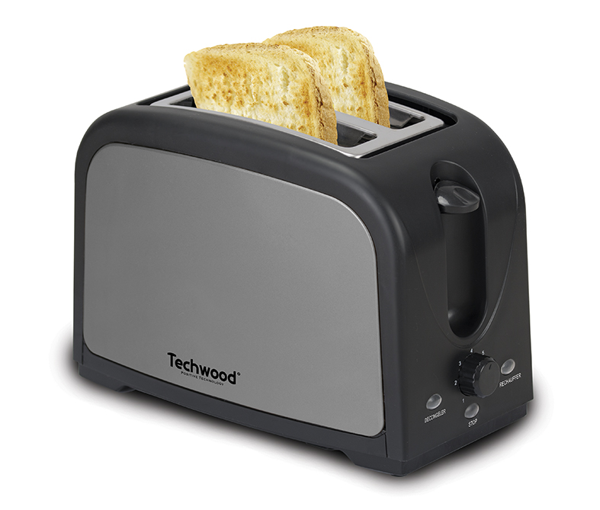
IMPORTANT SAFEGUARDS
Dear consumer, Please read these instructions carefully before use in order to avoid damage due to incorrect use and to better understand the functions of this product. Please pay particular attention to the safety guide.
If you pass the device on to a third party, these Operating Instructions must also be handed over.
Please keep them for future references.

- Please read these instructions carefully before use.
- Keep present instructions for future references.
- Check that your mains voltage corresponds to that stated on the appliance.
- Only use the appliance for domestic purposes and household or similar applications such as :
-staff kitchen areas, in shops, offices and other working environments ;
-by clients in hotels, motels and other residential type environments ;
- Environment type like :
• Farm Houses • Bed and Breakfast.
- Only use the appliance in the way indicated in these instructions.
- Never use this unit near bathtub, shower, wash-hand basins or other containers with water.
- Never use this apparatus near water projections.
- Never use this apparatus with the wet hands.
- If, unfortunately the apparatus is wet, immediately withdraw the cord of the socket-outlet.
- Inform potential users of these instructions.
- Never leave the appliance unsupervised when in use.
- The appliance must be used only for its intended purpose. No responsibility can be taken for any possible damage caused by incorrect use or improper handling.
- Children and persons with disabilities are not always aware of the danger posed by the use of appliances.
- This device can be used by children aged 8 years and older and adults, with reduced physical, sensory or mental capabilities or lack of experience and knowledge, if they have been given supervision or instruction concerning use of the appliance in a safe way and understand the hazards involved.
- Cleaning and user maintenance must not be made ​​by children unless they are older than 8 and supervised.
- Keep the appliance and its cord out of reach of children less than 8 years.
- This device is not a toy, do not leave children or people with disabilities to play with.
- In order to ensure your children‘s safety, please keep all packaging (plastic bags, boxes, polystyrene etc.) out of their reach.
- Caution ! Do not allow small children to play with the foil :
there is a danger of suffocation !
- From time to time check the cord for damages. Never use the appliance if cord or appliance shows any signs of damage.
- Never immerse the appliance in water or any other liquid for any reason whatsoever.
- Never place it into the dishwasher.
- Never use the appliance near hot surfaces.
- If the supply cord is damaged, it must be replaced by the manufacturer, its service agent or similarly Competent qualified person^{(*)} in order to avoid a hazard.
- Disconnect the power source cable before any operation of cleaning of maintenance and accessories assembly.
- Never use the appliance outside and always place it in a dry environment.
- Never use accessories, which are not recommended by the producer. They could constitute a danger to the user and risk to damage the appliance.
- Never use any other connector than the one provided.
- Never move the appliance by pulling the cord. Make sure the cord cannot get caught in any way.
- Never wind the cord around the appliance and do not bend it
- Ensure that the power cord does not come into contact with hot parts of this unit.
- Make sure the appliance has cooled down before cleaning and storing it.
- The temperature of accessible surfaces may be very high when the appliance is operating. Never touch these parts, of apparatus, to avoid burning itself.
- The bread may burn. Make sure the appliance never comes into contact with flammable materials, such as curtains, cloth, etc...& the power cord and plug do not come in contact with water.
- Before cleaning, always unplug the appliance from the power supply and let it cool down.
- This appliance is not intended to be operated by means of an external timer or separate remote-control system.
- Always place the unit on a flat surface. Ensure, also, not to cover the device and not to put anything on it.
- Always remove the plug from the wall socket when the appliance is not in use.
- When using an extension lead always make sure that the entire cable is unwound from the reel. Use solely CE approved extension leads. Input power must be at least 16A, 250V, 3000W.
- Incorrect operation and improper use can damage the appliance and cause injury to the user.
- This device, designed for home use, complies with standards relating to this type of product.
- The item is not to be used, if it has been dropped or if there are visible signs of damage or if it is leaking.
- Regarding the instructions for cleaning the device and removing the bread crumbs, please refer to the section “Maintenance and cleaning.”
- This appliance is only intended for household use.
- Avoid spillage on the connector.
- Potential injury from misuse
- The heating element surface is subject to residual heat after use.

^{(*)} Competent qualified person : after sales department of the producer or importer or any person who is qualified, approved and competent to perform this kind of repairs.

SPECIFIC SAFETY FOR THIS UNIT

Do not leave the appliance unattended (very dry bread can sometimes begin to burn in the toaster)
CAUTION : metal parts become hot !
Never insert fork, knife or any other object in the toaster !

GENERAL INFORMATION

The symbol "OPEN BOOK" means a recommendation to read important things contained in the record.

The symbol "BIN" crossed out, abbreviation WEEE (Waste of Electrical and Electronic Equipment) means that at the end of life, it should not be discarded with household waste, but filed to the sorting of the locality. Waste recovery can help preserve our environment.
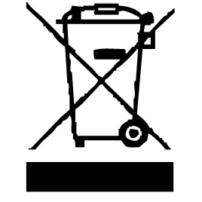

The symbol "CE" is the guarantee of compliance with harmonized European standards, voluntary, reflecting the essential requirements into technical specifications. These standards are not mandatory but are guarantees of compliance with essential requirements.


The symbol ROHS (Restriction of use of some Hazardous Substances) on the Environmental Protection, certifies that for each of the five hazardous substances • Lead • Mercury • (hexavalent) chromium • products for protection against flames PBB and PBDE, the peak concentration is equal to or less than 0.1% of the weight of homogeneous material, and 0.01% for the 6th • cadmium.

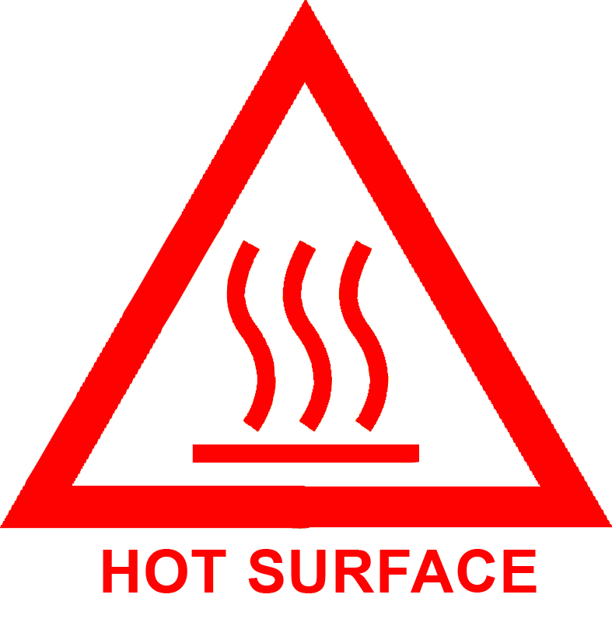
The symbol "HOT WALL" warns the user that the walls of the unit can become very hot, and to take precautions as required.


The symbol "GLASS / FORK" means that the device is compatible and can come into contact with foodstuffs.

The symbol "TRIMAN" indicates that the consumer is invited to dispose the product as part of a separate collection (eg recycling bin, waste, voluntary intake point).


For more information : http://www.quefairedemesdechets.fr

TO KNOW IT’S UNIT

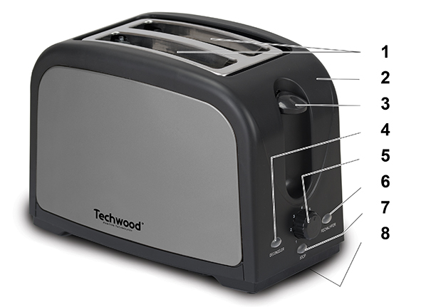
- 2 Large slots
- Housing with Stainless steel decor
- Bread carriage handle
- “Defrost function” button
- Browning control selector
- “Reheat function” button
- “Stop/Cancel” button
- Crumb tray (under the unit)
BEFORE FIRST USE

Let the unit run, without bread, about 3 minutes to remove the protective layer of resistance.
For this, select the MAX position with the Browning control selector.
The light emission of smoke and smell is normal.

USE

- Unroll the power cord completely.
- Check that the tension in force in the country where you are corresponds to that indicated on the apparatus.
- Connect the apparatus in a correct socket-outlet, (and connected to the ground if the unit is Class I), to avoid any danger.
- Disconnect the power source cable before any operation of cleaning of maintenance and accessories assembly.

Stand the appliance on a table or flat surface.
- The item must not be left unattended when it is connected to main supply.
- The item is not to be used, if it has been dropped & if there are visible signs of damage or if it is leaking.
- Never modify the appliance in anyway.
- Do not use or keep this product outside when it is raining.
- Certain parts of the appliance can get hot. Do not touch them, as you may burn yourself.
- Place the bread slices in the slot (for the French bread, cut a loaf shorter than the slot, then cut it in two pieces along its length.). Your appliance is provided to receive French bread, but also pieces of toast or other bread slices if their thickness and their length are shorter than the slot.
- Press down the bread carriage handle until it stops (in the same time, the grid inside the slot will tighten around the bread in order to keep it away from the heating wires). Then release the pressure and the handle will stay in the lower position, which means that the heating process has begun. If the handle comes up immediately, check if the appliance is plugged in as it blocks when the unit is plugged in.
- You can adjust the browning intensity to obtain a more or less toasted bread by positioning the browning control selector to one of the degrees marked from 1 to 7. Therefore you only have to turn clockwise to increase the intensity, and anticlockwise to decrease it. The higher the number is, the more toasted the bread will be.
To use complementary functions :
After pressing down the bread carriage handle, push on :
- The reheat button which allows you to reheat bread or to toasted bread.
- The defrost button which allows you to toast the bread that has been frozen beforehand.
- During the functioning, if you think that the bread is toasted enough or for another reason, you can break the heating process, simply by pressing the cancel button “STOP”.
- Always unplug the appliance after use and let it cool down before handling or storing it.

MAINTENANCE AND CLEANING

- Before attempting any cleaning operation, make sure the toaster is unplugged from the supply socket and fully cooled down.
- To remove bread crumbs slide the crumb tray situated on the side of the appliance.
- Never use sharp objects to clean. Doing so could damage the appliance.
- To clean the exterior surfaces, simply wipe over with a soft damp cloth.
- All other maintenance and repair should be performed by a qualified technician.

STORAGE

-Ensure the unit is completely cool and dry.
-Do not wrap the cord around the appliance, as this will cause damage.
-Keep the appliance in a cool, dry place.

GUARANTEE

Before being delivered, all our products are subjected to a rigorous control.
This apparatus is guaranteed 24 months starting from the date of purchase by the consumer.
The documents in proof of guarantee are :
• The invoice and
• The filled and stamped warrantee plate (located on side or bottom of the gift box). Without these documents in proof, no free replacement, nor no free repair, can be carried out.
During the warranty period, we deal for free, the defects of the apparatus or the accessories, rising from a defect of materials or manufacture by repair or, replacement. The services within the framework of the guarantee do not involve any extension of the warranty period and does not give right to a new guarantee !
In the event of recourse to the guarantee, bring back the complete apparatus to your retailer, in its original packing, accompanied by the proofs of purchase.
The breakage of parts out of glass or plastic is, in all the cases, not warranted. Defects on the accessories or the wearing parts (for example: coals of engines, hooks, drive belts, remote control of replacement, teeth brushes of replacement, webs etc) as well as cleaning, maintenance or it replacement of wearing parts are not guaranteed and are thus to pay !
In the event of foreign intervention, the guarantee becomes null and void.
After flow of the warranty period, repairs can be carried out, against payment, by a specialized trade or a repair service.

SPECIFICATIONS

Power supply 220-240V~ 50/60Hz
Power 700-850W
Norm Class I
Made in P.R.C

The characteristics can change without prior notice.

This unit is equipped with an electrical outlet with earth and must be earthed in an according plug.
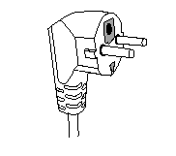
Note : In the event of question concerning the earth or electric connection, please consult a qualified personnel.
In the event of short-circuit, earthing reduces the risk of electric shock while making possible the current to be evacuated by the wire of ground.

CAUTION: In order to minimize the risks of electric shock, In the event of breakdown, not to open the case but to call upon a qualified technician for repairs.

This apparatus satisfied EC directives, it was controlled according to all the European current directives, like: electromagnetic compatibility (EMC) and low tension (LVD).

This apparatus was designed and manufactured in respect of the last safety regulations and technical specifications.

Imported by Sotech International
" LE PERIPOLE " N°A-107
33, Avenue du Marechal de Lattre de Tassigny
94120 Fontenay sous-bois - France

